Student Club and Organization Handbook
2017-2018

https://www.csusb.edu/student-engagement

Student Organization Handbook 2016-2017
Table of Contents

Student Organization Guiding Principles 1
Relationship between Student Organizations and the University 1
Affiliation with the University 1
Off-Campus Affiliations 1
Social Fraternities and Sororities 1
Competitive and Recreational Sports Clubs 1
Student Organization Standards 2
Recognition Requirements 2
Charter Renewal Procedures 2
Charter Changes 3
Probationary Status and Charter Revocation 4
Benefits of Recognized Student Organizations 4
Benefits of University Sponsored Organizations 4
Advisors 4
Advisor Role and Responsibilities 4
Organization’s Responsibility to the Advisor 5
Advisor/Officer Relationships 6
Changing Advisors 6
Co-Advisor 6
You’ve got Mail 7
Managing Your Organization’s Finances 7
Financial Responsibility 7
Banking 8
11
Cash Advances 12
Cash Reimbursements 12
Purchases 13
Contracts/Agreements: 13
Check Requests 14
Associated Students, Inc. 17
Facility and Event Scheduling 17
Food Protocol for Student Organizations 19
Fundraising 21
General Fundraising Information 21
Raffles 21
Campus Advertising and Posting 22
General Posting Guidelines & Regulations 22
Posters on Stakes and Banners Guidelines & Regulations 24
Sidewalk Chalking Guidelines & Regulations 24
Jack Brown Hall LCD Monitors 909-537-5700 24
College of Natural Sciences Buildings LCD Monitors 909-537-3302 25
Electronic Marquee 909-537-5236 25
Coyote Chronicle 909-537-5289 25
Coyote Advertising 909-537-5815 25
Coyote Radio 909-537-3486 25
Coyote Television 909-537-3486 26
Working with CSUSB Office of Strategic Communication 909-537-5007 26
Santos Manuel Student Union Posting and Advertising 27
Flyers and Posters 27
Banners 27
Display Cases 27
Coyote Connection Digital Advertising 27
SMSU Ad Rates 28
CSUSB Community Standards…………………………………………………………………………………………………….28
Hazing and Initiation…………………………………………………………………………………………………………………29
Student Organization Discipline Process 30
CSUSB Policies 33
POLICY ON SPEECH AND ADVOCACY 35
STUDENT CLUBS AND STUDENT ORGANIZATIONS SPECIAL EVENTS POLICY 40

Student Organization Guiding Principles

Relationship between Student Organizations and the University
California State University, San Bernardino (CSUSB) considers student organization activities and programs an integral part of the University’s mission. The programs and activities conducted by student organizations contribute significantly to a student’s total educational development and progress. Student activities provide experiences which stimulate interest and understanding of current social, economic, political, and cultural issues. Student organizations provide a leadership laboratory for students to gain and apply real-world experience in order to succeed in their chosen professions in the future.

Affiliation with the University
Student organizations are considered to be affiliated with, but not official entities of CSUSB. As a condition for continuation of the affiliation relationship, the organization agrees to abide by University regulations. In return, student organizations gain access to selected University facilities and resources.

Student organizations may only identify themselves with the University by using the following format in the organization name: “Club XYZ at CSUSB”. The name must not suggest University endorsement of the organization’s purpose or activities, or imply that the organization is speaking on behalf of the University, any of its divisions, or departments.

The seal of the University and any other logos, trademarks, letterhead or insignias of the University, may not be used unless permission is granted through the Office of Public Affairs. For additional information please refer to page 21 of the handbook or visit http://identity.csusb.edu/.

Off-Campus Affiliations
Many student organizations at CSUSB are affiliated with local, regional, state, and national organizations. These off-campus affiliates often have guidelines or regulations that organizations must comply with in order to remain in good standing and continue their affiliation. Such guidelines are considered important operating documents and must be on file in the Office of Student Engagement (OSE). Examples of this type of organization can include National Honor Societies and Pre-Professional Associations.

Social Fraternities and Sororities
Fraternities and sororities are a special type of student organization. These organizations are entitled to single-gender membership, provided they qualify under the provision of Section 1681 of the regulations promulgated under Title IX of the U.S. Education Act of 1972. History in the United States has demonstrated the many positive aspects of having Greek organizations present on a University campus. Additional requirements for recognition and affiliation with CSUSB may be required for these organizations due to their complexity and requirements of the University to fulfill its mission. For additional information please refer to the Fraternity and Sorority Policies & Procedures Handbook or visit https://www.csusb.edu/student-engagement/resources.

Competitive and Recreational Sports Clubs
Competitive and Recreational Sports clubs are recognized by Office of Student Engagement, but managed by the Student Recreation and Wellness Center to ensure compliance with CSU mandated insurance and other risk management requirements. To ensure safer operations for members of Sports Clubs, CSU developed a “Sports Club Model” that has been divided into two parts:

- Competitive Sports Clubs are defined as organizations which compete against other universities or community teams in games, contests, and/or events where travel is involved. These clubs may be affiliated with a National Governing Body (NGB), such as the Rugby Club, Lacrosse Club, Tennis Club, etc.
- Recreational Clubs are defined as organizations whose main purpose is to provide instruction, participation and/or social opportunities. Travel may be involved. Examples of these clubs include Ski Club, Salsa Club, Dance Club, Rock Climbing Club, etc.

Please note that organizations deemed Competitive or Recreational must be in good standing with both departments at all times. If you have questions about whether your organization falls into either of the categories, please contact the Trent Morgan at 909-537-3658 or tmorgan@csusb.edu

Student Organization Standards
The University requires that all student organizations charter annually with OSE in order to receive recognition. By chartering each year organizations can become aware of the current privileges, responsibilities, and regulations regarding student organization operation. In addition, organizations are required to update organization records throughout the year when changes are necessary.
Per the CSUSB Title IX and Gender Equity Office, all CSUSB students are required to complete End Sexual Violence Training each academic year. In addition, all members of CSUSB chartered organizations are required to complete one additional supplemental training per academic year.

Recognition Requirements
- All student organizations must maintain three officers, a President, Vice President, and Treasurer. Officers are required to maintain a 2.5 Grade Point Average (GPA) for each quarter and cumulatively. The officers must be in good standing and must not be on probation of any kind. Undergraduate students must earn nine quarter units per term while holding office and can earn a maximum of 225 quarter units or 125% of the units required, whichever is greater, for a specific baccalaureate degree objective in order to maintain eligibility.
Graduate and credential students must earn four quarter units per term while holding office and can earn a maximum of 75 quarter units or 167% of the units required, whichever is greater, for the graduate or credential objective in order to maintain eligibility.

Grade verification will occur after each academic quarter, and notification will be sent to the organization’s president and advisor(s) should an officer not meet the minimum standard. Each quarter there is a deadline to replace officers that do not meet the minimum academic standard, and organizations that fail to do so will be placed on probation or suspension.

- Each organization is required to submit and maintain an organization constitution. This constitution will assist in the general operations, membership criteria, and electionhttps://www.csusb.edu/student-engagement/resources. The most current copy of the constitution should be on file in the OSE Office. Any changes should be submitted to the office via email at clubs@csusb.edu no later than two weeks from the effective date of change.

Charter Renewal Procedures
Existing student organizations are required to renew their charters each academic year; all charters expire on June 30 regardless of the date the organization received recognition. The following steps must be completed for Charter Renewals:

- Go to orgsync.com
- Click on the green “Sign in with your campus ID” icon
- Locate the “Organizations” icon to the left under the CSU San Bernardino picture
- Once you have located your organization, go to “Settings” at the bottom left of the page
- Click “Organization Settings”, then “Profile”, then “Update and Renew Profile”
- Update the form accordingly, and upload your constitution and roster. Click finish.
- Once complete, you will receive a message in green at the top of the screen that says, “Your organization registration request has been successfully submitted”.
- You will be contacted by OSE for any pending requirements.
- Once all requirements have been received, you will be contacted by OSE to schedule your charter appointment.
- Meet with the appropriate OSE staff member.

You can check the status of your charter, and locate any pending items at “My Tools”, “Requests”. Once everything is complete, your organization will appear under “Browse Organizations”.

Charter Changes

- Fill out a Change of Charter Request Form from the OSE website to update officer contact information, change an officer, change the organization’s advisor or add a secondary advisor. The link to the form is https://orgsync.com/1146/forms/270378

- Once the form has been submitted, a new Trust Fund Fact Sheet will be sent to the president reflecting the new changes.

- Changes will not be considered official until the Trust Fund Fact Sheet is turned into OSE with all required signatures.

Probationary Status and Charter Revocation
Student organizations that do not comply with campus policies or procedures and/or federal, state or local laws may be placed on probation or lose University recognition. In addition, individual members and/or officers may be held individually responsible and subject to the student conduct process depending on the violation. Please refer to the Student Organization Judicial Process on page 29.

Benefits of Recognized Student Organizations
- Reserve campus rooms and space through Special Events and Guest Services and the Student Union Scheduling Office.
- Become eligible for Associated Students, Inc. Club Allocation Budget Committee Funding.
- Host fundraising activities on campus.
- Receive access to an Organization Mailbox.
- Attend Leadership Training Programs.
- Invitations to Special Recognition events.
- Invitations to participate in campus-wide events such as picnics, festivals, SOAR, Homecoming, etc.
- Subscription to electronic mailing list for all organization members.
- Receive 100 free black and white photocopies per quarter in OSE.
- Assistance with Food Events Notification Forms.
- Access to OrgSync as a tool for creating an online networking community.
- Fax Service to send and receive official student organization documents.

Benefits of Recognized Sponsored Student Organizations
- Reduced rates for campus rooms and space through Special Events and Guest Services and the Student Union Scheduling Office.
- Attend leadership training programs.
- Invitations to special recognition events.
- Invitations to participate in campus-wide events such as picnics, club fairs, SOAR, Homecoming, Late Night, etc.
- Subscription to electronic mailing list for all organization members.
- Assistance with Food Events Notification forms.
- Access to OrgSync as a tool for creating an online networking community.

Benefits of University Sponsored Organizations
- Listing in the Organization Directory.
- Invitations to participate in campus-wide events such as picnics, club fairs, SOAR, Homecoming, Late Night, etc.
- Subscription to electronic mailing list for all organization members.

Advisors

Advisor Role and Responsibilities
All advisors should understand that by agreeing to serve as an advisor, they assume the responsibilities of that role. An effective advisor has a strong belief in the organizations, a desire to help students succeed, a willingness to share expertise, and a commitment to spend time with the organization.

Student organization advisor roles and responsibilities include but are not limited to:
- Volunteer to be a University representative for a student group.
- Act as a liaison for the organization with OSE and the University.
- Provide continuity from year-to-year and during periods of transition.
- Help mediate conflicts within the group and assist with problems that may arise.
- Serve as a role model.
- Be aware of all plans and activities of the group.
- Know the organization’s short-term and long-term goals and provide guidance to help reach these goals.
- Provide insight and advice for activity planning.
- Be knowledgeable of University policies and procedures.
- Assist the officers and members in becoming acquainted with these policies and procedures.
- Oversee the expenditures of the organization, including the planning of the budget and the maintenance of financial records.
- Review all distributed material, publicity (including flyers), and official correspondence before the organization distributes them.
- Review and sign paperwork such as the annual charter packet, space reservations, CAB Funding Request forms, etc.
- Be sure that the organization submits all forms requested by the University on time.

- Be present at scheduled meetings and social functions of the organization, as time permits.
- Be aware of the activities of the organization.

Organization’s Responsibility to the Advisor
It is each organization’s responsibility to utilize its advisor and always maintain open communication lines. The following list is a guideline for working with advisors:
- When planning organization meetings for the year, the group should make an effort to designate times that are convenient for the advisor so that he/she may attend these meetings.
- Minutes of meetings as well as other materials of the organization should be distributed to the advisor. This keeps the advisor informed and allows him/her to keep files that may be useful for historical information.
- If executive meetings are established to determine agendas for meetings or to discuss organization issues, the advisor should be invited. If the advisor is unable to attend, he/she should be informed about what is discussed and requested to submit additional items.
- Officers should maintain a close relationship with the advisor and should provide opportunities for the advisor to meet as many members as possible.
- Organizations should invite the advisor to all events as a way of keeping the advisor involved and informed of sponsored activities. It is important to not only inform the advisor about what is happening, but also allow the advisor to provide input about the proposed event or activity.
- Advisors are encouraged to review all distributed material, publicity (including flyers), and official correspondence before they are distributed.
- If a situation arises that may cause problems for the organization or any of its members, the advisor should be informed immediately.
- Officers should regularly update the advisor regarding the financial status of the organization.
- Organizations must recognize that an advisor cannot be committed to any type of obligation unless he/she agrees to the commitment.
- Organizations should be aware that the advisor is providing services without compensation.
- Although advisors do not expect special recognition, they like to know their service is appreciated.
- An annual Charter Request must be submitted for the “partnership” to continue.

Advisor/Officer Relationships

What an Organization Officer Expects of an Advisor
    - To assist the organization in formulating long-range goals and in planning and initiating short-term projects.
    - To serve as a resource (due to their previous experiences and background information).
    - To assist them in evaluating group projects, performance and programs.
    - To make suggestions that improve leadership skills.
    - To be available when emergencies and problems arise.

What an Advisor May Expect of an Organization Officer
    - To keep the advisor informed of all organizational activities, meeting times, locations and agendas.
    - To receive minutes from all meetings.
    - To meet regularly with the advisor and use them as a sounding board for discussing organizational plans and problems.

Working with the Organization
    - Regular meetings with the officers should be established by the advisor. Advising meetings should be based on a genuine concern for their creative and personal development, as well as that of the other members of the organization.

Different Approaches in Advising Officers
    - If an idea is inappropriate, the advisor can encourage students to explore other alternatives.
    - The advisor will want to point out factors based on the ideas presented by the officers without imposing their own bias.
    - Informal meetings are conducive to open worthwhile discussions.
    - The officers should be encouraged to take an occasional chance by delegating authority to less proven members.
    - The advisor may point out the difficulties inherent in proposed courses of action.
    - The advisor may request that the group obtain the opinion of the individuals or agencies affected by programs.

Changing Advisors
If the club changes its advisor, a Change of Officer or Advisor Form must be submitted on OrgSync within two (2) weeks of the advisor change.

Secondary Advisor
If an advisor will be unavailable for a period of time or would like to share the responsibility of advising a student organization, he/she may designate a secondary advisor. The co-advisor should be treated as the primary advisor and may sign all forms. It is essentially important that the two advisors communicate with one another. The secondary advisor may be a part-time CSUSB faculty or professional staff member.

OrgSync
OSE has partnered with an online networking community called OrgSync. This benefit is provided to all recognized student organizations. OSE will host annual training opportunities for officers and members to familiarize themselves with the OrgSync system. OrgSync has proven to be a useful tool in communicating with your members, OSE, and other clubs and organizations on campus.

Our goal in utilizing OrgSync is to provide the ultimate online networking and member management service. By offering dedicated customer attention, along with highly regarded proven technology, they have created an exceptional experience for CSUSB students. We want our students to be able to centralize all aspects of student involvement in order to maximize their student experience.

All student organizations are required to maintain an up-to-date membership roster on OrgSync. Each organization is responsible for the upkeep of their account and members activities. Organizations can also create a web site through OrgSync. This web site must meet CSUSB Web Accessibility standards.

You’ve got Mail
Now that you are a recognized student organization, you are eligible to have a cubby adjacent to the OSE office. It can be used for student group purposes only. Please follow the policies listed below for proper mailbox maintenance. OSE will sign for packages, certified mail, and shipments. Packages unclaimed after two weeks will be Returned to Sender.
Your Student Organization’s mailing address is:
(Name of Student Organization)
California State University, San Bernardino
c/o Office of Student Engagement
5500 University Parkway
San Bernardino, CA 92407

Some student organizations have campus mailboxes in other locations due to close relationships with academic departments or program offices. These mailboxes must also be used for organization purposes only and the campus mailing address must be filed with OSE.

Managing Your Organization’s Finances

Financial Responsibility
Officers and members acting in executive positions in campus organizations are responsible for its activities. The individuals listed on the Financial Responsibility Form in the organization’s Charter Packet are jointly and severely liable for all debts and obligations to the University and its auxiliary units incurred by their organization. This includes use of all facilities and services, (i.e.; Student Union, Sodexo (Dining Services), Media Services, etc.). Each organization is limited to three (3) financially responsible officer positions.

CSUSB reserves the right to hold responsible the officers of an organization that fail to meet its financial obligations. An academic record, registration and transcript hold will be placed on officer’s student accounts should the organization fail to meet any financial obligation. In addition, the university reserves the right to suspend recognition of any organization that fails to meet its financial obligations. For this reason, the presiding officer of each organization is strongly encouraged to consult with OSE before undertaking any event which might exceed funds greater than the organization’s ability to pay. Financially Responsible officers will be listed on the organization’s university bank account.

Banking
Office of Student Engagement (OSE) along with the Financial Management Specialist (FMS) facilitates all financial transactions for University Clubs and works with student leaders, campus administrators, and business vendors to expedite the approval of payments, refunds, advances or withdrawals from University Club accounts. This Guide should provide you with instructions on how to conduct financial business for your University Club including setting up the account, making deposits and a variety of ways to access your club's funds, based on the university's required accounting procedures and the type of activity, event, or financial transaction necessary to complete the request.

The Student Financial Services Office is open 8:00AM-6:00PM Monday through Friday; Monday through Thursday 7:00AM-5:00PM during the summer.

Setting up an On-Campus Bank Account

- Be a current chartered Student Club through Office of Student Engagement (OSE)
- Set up meeting with FMS to go over process and forms by calling (909) 537-3236 or email crystalh@csusb.edu
- Provide information
- Officers sign TFFS
- The TFFS form will be routed for campus signatures
- The Trust Fund # will be provided to OSE, FMS, and University Club Officers
- The Trust Fund is your bank account and this number will be used on the following forms:
(Additional forms can be found on Office of Engagement web-site at https://www.csusb.edu/student-engagement/resources )

  - University Club Cash Deposit Form
  - University Club Financial Transaction Request Form
  - University Club Itemized Expense Report

All recognized CSUSB student organizations, with the exception of those granted exemption, must have a financial account with the University. University policy requires that student organizations deposit all funds in their CSUSB bank account. The purpose of this policy is to ensure the integrity of the funds from year to year.

Financial statements, donations, and all check and purchase order requests are processed by the FMS.

Clubs are not permitted to have off-campus bank accounts. Clubs found to have off-campus bank accounts are subject to disciplinary action. Requests for checks or transfers to any club account held off-campus will not be processed.

To be considered for on-campus banking exemptions, your organization must meet the following criteria:
- Maintain official affiliation with a national organization.
- Members must pay quarterly or annual dues that partially go to their national organization.
- Be incorporated as a non-profit – Internal Revenue Service Section 501(c).
- Must have filed IRS form 990 with Internal Revenue Service to maintain 501(c) in previous fiscal year.
- Copies of the aforementioned documentation must be submitted with the Exemption Form to the OSE.

Although it is not required, it is highly recommended that groups filing for exemption have insurance provided by the national organization to its affiliated chapters.

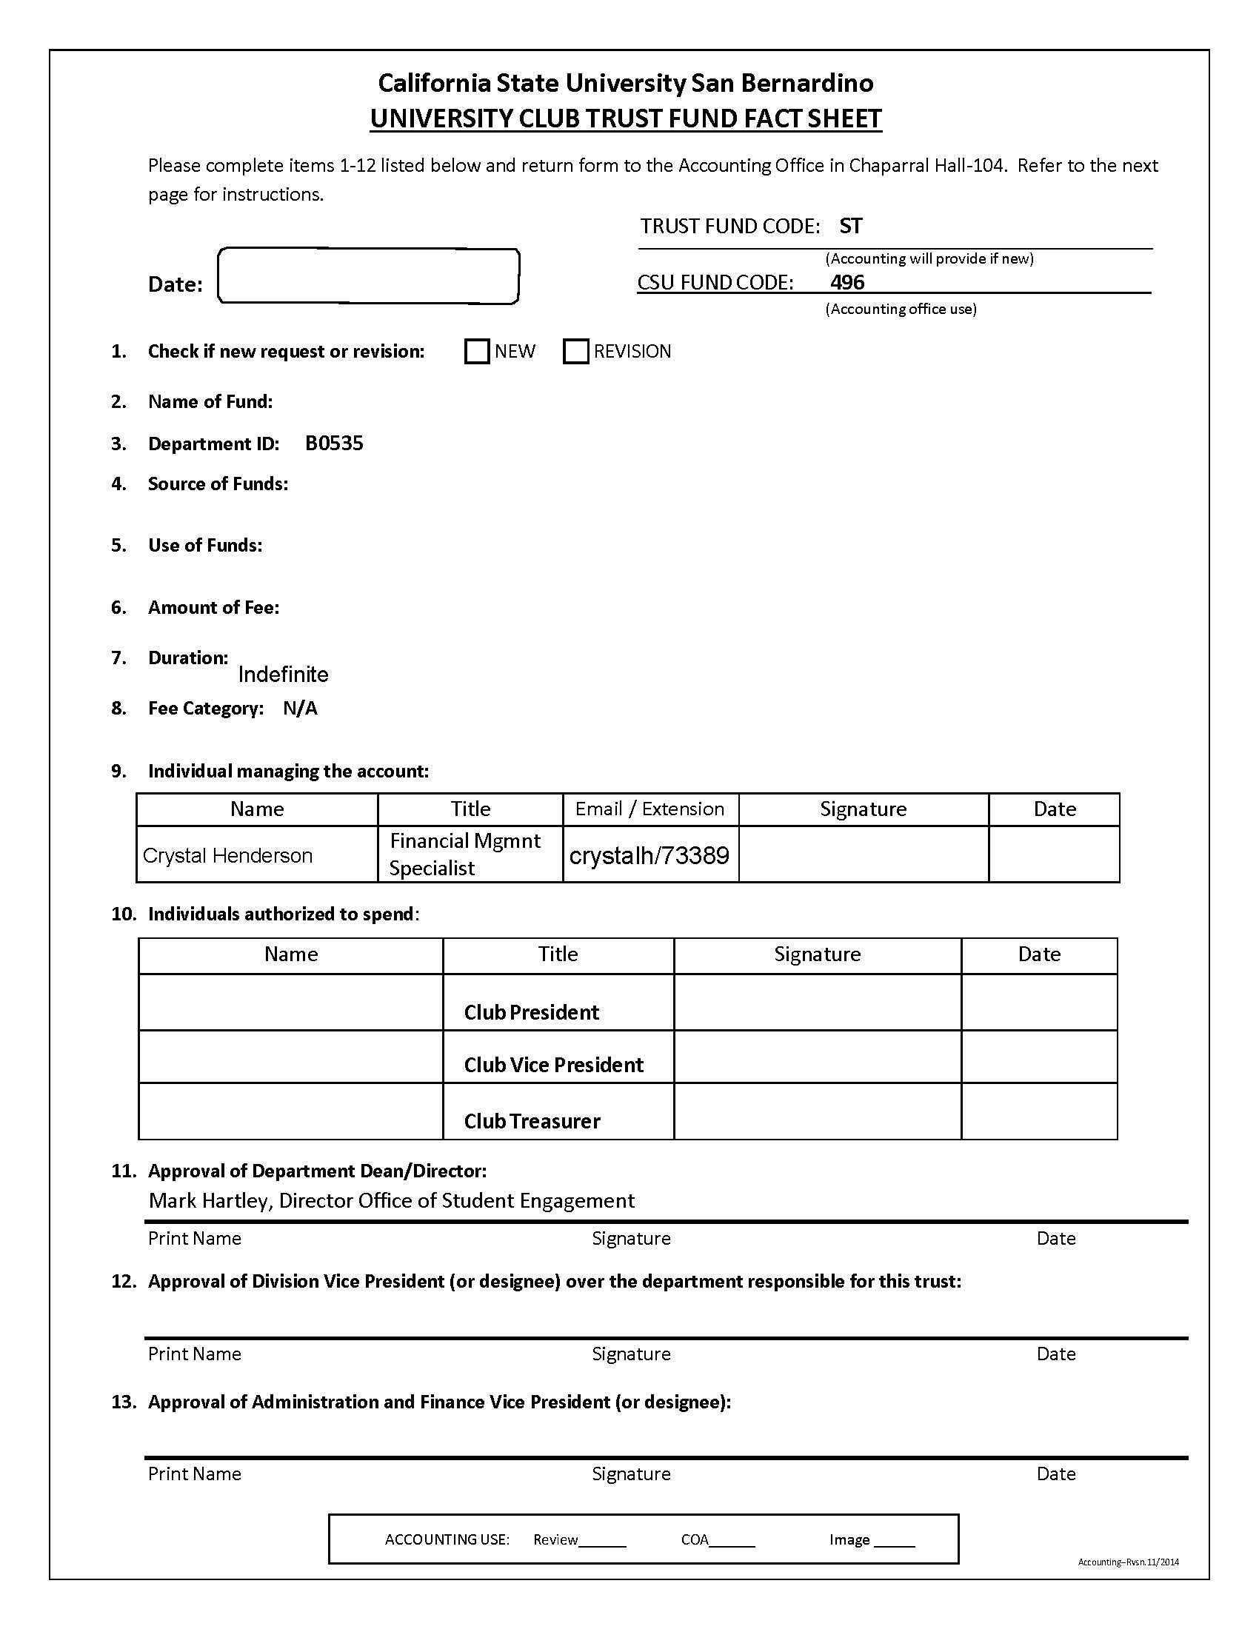

Deposits
Deposits can be made to your club account by utilizing the University Club Cash Deposit Form. The form is completed by the club representative making the deposit, and submitted to the Student Financial Services Office for processing. The Student Financial Services Office is open 8:00AM-6:00PM Monday through Thursday and 8:00AM-5:00PM Friday; Monday through Thursday 7:30AM-5:00PM during the summer.

- Deposit all receipts (cash/check payments) with the Student Financial Services Office within one week of receipt.
- Establish good controls over cash receipts, use a lock box or safe to store cash and receipts.
- Attach copies of hand receipts to the deposit form.
- Transport deposits to the Student Financial Services Office in a locked bag in dual custody if deposit is greater than $250.00 and by police escort for deposits over $2,500.00.
- On the deposit form enter the following:
  - University Club Name: Enter your Club name here.
  - Prepared by/Phone #: Enter the name and phone # of the person preparing the deposit.
  - Date: Enter the date the deposit was prepared.
  - Total Cash (adding machine tape or worksheet): Enter the total of all the cash (currency/coin).
  - Total Checks (adding machine tape or worksheet): Enter the total of all the checks.
  - # of Checks: Enter the number of checks in the deposit.
    - Note: Checks should be made payable to CSUSB- and Club Name.
  - Deposit to: Enter the Club's five digit fund number beginning with ST; the rest of the chartfield string is hard-coded.
  - Philanthropic (gift/donation- donor requires receipt for tax purposes): If a portion of the deposit needs to go to a Philanthropic account, enter the amount here. Student Financial Services will issue a check for this amount to Philanthropic.
  - Shortage: If the deposit is short, enter the Club's fund number; the rest of the chartfield is hard-coded.
  - Overage: If the deposit is over, enter the Club's fund number; the rest of the chartfiel d is hard-coded.
  - Total Deposit: Enter the grand total of the deposit here.
  - Description or reference information: Enter the name of the event or other description here.
  - Hand Receipt #'s: If hand receipts were used, enter the receipt numbers here. Note: Attach the Student Financial Services copy of the hand receipt to the deposit form.
  - Verified by: Enter the name of the person that verified the deposit. Note: The preparer and the verifier cannot be the same person.
  - Date: Enter the date the deposit was verified.

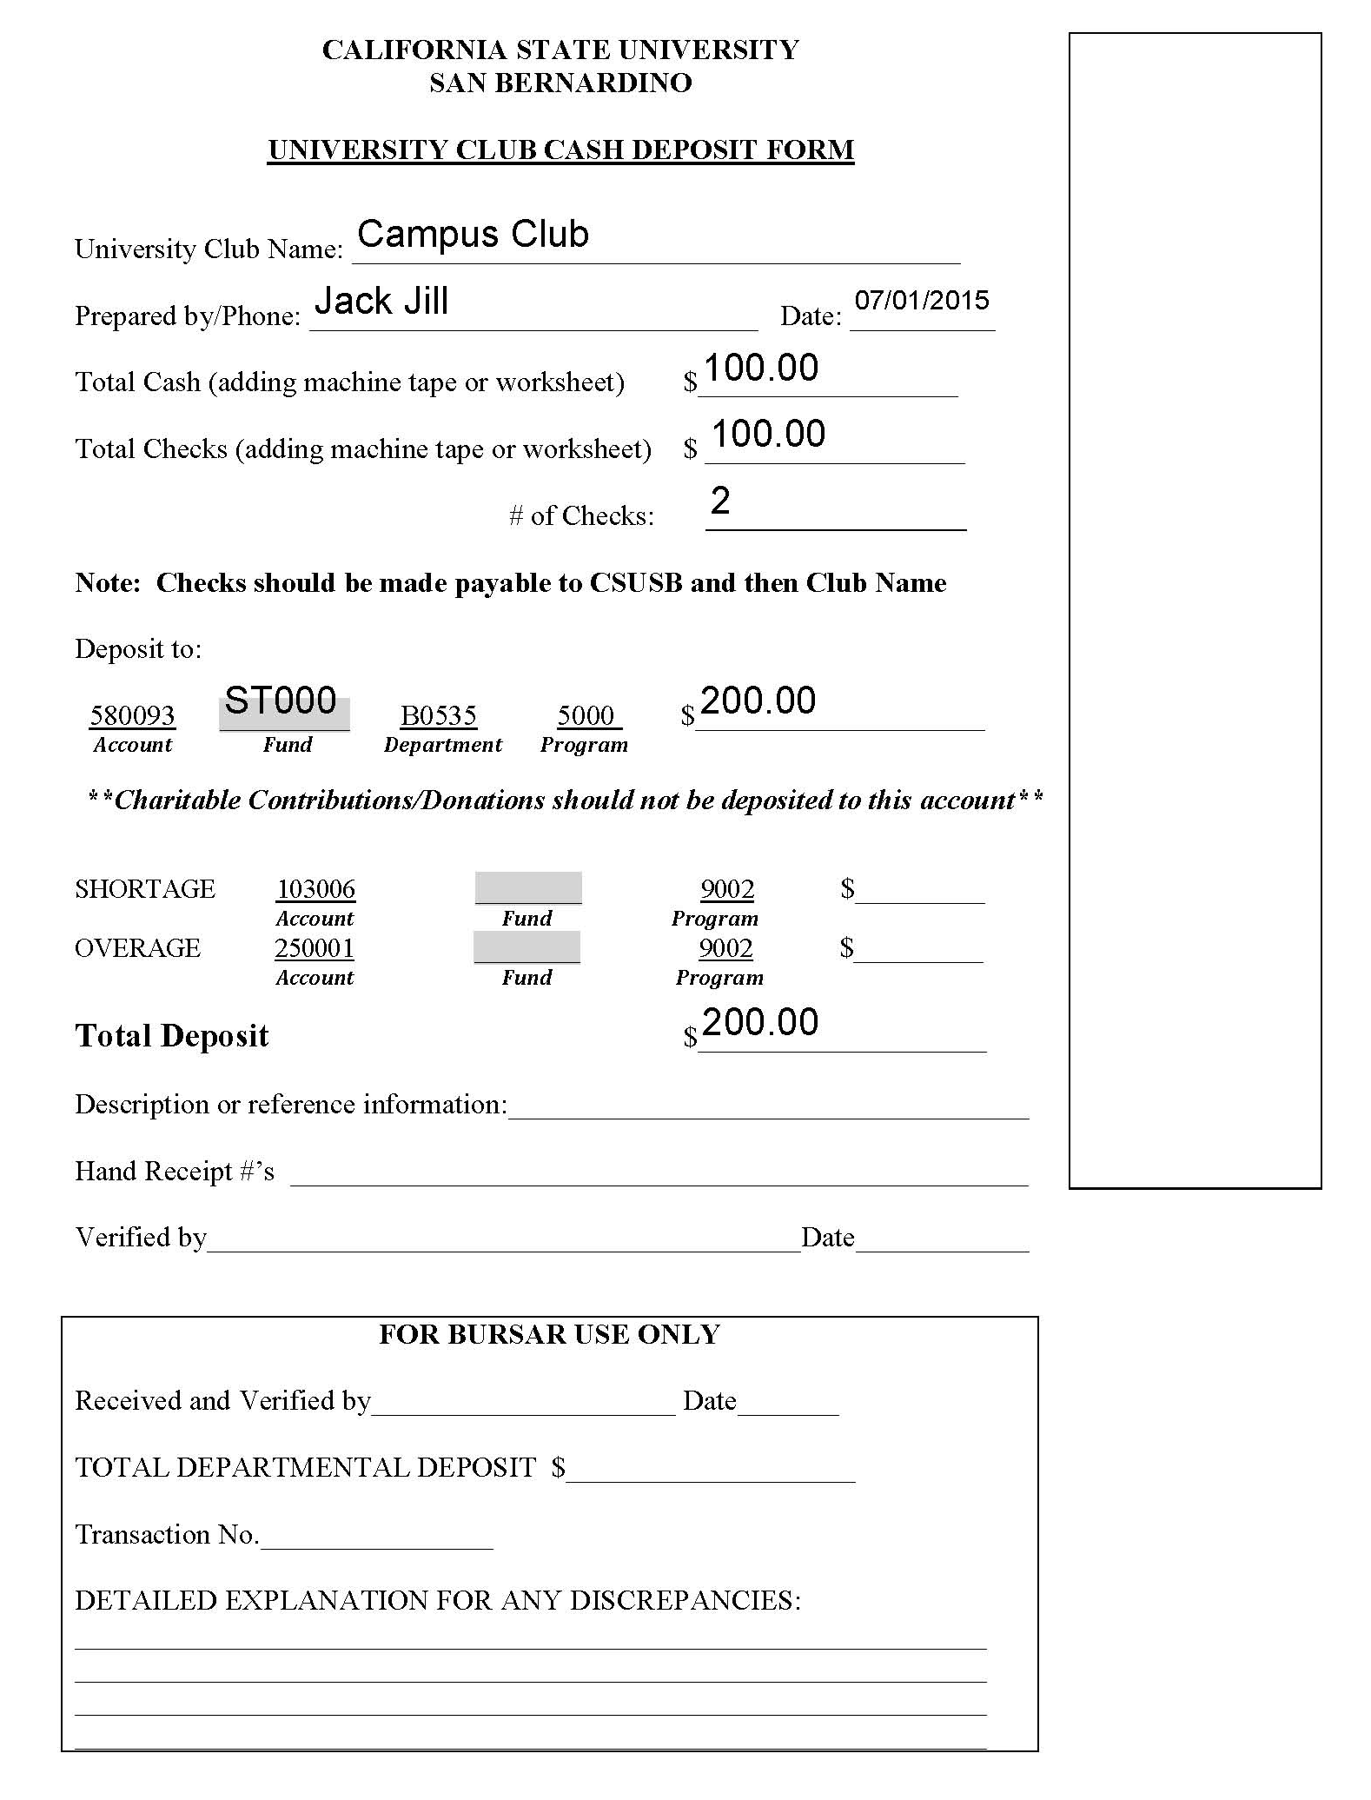

Cash Advances

The Club must have funds available in their account to cover the cash advance. Cash advances are typically used for advertising, printing/duplicating, food (restaurant/grocery store purchases), banners, flyers, decorations, t-shirts, and other event supplies or organizational purchases. For purchases that cannot be made by check, procurement card or other processes cash advance is available.

- Establish the need for the cash advance (maximum is $500) with some form of documentation such as a quote or budget and when you will need the cash advance, allow yourself five business days to obtain necessary signatures. Cash advances can be issued by Student Financial Services two business days ahead of the event the advance is for.
- Complete the University Club Financial Transaction Request Form per instructions:
  - Select the Cash Advance Box
  - Indicate the Amount
  - Sign as Club Officer
  - Obtain signature of another Club Officer
  - Obtain signature of OSE Director or Designee if over $100.00
  - Obtain Signature of FMS who signs to indicate there are funds available.
- Take signed form to Student Financial Services Office
  - Student Financial Services will issue the cash advance, assign Advance #, and provide a University Club Advance envelope filled out with the required information and include an Itemized Expense Report form to keep track of the expenses paid with the advance.
- Once your event that required the advance is complete you must bring the University Club Advance envelope along with the Itemized Expense Report and any unused funds back to the Student Financial Services Office no later than two business days after your event. The Itemized receipts/invoices (complete with vendor name and address) and the unused funds should add up to the original advance amount. If $25. over the advanced amount is incurred, a Financial Transaction Request Form is needed to be reimbursed for the difference. A copy of the completed information on the University Club Cash Advance Envelope will be provided to you and to the FMS.

Cash Reimbursements

Funds must be currently available in the club's account to receive a reimbursement.
1. Spend out of personal funds (maximum is $500) for club business that has been approved by more than one officer and this can be via email.
- Complete the University Club Financial Transaction Request Form per instructions:

  - Select Cash Reimbursement Box
  - Indicate the Amount
  - Sign as Club Officer
  - Obtain signature of another Club Officer
  - Obtain signature of OSE Director or Designee if over $100.00
f. Obtain Signature of FMS who signs to indicate there are funds available.
- Take signed form to Student Financial Services Office along with original itemized receipt.
- If everything is complete you will receive your reimbursement upon submission of the above.
- Receipts should be submitted within 30 days

Purchases

Plan ahead. Most purchase orders have a one to two day turnaround after receipt of an approved requisition. Orders requiring evidence of appropriate insurance where we don't already have the evidence on file can take 7-14 days and longer if the vendor is non-responsive.

- Credit Card - A procurement (credit) card is primarily used for conference registrations and national membership dues for student clubs and organizations. The procurement card can also be used to pay for supplies such as t-shirts, catering, or other supplies/services, however it cannot be used for services performed on-campus, with the exception of Sodexo. See OSE or FMS if you think you need to use a procurement card.
  - Complete the University Club Financial Transaction Request Form per instructions:
    - Select the Credit Card Box
    - Indicate the Amount
    - Sign as Club Officer
    - Obtain signature of another Club Officer
    - Obtain signature of Club Advisor if purchase is over $500.00
    - Obtain signature of OSE Director or Designee if over $100.00
    - Obtain Signature of FMS who signs to indicate there are funds available.
  - Attach completed registration forms, membership forms, ordering details, etc., and submit to the FMS

- Purchase Orders - A Purchase Order (P.O.) is required for purchases over $1,000 where a procurement card cannot be used, or for any services performed on campus. Purchase orders are frequently used to pay for multiple items for large off campus events. Clubs are not allowed to sign contracts on behalf of the University. OSE along with FMS can assist you if you need to utilize a Purchase Order:
  - Complete the University Club Financial Transaction Request Form per instructions:
    - Select the Purchase Order (PO) Box and see steps 2-7 above
  - Complete a University Club Purchase Requisition Form
  - Attach the purchase requisition to Financial Transaction Request Form and submit to the FMS.
  - The FMS or support staff will enter a requisition into the financial system and the Purchasing Office will issue a purchase order.

Purchase orders are typically issued with Net 30 terms meaning that vendors will be paid after receipt of the items and within 30 days of the invoice date. Purchasing will work with vendors to obtain necessary evidence of insurance for services provided on campus. If you require a status on the purchase order, the FMS should be able to provide you with a requisition ID and you may call the Purchasing Office at 909-537-5142 and ask to speak with the buyer assigned to that requisition.

Contracts/Agreements:

Contracts and agreements must be reviewed, approved and signed by the Purchasing Office. Clubs are not allowed to sign contracts on behalf of the University. Contract language is reviewed to ensure that the University and Club are not held to unacceptable terms. If the agreement requires payment, the unsigned agreement should be included with the University Club Purchase Requisition. If no payment is required submit the unsigned agreement to the FMS and include a note requesting the contract be reviewed by Purchasing.

Check Requests

Chargebacks from Campus: If your club has transactions between campus departments for goods/services provided, a Chargeback may be possible. Contact FMS if you will be using these campus departments for services. Creative Media Services. Event Planning, Parking Services or Printing Services.

Raffles/Prizes: If your club will be providing merchandise (laptops, gift cards etc.) as raffle prizes, the recipient must sign Raffle/Prize Information form. Please contact FMS.

Funds must be currently available in the account to request a check. For purchases/items/services up to $1,000.00. Check requests are commonly used to pay for supplies and services, such as guest speakers, catering, comedians, DJs, set-up crews, rental equipment, special event insurance, etc. Checks issued to vendors will be mailed to the vendor's remitting address after the event is over and the service is completed.
Checks that are required to be held for pickup must indicate such on the check request form and include the on campus contact responsible for picking up the check from the Student Financial Services.

Note - For Student Payments Only: Students are encouraged to complete a Direct Deposit form for Accounts Payable in order to expedite their reimbursements. (This form is different/separate from the direct deposit enrollment offered through Student Finance. The form may be obtained from OSE or from the FMS).

- When requesting checks, plan ahead to allow sufficient routing and processing time for you, OSE, FMS, and Accounts Payable. Best to allow a minimum of ten business days. Complete a University Club Financial Transaction Request Form:
  - Select the Check Request Box
  - Indicate the Amount
  - Sign as Club Officer
  - Obtain signature of another Club Officer
  - Obtain signature of Club Advisor if purchase is over $500.00
  - Obtain signature of OSE Director or Designee if over $100.00
  - Obtain Signature of FMS who signs to indicate there are funds available
- FMS will complete Check Request based on information provided by club.
  - Name and full address of Payee are required
  - Club contact information is required
  - Type of payee (vendor, student, employee) must be identified
  - Employees may not be paid for services, only reimbursement of goods
  - Provide complete chartfield string (contact FMS)
  - Business purpose/description of event are required
- Proper back up documentation is required for all check requests. Attach original itemized receipts (for reimbursements) or original itemized invoices (for payments of goods/services) to check request.
- Keep copies of the above for your records.
- If you need assistance, please contact the FMS.
- When completed, submit check request, attached receipts/invoices, to SMSU 203.
- After the FMS has approved the document it will be submitted to Accounts Payable for payment to be issued.

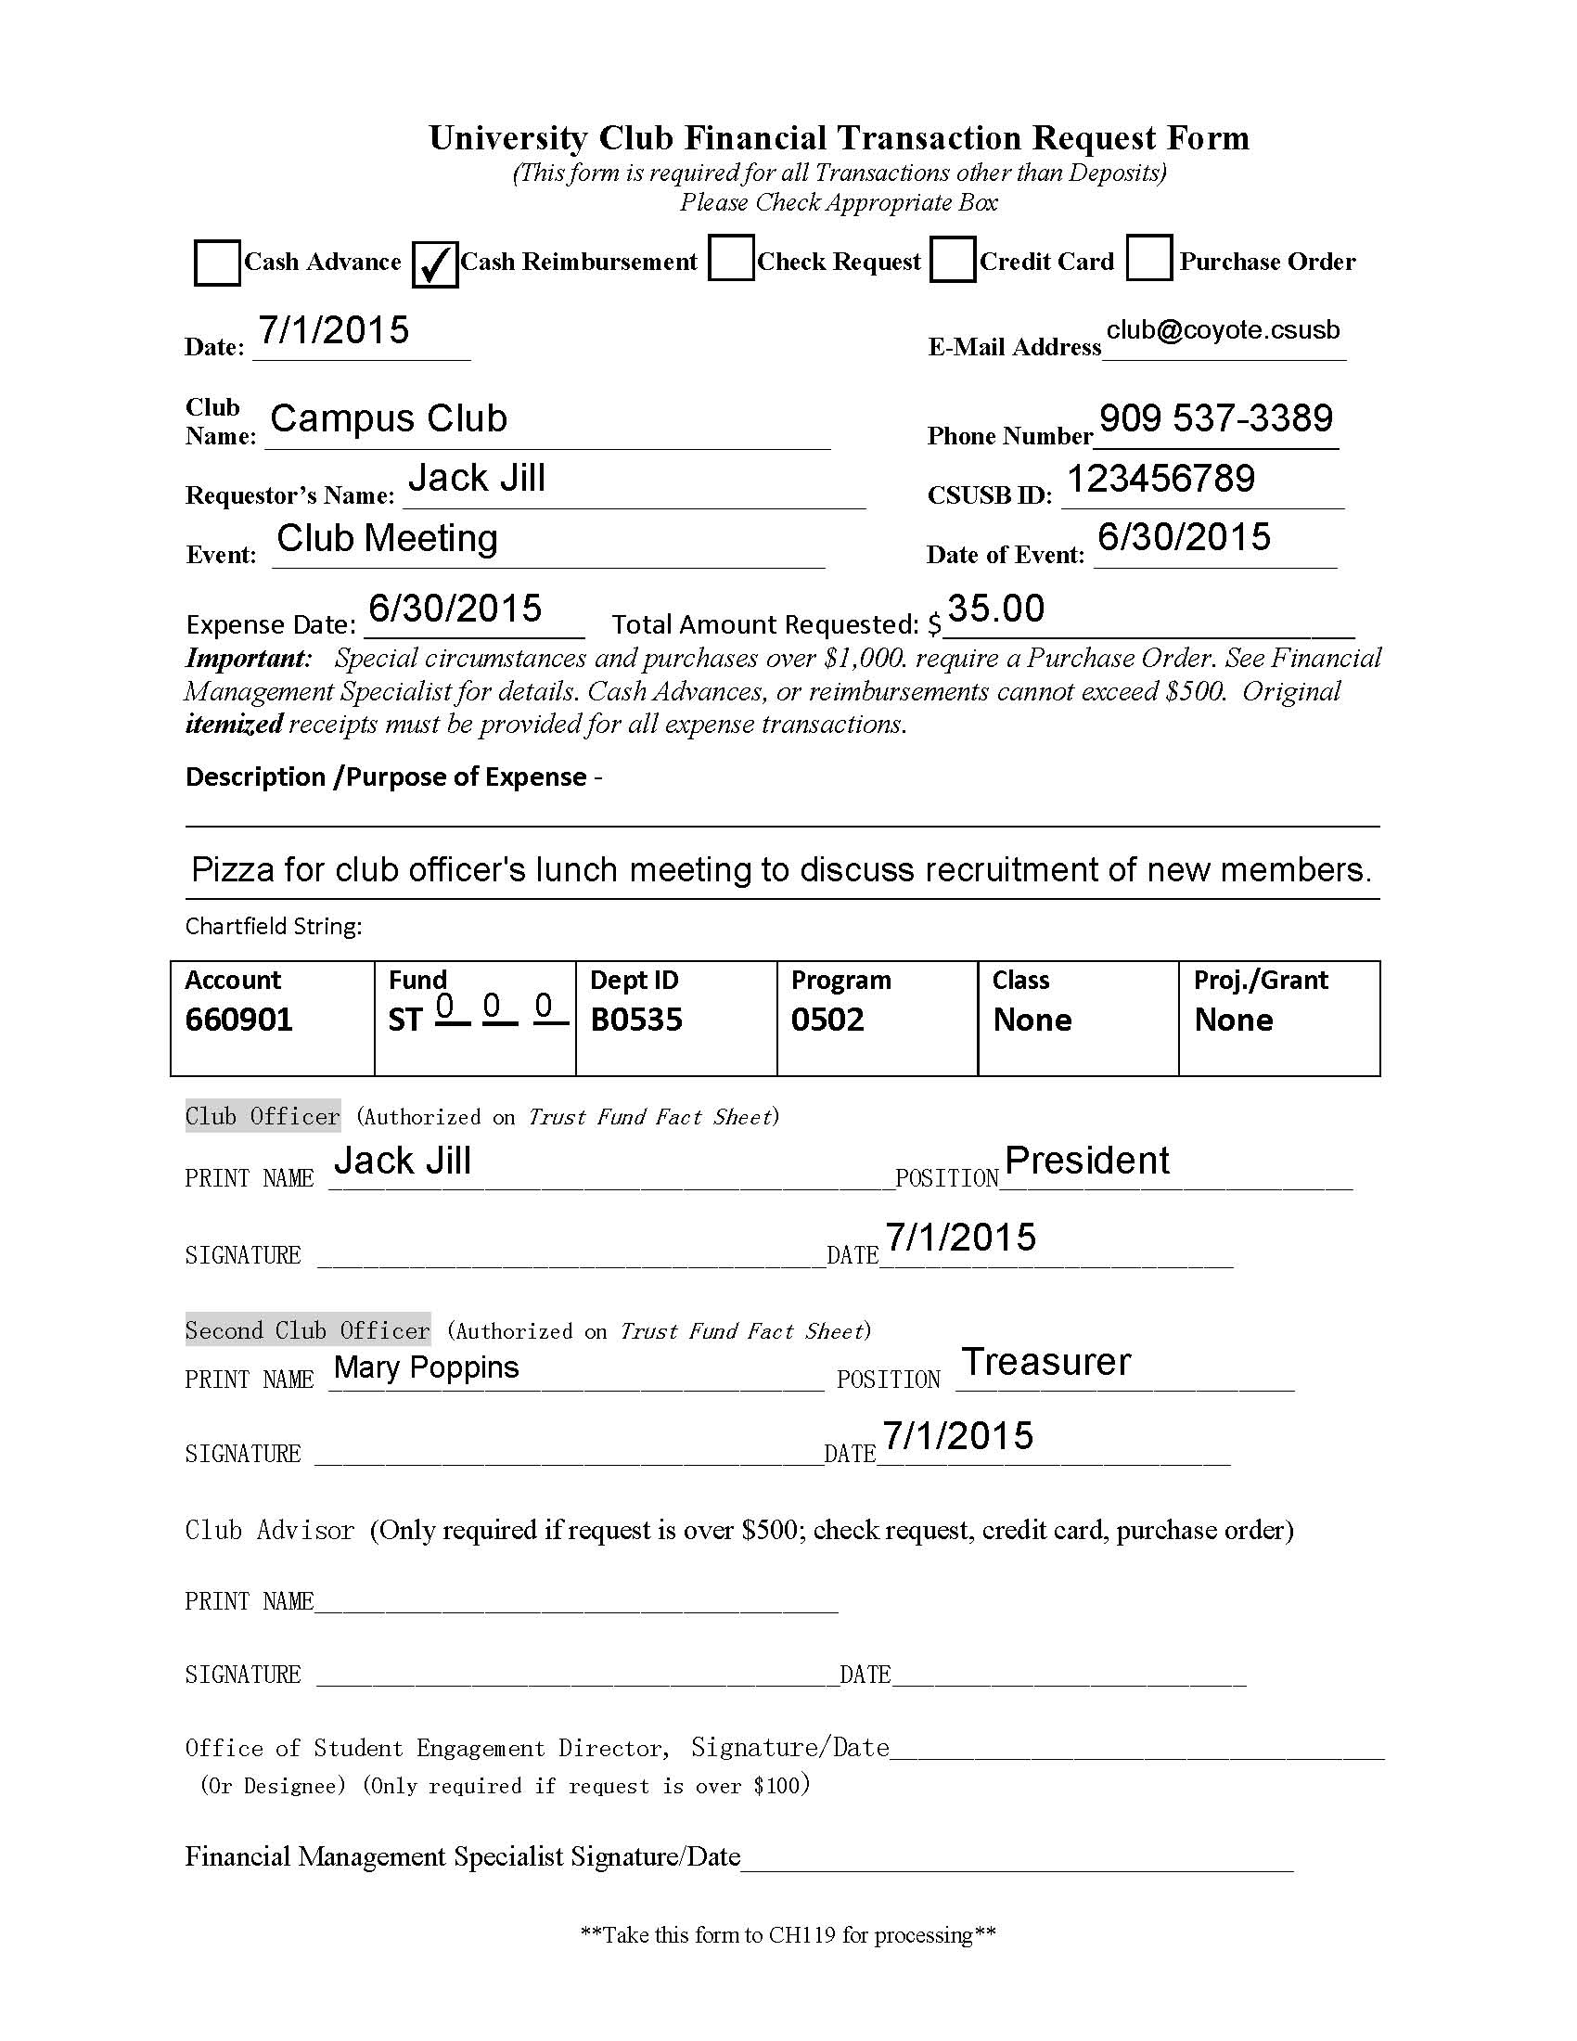
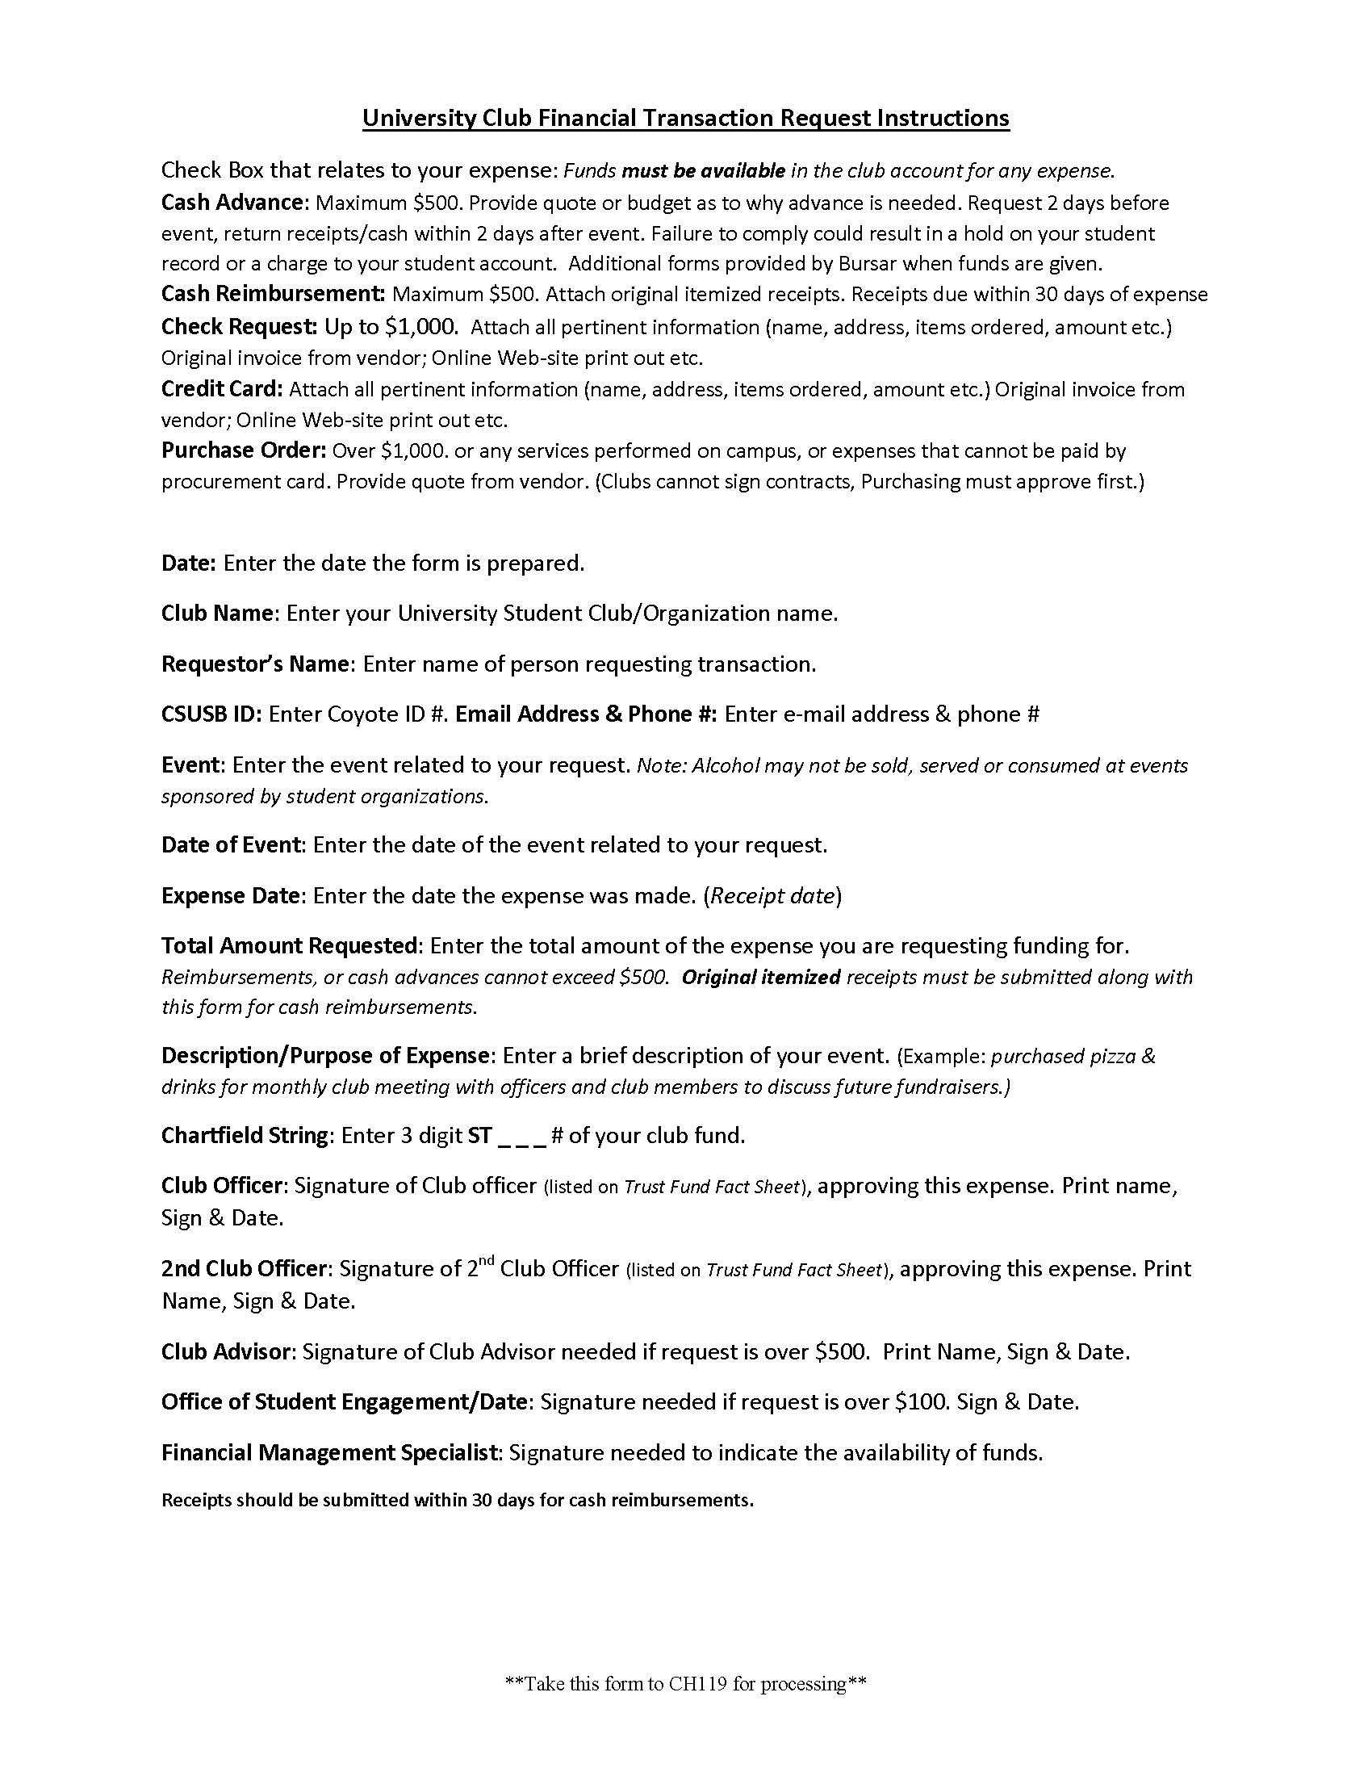

Associated Students, Inc.
CAB Funding
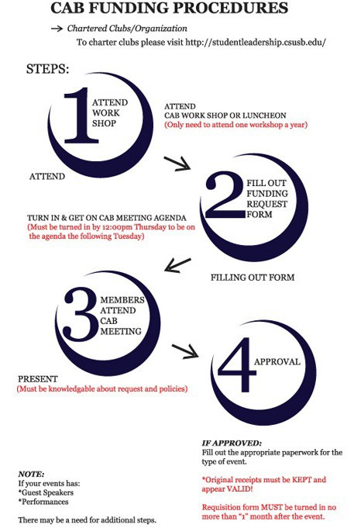
The Club Allocation Budget (CAB) Committee’s mission is to support recognized CSUSB student organizational activities that will directly enhance on-campus life, and allow students to develop leadership and personal skills. Student organizations are encouraged to request grant funding for the following services:

- On-Campus Events and Programs
- Organization Fundraisers or Philanthropy Events
- Conference Registration Fees
- Artist/Speaker Fees
- Advertising
- Food/Beverages

Representatives of all organizations receiving funds through CAB are required to attend a mandatory workshop each year explaining CAB procedures and prior to submitting a request. Organizations will be ineligible for CAB funding until this requirement is met.

Student Organizations requesting funds must show financial investment in the event for which they are requesting CAB funding. New Organizations will have one (1) year from the date they were chartered with OSE to establish financial stability before meeting this requirement. It is important for organizations to note that receiving CAB funds is a privilege and not a right, and funds will be considered for distribution on a first-come,
first-served basis. The CAB Committee is entrusted with the responsibility for ensuring that CAB funds are allocated wisely and as fairly as possible. Sponsored Student Organizations (SSO) and University Sponsored Organizations (USO) are not eligible for CAB funding through Associated Students, Inc.

For more information, email asi-finance@csusb.edu or visit http://asi.csusb.edu/cabFunding/index.html or call (909) 537-3936.

Facility and Event Scheduling

All student organizations are required to schedule events utilizing the online reservation system located at https://eventmanagement.csusb.edu/emswebapp/. Access to the scheduling site is granted to financially responsible officers only after attending a brief training session. For training sessions please contact Special Events and Guest Services at (909) 537-7360.

All areas are reserved on a “first-come, first-served” basis after instructional/academic priorities have been met. No student organization or person may reserve space on behalf of another organization, on-campus department, off-campus entity, or person. Organizations may not sell, sublease, or transfer reservations to another individual or organization. The organization reserving the space must be the primary organizer and utilizer of the space requested for the event.

After you have submitted your request, it will be electronically routed to the Office of Student Engagement (OSE) for approval. Next it will be routed to either the Student Union Scheduling Office or Special Events & Guest Services (SEGS) (depending on the location of your event) for final review and approval. Your request is not officially scheduled until you receive a confirmation email.

For all Student Organization Special Events, a meeting with OSE is required to go over the event plan, including event details, marketing, advertising and risk assessment. Sponsored Student Organizations must list the department as a co-sponsor, but do not need to meet with OSE.

CSUSB is committed to providing a healthy learning environment that facilitates the highest level of academic achievement and fosters the full development of all its students. The campus community strives to support and promote safety and legal standards and practices regarding the use of alcohol and drugs. In accordance with this mission, OSE will not approve events and/or fundraisers where “drinking games” will be promoted. Examples include beer pong, quarter’s tournaments, chugging contest, etc.

The following list contains some of the most frequently requested facilities and their contacts:

Student Union Facilities | SMSU Scheduling | 909-537-5962
Obershaw/Upper Commons | SEGS | 909-537-5236
Lower Commons, Classrooms, Fields, etc. | SEGS | 909-537-5236
Department Conference Rooms | Departments

All reservations must be completed in advance in order to secure space. Organization meetings must be scheduled at least three (3) business days prior to the meeting date. General events must be scheduled at least ten (10) business days prior to the event date. Special events must be scheduled at least four (4) weeks prior to the event date.
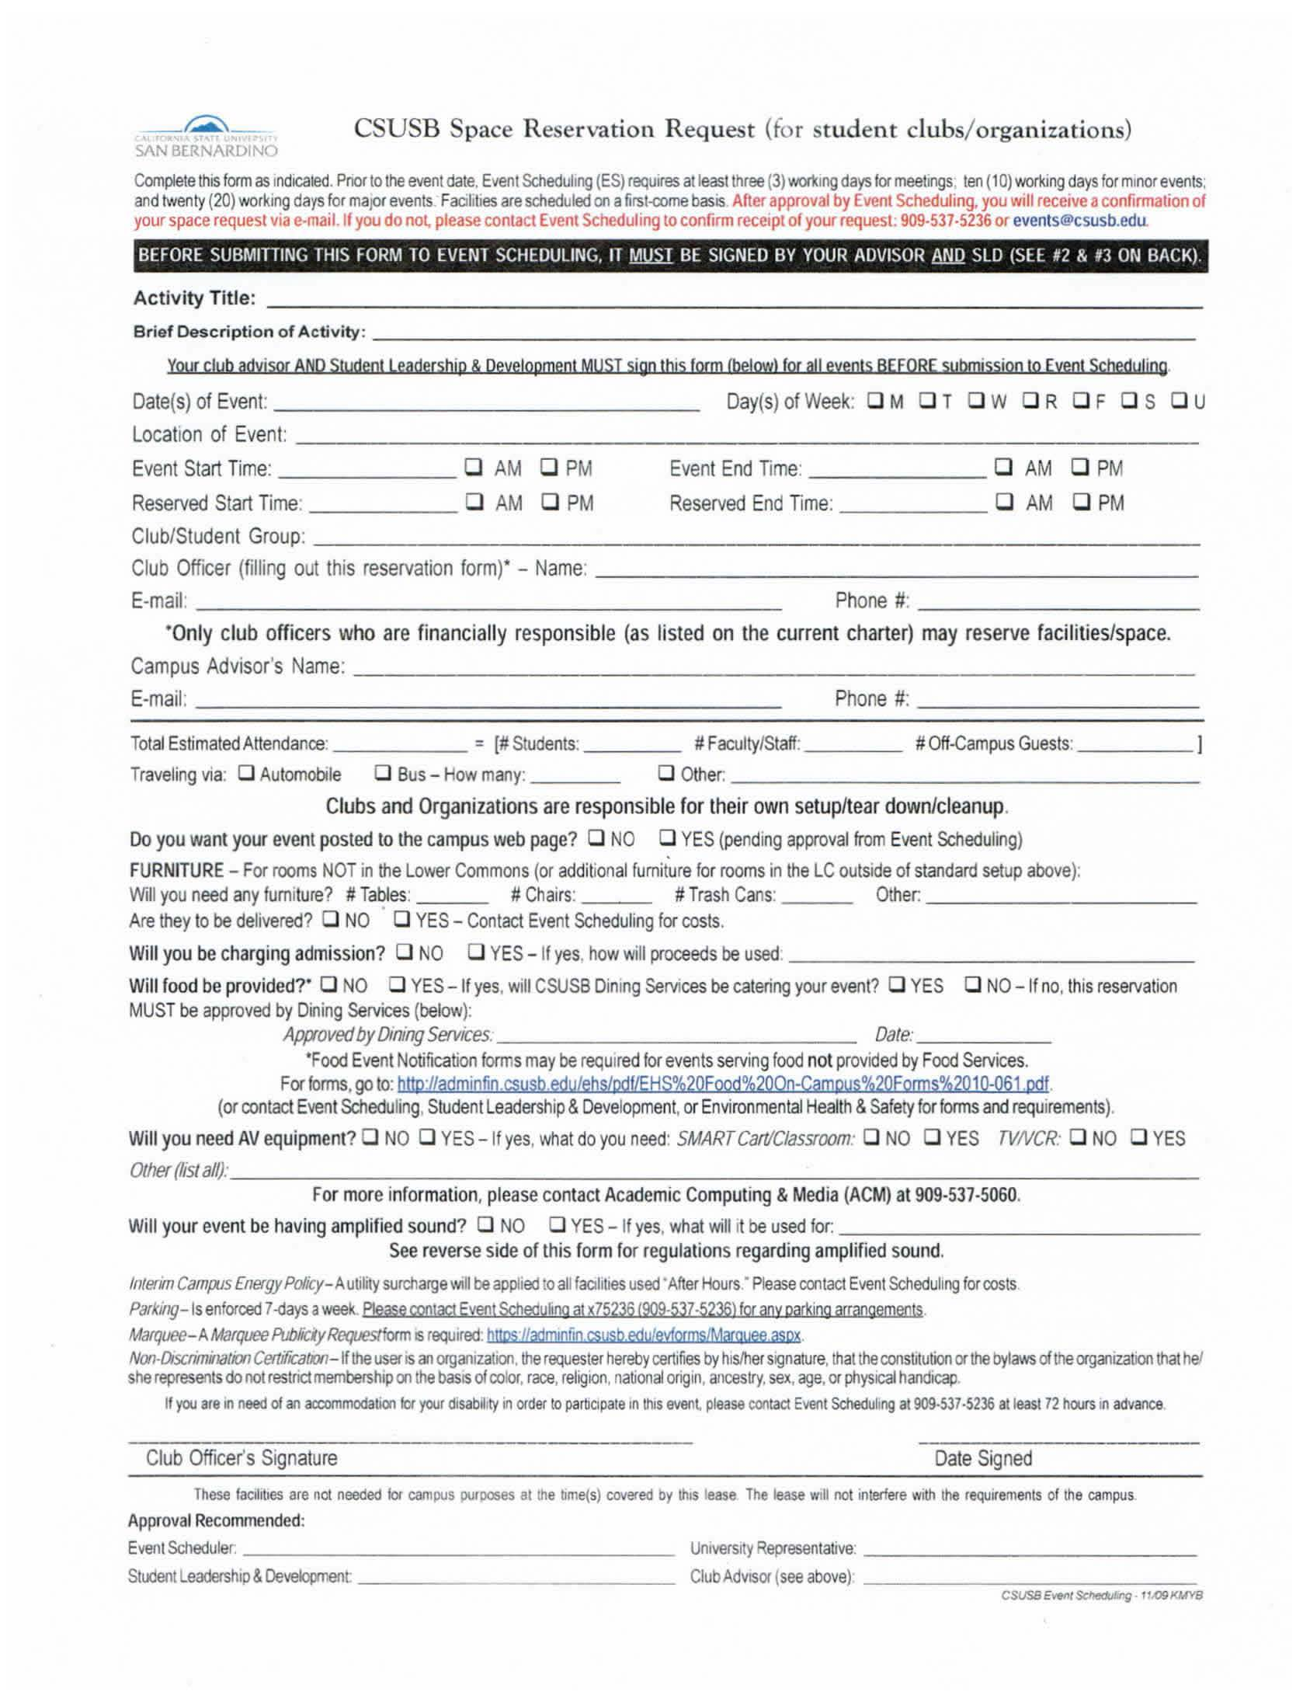

Food Protocol for Student Organizations
CSUSB recognizes the importance of food at a student organization’s event. As a result, OSE in collaboration with Dining Services (Sodexo) and Environmental Health and Safety (EHS), have created a step-by-step protocol to be followed any time food is present at an organization’s event. The purpose of this protocol is two-fold:

- Sodexo has a unique relationship with the campus. They have a contract with the University to be the main provider for food service on campus. This contract gives them the “first right of refusal,” meaning they have the option to either provide food for campus events or allow an outside party to provide the food. Either way, clubs and organizations must give Sodexo the choice to provide food or not. The campus supports Sodexo and encourages student organizations to use them whenever possible.

- The safety of our campus community is a top priority. When food is not processed, cooked, stored, and/or served properly, illness can occur. It is crucial that we take all necessary steps to ensure safety. EHS has created a brief workshop to educate student organization’s members on the importance of role in creating a safe culinary environment.

Here are the necessary steps organizational members need to take in order to be in compliance with the procedures of CSUSB’s Food Protocol.

“Closed Events”
A closed event is defined as any event in which there are only members of the organization in attendance.

- Example: The Chess Club is having its elections and believes the meeting may run long. Members are encouraged to bring their own food or it is agreed upon that the group will purchase pizza for all members who show up for the election.

Protocol: The Chess Club does not need to contact Sodexo or EHS. Because this meeting is considered a “closed event” and no individuals outside of the organization’s membership are invited, food will be considered property of the individual and is not subject to inspection.

“Open Group Meetings/Events” – Not Selling Food
An open group meeting/event is defined as an event which food will be available for members of the organization as well as individuals who are not associated with the organization.

  - Example: The Society for Literary Advancement Club is hosting an open forum to discuss the degree to which Shakespeare’s writings are having on the 21st century college student.
    - They would like to serve appetizers at the conclusion of the event. The groups’ members are inviting classmates to the event as a way to encourage them to join the club.

Protocol: The first thing The Society for Literary Advancement Club needs to do is set up a meeting with Sodexo to present their budget, menu and the purpose of the event. It is suggested that this meeting be set up about a month prior to the event taking place. If Sodexo decides to provide and serve the food for this event, then the club completes the necessary paperwork, communicates with Sodexo about payment options, and hosts a successful event.

However, if Sodexo is providing the food but the organization is serving it, the members need to contact EHS and arrange for a Food Handler’s Workshop.

If Sodexo waives its right to provide food for the event, the club will provide Sodexo the proper paperwork to sign off on the event. Members will then contact EHS to coordinate a time to go through the Food Handlers Training Workshop (even if members have County Food Handler’s Licenses, they must complete the workshop). As long as the members who have completed the workshop are at each event where food is served, the organization only has to complete the workshop once per academic year. EHS reserves the right to inspect the food the day of the event. All food from off-campus must come from an “A” rated provider and insurance may be required.

“Open Group Fundraiser” – Food Sales
An open group fundraiser is defined as an event which food will be sold to the campus community. This may or may not include pre-packaged food.

- Example: Sigma Lambda Delta fraternity wants to raise money for the local Boys and Girls Club of San Bernardino. They decide to host a luncheon and sell tickets for $20 and give $10 per ticket sold to the Boys and Girls Club. The remaining $10 will cover the cost of the food.

Protocol: Sigma Lambda Delta needs to set up a meeting at least a month prior to the event with Sodexo to present their budget, menu and the purpose of the event. If Sodexo decides to provide and serve the food for this event, then the fraternity completes the necessary paperwork, communicates with Sodexo about payment options, and hosts a successful fundraiser. However, if Sodexo is providing the food but the organization is serving it, the members need to contact EHS and arrange for a Food Handler’s Workshop.

If Sodexo waives its right to provide food for the event, the fraternity will provide Sodexo the proper paperwork to sign off on this event. Members will then contact EHS to coordinate a time to go through the Food Handlers Training Workshop (even if members have County Food Handler’s Licenses, they must go through this workshop). As long as the members who have completed the workshop are at each event with food, an organization only has to complete the workshop once per academic year. EHS reserves the right to inspect the food the day of the event.
All food from off-campus must come from an “A” rated provider and insurance may be required.

OSE understands that there may be exceptions to the three scenarios listed in this section. When those exceptions arise, a member of OSE will gladly sit in on meetings with Sodexo and/or EHS to come up with a fair solution for all parties involved.

EHS can be reached at (909) 537-5179 or emailed at allehs@csusb.edu and Sodexo can be reached at (909) 537-7159 or emailed at catering@csusb.edu.

Fundraising
Fundraising events are activities where organizations receive monies (directly or indirectly) in exchange for merchandise, service, or entertainment. An exception to this policy would be when organizations are conducting small inconsequential fundraising activities, e.g., a sorority selling T-shirts.

Fundraising by On-Campus Organizations:
Recognized student, faculty, and on-campus organizations may raise funds on-campus either through direct solicitation or by sponsoring revenue-producing activities in accordance with the following:
- The appropriate University officials or designees must approve the fundraising activity in advance on the basis of their conformity to the general principles of this policy and to all applicable federal, state, and local laws. The viewpoint of the group sponsoring the activity and the content of any materials to be distributed shall not be considered in the decision to grant or deny permission.
Student groups must receive prior approval from Student Engagement at
(909) 537-5234. Faculty/staff must receive prior approval from the Office of the Vice President for Advancement at (909) 537-5004.

- The fundraising activity must be consistent with the stated purpose of the organization.

- The net proceeds from the fundraising activity must be used for the stated purpose and are in some direct relation to the educational, research or service missions of the University, or donated to a charitable organization.

General Fundraising Information
- Members of the University community may collect dues, initiation fees, and admission charges where they are applicable. All fundraising events must be scheduled with the appropriate campus scheduling unit(s).
- Student organizations that wish to sell tickets or any other commodity must receive permission from OSE.
- Official alumni and similar university-related organizations may raise funds in accordance with established procedures and regulations.

- Non-members of the University community may not raise funds on campus; however, the University President may approve a limited number of fundraising programs for charitable organizations and public service agencies.
- Gambling is not permitted as a fundraising activity (California Penal Code, Sections 319-329).
- The fundraising activity must be consistent with the stated purpose of the organization.
- The net proceeds from the fundraising activity must be used for the stated purpose and are in some direct relation to the educational, research or service missions of the University, or donated to a charitable organization.
- CSUSB’s W-9 will be forwarded directly to vendors from OSE. Please obtain the vendor’s contact name and email address.
- Checks will be made payable to CSUSB, with the Club’s Name listed in the memo section.

Raffles
“Raffles” and “lotteries” are illegal in the State of California (Penal Code 335A). However, organizations may “sell” chances on a prize to raise funds by adhering to the following guidelines:
- Never print the word “Raffle” on the face of your ticket or advertisement. Alternative wording may be: “Fundraising event,” “Prize Give-away,” or “Opportunity to Win.”
- You must give the buyer something besides the ticket in exchange for their donation. Example: A pizza coupon printed on the back of the ticket. Many pizza restaurants will actually print the tickets for you in exchange for the publicity.
- You are obligated to give one ticket to anyone requesting one whether or not they give you a donation.
- Tickets and ticket stubs must be individually numbered and you must keep an account of every ticket you print. Tickets can be numbered through CSUSB Printing Services.

- The following must appear on every ticket:
The name of your organization (not an acronym)
Date, time, and location of the drawing
“No purchase necessary”
“Winner need not be present”
“Suggested Donation” next to the ticket price
“Proceeds benefit...”

Campus Advertising and Posting

The University recognizes that signs (including posters, banners, handbills, announcements, notices, brochures) serve as a means for communicating information to the campus community in a timely and orderly manner. Signs containing false, misleading or fraudulent information or expression that constitutes criminal or severe harassment, defamation, or obscenity are prohibited.

Bulletin boards are of four types:
- General Bulletin Boards: Students, recognized student organizations, faculty, and staff of the University and non-University individuals may post signs on General Bulletin Boards (indoor or outdoor).
- University Bulletin Boards: University bulletin boards are for posting of official University documents and announcements.
- Department Bulletin Boards: Department bulletin boards are identified, controlled, and maintained by specific University departments, and only materials approved by that Department can be posted.
- Union Bulletin Boards: Union bulletin boards are for posting of official union documents and announcements.

General Posting Guidelines & Regulations
Student organizations may post on any bulletin board marked “General Use” without prior permission, provided that CSUSB and the organization’s name and contact information are clearly visible. Out of date posters must be removed within 48 hours. Any deviation from the below points will result in the removal of the poster and may result in disciplinary action toward the organization or individual. Faculty-Staff bulletin boards are under the jurisdiction of the appropriate academic and administrative organizations.

- Posted materials can be no larger than 11" x 17".
- All posters or announcements must clearly indicate the name of the sponsoring organization, along with contact information (e.g., phone number or web address).
- Posted materials must not promote the use of alcoholic beverages or be sexually offensive/explicit.
- Do not remove or post over other posters and announcements.
- Posters and announcements may not be affixed to painted or varnished surfaces, glass, ceilings, sidewalks, building walls, restrooms, windows, doors, benches, utility poles, sculptures, garbage receptacles, railings, trees, traffic control signs, stairs or bus stop areas.
- Organizations may not distribute any materials on cars or in any parking lot/structure.
- Posters or announcements may not be affixed to the exterior of buildings.
- Signs on bulletin boards shall be posted by thumbtacks, staples, or pushpins only.
- Other methods of posting which damage a bulletin board will subject the posting party to liability for damages.
- All posted materials are removed from General Bulletin Boards at each academic quarter break.

The following are areas designated for club and organization postings:

Administration
- board by north doors, near women’s restroom 1 board, between 161 and 162

Chemical Sciences
- boards, 1st floor, next to each elevator 1 board, 1st floor, across from J101
- board, 1st floor, next to 1141A
- boards, 2nd floor, next to each elevator 1 board, 2nd floor, next to 220
- boards, 3rd floor, next to each elevator

College of Education
- boards, 1st floor, across from 105 3 boards, 1st floor, near 114
3 boards, 1st floor, near 119

Jack Brown Hall
2 boards, 1st floor, near computer labs
1 board, 2nd floor, across from vending machines 1 board, 4th floor, next to women’s restroom

Library
4 boards, 2nd floor, across from elevator 1 board, across from 226
1 board, across from 253
1 board, inside the Cafe au Lib (room 107) - must be approved by Library Administration in room 2006

Library Walkway (behind Library)
1 glass case board, near temporary buildings

Library Walkway (West of Wedge)

Performing Arts Walkway
1 glass case board by Performing Art Building

Physical Education
- board, in hallway near north door

Physical Sciences
- boards, basement, next to 10 and 22

Santos Manuel Student Union
1 board, across from 203 (Posting on all other boards in SU must get approval from main desk)

Sierra Hall
1 board, next to 127

Social & Behavioral Sciences Building
- board, basement, between the elevators 1 board, 1st floor, between the elevators
- boards, outside room 127
2 boards, inside room 128 doors
2 boards, outside room 128 doors
- boards, outside room 129
- boards, 2nd floor, 1 between the elevators, 1 at the student lounge and 1 near the water fountain
1 board, 3rd floor, between the elevators 1 board, 4th floor, between the elevators 1 board, 5th floor, between the elevators

University Hall
1 board, 3rd floor, left of elevator 1 board, 4th floor, left of elevator
1 glass case board, between Wedge and Faculty Offices

Visual Arts
1 board, opposite 104

Posters on Stakes and Banners Guidelines & Regulations
Posters on stakes as well as those on A or T-frame stands (24" x 48") may be placed on campus grounds on the day of the scheduled event. OSE must approve the posters on stakes and A-frame/T-frame locations before any posting occurs. Removal of signs, other than by the posting party or University personnel acting pursuant to their duties is prohibited.

A request for posting banners must receive the prior approval of the OSE at (909) 537-5234. Approval will be based solely on the availability of posting space.

Sidewalk Chalking Guidelines & Regulations
In addition to posting flyers and banners on campus, another option for promoting student organizations and their events is through sidewalk chalking. For more information or to request approval contact OSE.
- Sidewalk chalking is permitted on the patio area of the Commons building.
- This must be cleaned and removed within 24 hours after the event is over by the same individuals/ groups/sponsors that created the sidewalk chalking in the first place.
- Student organizations must request approval for chalking space in advance through OSE.
- Student organizations must provide their own chalk. Chalk must be non-toxic and water-soluble only.
- Student organizations utilizing sidewalks to promote events or communicate messages should be sensitive to the larger campus community and be conscientious of content and images. OSE reserves the right to request that the chalking be removed if the content is determined to be offensive or inappropriate.

Associated Students, Inc. Graphics 909-537-5932
ASI Graphics provides free and discounted services to student organizations. Student organizations are encouraged to take advantage of the following services:
  - Two free hours of graphic design consultation, including but not limited to: flyer, brochure, poster, ticket, T-shirt, logos or invitation design.
  - Low cost advertising on the digital display monitors in the Santos Manuel Student Union.
  - A discount for duplicating at CSUSB Printing Services if approved for CAB Funding.

For more information go to the ASI office located in SMSU 108 or email asi-ga@csusb.edu.

Jack Brown Hall LCD Monitors 909-537-5700
Student organizations are welcome to submit announcements and event information for on- campus activities. All requests should be submitted to the Assistant to the Dean located in JB 278. All advertisements will be submitted to the Dean of the College of Business and Public Administration for review. Upon approval, the advertisement will be published on the LCD monitors.

College of Natural Sciences Buildings LCD Monitors 909-537-3302
Student organizations are welcome to submit announcements and event information for on-campus activities. All requests should be submitted to the Assistant to the Dean located in BI-107. All advertisements will be submitted to the College of Natural Sciences for review. Upon approval, the advertisement will be published on some or all of the following LCD monitors: Chemical Sciences, Physical Sciences, Health & PE Complex and Biology Buildings.

For more information, please contact llewis@csusb.edu or call (909) 537-3302.

Social & Behavioral Sciences Building LCD Monitors 909-537-7500 Student organizations are welcome to submit announcements and event information for on-campus activities. All requests should be submitted to Dr. Pamela Schram, Associate Dean via email at pschram@csusb.edu. Upon approval, the advertisement will be published on the LCD monitors.

Electronic Marquee 909-537-5236
Notices on the electronic marquee must appeal to the entire campus community and are approved and scheduled through the Event Scheduling Office. Organizations wanting to utilize the marquee to advertise on-campus events must complete and submit a Marquee Request Form at least 10 working days in advance. Request for the marquee will only be approved if the scheduled event has been confirmed.
Organizations who have been approved for marquee use must contact the Event Scheduling Office immediately with event changes or cancellations. Due to space limitations, Event Scheduling reserves the right to revise, prioritize, and/or omit messages.

For information, please contact the Special Events and Guest Services at (909) 537-5236.

Coyote Chronicle 909-537-5289
All clubs and organizations are encouraged to use the campus newspaper to promote their events. Articles must be typed, double-spaced, proof-read, and submitted 10 days prior to the issue date. The Coyote Chronicle does not offer free advertising services to student clubs and organizations; however, they do provide low on-campus rates for on-campus advertising. For information on pricing and availability, please contact the Coyote Chronicle at (909) 537-5289.

Coyote Advertising 909-537-5815
Coyote Advertising is a full-service advertising agency located at CSUSB. They specialize in on-campus media planning and placement and offer a full-range of media products and professional advertising services to our campus and surrounding community.
Services include:
- Video Production Services (TV commercials and promotional videos)
- Audio Production Services (Radio commercials and other audio recordings)
- Creative/Copywriting Services
- Graphic Design Services
- Media Planning and Placement - Buying Services

Coyote Radio 909-537-3486
Coyote Radio is an internet-based radio station broadcasting live 24/7 from the CSUSB campus. Student organizations are encouraged to utilize Coyote Radio as a means to promote upcoming events, increase club awareness and reach out to the student body and community.
- Great promotional opportunities are available right now on Coyote Radio.
- Discounted pricing for CSUSB clubs and organizations.
- Professional commercials created in our state of the art audio production studios.
- Listen to Coyote Radio on the internet, local cable TV, and iTunes.

Coyote Television 909-537-3486
Coyote TV is the home of CSUSB Athletics and MyCSUSB educational programs, featuring discussions on Academics, Athletics, and Student Life. Coyote TV is broadcast on local cable television via Time Warner Cable, Charter Cable, Verizon FiOS, and AT&T U-Verse.
- Great promotional opportunities are available right now on Coyote TV.
- Discounted pricing for CSUSB clubs and organizations.
- Reach a potential audience of over 60,000 households in our local community.
- A great way to improve the image of your club or organization in the local community.

For information on Coyote Advertising, Coyote Mobile, Coyote Radio and Coyote Television’s pricing and availability, please contact Coyote Advertising at (909) 537-3486 or visit http://coyoteadvertising.com.

Working with CSUSB Office of Strategic Communication 909-537-5007
The Public Affairs Office is available to assist in developing news releases and “media pitches” for campus events that have community appeal to local newspapers, radio, and cable television. Remember that your news release should be about current or upcoming news, so its preparation and submittal to the Public Affairs Office should be at least 3-4 weeks prior to the news event if possible. To start the news release process, visit the “Do-It-Yourself News Release Forms”. For more information, visit http://publicaffairs.csusb.edu.

Student Organization Logo Usage
Student organizations (i.e. student clubs, Greek organizations) are not required to use the university identity or logo.

Students wanting to align their groups with the university identity are strongly encouraged to contact the Office of Public Affairs for consultation and more information.

If organizations would like to use the university’s identity, they must request and receive written permission from the Office of Public Affairs. If permission is granted, the identity cannot be modified in any way. Design elements of the identity are not allowed to be extracted and used in designs. For instance, the mountain icon cannot be taken from the logo and used as a design element or used to create an organization’s logo.

Logo usage evaluation is based on the goals and missions the organization has in place. If they are consistent with the university goals and missions, that will increase the likelihood of approval.

All university logo usage must be approved by the Office of Public Affairs. For approval contact the Office of Public Affairs at (909) 537-5007 or email logo@csusb.edu. For updated information visit http://identity.csusb.edu/.

Santos Manuel Student Union Posting and Advertising
All flyers, posters, and banners posted in the Student Union must be approved by Student Union Main Desk.

Flyers and Posters
Student organizations may have announcements, posters, and notices posted on general purpose bulletin boards throughout the Student Union. Posted materials must include the sponsor’s name, reflect good taste, and be no larger than 11” x 17”. Materials for posting must be approved by the Scheduling Coordinator or designee. Materials are limited to a two week posting time, and will be dated, stamped “approved”, posted, and cleared from the bulletin boards by Student Union staff. Duplicate postings on the same board are subject to removal at any time. Materials posted on windows, doors, walls, pillars, or other unauthorized areas will be removed. Student organizations in repeated violation of this policy will be referred to the OSE Office and posting privileges may be revoked.

Banners
Requests for placement of banners on interior beams must be approved by the SMSU Executive Director or designee. Requests for placement of banners on balconies or exterior beams must be approved by the Vice President for Student Affairs or designee. Banner space is usually available for a maximum of one week on a first-come, first-served basis and may be reserved at the main desk. Banners will be put up and removed by SMSU personnel. Banners must meet the following requirements:
- The subject matter of banners must relate to events or topics which are of broad general interest and importance to the campus community, and is restricted to promotion of current or upcoming events and services.
- Banners cannot exceed 5’ x 10’ in size.
- Banners must include the name of the sponsoring organization.

- Banners hung from balconies must be made of vinyl or cloth with paint or ink that does not bleed or run and must be affixed to the railing with strong twine in a secure manner which does not damage railings or paint.

Display Cases
Recognized student organizations may use the display case and portable display cases by reserving the space at the Scheduling Office. Student organizations may reserve one of the large display cases for a two week period once per academic year. Portable display cases may be reserved for a two week period once each quarter. Materials not removed at the end of the reservation period will be removed and disposed of by Student Union staff. Student organizations may not reserve the main display case in SMSU lobby and the outside display case.

Coyote Connection Digital Advertising
Throughout the SMSU are several large display monitors used to advertise student events. The use of these monitors is offered for advertising to On-Campus Entities, Chartered Clubs & Organizations.
File Specifications
- File Extension - .jpg file extension
- Dimensions - 900 pixels by 550 pixels
- Resolution - 72ppi
If you need assistance in creating your advertisements or fitting them to our system specifications, contact the SMSU Marketing Department or the ASI Graphics Department for assistance (charges may apply).

SMSU Ad Rates
Affiliation | Weekly | Monthly | Quarterly
Student Club | $10.00 | $30.00 | $85.00
University Department | $25.00 | $95.00 | $250.00
External Organization | $50.00 | $180.00 | $500.00
- Please allow 2 business days for your artwork to appear on screen in order to process payment and to upload file.
- 1 week = 7 consecutive days
- 1 month = 4 consecutive weeks
- 1 quarter = 11 consecutive weeks
- All ads submitted will be charged separate fees regardless of start and end time.
- Ads rotate every 15 seconds
- Number of views by user will vary based on the number of ads submitted.

For additional information, contact the Student Union Marketing Department at sugraphics@csusb.edu or by phone (909) 537-3942.

CSUSB Community Standards
Student organizations and clubs at CSUSB (the “University”) must comply with University policies and/or regulations, as well as local, state and federal laws. When a student joins, or is joining, the student accepts responsibility for the actions of the club or organization and for the other members and their guests while engaged in club or organizational endeavors.

Each student organization is responsible for the conduct of its members whenever individual actions are encouraged, permitted, or assisted by the officially-recognized club or organization, and violate University policies and/or regulations and local, state and federal law. Abetting on the part of the organization may include, but is not limited to, organization sponsorship, sanctioning, participation in, or condoning of the misconduct.

Violation or an attempt to violate any University policy, rule and/or regulation and local, state and federal law and/or encouraging others to engage in a violation or attempted violation constitutes “misconduct” and can result in sanctions being issued by the University against the organization as described below and/or those individuals involved.

Misconduct can result in sanctions against the organization and/or individual members if the misconduct (A) occurs on University property, or (B) off-campus if that conduct: (1) occurred as part of a campus-related or recognized event; (2) adversely effects the health and safety of members of the campus community; (3) is sufficiently severe or pervasive; (4) harms university property; or (5) thwarts or interferes with the mission of the university.

Although not an exhaustive list, here are examples of the kinds of violations that will result in sanctions:
- Any violation of the university Standards for Student Conduct or university rules and regulations, available online at https://www.csusb.edu/student-affairs/student-conduct.
- Any violation of Student Organization Standards, Expectations, and Policies (see: Student Organization Handbook, se.csusb.edu).
- Hazing of any kind. Hazing is defined as any method of initiation into a student organization or any pastime or amusement engaged in with regard to such an organization which causes, or is likely to cause, bodily danger, or physical or emotional harm, to any member of the campus community; but the term “hazing” does not include customary athletic events or other similar contests or competitions. Organizations or individuals found guilty of violation of this section of the Education Code will be subject to suspension by the University. (Title 5, California Education Code, Sub chapter 4, Article 2, Section 41301(b), Standards for Student Conduct).
- Violation of the CSUSB policy prohibiting discrimination based on a sex including sexual harassment, sexual violence (including assault, rape, and stalking), domestic and/or dating violence, and/or retaliation. The University policy prohibiting such discrimination is determined by Executive Order 1095 which can be found at http://www.calstate.edu/eo/EO-1095-rev-6-23-15.html and http://www.calstate.edu/eo/EO-1097-rev-6-23-15.html.
- Failure to abide by the open membership policy or discrimination on the basis of race, religion, national origin, ethnicity, color, age, gender, marital status, citizenship, sexual orientation, or disability shall be withdrawn.

Hazing and Initiation
In accordance with state law CSUSB has a zero tolerance stance towards hazing. Joining an officially recognized organization should be a positive experience. New member activities and initiation rituals should focus on the positive aspects of both the organization and the individual. Abusive behavior toward, or hazing of, a member of the campus community is forbidden. The definition of hazing can be found in California Education Code Title 5, Article 2, Section 41301(b) and Article 5, Section 32050-32051 and California Penal Code 245.6.

Hazing includes any method of initiation or pre-initiation into a student organization, or any pastime or amusement engaged in with respect to such an organization, which regardless of location, intent, membership status or consent of the participants, causes or is likely to cause bodily danger, physical harm, mental or physical discomfort, embarrassment, harassment, fright, humiliation, intimidation, degradation, or ridicule, extreme mental stress, or otherwise compromises the dignity of any student or member of the campus community. Hazing also includes any activity that compels an individual to participate in any activity which is unlawful, perverse, publicly indecent, contrary to the rules, policies, and regulations of the University, or any activity which is known by the compelling person to be contrary to the individual’s genuine moral or religious beliefs, or any activity that will unreasonably or unusually impair an individual’s academic efforts. Hazing does not include customary athletic events or similar contests or competitions. Participation in a hazing practice will result in both individual and organizational disciplinary action, including possible expulsion.

Commission of hazing is also a misdemeanor, punishable by up to one year in jail and up to a $5,000 fine. Hazing cases that involve serious bodily injury or death may be charged as felonies. Disciplinary action will also be instituted against officers who permit hazing to occur within their own organization and students who allow themselves to be hazed may also be subject to disciplinary action. Any hazing incident involving serious bodily injury will result in revocation of University recognition, and where applicable, a recommendation to national organization for revocation of the organization’s charter.

The University takes hazing very seriously and in conjunction with CSUSB’s zero tolerance policy, organizations will be held responsible if the University believes that hazing is likely to have occurred and/or a creditable witness has come forward.

It is the specific responsibility of the organization president to ensure that this policy is communicated to and adhered to by all members and new members.

Organizations are responsible for the behavior of their alumni members during initiation or pre-initiation activities.
For more information on Hazing, visit www.stophazing.org.

Student Organization Discipline Process
The following section describes the process through which alleged misconduct by student organizations will be investigated and the issuance of any resulting sanctions. A student organization and its officers may be held collectively or individually responsible when violations associated with the organization are reported to the university administration. Misconduct may simultaneously be investigated by and processed through the Office of Student Conduct and/or the Title IX Coordinator/DHR Coordinator and/or University Police.

The Student Organization Discipline Process’ primary purpose is to establish the official procedure for reviewing alleged violations and/or complaints regarding student organizations. This Discipline Process should be read broadly and is not designed to define misconduct in exhaustive terms. OSE, as well as the university as a whole, is committed to educating students and student organizations of policies, procedures, and legal matters that affect students and student organizations. For further information, contact OSE at (909) 537-5234 or clubs@csusb.edu.

- Overview of Student Organization Discipline Process.

OSE's guidelines for addressing alleged violations and/or complaints are as follows:

- Any member of the campus community (including the Office of Student Engagement and University police) or a person or organization outside the campus community can initiate an allegation of misconduct against a student organization. Allegations of misconduct shall normally be brought to the attention of the Director of OSE whose office is in the SMSU 203 and phone number is 909-537-5234. Unless otherwise impracticable, this notification should be in writing, signed and dated and should include sufficient detail if known (i.e.: name of the complainant, date, time and place of the incident, names of people involved, description of events and circumstances, and names of witnesses). OSE will determine whether and to what extent the student organization will be informed of the identity of the individual who has made the allegation. OSE will notify the student organization of the allegations within ten (10) working days of receipt. Official written notice from OSE will be sent to the president of the organization within ten (10) working days of receipt, unless asked to defer notice by law enforcement or Title IX/DHR investigators. Copies may also be shared with the organization advisor(s), and in some cases, the organization’s national headquarters. The notice will cite the alleged policy that was allegedly violated and/or the nature of the complaint.

- OSE will determine the nature of the alleged violation and/or complaint and, in consultation with the Associate Vice President/Dean of Students, will initiate an investigation. OSE will review and address violations or complaints related to student organization policies. In cases involving violations of University policy and/or the Student Code of Conduct, OSE will forward a report to the appropriate administrator (for example, Dean of Students, Director of Student Conduct, Title IX/DHR Coordinator, or University Police) for further investigation and adjudication, depending on the nature of the incident.

- In circumstances where OSE determines, in its discretion, that as a result of the allegations the health and safety of members the campus community is threatened or at risk, the OSE Director, in consultation with the Vice President for Student Affairs, or their designees, may place an organization on immediate suspension and/or may direct the student organization to cease and desist all organization activity until the conclusion of the investigation and resolution of the allegation. This decision is not subject to review.

- OSE and/or designated investigator(s) will determine when and how to meet with the leadership of accused student organization and/or individual members, the complainant, and witnesses. OSE may also engage in attempts to informally mediate the matter during the investigation.

- In cases where a student organization has been accused of substantial violations that may result in temporary or permanent loss of university recognition, the OSE Director or designee has the discretion to convene an Ad Hoc Administrative Review Board to review investigation findings. The Review Board may include, but is not limited to, the OSE Director, the Associate Vice President for Student Affairs/Dean of Students, the University Police Chief, the Director of Student Conduct & Ethical Development, the Greek Advisor and/or each area’s designee. The Review Board will determine if violations were likely to have occurred and determine appropriate sanctions.

- Once a finding is reached, based upon a preponderance of the evidence resulting from the investigation, the Director of OSE and/or the Director of Student Conduct & Ethical Development will determine appropriate sanctions for actions of the student organization and/or individuals deemed in violation of the Standards for Student Conduct and/or university policies and procedures. The student organization will be informed in writing by OSE of the outcome of the investigation and nature and scope of any sanctions.

- An organization may request an appeal, or reconsideration, of the decision. Guidelines for Appeal/Reconsideration are provided in Section D, below.

- Confidentiality

Information presented during the course of any investigation may be shared with Student Conduct Administrators and other University employees and law enforcement on a “need to know” basis. The University shall weigh requests for confidentiality against its duty to provide a safe and nondiscriminatory environment for all members of the campus community. Confidentiality, therefore, cannot be ensured.

- Sanctions.

Organizations found in violation of the Standards for Student Conduct and/or university policies and procedures may be assigned university sanctions. A notice of action taken will be sent to the organization president, advisor(s), and in some cases, the organization’s national headquarters.

  - Sanctions for organization misconduct may include, but are not limited, to the following:

- Sanctions for Student Organizations:
- Official reprimand (written or oral) (with or without conditions).
- Restriction of privileges granted to the organization.
- Restitution, community service, educational sanctions, or any combination of these.
- Required training and/or education.
- Probation for a specified period of time, during which the organization is subject to close observation and review, with or without conditions. Probation may include the suspension of some of the organization’s rights and privileges. The organization must demonstrate compliance with university policies and procedures and the terms of the probation for the violation(s) committed.
- Suspension of charter for a specified period of time, with or without conditions. Suspension of Charter is a temporary loss of university recognition and privileges for a specific period of time. Organizations may be placed on suspension for failure to meet the University minimum standards or non-compliance with university policies and procedures.
- Total revocation of university recognition (e.g. the club or organization loses all privileges associated with university recognition). Loss of University Recognition is a severe action intended for organizations involved in extraordinary violations. An organization whose recognition has been withdrawn loses all of the rights and privileges indefinitely, and must petition the OSE office for consideration to return to the university. In addition, withdrawal of recognition may occur at the request of the national organization.

- Sanctions for Individuals:

Any sanctions that are listed under Article VI. of California State University Executive Order No. 1098-R (or its successor) that can apply to individual students for violation of Standards for Student Conduct can also apply to a student organization (except sanctions affecting individual student status, such as suspension or expulsion, which must be assigned by a Student Conduct Administrator under EO 1098-R).

- Official reprimand (written or oral) (with or without conditions).
- Restriction of privileges within an organization.
- Probation for a specified period of time, with or without conditions.
- Suspension or Removal from participation in the organization for a specified period of time, with or without conditions.
- Individuals violating the university Standards for Student Conduct or university rules and regulations, available at https://www.csusb.edu/student-affairs/student-conduct will also be subject to the Student Discipline Process.

- Appeal/Reconsideration.

- A student organization that disagrees with the determination made by OSE and/or the sanction issued by the designated administrator (as described above) it may seek reconsideration of the determination and/or sanction within ten (10) working days of the issuance of the written decision from OSE. OSE’s decision shall be deemed delivered to the organization five (5) days after the date emailed to the last known email provided by the president or other head officer of the organization to OSE.

- To seek reconsideration, the student organization must submit a request in writing within the time described in D.1. to the Associate Vice President for Student Affairs (AVP)/Dean of Students. The student organization should outline in the written request the reason it believes the decision and/ or sanctions should be reconsidered. The AVP/Dean will only review decisions and sanctions pertaining to the organization and not any actions taken by Student Conduct regarding individual members of the student organization. In requesting reconsideration, the student organization must identify one or more of the following as the basis for the request and the facts that support that basis:

  - New evidence that was not available when the decision was rendered;
  - The sanction is not supported by a preponderance of the evidence for the determined violation;
  - OSE substantially deviated from the procedures delineated in these Disciplinary Procedures.

- The AVP/Dean may determine which individuals will be consulted and/or questioned as part of the reconsideration process and what documentation the AVP/Dean will review.

- The AVP/Dean may also consider the student organization’s cooperation in the investigation of the complaint by OSE and any failure to abide by any interim sanctions in place as part of the reconsideration process. The AVP/Dean may refer the matter back to OSE for further investigation and/or follow up. The AVP/Dean may also confirm, modify, and/or reject the decision and sanctions issued by OSE.

- Notification of Reconsideration Outcome: Written notification of the outcome of the student organization’s request for reconsideration will be provided to the student organization within a reasonable time frame. Once rendered, this decision is final.

CSUSB Policies
The policies included below are university policies that leaders of student organizations should be familiar with and are responsible for following. For your assistance we have taken sections from the policies that are most relevant to student organizations. If you have any questions regarding these policies please contact OSE for consultation. All campus policies can be found at http://policies.csusb.edu.

POLICY REGARDING THE SALE, CONSUMPTION AND POSSESSION OF ALCOHOLIC BEVERAGES (excerpt only - for the policy in its entirety see http://policies.csusb.edu/alcoholpolicy.htm)

Alcohol Advertising
  - Advertising from local retailers or distributors that promote “drink specials” (e.g., 2 for 1 drinks, half-price happy hour drinks, etc.) should not be accepted or posted.

  - Beverage alcohol advertising on campus or in institutional media should not portray drinking as a solution to personal or academic problems, or as necessary to personal, social, sexual, or academic success.

  - Alcoholic beverages should not be provided as free awards to individual students, campus organizations or other members of the academic community.

  - University departments and organizations may not distribute clothing, posters, or other promotional items that utilize the University symbol in combination with an alcoholic beverage trademark or logo.

Special Events
Alcohol may not be sold, served or consumed at events sponsored by student organizations.

FACILITIES USE POLICY DRAFT --- REVISION #2 (OCTOBER 2004)

(excerpt only - for the policy in its entirety see http://policies.csusb.edu/facilities_use_policy.htm)

Groups Authorized to Use Campus Buildings and Grounds
University buildings and grounds may be scheduled and resources and personnel used only for events which are consistent with the goals, mission, and current priorities of the University. Facility use requests will be considered based on the size and nature of the event, number of attendees, availability of space, impact on university budgets and personnel, and educational value or purpose of the events. Campus buildings and grounds will be assigned in a manner which maximizes efficiency of operation.
The University may allow use of its facilities under license or lease by some non-University organizations whose activities are consistent with the university’s mission and the proposed activity benefits the university community.

The following groups may use university buildings and grounds:
- University units or departments (academic departments, administrative units, etc.).
- Chartered clubs and organizations -- Associated Students, Inc., the Student Union, clubs and organizations officially recognized by the university.
- Faculty/staff groups -- officially recognized faculty and staff boards and committees conducting university business, employee organizations, and collective bargaining units.
Groups in the above categories may use University buildings and grounds on a fee-exempt basis during regular university operating hours. The regular operating hours are published in the quarterly Course Schedule and are typically between 8:00 am and 10:00 pm, Monday through Thursday, and 8:00 am through 5:00 pm, Friday through Sunday. Saturday and Sunday operating hours will typically be scheduled in University Hall and Jack Brown Hall to reduce operating expenses. If needed, the following buildings may also be scheduled:
- Pfau Library
- Lower Commons
- Biological Sciences
- Performing Arts

*Events Scheduling will recommend rooms in these facilities to ensure maximum energy efficiency to avoid providing air conditioning service to the entire facility.

There is no fee for mission-related uses during these operating hours and in these buildings. Fees may apply to events requiring more than two rooms or for special services such as furniture set-up or deliveries.

The use of buildings and grounds outside of regular operating hours typically will require a fee to cover operating costs of the facility. An appeal to exempt the fee may be filed with the campus Facilities Use Committee.

Summer Schedule
It has been the practice of the university to operate on a 4/10 summer schedule to avoid expensive air conditioning costs during the hot summer months. The summer schedule typically has run from the week after June graduation through the week after Labor Day. The normal operating schedule during this period has been Monday through Thursday, 7:00 am until 10:00 pm. Any activities scheduled outside of these hours will require funds to pay the non-budgeted operating costs.

Facility Reservation
- Groups or individuals wishing to reserve University buildings and grounds must do so in writing on the Facility Lease Agreement form. An individual must be designated who will be held accountable for adhering to all University policies, the safety of the persons attending the event, and the preservation of the facility. This person will typically be either a faculty advisor or club officer (financially responsible officers).
- No organization or person may reserve space on behalf of another organization or person. Organizations may not sell, sublease, or transfer reservations to another individual or organization. The organization reserving the space must be the primary organizer of user of the space for the event.
- The reservation process is completed only when the requestor has received a written confirmation of the request from the Events Scheduling Coordinator.

- All facilities must be scheduled in advance and must receive confirmation as follows:
- Meetings -- 3 days (72 hours) prior to the meeting.
- Minor Events -- 2 weeks (10 working days) prior to the event.
- Major Events -- Dance, banquets, concerts, and other major events -- a minimum of 4 weeks (20 working days) prior to the event. For additional information on Student Special Events sponsored by student organizations refer to the “Student Clubs and Organizations Special Events Policy”.

The scheduling of activities, meetings, or programs by chartered clubs or organizations must be executed by an appointed or elected officer, leader, chairperson, or club advisor of the organization, as indicated by the Office of Student Engagement. The university requires at least one organizational officer and an advisor to be present for the entire duration of the event. A responsible representative from the sponsoring department must be present for the duration of any university-sponsored event. The sponsoring group shall be held responsible for any and all damages to university property. Failure to pay scheduled fees or damages, or failure to comply with this policy of responsible supervision may result in the immediate loss of scheduling privileges.

Charter clubs and organizations may reserve meeting space normally not to exceed two hours per meeting. Special events such as seminars, socials, dances, and concerts may exceed this limit but are governed by the Student Special Events Policy. Exemptions to this policy must be granted in advance by the Director of the Office of Student Engagement, in consultation with the Director of Physical Plant Facilities Services.

Catering Services
Sodexo Dining Services offers complete catering services for functions held on campus. All food and beverages served at the university must be provided through Sodexo Dining Services, unless permission to utilize another food supplier is granted in writing by the Director of Dining Services. Catering arrangements for banquets, buffets, receptions, or refreshments may be made by contacting the catering manager at (909) 537-5916. The catering manager is available to assist in menu planning and other details. Information regarding catering prices and guarantees is also available from the catering manager. Completing a food service contract does not constitute or imply that an event has been approved for campus scheduling.

POLICY ON SPEECH AND ADVOCACY

(excerpt only - for the policy in its entirety see http://policies.csusb.edu/speechadvocacy.htm)

Free Expression at California State University, San Bernardino
At the CSUSB campuses, the time, place, and manner of expression are limited solely by the following general conditions and by additional specific conditions as defined in this policy.

The exercise of free speech and assembly rights must comply with all applicable federal, state, and local laws. In addition, such activities may not:
- Interfere with classes in session or other scheduled academic, educational, cultural/arts programs or with use of the University Library.
- Obstruct the flow of pedestrian or vehicular traffic.
- Interfere with or disrupt the conduct of University business.
- Employ unauthorized sound amplification or create unreasonable noise disruptive of normal University activities.
- Harass or intimidate persons in the immediate area of the activity.
- Violate any federal, state, or local safety codes, such as regulations set by the State Fire Marshal.

There shall be no restrictions on legal free speech activity based on the content of such speech or expression or on the political, religious, or other affiliations of speakers. Illegal speech activity, not protected by the First Amendment to the U.S. Constitution or by this policy, includes defamation, obscenity, terrorist threats, false advertising, and the promotion of actual or imminent violence or harm.

Use of University Name
- Care should be exercised regarding the use of the name, seal, or logo of the university in matters of speech and advocacy. Members and recognized organizations of the university community should not claim official relationship in matters of speech and advocacy unless authorized by the president or designee.

- Events or activities sponsored by members of the university community may not be advertised or promoted in such a way as to suggest that they are sponsored by the university.
- Campus organizations may not use the seal of the university without prior approval of the president or designee.

- All individuals or organizations using university properties and services must not make any unauthorized statements that they are sponsored, endorsed, or favored by the university.

Palm Desert Campus
A separate document addressing the principles and regulations on speech and advocacy at the Palm Desert campus can be found at http://pdc.csusb.edu/documents/Designated_Free_Speech_Areas.pdf

Public Meetings, Performances, Rallies, Demonstrations, or Similar Public Events
Members of the university community and non-university community may use campus buildings and grounds for public meetings, performances, rallies, demonstrations, and similar events in accordance with the general limitations described in the Free Expression at California State University, San Bernardino Section.

Students, faculty, staff or other members of the university community or their organizations, or non-university groups, who seek to hold such events inside university facilities, including all buildings, the amphitheater, athletic venues, and areas surrounding residence halls, other than the designated forums described in the Designated Public Forums Section below, must reserve such facilities at least 48 hours in advance. These shall be available on a first-come, first-served basis, which is the only basis upon which requests will be granted or denied. Recognized student organizations must schedule through OSE. Outdoor demonstrations or public protests may be held on university property without advance permission provided these adhere to the general limitations described in the Free Expression at CSUSB Section. Any non-university group that wishes to conduct such a demonstration or protest should register with the Special Events and Guest Services office on the San Bernardino campus located at CO-132 (909) 537-5236 or the Office of the Dean at PDC located in RG-203 (760) 341-2883 x78101 upon arrival on campus. Demonstrations, rallies, and other public events may not be conducted in classrooms when classes are scheduled, in offices, or in reception areas.

Speakers at such meetings, performances, rallies, demonstrations or similar events shall not be subject to harassment, nor shall the right of all to hear the speaker be infringed. At the same time, members of the campus community and outside guests shall have the right to peacefully protest any speaker, meeting, or event, so long as the event being protested is not significantly or materially disrupted.

Spontaneous events occasioned by news or affairs coming into public knowledge less than forty-eight hours prior to such event may be held in the designated public forums described in the Designated Public Forums Section and outdoors without advance permission and in university buildings with special permission of the President or the President’s designee.

Where appropriate or necessary, the university shall provide security to ensure that the rights of all speakers are upheld.

Handbills and Circulars
Non-commercial leaflets, fliers, handbills and circulars may be distributed at all times in the designated public forums identified in the Designated Public Forums Section and from 8:00 am to 5:00 pm Monday through Friday on other university walkways and outside entrances to university buildings so long as such activity conforms to the limitations described in Section III above. Any non-university group or individual who is not a student or employee of the university that seeks to circulate such handbills and circulars should register with the Office of Student Engagement and with the Office of the Dean at PDC upon arrival by providing copies of the material they will be circulating and identifying any organizational affiliation. Personal identification is not required.
Handbills and circulars may not be left on the windshields of automobiles parked on university grounds.

Designated Public Forums
  - Campus Sites in San Bernardino
The following four areas at the San Bernardino campus are designated public forums in which all members of the university community and non-university community may exercise their free speech rights without special restriction.
    - The patio area of the Commons Building
    - The grassy knoll (Coyote Corral) between the Lower Commons Plaza and the campus service road by Serrano Village
    - Library Lawn
      - Clubs and organizations will be allowed to use the library lawn on Wednesdays and Thursdays between the permitted amplification hours (11:00 am to 2:00 pm and 4:00 pm to 6:00 pm)
    - Grass area west (Wilson Park) of the Student Recreation and Fitness Center

Campus Site in Palm Desert
The R. D. and Joan Dale Hubbard Plaza at PDC is also a designated public forum. Amplified sounds are not permitted at the PDC location due to its proximity to classrooms.

All areas are available to individual students, faculty, and staff and to university organizations on a first-come, first-served basis for free speech activities. If and when sound amplification is to be used at any of the San Bernardino sites, prior reservations must be made as described in the Amplification Section below.

Amplification
Outdoor sound amplification is limited to the four designated free speech areas at the San Bernardino campus and must be scheduled with the Special Events and Guest Services office at (909) 537-5236. Amplification is limited to 11:00 am to 2:00 pm and 4:00 to 6:00 pm on days when classes are in session or when events or programs are scheduled in adjacent buildings. Advance permission to use amplification outside of the
designated free speech areas or at special times shall not be granted or denied on the basis of the content or viewpoint of the activity.

    - The use of outdoor amplified sound is generally prohibited at all outdoor areas. For certain designated outdoor areas, approval for scheduled events with amplified sound may be obtained (see below, item B). Approved outdoor events with amplified sound are subject to monitoring and regulation. Amplified sound includes, but is not limited to, bands, bullhorns, microphones, CD players, amplifiers, VCR/TV set-ups, cassette decks and DJ systems including radio stations. Amplified sound is intended to be heard in the immediate area only. When approved, amplified sound pressure levels may not exceed a maximum of 80 to 85 decibels with the insertion of a 300 Hz equalizing filter when measured at a facility (e.g., classroom and other occupied buildings) closest to the sound source. However, any amplified sound that is considered disruptive to campus business, regardless of the measured decibels, shall have the level reduced immediately. During an event where amplified sound is in use, the university shall have the right to monitor amplification levels to insure compliance with stated maximum permissible decibel limits. Should amplification exceed the authorized decibel levels thereby violating this policy, CSUSB will request that the event producer lower the amplification. Should there be a lack of compliance, CSUSB will exercise its right to immediately cancel the event. In addition, future events from the sponsoring organization or department may not be approved.

    - Faculty, staff, management, and/or students sponsoring the event with amplified sound shall be responsible for insuring compliance with the amplified sound pressure level, and shall be responsible for lowering the decibel level to comply with the provisions as stated below.

    - Amplified sound is allowed under the amplified sound guidelines that are detailed above and noted below:
- The patio area of the Commons Building (80 db with 300 Hz equalizing filter)
- The grassy knoll (Coyote Corral) between the Lower Commons Plaza and the campus service road by Serrano Village (85 db)
- Library Lawn (80 db with 300 Hz equalizing filter)
- Campus entities shall be permitted to use the Library Lawn no more than four (4) academic days per quarter.
- Clubs and organizations will be allowed to use the library lawn on Wednesdays and Thursdays between the permitted amplification hours (11:00 am to 2:00 pm and 4:00 pm to 6:00 pm)
- Grass area west (Wilson Park) of the Student Recreation and Fitness Center (85 db with 300 Hz equalizing filter)

As is the case with any expressive activity, the use of acoustic or ambient sound, such as that generated through musical instruments, and the use of sound amplification equipment otherwise permitted by this policy may be limited when (1) such use exceeds the authorized decibel levels, (2) otherwise violates this policy, or (3) interferes with the orderly conduct of university business or authorized events.

Amplification is permitted in the aforementioned areas from 11:00 am to 2:00 pm and 4:00 pm to 6:00 pm, Monday through Friday by prior written approval. Exceptions for events requiring amplification, not in conflict with classroom or Library activity, must be approved by the university President or designee. For events involving live bands, sound check may commence at 10:45 am. Prior written approval from the appropriate venue scheduler will be required for all amplified sounds at least 48 hours before the event. Sponsoring department(s) for the event with amplified sound shall be responsible for insuring that a sound check is conducted according to the guidelines set forth in this policy and that sound levels throughout the event stay within the guidelines. During any event where an amplified sound is in use, the university shall have the right to require a sound check in advance of the event, and to inspect the sound system or other amplification equipment to monitor compliance with the maximum permissible decibel limit. As a courtesy, sponsoring unit(s) for any event in which amplified sound is scheduled are encouraged to keep their users aware of any change in sound level conditions. Violations of the amplification restrictions should be reported to the University Police at (909) 537-7777 or on-campus at x77777. The University Police will call an Information Resources & Technology representative to determine whether the db values have been exceeded. Should that be the case, the University Police will take appropriate action as per this policy.

Sale, Solicitation and/or Distribution of Merchandise, Publications, or Other Printed Matter
In accordance with Section 42350 of Title V of the California Code of Regulations, commercial transactions and the display of property or services for sale on the university’s campuses is prohibited except with written permission by the campus president or president’s designee. Such permission shall be granted if:
- The proposed activity aids achievement of the educational objectives of the campus, does not unreasonably interfere with the operation of the campus and is not prohibited by law, or

- The prospective buyer has agreed in writing in advance to an appointment, and the prospective seller makes no more than one appointment for any day, and such appointment does not interfere with the operation of the campus.

No student, student organization, non-university person, employee, employee organization, or outside agency or person shall solicit sales to any employee or student at CSUSB without first obtaining written permission from the President’s designees as indicated below.
The content or expressive viewpoint of any materials to be made available for sale shall not be considered in granting or denying permission to solicit for sale.

Commercial solicitation is limited to the hours of 8:00 am to 5:00 pm, Monday through Friday, except by special permit. Vendors interested in doing business on university property must submit an application in advance for review to the Vice President of Student Affairs or his/her designee or other vice president as deemed appropriate at the San Bernardino campus or to the office of the Dean at the PDC site. The university will identify a vendor area where products/services such as books and other materials may be offered for sale.

Any published materials offered for sale must not violate the provisions of Chapter 7.5, Title 9, Part 1 of the Penal Code (relating to the sale and distribution of obscene matter) or of Chapter 6, Title 3 (commencing with Section 66400) of the Education Code (relating to the preparation, sale, and distribution of term papers, thesis and other materials to be submitted for academic credit).

Distribution of Published Materials
The display and free distribution of books, newspapers, pamphlets and other published materials is permitted provided that such published materials are not available for sale at the campus bookstore.

Sale, display, or distribution of published materials will be permitted from 8:00 am to 5:00 pm Monday through Friday, or at other times by special permit, in the designated vendor area as indicated in Sale, Solicitation and/or Distribution of Merchandise, Publications, or Other Printed Matter Section or other location by special permit, provided such activity conforms to the general limitations outlined in this policy and there is:
- No harassment of persons in the area
- No physical contact of individuals without their consent
- No prolonged or repeated contact with persons who have declined the material
- No noise louder than normal conversation
- No illegal misrepresentation of the true name or purpose of the material or of any organization involved in its distribution

STUDENT CLUBS AND STUDENT ORGANIZATIONS SPECIAL EVENTS POLICY

(http://policies.csusb.edu/studspecevents.htm)

Background
CSUSB recognizes the importance that student special events such as dances, concerts, and other large (more than 150 attendees) programs play in the social development of its students. The University also recognizes its responsibility in assuring that the social environment on campus is safe for students and their guests. In keeping with the University Strategic Plan, the University shall place the safety of persons and property as its primary priority in determining whether a special event will be held on campus and what safety measures may be required at the expense of the event sponsor. To assure that the privilege of scheduling events on campus is safeguarded, the University has adopted the following policy:

Scope
This policy is intended to assess and manage risk and applies to CSUSB student clubs and student organizations.

Policy
Student-sponsored and co-sponsored events which have the potential of attracting over 150 attendees, including but not limited to dances or concerts, are governed by this policy. In addition, any student event that poses a potential threat to persons or property may be subject to the provisions of this policy as determined by the Director of the Office of Student Engagement or designee (the “Director”) and the University Police Chief or designee (the “Chief”). All such events must be approved by the Director and the Chief.

Event Plan
In order to gain approval, the sponsors must meet with the Director and the Chief, and submit an event plan. The event plan shall include a description of the activities, entertainment, number of persons attending, promotion, etc. The event plan shall include an access and exit plan which ensures that no unauthorized persons will be able to enter the event area. Dress codes are highly recommended. Valid identification indicating that the event attendee is a current registered student at CSUSB may be required at student special events, depending upon the risk assessment as determined by the Chief. No alcoholic beverages will be allowed at student club and organization sponsored events. Failure to adhere to this policy will result in the loss of scheduling privileges and/or disciplinary action.

Review/Approval of Event Plan
The Director and the Chief shall review the plan to ensure the safety of persons and adequate safeguarding of persons and property. The plan must be submitted and approved a minimum of four (4) weeks prior to the event. The Director and the Chief must review the plan within five (5) working days of submission. Should the event plan be rejected, a written explanation as to why the event was denied shall be provided within five working days. Upon reviewing the plan, the Chief may require the hiring of police officers and/or private security guards or the implementation of other security measures at the sponsoring organization’s expense. This may include, but is not limited to, additional police officers to provide for the safety of all attendees, faculty, and staff, and safeguarding property of the University. The Chief and the Director may require that a faculty/staff advisor or a designee identified and approved in the plan be present during the entire event.

Change in Scope of Event Plan
Any change in the nature and scope of the event must be approved in writing by the Director and the Chief within five (5) working days after the proposed change is submitted to the Director and the Chief. Such changes include, but are not limited to, size, publicity, time or date, type and number of performers or acts, etc.

Event Publicity
Clubs and organizations sponsoring student special events must adhere to all university policies. Appropriate publicity for such events is limited to posting of materials on campus and distributing fliers on campus to members of the university community and word-of-mouth invitations to friends of the sponsoring organization. All off-campus advertising, including but not limited to bulletins, flyers, newspapers, radio and television advertisements are subject to this policy and must be presented to the Director to ensure compliance with this policy and other applicable university policies governing use of the University’s name and identity for publicity purposes. Dissemination of events information and publicity by electronic mail and other web-based methods is considered a form of advertising and subject to compliance review by the Director. All promotional strategies for the event must be included in the event plan.

Responsibility for Damages
Sponsoring organizations and/or sponsoring individuals shall be held responsible for any damages caused to university facilities as a result of the event. Such charges will be determined in consultation with the Director of Facilities Services or CSUSB venue operator.

Event Parking
CSUSB parking policies shall apply during all special events. Vehicles will not be allowed to cruise university parking lots during special events. In addition, all vehicle laws, as listed in the California Vehicle Code, will be enforced by the University Police Department. No loitering will be allowed in the parking lots around the event, or anywhere on the university campus.

Appeals
Student clubs and organizations that were denied an event may appeal the decision to the Office of Student Engagement Special Events Policy Appeals Panel. Appeals must be submitted in writing to the Student Engagement Office within five (5) working days after the denial of the event.

The Appeals Panel will include the following:
- Chair: ASI Vice President for University Affairs (ex-officio, voting in the event of a tie)
- One representative from the Office of Student Engagement
- University Chief of Police, or designee
- One club or organization advisor, to be appointed by the University President
- Two student representatives, to be appointed by the Associated Students, Inc.

Appeals Process
- The Appeals Panel will be convened, with the assistance of the OSE staff, within five (5) working days of the submittal.
- Student clubs and organizations must provide copies of the denial letter and rationale as to why the decision should be overturned.
- The Appeals Panel will review all appropriate documentation and make a determination by majority vote.
- The Chair of the Appeals Panel will forward the written recommendation of the panel to the Vice President for Administration and Finance. A copy of the original appeal will be submitted with the recommendation of the Appeals Panel.
- The Vice President for Administration and Finance will provide the final decision and appropriate explanations, in writing, to the student organization within ten (10) working days of submission. The decision of the Vice President for Administration and Finance is binding.

