CSU Salary Schedule
http://www.calstate.edu/HRAdm/SalarySchedule/salary.aspx

The Office of the Chancellor, system wide Human Resources, is the official distributor of the CSU salary schedule.

The salary schedule is sorted by collective bargaining unit and contains useful information when creating/updating positions.

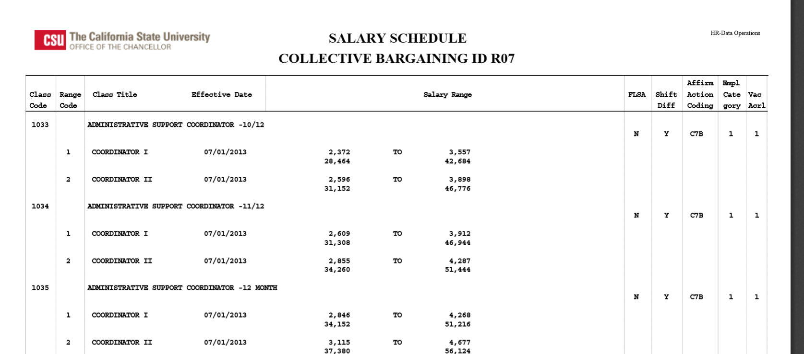

Positions can be looked up by their four digit job code (listed as class code on the salary schedule) or can be searched for by title.

Salary range minimums and maximums are listed, as well as, the different ranges in each position. For example, above you will see job code 1035- Administrative Support Coordinator-12 month. There is an ASC1 and an ASC 2 listed.

