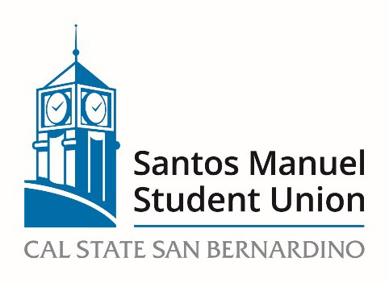

California State University, San Bernardino

Santos Manuel Student Union Board of Directors

Policies and Procedures Committee

April 20, 2023

MINUTES

Quorum was not met. Meeting was cancelled.

Call to Order
Roll Call
Approval of Minutes from March 16, 2023
Open Forum
Adoption of Agenda
NEW BUSINESS:
PC 09/223 Review and approval of Hospitality Policy (Action, Felix)

Announcements

Adjournment

