CSUSB Palm Desert Campus Safety Committee
Meeting Minutes
September 24, 2018

Attendees:
Jack Macfarlane
Cary Tyler
Francisco Castro
Jorge Esparza
Benjamin Virzi
Teresa Fricke

- 1. Review of June 2018 Safety Committee meeting minutes results in approval. Regarding the concern with student jaywalking across Cook Street: Jack reported that signage has been installed.
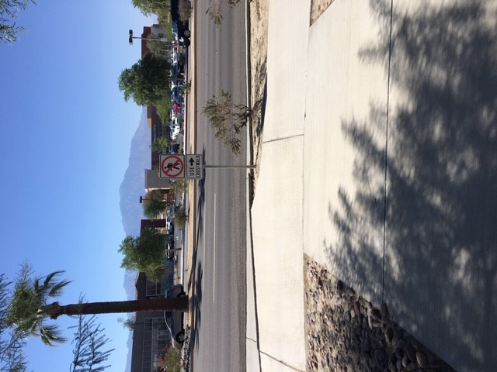
- New Items:
2. CSU Laboratory Safety Audit. Teresa explained the audit being undertaken by the Office of the State Auditor, occurring because of CSUEU complaints/allegations that the CSU Chancellor’s Office is not ensuring adequate oversight to ensure safety compliance in labs as well as other campus areas/programs. In response, the state Occupational Health and Safety Division (Cal-OSHA) will be inspecting all campuses throughout the next year. The inspections are unscheduled, and unannounced. Campus staff should contact Environmental Health and Safety should an OSHA inspector show up on campus.
The Chancellor’s office is purchasing and providing training on a new laboratory management software program, which will be implemented system wide to conduct hazard assessments, inspections, and input chemical inventory. In addition, the Risk Management Division of the Chancellor’s Office has developed a timeline of activities to be completed to address the State Auditor’s findings. EHS will be responsible for ensuring appropriate departments are notified and updating policies and procedures as necessary.

3. GHS/Lab Safety Training. A new online platform is being rolled out for laboratory safety training. This training is required of any faculty, staff, and student employee with the potential for hazardous material/waste exposure, and completion is required in order to ensure compliance with Cal-OSHA regulations. The course is now available on Skillsoft, and will be transferred to the new SumTotal Learning Management System in early 2019. Training is being assigned to all persons with potential exposure as well as regular lab users.

4. Laboratory Safety. As a reminder to incoming instructors and students, general housekeeping, personal protective equipment (PPE), and Safety Data Sheets (SDS) must be maintained at all times. SDS for chemicals being used must be reviewed and hazards identified and addressed by instructors. Instructors supervision is required in all teaching labs.

5.Chemical Labeling. Ensure that all chemical labeling is compliant with the Global Harmonization System (GHS) of labeling, and that a current chemical inventory is completed for each space on campus.

6. Fume Hood Certifications. EHS is working with Facilities Management to schedule inspections and certifications, and will keep Palm Desert campus appraised of dates.

7. Food Event Notifications. EHS has noted a marked increase in proposed food sale events by student groups. Please remind student organizations that a seven-day advance is required and that notification and approvals can all completed on line via the EHS portal.

8. Update for Tracy Stark theatre inspections. Theatre “As-Built” architectural drawings are now available and will be forwarded to campus personnel for sharing with contractors requiring additional information to complete work.

