Reviewing Applicants

- Access: NEOGOV

- Click the Login link in the upper right corner

- Enter your Username & Password; then click Sign In

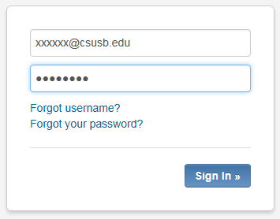

- Once logged in, hover over your user name located on the upper right of the screen and click on link labeled My SME Review

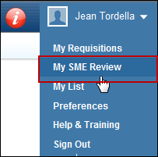
- Under Review Process, click the position title to review applicants (you also have the option of printing applicant materials by clicking the Print link to the right)

If you click the Print link the applicants will appear as shown below. You have the option of printing and/or downloading the materials. Return to the previous screen be clicking Return to SME Review

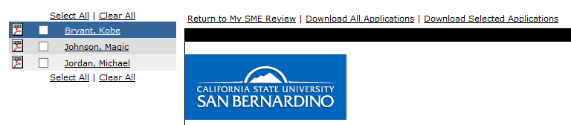
- Clicking the position title (e.g. Instructional Faculty shown above) takes you to the list of all applicants. Click the Candidate’s Name to view their application record. From this screen you can also add Comments by clicking the Add link. Comments are for internal notes viewable to the search committee.
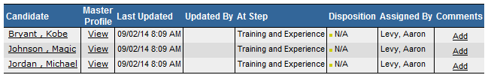

Clicking the Add link takes you to the below screen where new comments can be added, or to review previous comments. Click View Review Process Candidates to take you to the previous screen.

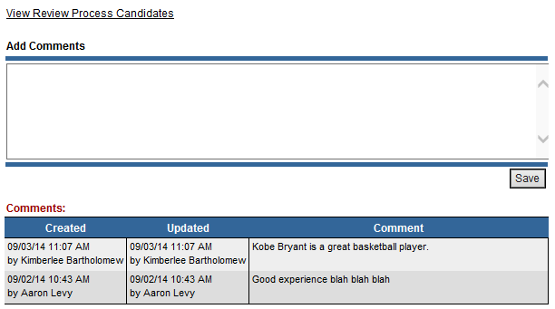

NOTE: Steps 7-9 provide instruction on how to move applicants through the recruitment process within NEOGOV. It is critical that one person (e.g. Chair or designee) is assigned this role.

- To decide on candidates that meet your minimal qualifications, click the Candidate’s name which takes you to the below screen. Next, click Show Candidate Disposition to open the Pass/Fail radio buttons.

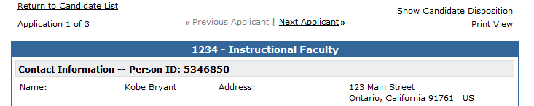

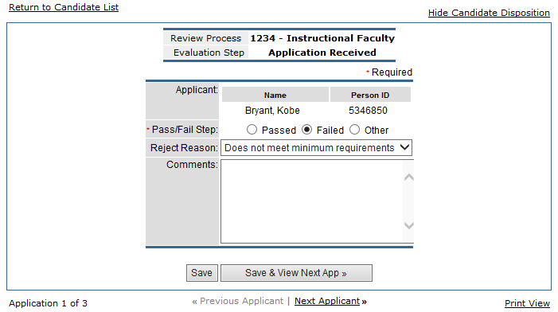
- If the applicant meets your minimal qualifications select Passed. Select Failed if the applicant does not meet the minimal qualifications and use the dropdown ‘Does not meet minimum requirements’ option as shown above. Do no choose Other. Select Save & View Next App until all applicants are decided upon.
- Select Return to Candidate List (shown above on the left side) which takes you to the screen shown below and click SME Review Complete.

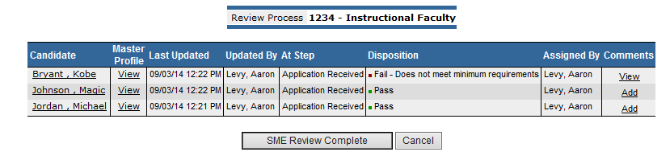
This auto-alerts Academic Personnel to send the Biographical Data Form, Applicant Data Form, and voluntary Veterans and Disability status forms as required by technical letter EEO2014-01 to all applicants that meet minimal qualifications.

- As you continue reviewing applicants that meet your minimum qualifications and are ready to select Finalists, repeat steps 7-9 and select ‘Passed’ for applicants that you are interested in moving forward. Choose ‘Failed’ and use the dropdown ‘Not best qualified’ for the applicants that have met your minimum qualifications but will not be a finalist.

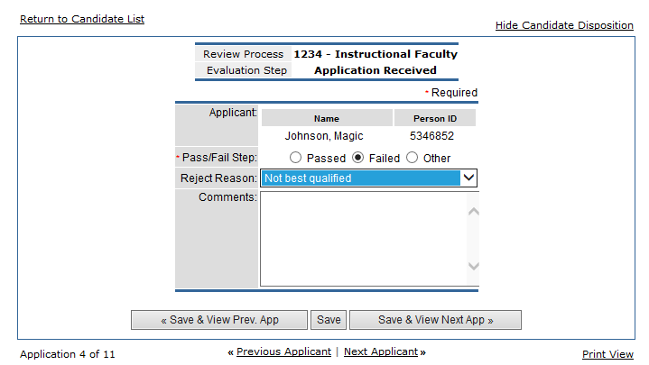

- Once you have reviewed all applicants, select SME Review Complete which auto alerts Academic Personnel to query the faculty applicant roster and confidential applicant roster.

You have completed the applicant review process within NEOGOV. Please proceed as specified by your department/college for interviewing, campus visits, selection of incumbent, etc. Once you select your new hire, submit the New Hire Folder to Academic Personnel for processing.

