Financial Affairs Collaboration Team (FACT)
June 3, 2015
Agenda

Present:
Aguirre, Ahmed, Alejandre, Calderon, Chester, Contreras, DeLeon, Escamilla, Farre, Fuller, Guzman, Hansen, Henderson, Iannolo, Kuenz, Lewis, Lindsey, Prado, Smith, Valencia, Watkins

Absent:
Anderson, Brown, Maculsay

Guest
Monir Ahmed – Internal Controls
Monir encouraged the group to participate and provide feedback in the upcoming open forums. Over the past few weeks there have been open forums for the positions of Chief of Police, Associate Vice President of Facilities, and UEC Executive Director. Monir mentioned the importance of attending the Master Plan Update scheduled for June 4. There will be two sessions containing the same content to accommodate for schedule conflicts.

Monir presented on the benefits of internal controls and provided information as a guide to tailor a more cohesive approach (see Appendix).

General
- Year-End Deadlines
STATE:
June 5 – Purchase Requisitions
June 8 – Travel, Independent Contractors, Direct Expenditures
June 9 – Petty Cash
June 10 – Construction Costs, OfficeMax
June 12 – CPO Requests
June 15 – Pro Card Purchases
June 18 – RFI, TOE, Request for Chargeback, Budget Transfers
June 25 – Deposits to Bursar
AUXILIARY:
June 19 – Equipment, RFI, Supplies
June 25 – Travel, Reimbursements
June 30 – Deposits

The group was reminded of the year-end deadlines and asked to share with departments. The deadline for Auxiliary deposits is 2pm on June 30. The deadline for deposits to Bursar is noon on June 25.

Accounting
- Deadline for scholarship disbursements
Matias expressed the ongoing concerns of undispersed scholarships. Concerns included donor perceptions and summer school disbursements. The preference is to disburse before June 30. This item will be on the next meeting’s agenda for further discussion.

Auxiliary Financial Services
No updates.

Budget
- Lottery swap to reduce balances
Dena shared that lottery funds are almost down to 50%. Dena will reach out to those departments which are not at 50% for possible swaps. The 50% is a Chancellor’s Office guideline.

- Review outstanding encumbrances
Dena reminded the group to check on encumbrances. The deadline to disencumber is June 30.

Support Services
No updates.
Next meeting: Wednesday, July 1 at 8:30am
APPENDIX

Internal control, as defined in accounting and auditing, is a process for assuring achievement of an organization's objectives in operational effectiveness and efficiency,
reliable financial reporting, and compliance with laws, regulations and policies.
Administration & Finance 1

Internal Control Objectives:

- Protect the University's Assets
- Ensure Records Are Accurate
- Promote Operational Effectiveness and Efficiency
- Encourage Adherence to Policies
- Ensure Compliance with Laws, Regulations, and Contracts
- (Be Transparent)

https://www.calstate.edu/audit/internal.shtml
OBJECTIVES
INTERNAL CONTROLS

Monitoring Risk Assessment

Control Environment

Information & Control
Communication Activities

COSO => Committee of Sponsoring Organizations

There are five components of internal control in the COSO Model:

- Control Environment
Examples ‐
  - The philosophy, ideology, and operating style of management
  - The structure of the organization, key personnel and their applicable roles, responsibilities, and duties
- Risk Assessment
Example
  - Annual Audit Plan
- Control Activities
- Information and Communication
- Monitoring
KEY COMPONENTS OF CONTROL
COSO’S INTERNAL CONTROL FRAMEWORK… FIVE INTER-RELATED STANDARDS

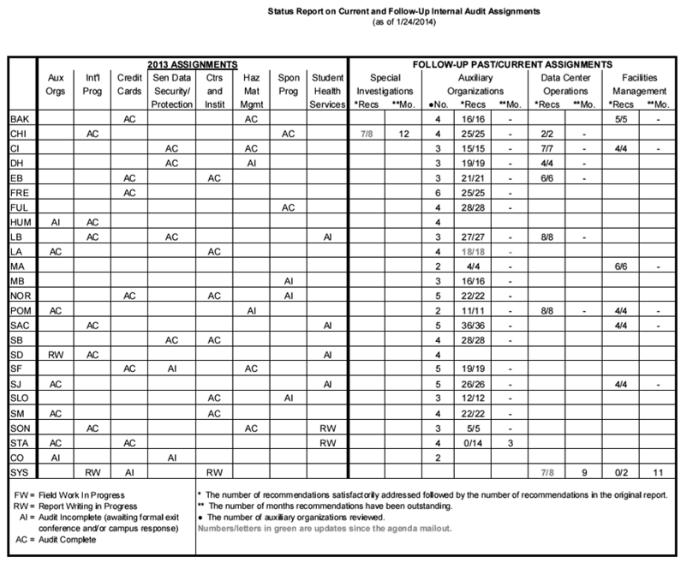

Selected activities that are intended to create a sound fiscal environment for the university:

- Access Control
  - Appropriate Authorization
  - Required Training
  - Periodic Review
- Delegation of Authority
  - Hierarchal
  - Need Based
  - Separation of Duties
- Reconciliation Process
- Periodic Financial Management Review
RISK ASSESSMENT – AUDIT LOG
INTERNAL CONTROL INITIATIVES

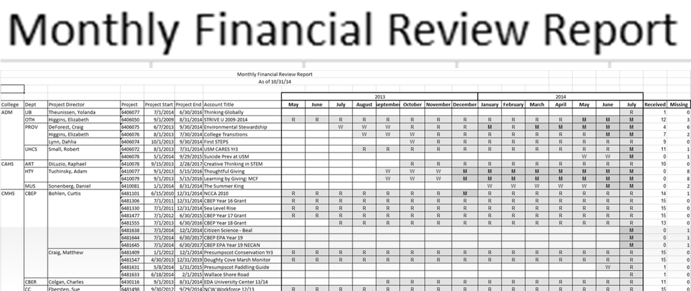

- Formation of Controls Working Group
- Control Self Assessment Questionnaire
- Establish Monitoring
- Communicate
- Review, Modify & Repeat
MONITORING
WHAT’S NEXT

NEXT STEPS

