How to Print a Completion Certificate in Skillport

Step 1: Login to Skillport: https://ds.calstate.edu/?svc=skillsoft
Step 2: Click Quick Links > Learning Transcript
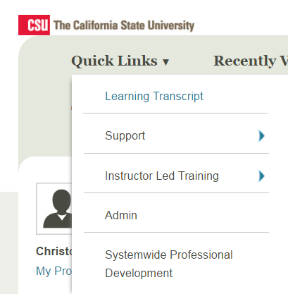

Step 3: Locate the course you wish to print a certificate
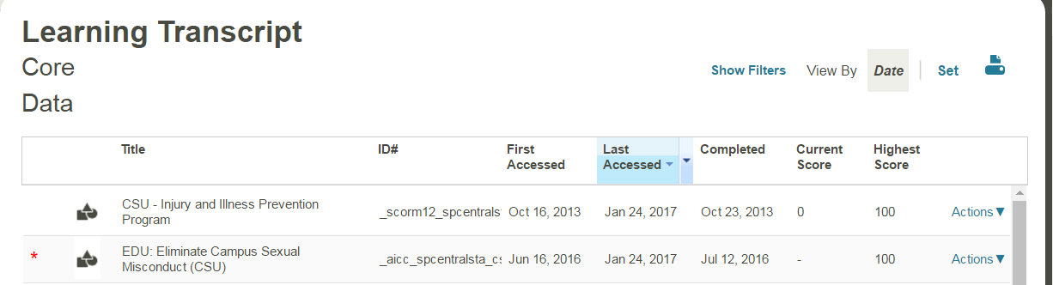
*Only courses which have a completed date next to it will be available to be printed
Step 4: Click Actions > View Certificate
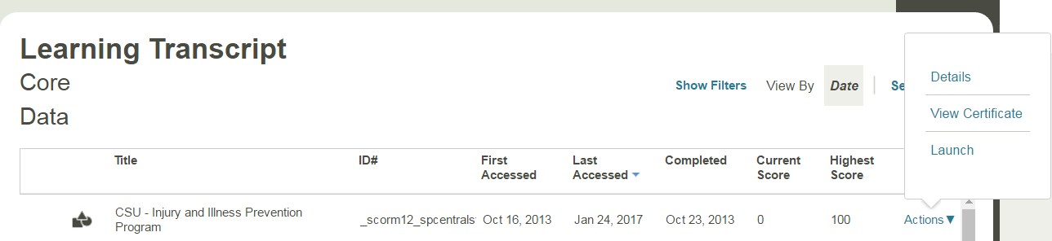
*If you do not see a view certificate button, the course has not registered completion. You may need to launch the course again to verify course has been completed, including any policies that need to be acknowledged, slides viewed and the appropriate test score has been reached.
Step 5: Click the Print button to receive your certificate
