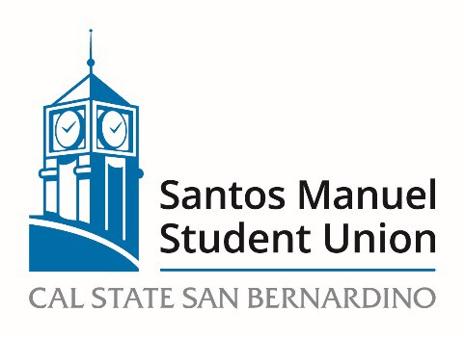

California State University, San Bernardino

Santos Manuel Student Union Board of Directors

Facilities and Sustainability Committee

March 23, 2023 – 2:00pm

https://csusb.zoom.us/j/85113685482

Agenda

Call to Order
Roll Call
Approval of Minutes from February 2, 2023
Approval of Minutes from February 23, 2023
Open Forum
Adoption of Agenda

OLD BUSINESS:
FS 19/23 Campus Dining in the SMSUS (Discussion, Roberson)

NEW BUSINESS:
FS 20/23 Proposed Basic Needs and Support Center Space (Discussion, Roberson)

FS 21/23 Timeline for moving Undocumented Student Success Center to SMSU
(Discussion, Roberson)

FS 22/23 Update on a quiet study space for students with Neurodevelopmental Disabilities (Discussion, Roberson)

FS 23/23 Timeline for moving The Retreat to SMSUS (Discussion, Roberson)

FS 24/23 Timeline for moving the Title IX Office to SMSUS (Discussion, Roberson)

FS 24/23 Update on Centers and Services hours and student use charges
(Discussion, Roberson)

FS 25/23 Update regarding Repair, Replacement, and Improvements to facilities (Discussion, Roberson)

Announcements
Adjournment

