Financial Affairs Collaboration Team (FACT)
August 2, 2017
UEC Boardroom 9:00 a.m.-10:00 a.m.
Minutes

Attendees: Alejandre, Apodaca, Anderson, Badulis, Beechko, Beran, Calderon, Chester, Contreras, De Leon, Farre, Gee, Guzman, Jensen, Kelley, Levin, Lopez, Maculsay, Powell, Prado, Salazar, Saucedo, Smith, Valencia, Walls, Watkins
Members not in Attendance: Aguirre, Fuller, Galvin, Iannolo, Lindsey, Vahovick

Introductions and General Information
Introductions were made around the room and it was announced that beginning on the September 2017 meeting, Farre would take the lead for FACT meetings.
DocuSign Presentation/John Salazar, Logistical Svcs
Salazar presented on the current usage of DocuSign for the Property Survey Report. He walked us through the processes of both, as it existed without DocuSign, requiring hard signatures on forms that were transferred via intercampus mail, and also through the process as it exists using DocuSign. Using intercampus mail to garner hard signatures increases process time as it makes its rounds to becoming fully executed. If there is a delay, Property often is unaware of where the delay resides and sometimes necessitating the reprint of a new packet, a sure indication of inefficiency. With DocuSign, it’s trackable at every step. It will also send reminders to signers who still have the document sitting in their email inbox. It also allows documents to be saved electronically, useful in the efforts to comply with document retention schedules.
Salazar explained that the Property Survey Report requires three signatures, comprising of department heads and VP’s. He has an internal document that outlines who has authority signature in each department. A question arose if the signatures are based on DACS and he said it is not based on DACS at this time, but there is a potential of integrating it in the future. Gee shared that the he’s been utilizing digital signatures for 6 months for internal purposes and for contracts. He’s currently conducting a pilot project with the School of Social Work to utilize DocuSign. A question arose if Auxiliary assets would be workable with DocuSign, and Salazar answered affirmatively.
Accounting
- New Process for Chartfield Requests/Farre
Farre described the process for making any requests concerning chartfield changes, including requesting a new chartfield. There is an online form available on the Chart of Accounts Page, under the Reporting and Tax page, in the Accounting Services website.
https:// www.csusb.edu/accounting/reporting-tax/chart-accounts
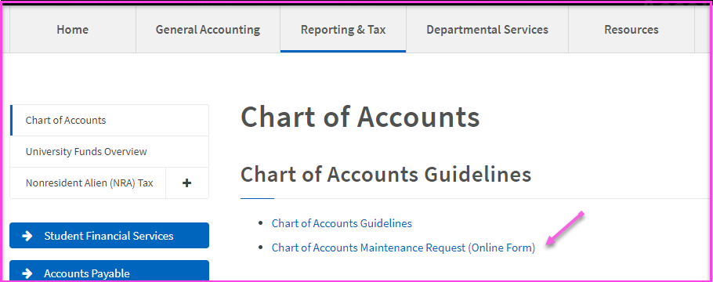
All requests made through the online form, get logged for Reporting and Tax staff to proceed with the requests. They will reach out to requesters for additional documentation if necessary. Any change or request regarding department id’s require the approval of a VP or Dean. Currently, an email approval is sufficient.
- Student Fee Report/Anderson
Anderson announced that the Annual Student Fee Report is due to the Chancellor’s office on August 27. She gave a deadline of August 15 to receive all data from college analysts detailing the planned use of cash balances of these student fees. She will send a follow up email.
Travel; Assembly Bill 1887/Levin
With the travel ban in effect as established in Assembly Bill 1887, Levin clarified that while state funds may not be used for travel to banned states (including Alabama, Kansas, Kentucky, Mississippi, North Carolina, South Dakota, Tennessee and Texas), auxiliary funds are allowable.
She also went on to promote the careful regard for international travel request guidelines, to ensure everything needed in Concur and for international travel, such as CSURMA’s foreign travel insurance, is in place prior to the travel dates.
Budget
- 17/18 Budgets Posted (Baseline, 1x, Rollover)/Chester
Chester announced that budget has been posted, in record time. Maculsay is currently working on one time funds. All unfunded needs requests have been received and will be discussed at UBAC at the end of the month and then provided to the cabinet for further review and input.
- Reporting Changes for Pre-Encumbrances/Chester
Chester stated that pre-encumbrances will no longer appear in the budget as its own rollover, but will be integrated with the BBA rollover. She went on to recommend that at year end, when inputting requisitions for services that will occur in the following fiscal year, to use a date of 7/1 to ensure funds are encumbered in the correct year.
Purchasing
- Process for Reviewing/Closing old POs/Beran and Gee
Beran explained the current process of closing out straggler purchase orders. Usually departments contact Purchasing to close out the POs, but for stragglers, they will run an expedite report by Buyer, that pulls up POs by due date. They then reach out to the departments to close them out. They are proposing to run expedite reports on a yearly basis, in March, contact the department about the open POs and give them 30 days to respond, before they are closed automatically by Purchasing. The FACT group seemed amenable to the proposal.

Meeting adjourned at 10:00 a.m.

