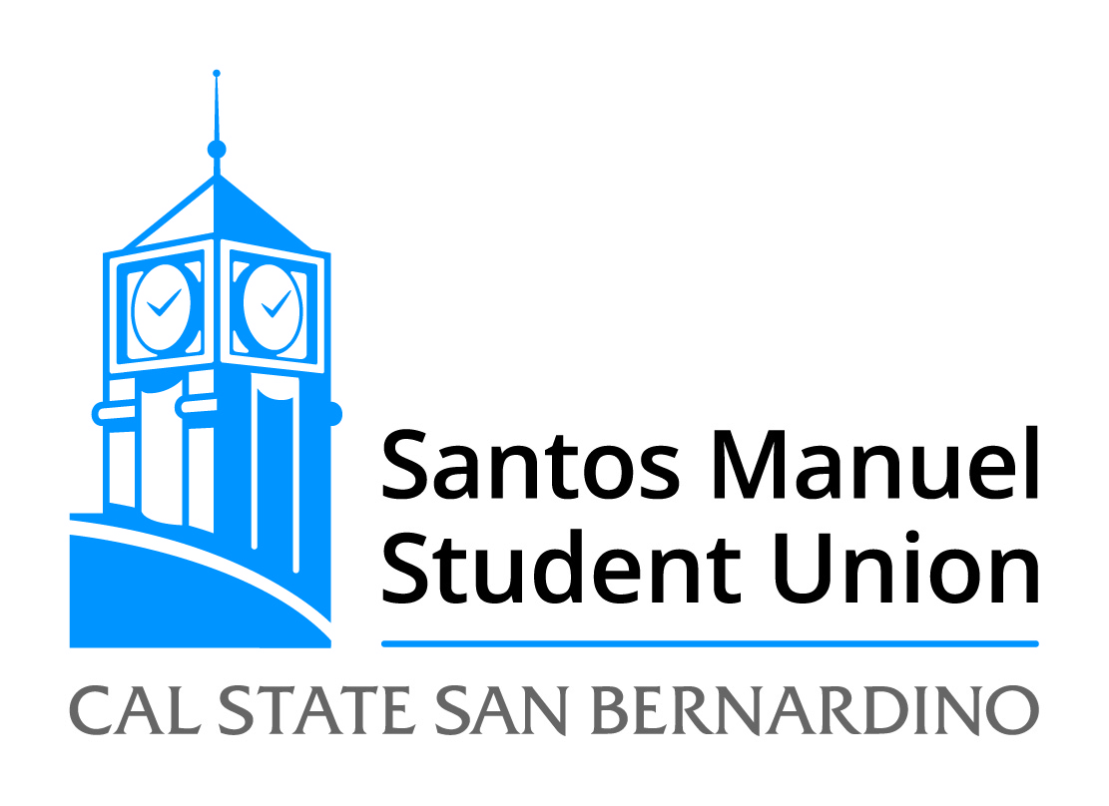

California State University, San Bernardino
Santos Manuel Student Union Board of Directors
Executive Committee
Friday, December 5, 2014
10:30 a.m. – SU 219
Agenda

Call to Order
Roll Call
Open Forum
Adoption of Agenda

New Business:

SMSU 20/15 LPA Agreement

Announcements

Adjournment

