Year-end Projections made easy!!

A useful tool in the DataWarehouse is the “Financial Summary Between Periods” module. You will be able to see a side by side comparison of actual expenses per period.

Navigation is as follows:
Dashboards > Financial Reporting> Financial Summary Between Periods

Enter as much, or as little, data as you would like.

*If looking up general fund actuals (SB001), we recommend entering “603” for the “NOT Account Category” so the benefit amounts will be excluded in your report.

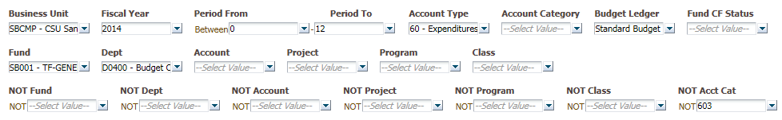

Click Apply Filters and a clear concise report will be generated showing month by month actuals.

