  CSUSB Logo 1  CSUSB Logo 2 | Data Warehouse  10G to 11G Upgrade  Delta Training Guide  BASIC

Last Revised: 02/24/14
Final 01/22/14
REVISION CONTROL
Document Title: Data Warehouse, 10G to 11G Upgrade Delta Training Guide BASIC
Author: CMS
File Reference: /tmp/in/input.doc
Revision History
Revision Date | Revised By | Summary of Revisions | Section(s) Revised
1-22-14 | Andrea Beechko | Original Document | all
2/24/14 | CMS-TB | Clean up | All
4-10-14 | - Beechko | Revised for Go Live, updated page shots throughout, updated header/footers, added Tip on last page, updated text and added text boxes in several places for clarification. Refreshed TOC. | all
Review / Approval History
Review Date | Reviewed By | Action (Reviewed, Recommended or Approved)
Click here to enter Review Date | Click here to enter Review Date | Click here to enter Review Date

Table of Contents Page
1.0 Introduction 4
1.1 Course information 4
1.2 Web Browser Inforamtion 5
1.3 Log in to DW 11G 6
2.0 Home Page 8
2.1 11G Home Page 8
2.1.1 Menu Bar/Home 8
2.1.2 Dashboard Navigation 9
2.1.3 “Open” 10
2.1.4 Name/My Account 11
2.1.5 Home page / Recent links 12
3.0 Dashboards 14
3.1 Filter Search Enhancements 14
3.2 “Apply” replaces “Go” 16
3.3 Results 16
3.4 Page Options/Customzations 17
3.5 Drill down 19
3.6 Breadcrumbs 20

Introduction
In March 2014, the CSU released the new Data Warehouse upgrade to Oracle 11G. The 10G version will still be available through June 2014.
The 11G upgrade offers some noteworthy changes. This guide identifies some of the Basic key changes & new functionality. For information on the more advanced new functionality, please attend a DW 11G Upgrade-Advanced course, or contact Andrea Beechko, x73755, abeechko@csusb.edu.

Course information
Areas of new or changed functionality covered in the BASIC and ADVANCED courses:
BASIC
- Look and feel
- Home Page
- Dashboard Navigation
- “Apply” vs “GO”
- Customizations
- Filter Search Functionality
- Report column sort-Ascending/Descending
- Breadcrumbs report navigation
ADVANCED
- Report Results
- Show column additional features and “Pivot” functionality
- Add columns
- Simple Sort
- Create sections
- Move columns
- Create Pivots
- Drilldown
- Additional on-line functionality
- Add Columns
- Move Columns
- Pivot features
- Create Sections
- Create dropdown box selections

Web Browser Inforamtion
As of February 21, 2014, the DW 11G has not been certified with the Internet Explorer v11. Please use IE10 or older or Firefox or Chrome browsers when you work with the DW 11G.
To check your browser version, click the “Tools”, then “About xxx” and it should tell you the version.
DW 11G is certified on the following browsers and versions as of February 2014.
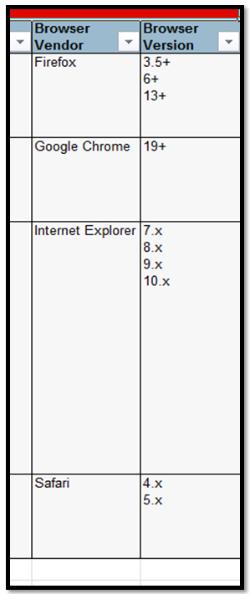

Log in to DW 11G
On Firefox or Chrome browser,
- Enter CSYou.calstate.edu in the address bar, and go to the CSYou log in page.
- Enter your Campus
- Log in using your MyCoyote ID and password.
- Navigate to the Data Warehouse page:
- Main page > Tools and Services > Financial Tools > CFS Data Warehouse > this is the main Data Warehouse page
- Create a bookmark and save it on your browser Menu Bar
- This page will contain important Data Warehouse system wide announcements and information.
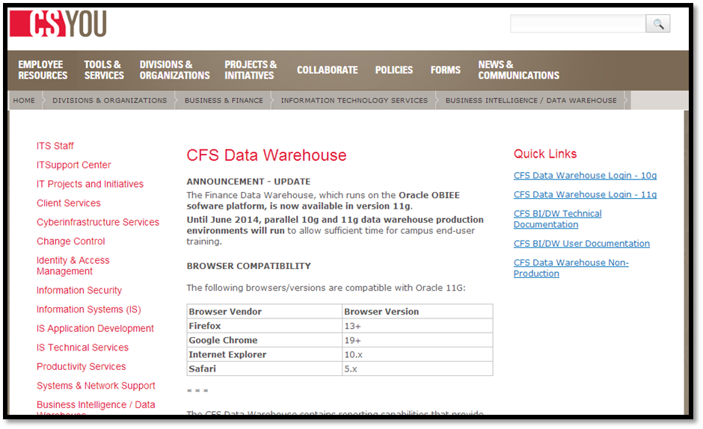
In the upper right, under Quick Links, you can access:
- Data Warehouse 10g (current/old)
- Data Warehouse 11g (Upgrade)
- User Documentation
See next page for explanation of these links.

- Data Warehouse Login - 10g—this is the current version of the DW which is refreshed from CFS PRD nightly. Available only until June 30, 2014.
- Data Warehouse Login - 11g ---This the upgraded version of the Data Warehouse that was released in March 2014. Please switch to the 11g version for your Data Warehouse reporting needs after training.
- BI/DW User Documentation-- This page contains systemwide DW training documentation for DW 10G and 11G. You can also find short videos on how to use different features of the DW 11G.
The Dashboard and report guides for 10G and 11G are from a systemwide perspective but if you wish to know more about any reports in your dashboards, please feel free to download and review these guides. Refer to campus training courses and guides for campus specific training and information. Contact Andrea Beechko if you have any questions.
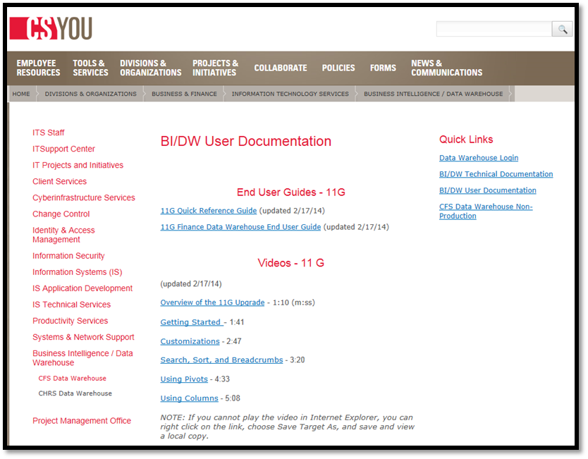
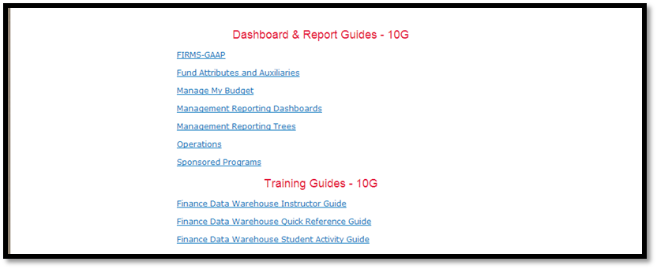

Home Page
In DW 10G, the home page was the Manage My Budget Dashboard, there really wasn’t a “Home” page for the DW as a whole.
- In DW 11G, there is an actual Home page with links to your Recent reports along with other informational links that are always available.

- DW 11G also has a new look and color scheme.

11G Home Page
The Home page has a list of Recent reports as well as a Menu Bar that is visible regardless of the Dashboard or report or drilldown you are using.
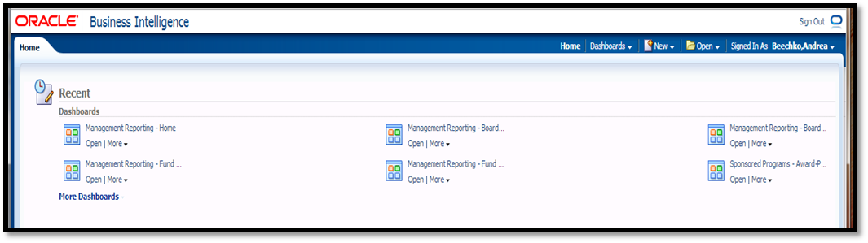

Menu Bar/Home
This menu bar will remain as you navigate through your dashboards and reports. To return to the Home page, just click the Home button.
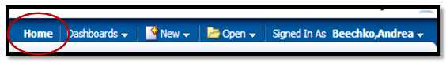

Dashboard Navigation
10G --navigation to different dashboards was done using the links at the top of the page.
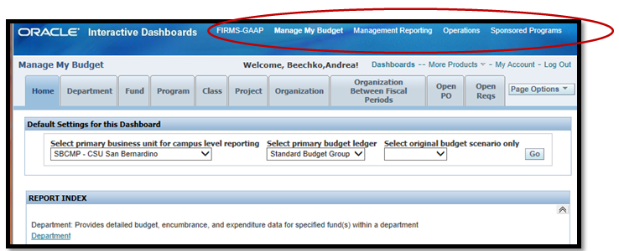

11G -- Report Navigation is now a drop down menu from a tool bar that is constantly visible as you select your dashboard and navigate to your report tab. This allows the user to easily navigate between Dashboards from within any report or return to the DW Home page.
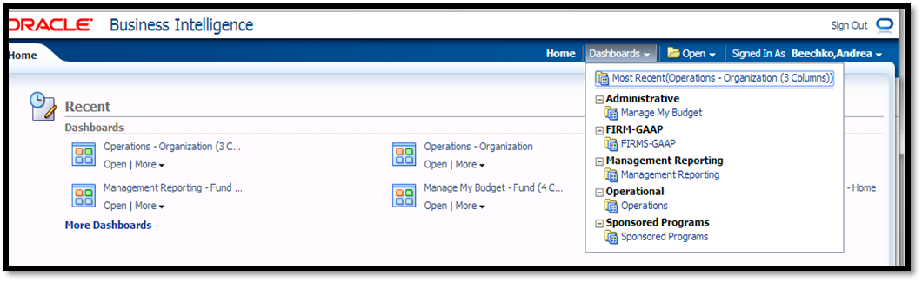
The dashboards are arranged in alphabetical groups.

- Click the group to reveal the link to the actual dashboard.

- Click the dashboard link to go to the Home page for that Dashboard.

- Notice that Manage My Budget is now under the Administrative group

- The last dashboard/report you visited will be displayed at the top of the list as “Most Recent. You can click this link to quickly return to that dashboard/report.

- The groups will remain in the status you leave them. Close groups you don’t use for a cleaner look.

“Open”
The Open button on the tool bar is another way to access your most recent reports from within any dashboard without going back to the Home page.

Although “Drill downs” are shown, they error out. Do NOT use the drilldown links at this time. Drilldown data can’t be saved and so the link will not be able to find your last drilldown location.

- Most Popular refers to systemwide selections. Clicking on a selection here will take you to that location within our Data Warehouse and using our values. May give you ideas on other reports to try.
- Most of the time, you will be using your own Recent list.

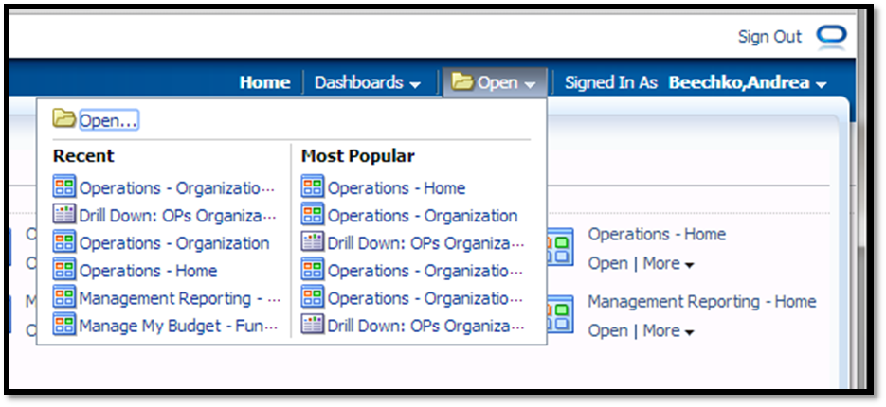

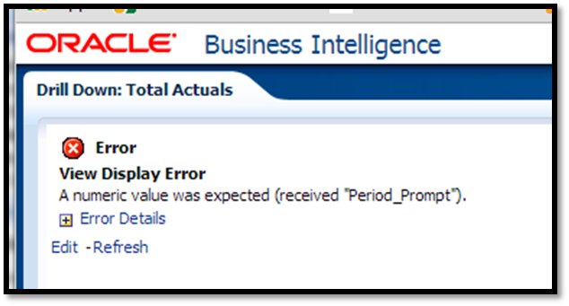
If you click Drilldown and receive this error, simply click the Home, Dashboards, or Open buttons on the menu bar to navigate to a different report.

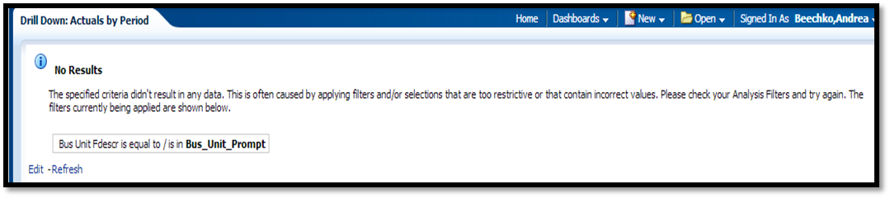

Name/My Account

Use this feature to set the dashboard you would like the DW to open with for you. This feature is available in DW 10G as well.

- Click on your name

- Click on My Account
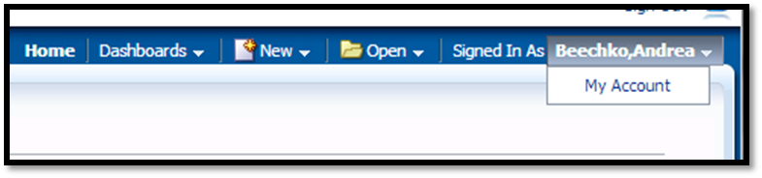

- Click the Search button for Starting page and select the dashboard you would like the DW to open in.
- Leave all other settings as they are.
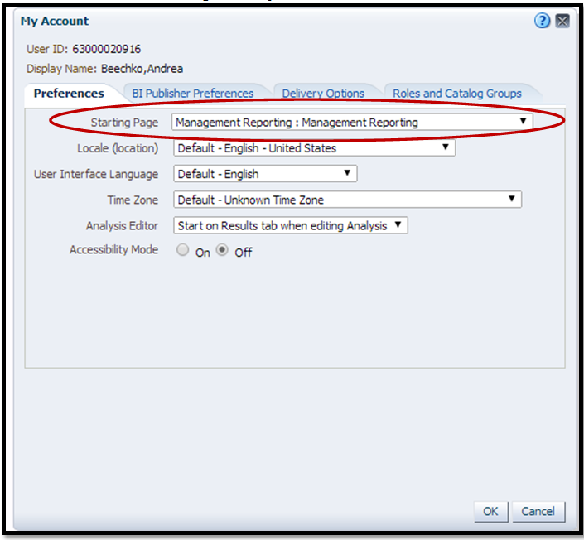

Home page / Recent links
On the Home page, up to 6 of the reports you last visited will display. Click on them to quickly return to that report, tab or dashboard home page.
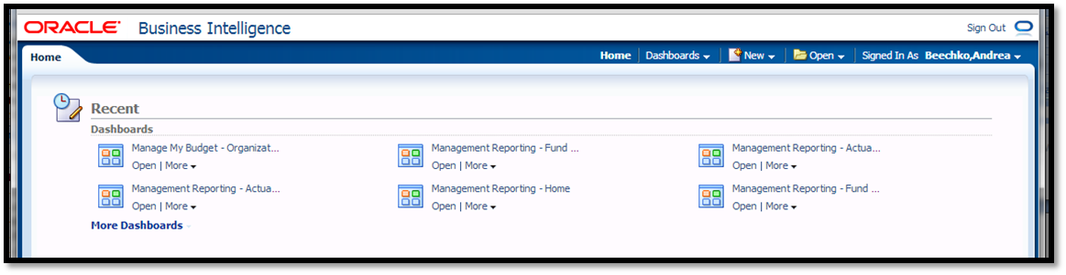
Hover the cursor over the link for more information, click to go there. It will tell you if it is the tab name or the tab and column selected
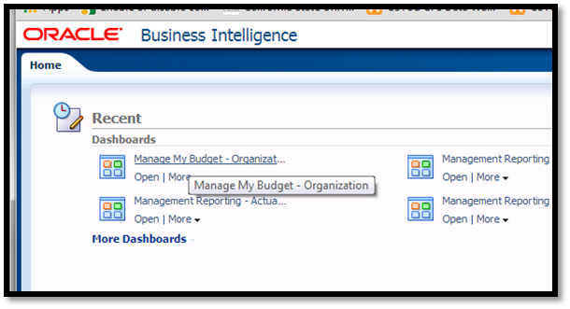
Click Open to go to the report, tab or dashboard.
Click More –
If the Recent location was a report, you can Print the report from here and select PDF or HTML.
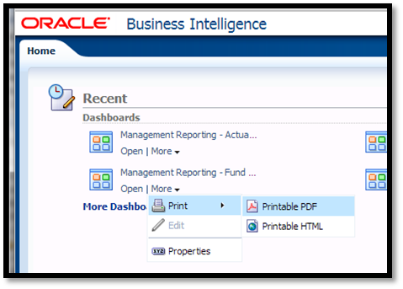
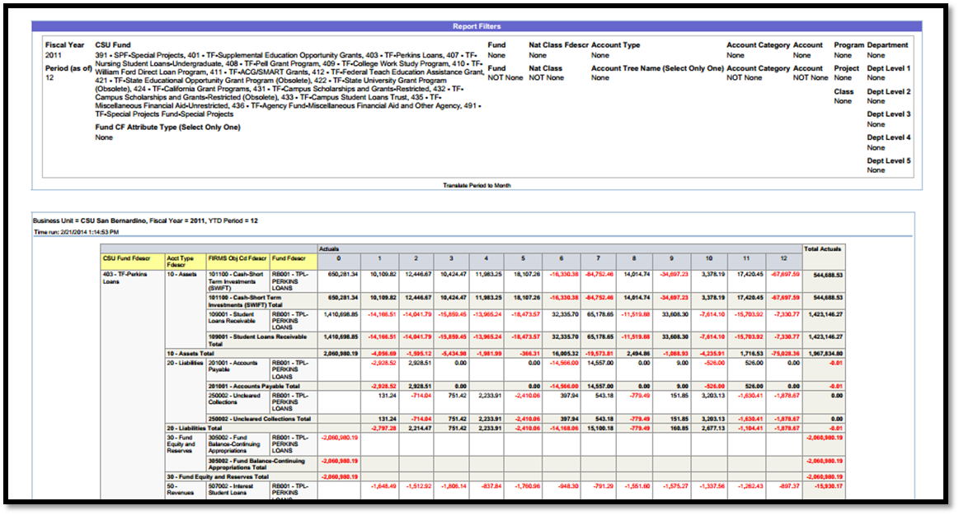
If the recent location was a “tab”, you will see the tab information, something like this when selecting Print
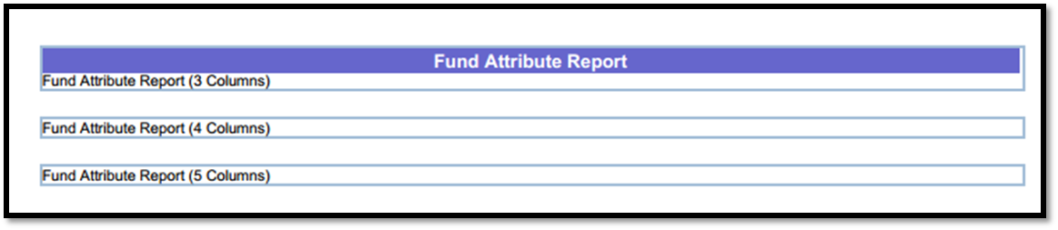
- The Properties option is grayed out and does not allow users to change the settings.

Navigate to a report

Dashboards
The dashboards, report tabs and basic 10G functionality remain the same. However, there are a few changes and enhancements.

Filter Search Enhancements
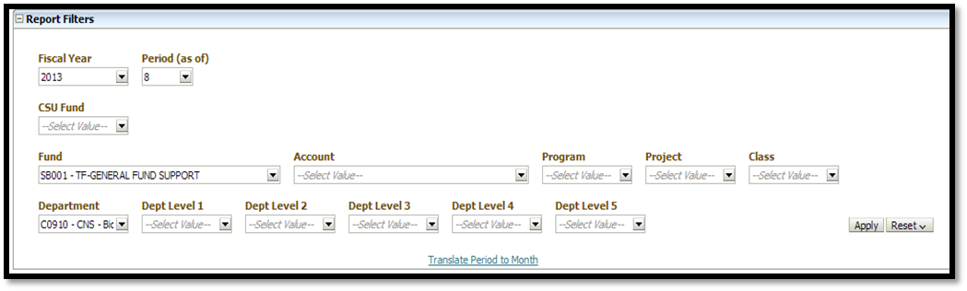
The filter search features have been enhanced.
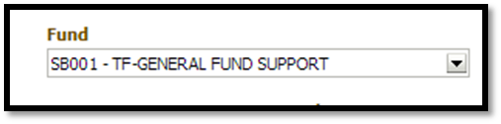
- You can now click on the field or use the dropdown arrow to activate the search.
- If the list is short, just click the value you want and click outside the box, no more clicking OK.
- If you need to search, or change the selected item,
- Every item has a check box in 11G. Click to check or uncheck the box.
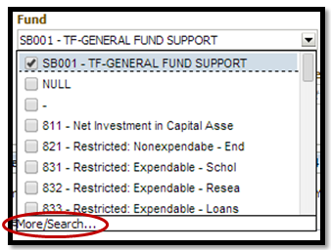
Uncheck the “X” or “Null” if checked.

Click on More/Search to open the Search feature box.

By un-checking the ‘Match Case’ & using ‘Contains’ – you can run a broader search – see below:
- Match Case
Uncheck the Match Case to use Upper or Lower case letters in your search. (10G only allowed Upper Case)
Change the name search to Contains or leave as Starts. Same options as 10G just named differently.

Search results will highlight the segment of the item that matches your search criteria.
Cursor acts differently and may not change to a pointer so, just hover over the value and click to select and use the Arrows or, double click to select and move selected values to the Right side.
- Selected values are on the RIGHT side now.
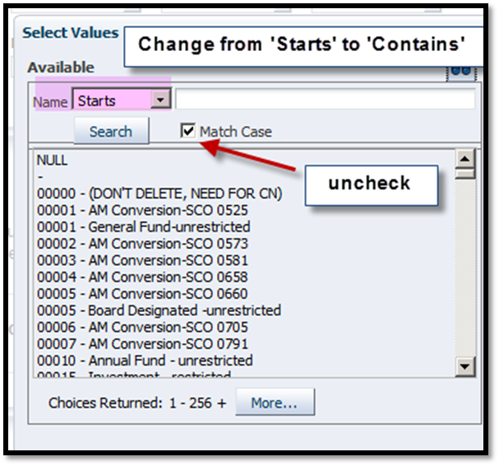
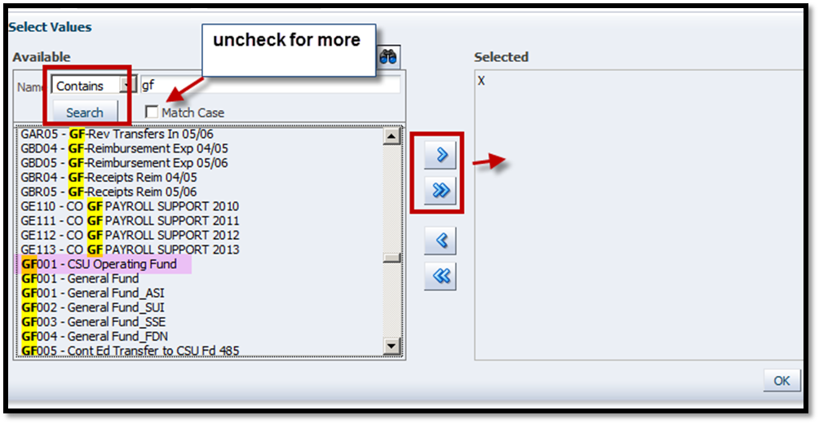

“Apply” replaces “Go”
In most places where you would click the Go button, Home tab, run the reports, change column selectors, the GO button has been replaced by “Apply”.
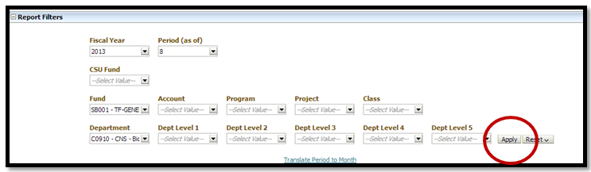

Results
OK replaces GO to change the columns selector fields.
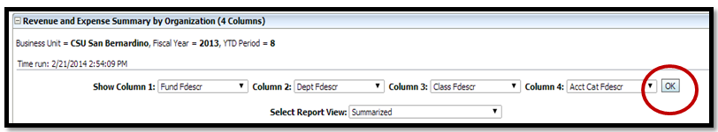
Column Sort
The new option to sort by column is now available. Hover on the desired column & click ‘Sort Ascending’ or ‘Sort Descending’. The column sort is one column – sorting column w/in a column sort is not available.
- This feature is available on any of the result columns, yellow or blue.
- Hover over the column and choose Ascending or Descending by clicking the arrow.
- This is a simple sort. The whole report will be re-sorted based on that one column.
- Think before you sort. If you don’t like it, you have to start over or try to select a yellow column to restore the original sort in Ascending order.
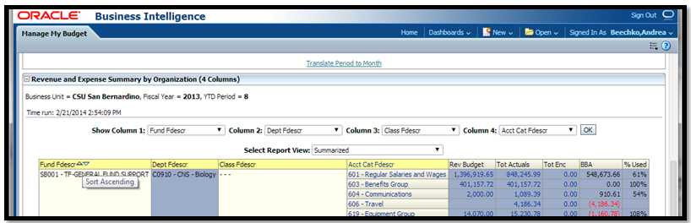

Page Options/Customzations
Save your report. The “look” of the Page Options button has changed. It looks like 3 bullet lines and can be found in the same location, in the upper right of your page.
- The Page Options button will remain visible regardless of where you are in your report. No more scrolling back to the top of your data to use it.
To save your Home or Report page preferences – click 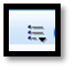 in the upper right corner of the page– then select ‘Save Current Customizations’.
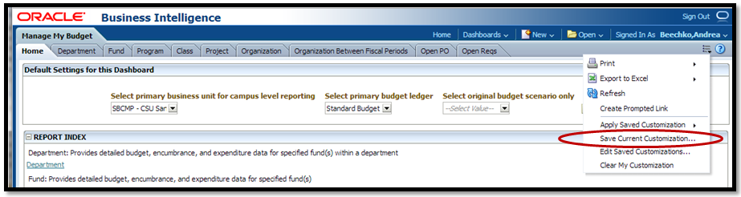
In 11g, you have to name your customization, no default values. Check the box to Save it as your Default.
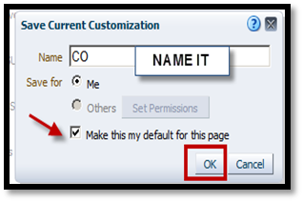
Next time, Click the Page Options button, select ‘Apply Saved Customization’ and select your report name from a list. If there is only one report, it will automatically open.
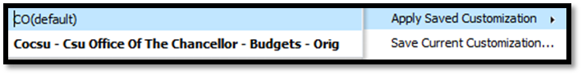

TIP:
Be sure to save your report before making any changes or trying out new features!!

Under the Customization button you also have Print and Export to Excel. The Edit button is more visible to manage your saved reports.
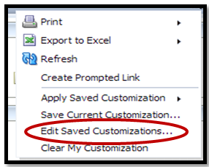
Clear My Customizations will clear the current visible report. It will not clear the saved report settings.

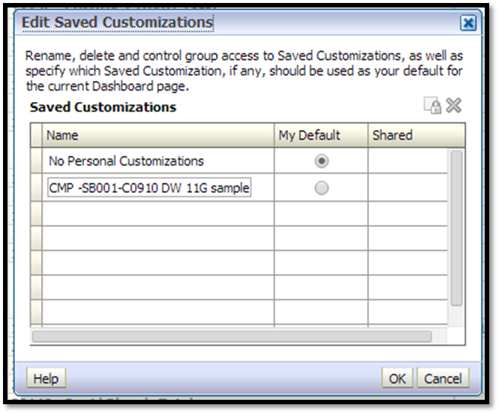
Edit your saved reports easier in 11G.
Change the name, select a default or delete all together.
Click OK to save setting changes.

Drill down
Click on a numeric field to drill down to the detail transactions.
- The look of the 11G drilldown is a little different but provides the same column data detail as 10G.

- The same column sort feature is here as in 10G but uses the little arrows to indicate the activity. Click on the arrow to activate the sort.

- The Sort Ascending/Descending feature will sort the entire worksheet by that column.

- Advanced Pivot features are covered in the ADVANCED DW 11G training guide.

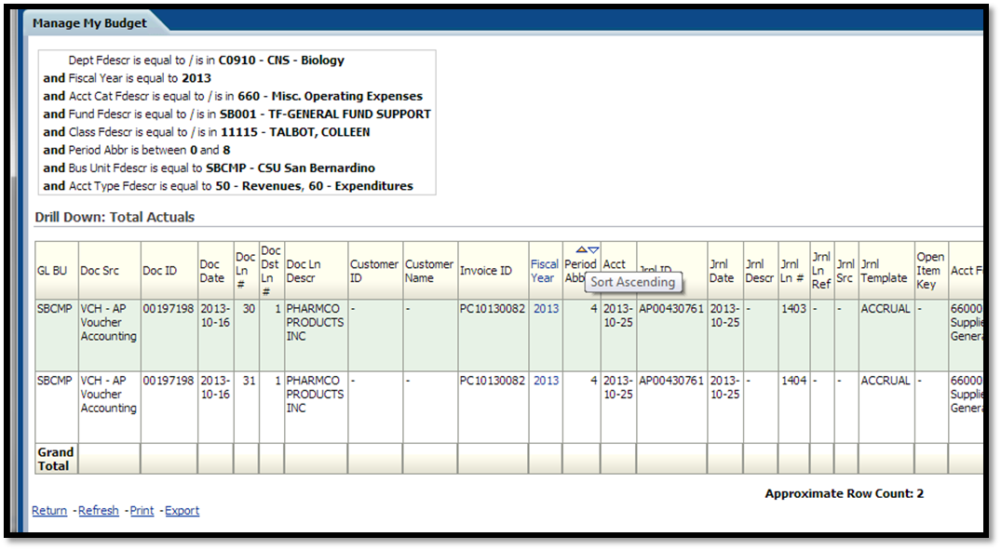

Breadcrumbs
DW 11G had added “breadcrumbs” to make it easier to return to different levels of the report and dashboard.
- These can be found at the bottom of your browser window.
- No need to scroll to the bottom of your data, Breadcrumbs are always visible.
- Use the Breadcrumbs (click to the left of the drilldown level) or Return to go back to the main report.
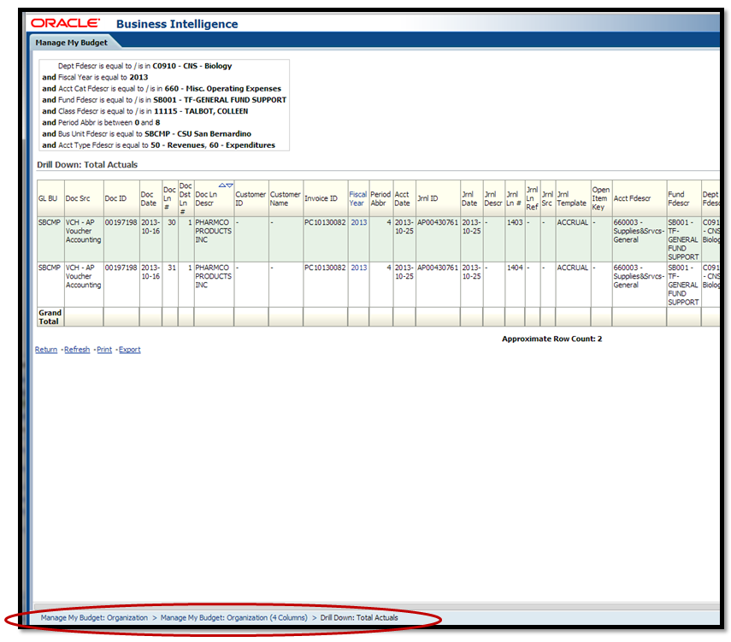
Click here to return to the report
Click at the far left to return to the Organization Report Tab. From there, click the Home Tab for the dashboard to change the Business Unit.
Click the Home Button to return to the Home Page

TIP:

There are several new places from which to print in 11G. It is recommended to test each one out and see which one works the best.
Keep in mind you may be using a browser that is new to you (Firefox or Chrome) and its print features may work slightly differently than you are used to.
Determine the best way to print your reports BEFORE you have to print them under pressure.

End of Basic new Features

