  CSUSB Logo 1  CSUSB Logo 2 | CFS 9.2 Upgrade  General User  Delta Training

Last Revised: 03/20/14
Final 03/20/2014
REVISION CONTROL
Document Title: CFS 9.2 Upgrade General User Delta Training
Author: ACBI—Andrea Beechko
File Reference: /tmp/in/input.doc
Revision History
Revision Date | Revised By | Summary of Revisions | Section(s) Revised
12-11-13 | Andrea Beechko | Original Document | all
March 2014 | Andrea Beechko, CMS | Update entire document | all
Review / Approval History
Review Date | Reviewed By | Action (Reviewed, Recommended or Approved)
Click here to enter Review Date | Click here to enter Review Date | Click here to enter Review Date

Contact Information:
Trainer: Andrea Beechko
Department: Administrative Computing & Business Intelligence
Location: PL2105-7
Email: abeechko@csusb.edu
Campus extension: 73755
Table of Contents Page
1.0 Introduction 4
2.0 User Interface Enhancements 5
2.1 Color Scheme and Main Menu 6
2.2 Favorites / Recently Used 7
2.3 Re-organized Main Menu 8
2.4 Cascading Menus 9
2.5 Breadcrumbs 10
2.6 Autocomplete 11
2.7 Additional Information 14

Introduction
The CSU is upgrading their financial reporting system from CFS 9.0 to CFS 9.2.
Go Live - April 22, 2014.
Also being upgraded are People Tools, to v 8.53, and Oracle OBIEE (the CSU Data Warehouse) from 10g to 11g.
This document will cover the general changes for the CFS and People Tools upgrades for campus department users.
Covered topics include:
- New Look
- Main Menu
- Favorites
- Breadcrumbs
- Navigation

This document will be available on the campus CMS web site. In class instruction is also being provided to users.

Access:

- Prior to go live, if a non-Prd instance for CFS 9.2 is available, please log in to CSYou and navigate to the link using instructions provided.

- After Go-live, logIn as usual to CFS Finance on the CSYou.calstate.edu website.

- To access the CSYou web site on any browser, type in CSYou.calstate.edu in the address window. Be sure you see that the location begins with “https://…” and you should see the Select Campus menu.

- At the main Page, navigate to the CFS Finance page

- Main Menu > Tools and Services > Financial Tools > Common Financial Systems (CFS)

User Interface Enhancements

CFS 9.2 with the PeopleTools 8.53 will have a new look and feel but the functionality will be the same. This section will cover the changes most campus users will encounter.

Specific modules may have new functionality that will be covered in training for those modules.

Common New features in CFS 9.2

- Color scheme
- Main Menu layout
- Favorites/Recently Used
- Re-organized Menu
- Cascading Menus
- Breadcrumbs
- Autocomplete
- Column Formatting

Color Scheme and Main Menu

- Lighter color scheme
  - Message from Oracle that indicates things have changed
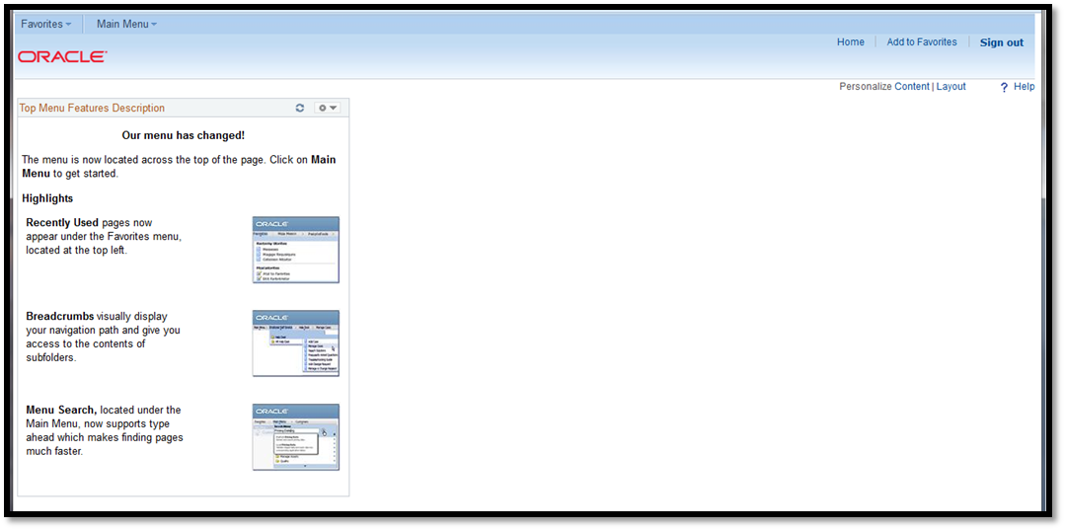
NOTE: To remove this message
Click the little page options arrow in the upper right of the window
Select Remove
Click ck Yes, Remove Use the Favorites and Main Menu tabs to navigate off the Home page.

- Main Menu is now a dropdown from the top menu bar
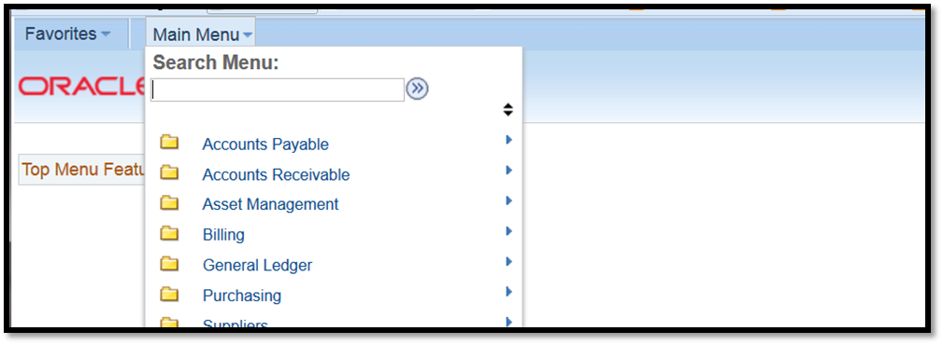

Favorites / Recently Used

- Favorites button now located at the upper left corner of the Home page.

- Favorites will also display your 5 most Recently Used pages.

- Your Favorites list from CFS 9.0 should be visible in your “My Favorites” section.

- As in 9.0, you have the ability to Add or Edit your Favorites list from here.

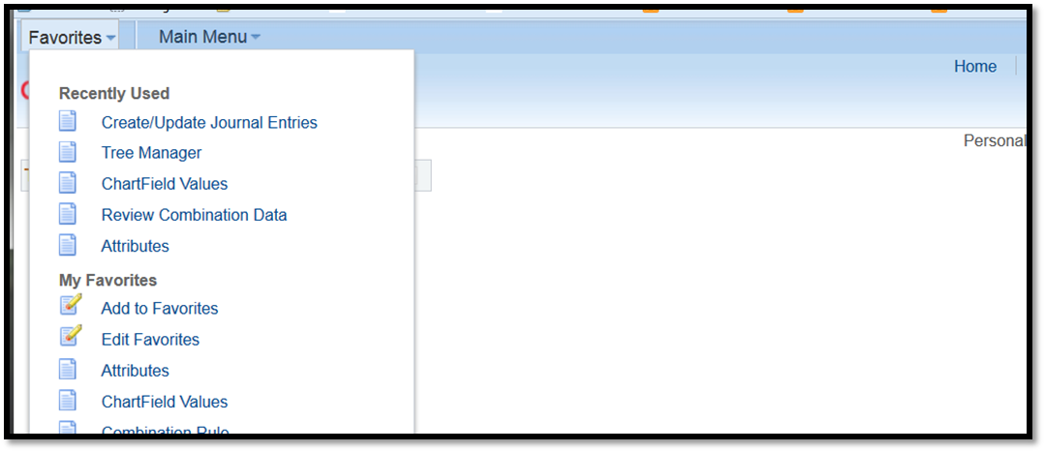

Re-organized Main Menu
- The Main Menu has been reorganized to allow the user to quickly find the sub-menu they are looking for.
- The user Role will determine which of these items will be seen on their own Main Menu
  - The first 6 items are Core modules of CFS in alphabetical order
    - AP, AR, AM, BI, GL, PO
  - The next items are commonly used Oracle/PeopleSoft menus
    - Suppliers, Customers, Setup Financials, Reporting Tools, etc
  - Lastly, the CSU Modifications to Oracle/PeopleSoft are listed.
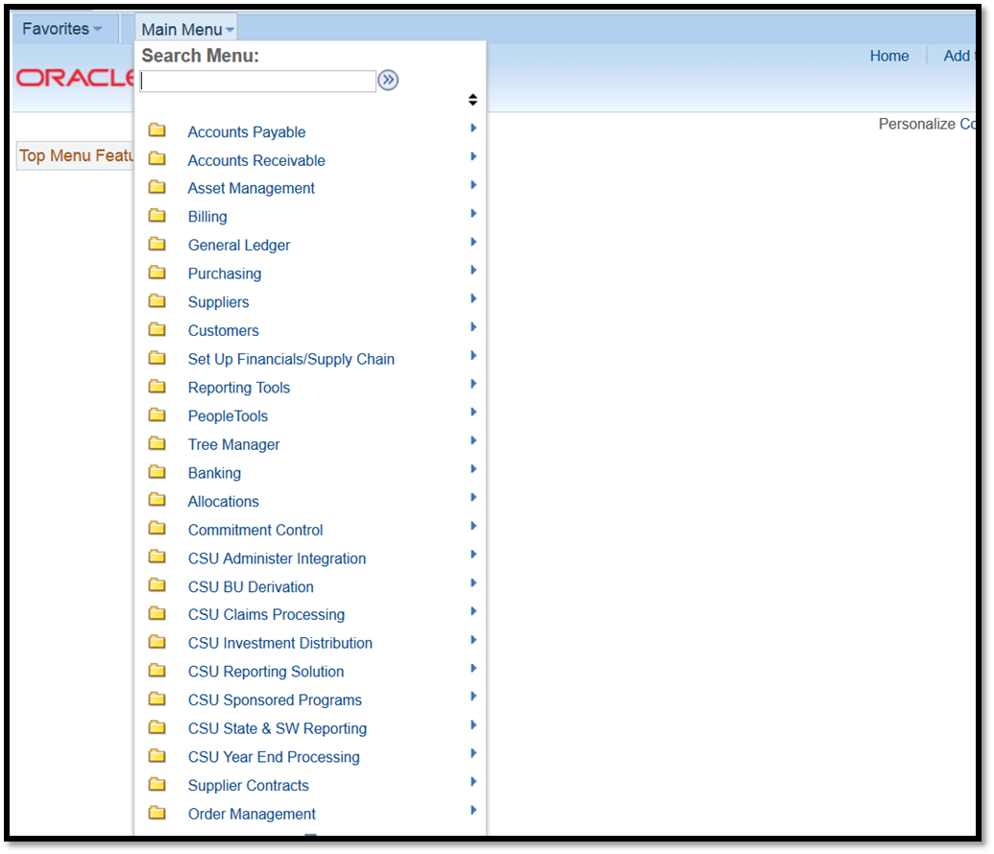
A – Core Modules
B – Commonly Used
C – CSU Modifications

Cascading Menus

As you navigate to a menu and sub-menus, each menu will stay on the page until you click your final destination. Click your selection for the next sub menu to open.
This new Cascading Menus feature saves each selected sub-menu so that you can easily retrace your steps without losing your place and having to start over.

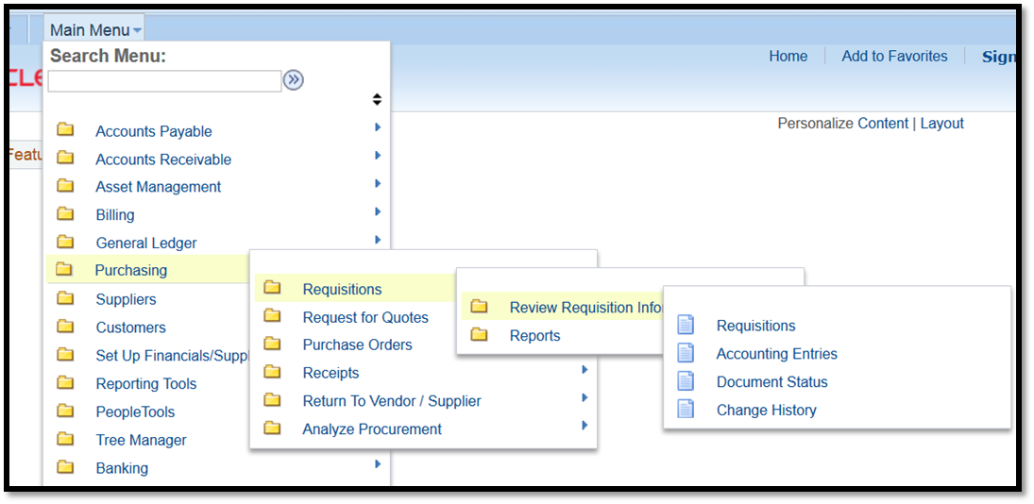

NOTE: Options shown may be different than those of the user.

Breadcrumbs
Once you have selected your desired page, you will notice that you have a navigation path across the top of the page reflecting your selections. This path is referred to as “breadcrumbs”.
Breadcrumbs allow the user to quickly select a different location along the path without having to start over at the Main Menu.
Click on any section of the path to reveal the selections at that point. Click another section if you don’t see what you are looking for. A selection is not made until a link is clicked in the dropdown window.
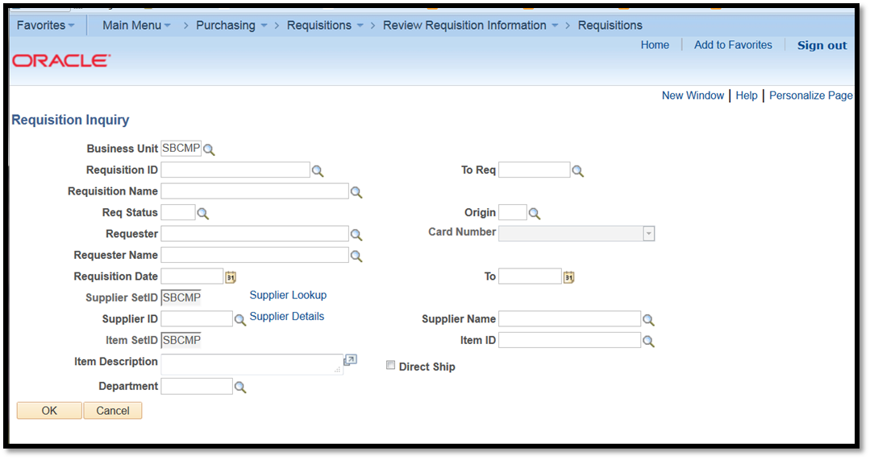
NOTE:
The term “Supplier” has replaced the term “Vendor” in the Purchasing system.
For example:
If the user decided to view a Requisition Report, they would click on the first Requisitions link in the path and select Review Requisition Information from that menu without having to return to the Main Menu.
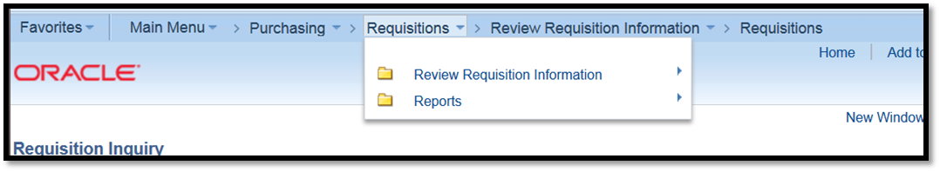

Autocomplete
In a search box, the Autocomplete feature, automatically brings up a search list matching the criteria as you type.
As seen below, as the user types “sb” in the business unit search box, all of the options that begin with sb will display.
This can save time, keystrokes and increase accuracy of data entry when the user has an extensive list of options to search through.
To select, Click on the desired option that is displayed in the list or keep typing for reduced options.
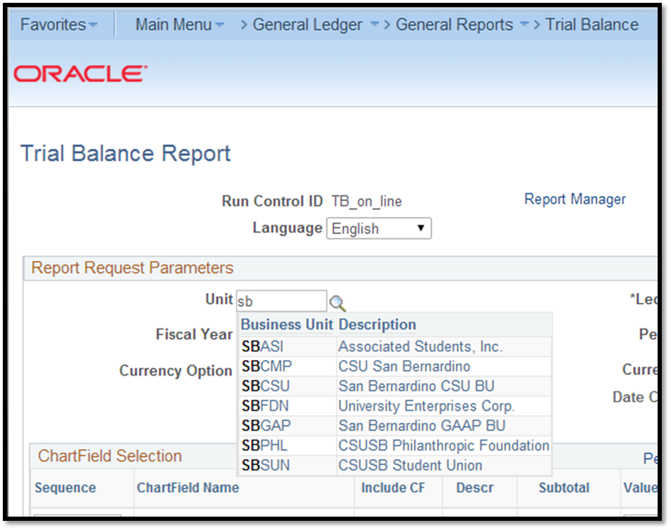
TIP: May be useful when entering requisitions to save typing in a whole field.

Autocomplete is an optional feature and will need to be set up by the user in your Personal Settings. See next page for instructions.
Autocomplete - Cont.
To activate the Autocomplete feature for yourself…
- Click on My Personalizations at the bottom of the Main Menu
- Click on Personalize Navigation Personalizations
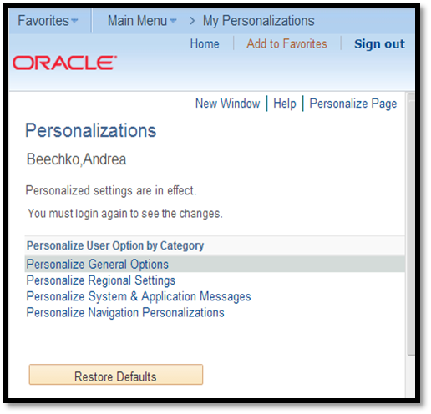
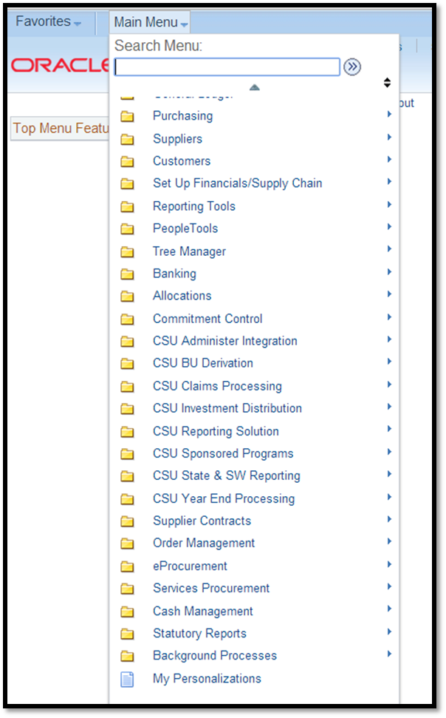

At the bottom of the Navigation Personalizations page you will see the Autocomplete option.
- Select Yes in the Override Value column.
- Click OK to Save
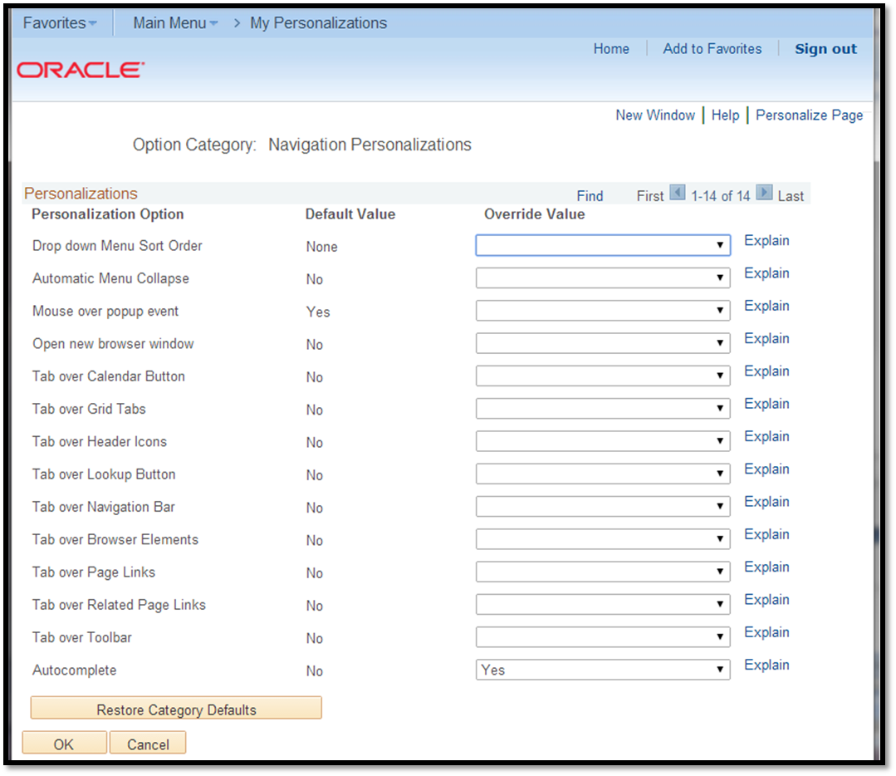

TIP: If you decide that you don’t like the Autocomplete feature, you can return here and change the override value back to “no”.

Additional Information

Queries
- Your favorite queries should transfer over to CFS 9.2.
TIP: Take a page shot or print out your query Favorites so you can compare and be sure all of the queries you want to use were moved to CFS 9.2.
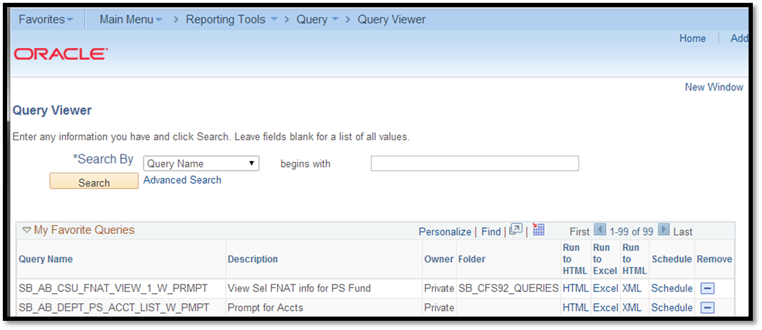

Requisitions
- The Term “Suppliers” has replaced “Vendors”
- Minor functionality enhancements
Please contact Purchasing if you have any questions on Requisitions or POs in CFS 9.2.

