| CSUSB Information Technology logo  Image of Information Technology Services logo  CSUSB Logo 1  CSUSB Logo 2 | Basic Student Records and Inquiry  Business Process Guide |
| --- | --- |

REVISION CONTROL

**Document Title:** HCM 9.2 Business Process Guide: CSU ID Search

**Author:** Records\_ITS Training Services

**File Reference:** InformationTechnology\_Standard Template\_Numbered Headings

Revision History

| Revision Date | Revised By | Summary of Revisions | Section(s) Revised |
| --- | --- | --- | --- |
| 04/16/2007 | Mary Chouinard & Amy Braceros | Initial Document | All |
| 01/30/2012 | Mary Chouinard & Amy Braceros | 9.0 Upgrade | All |
| 09/17/2014 | ACBI D. Selva | Update Cover | 1 |
| 12/12/2017 | ITS mg | Update for 9.2 | All |
| 12/13/17 | ITS ds | Update template | All |
| 02/19/18 | Melissa Cobb | 9.2 Upgrade | All |
| 07/23/18 | D Selva | All ADA Compliance | All |

Review / Approval History

| Review Date | Reviewed By | Action (Reviewed, Recommended or Approved) |
| --- | --- | --- |
| 07/23/18 | 1. Braceros | Approved |

Table of Contents Page

[1.0 Navigation 4](#_Toc500945828)

[2.0 Creating Favorites in PeopleSoft 5](#_Toc500945829)

[2.1 User Defaults 8](#_Toc500945830)

[2.2 CSU ID Search 9](#_Toc500945831)

[2.3 Campus Community – Biographical Information 10](#_Toc500945832)

[2.4 Service Indicators (Holds) 13](#_Toc500945833)

[2.5 Adding a Service Indicator 14](#_Toc500945834)

[2.6 Deleting a Service Indicator 17](#_Toc500945835)

[2.7 Program Plan Stacks 20](#_Toc500945836)

[2.8 Enrollment Appointments 26](#_Toc500945837)

[2.9 Class Permissions 28](#_Toc500945838)

[2.10 Quick Enroll – Add, Drop, Swap 32](#_Toc500945839)

[2.11 Adding a Class 33](#_Toc500945840)

[2.12 Dropping a Class 36](#_Toc500945841)

[2.13 Student Schedule 39](#_Toc500945842)

[2.14 Transcript Request 43](#_Toc500945843)

[2.15 Transcript Request Detail 46](#_Toc500945844)

[2.16 Transcript Report Results 47](#_Toc500945845)

[2.17 Degree Audit – PAWS 50](#_Toc500945846)

[2.18 What If Audit Request 54](#_Toc500945847)

[2.19 Reference Materials 58](#_Toc500945848)

[2.20 PeopleSoft 9.2 Quick Navigation 59](#_Toc500945849)

# Navigation

The navigation in version 9.2 consists of “breadcrumbs” across the screen.

1. Start by clicking on Main Menu at the top of the page and then click on the appropriate folders until you locate the appropriate page. The navigation below goes from *Main Menu 🡪 Records and Enrollment 🡪 Career and Program Information.*

Navigation to Student Program Plan
Main Menu 
Career and Program Information 
Student Program Plan

1. Once a page is selected in the Career & Program menu options, that screen will appear.

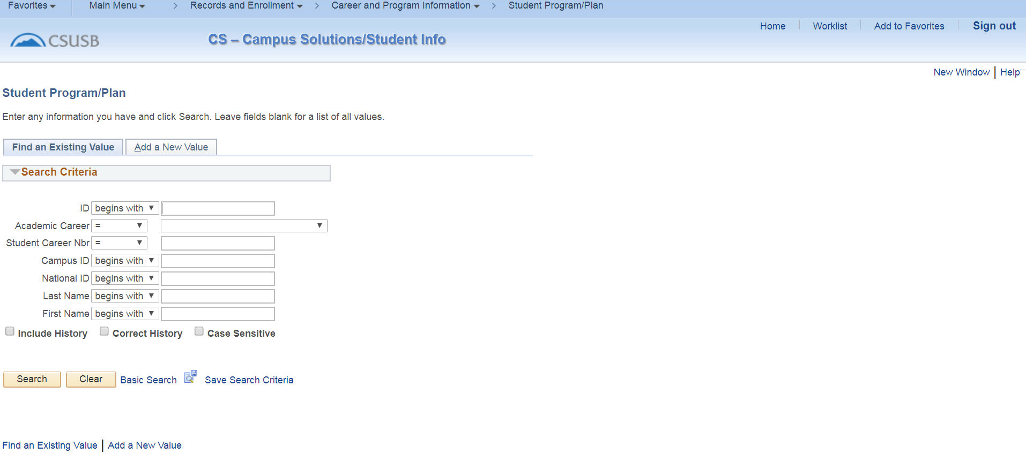

Navigation to Records and Enrollment
Main Menu 
Records and Enrollment

1. Once you navigate to the Records and Enrollment folder in the left hand menu above, this is the screen shot that will display. You can then navigate through the folders for your information.

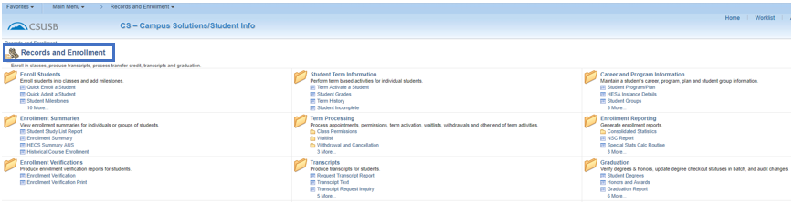

# Creating Favorites in PeopleSoft

If there is a screen that you will use often, you can save it to your “Favorites”.

1. **Navigate** to the screen you would like to add to your Favorites.

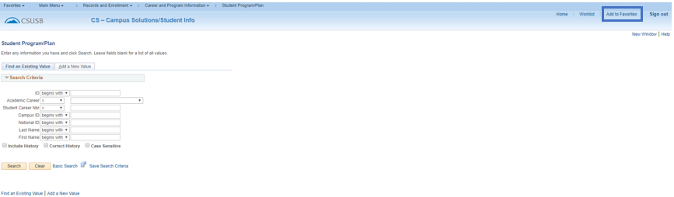

1. **Click** Add to Favorites at the top of the menu.
2. The screen name defaults as the page description.

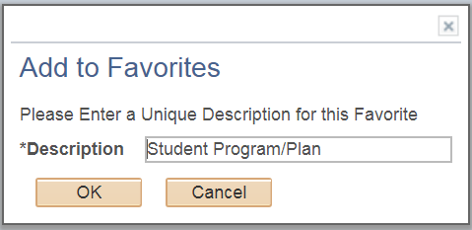

1. You can modify the description to display something that is more recognizable for your use such as – Student Major.

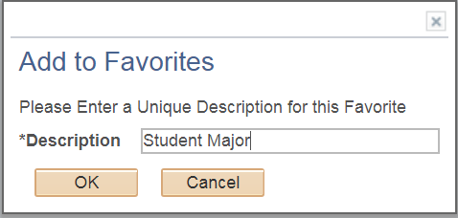

1. **Click** OK button to add to favorites and then again to acknowledge that the favorite has been saved.
2. You can repeat this process for every screen that you navigate to regularly.
3. **Access Favorites** by selecting “Favorites” from the header bar.

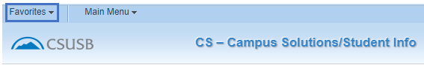

1. Two separate menus will display.

* **Recently Used** – Select one of these pages you have recently used and you will navigate directly to that screen.
* **My Favorites** – Select one of the favorites that you have saved and you will navigate directly to that screen.

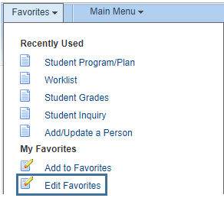

1. You can edit your favorites (favorite name, sequence/display order, or delete) by selecting Edit Favorites.

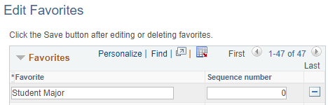

## User Defaults

Navigation – Main Menu 🡪 Set Up SACR 🡪 User Defaults

Certain information appears on most pages. Quite often there is only one value or there is one value you use most often. You can set those values to default so you don’t have to add them each time you access most screens. These are your own personal defaults that go along with your EMPLID. You will see your User ID and Name on each tab.

1. User Defaults 1 – The most common setting here would be SBCMP in Academic Institution, Career Group SetID and Facility Group SetID. You can set other defaults on this page if the information is always or most often used by you in accessing information. The values can always be updated, or you can override them on any page of information you go to if you default value doesn’t fit your needs.

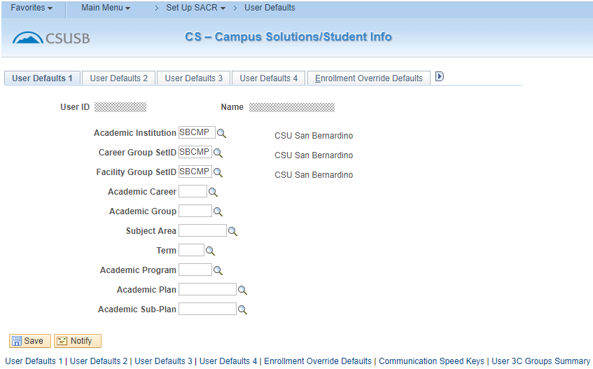

1. User Defaults 4 – This page has important default settings.

* If you check box Carry ID, you will not have to re-enter a student’s ID when you go from page to page.
* Set your Output Destination to “Printer” and your Flexible Transcript Type to the type of transcript that you will be most often using. For most users, that would be UNOFF (Unofficial). You can only select values for which you have security.

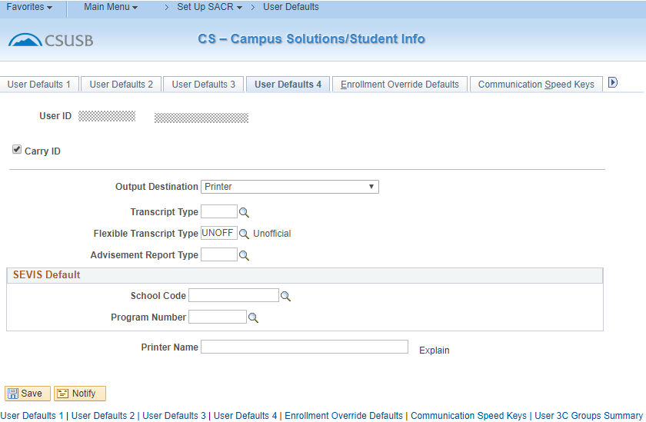

## CSU ID Search

Navigation – Main Menu 🡪 CSU ID Search

1. **Search Criteria** – Enter an Empl ID, National ID (SSN) or First and Last Name to conduct a search.

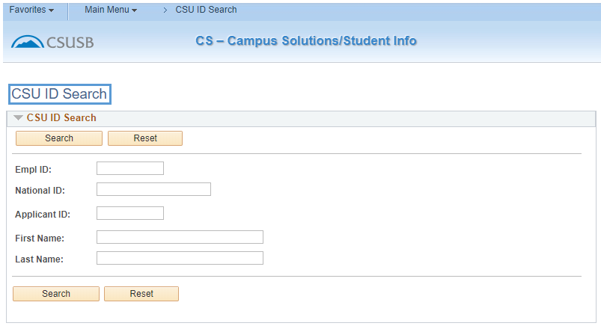

1. **Click** Search button.

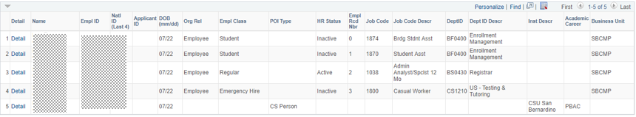

1. **Reading Information** – This person has 5 lines of information –

* Line 1 and 2 is an employee who is inactive in a student (student assistant) classification.
* Line 3 is an employee who is active in a regular classification.
* Line 4 is an employee who is inactive in an emergency hire classification.
* Line 5 shows “CS Person”. This is the designation for a student at the University.

1. **Click on the Detail hyperlink on line 5 which corresponds with the actual student classification if you have security to Campus Community Add/Update a Person.**

## Campus Community – Biographical Information

*Navigation – Main Menu 🡪 Campus Community 🡪 Personal Information (Student) 🡪 Add/Update a Person*(this is where you will automatically go if you click the Detail hyperlink on the CSU ID Search and have the appropriate access).

1. **Biographical Information** – This brings you to the biographical information pages. To view all Names and Addresses click on their hyperlinks.

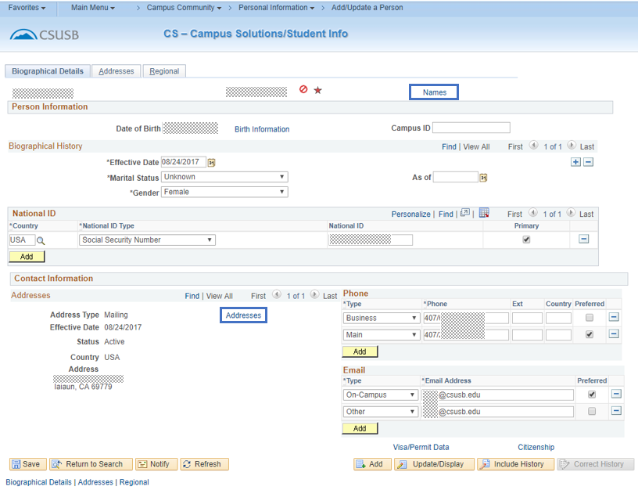

1. **Things to remember** –

* **Name types** – Each person has a Primary and a Preferred name. Some individuals may have additional name types as necessary.
  + If this is a student only, the information is maintained by the Office of the Registrar.
  + If this is an employee only, the information is maintained by the appropriate Human Resources Office.
  + If this is a student and an employee, the Primary is maintained by Human Resources and the Preferred name is maintained by the Office of the Registrar.
* **Address types** –
  + **Home** – This address belongs to the appropriate Human Resources Office. Students will not be allowed to update this address through MyCoyote but will be required to make any changes through the appropriate Human Resources Office.
  + **Permanent** – This address belongs to the Office of the Registrar. Students will be allowed to update this address through MyCoyote, but may not delete the address.
  + **Mailing** – This is a shared address – students will be allowed to update this address through MyCoyote.
  + **Diploma** – This is the address the Office of the Registrar uses to identify where the student wants their diploma mailed – students will be allowed to update this address through MyCoyote.
  + **SEVIS Foreign** – This address belongs to the Office of the Registrar, but is maintained by the Center for International Studies and Programs (CISP) – students will not be allowed to update this address through MyCoyote.
  + **SEVIS Domestic** – This address belongs to the Office of the Registrar, but is maintained by the Center for International Studies and Programs (CISP) – students will not be allowed to update this address through MyCoyote.
* **Phone types** –
  + **Home** – This phone number belongs to the appropriate Human Resources Office. This can be updated but cannot be deleted through MyCoyote.
  + **Permanent** – This phone number belongs to the Office of the Registrar. It can be updated through MyCoyote, but cannot be deleted.
  + **Business –** Shared among offices. It can be updated through MyCoyote.
  + **Mobile –** Shared among offices – It can be updated through MyCoyote.
  + **Main –** Shared among offices. It can be updated through MyCoyote.
* **Email Address types** –
  + **On-Campus** – The campus policy states that all employees and students will have a campus email that will be used for all official campus emails. This cannot be updated or deleted through MyCoyote.
  + **Other** – Students can maintain this email address on the system. It can be updated or deleted through MyCoyote.

## Service Indicators (Holds)

Navigation – Main Menu 🡪 Campus Community 🡪 Service Indicators (Student) 🡪 Manage Service Indicators

1. Enter Student’s Coyote ID (ID) or Last/First Names to find the record.
2. ClickSearch button.

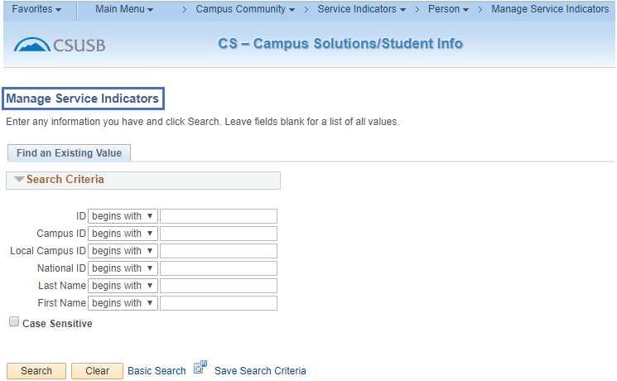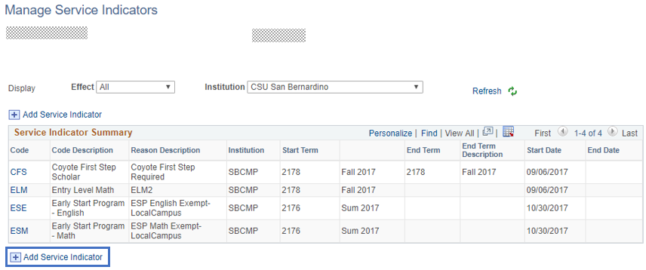

## Adding a Service Indicator

**You will only be able to add and/or delete the Service Indicator(s) for which you are authorized through your security access.**

**j0290516[1] Service Indicator Icons –**

* Add a service indicator plus button= Negative Service Indicator – particular services will be affected until cleared – such as inability to register.
* Add a Service indicator icon   = Positive Service Indicator – usually informational in nature.
* By clicking on one of these icons on the screens, you will see the negative or positive service indicator information that has been placed on the student.

page_note Using the[Look up Student Attribute (Alt+5)](javascript:submitAction_win0(document.win0,'STDNT_ATTR_DTL_STDNT_ATTR$prompt$0');) lookup icon you assist in determining the appropriate values for the fields indicated on the screen.

1. Click Add service indicator icon or add service indicator icon.
2. **Institution –** SBCMP will default in for you if you have it set up in your User Defaults.
3. **Service Indicator Code –** Enter the code for the Service Indicator to be assigned to the student’s record. Remember to use the lookup icon if you don’t know the code.
4. **Service Indicator Reason Code –** Enter the reason that coincides with the Service Indicator that is being placed on the student’s record.
5. **Description –** This is the message the student will see in their MyCoyote Student Center. It automatically populates from a setup table and cannot be updated here. If the information is incorrect, contact the Office of the Registrar to discuss an appropriate update.
6. **Effect –** Negative or Positive Service Indicator.

**EFFECTIVE PERIOD**

1. **Start Term –** Enter the term for which this Service Indicator becomes valid. This field is not required for the Service Indicator to be active. Functions that are term based will look at this field first and then to the Start Date field.
2. **End Term –** Some Service Indicators can be valid for one or more terms and then they are no longer applicable. This could be in the case of pre-payment of fees for a particular term. Most Service Indicators will not have an end term and are open until cleared by the student.
3. **Start Date –** This is the date that the Service Indicator becomes valid. Most often, it is the current date, but it can be pre-set to a later date.
4. **End Date –** If the Service Indicator is only valid for a particular length of time, a date can be entered. Most Service Indicators will not have an end date and are open until cleared by the student or when the End Term expires the Service Indicator.

**ASSIGNMENT DETAILS – CONTACT INFORMATION – COMMENTS – SERVICES IMPACTED**

* Information already displaying in fields defaults in from the setup tables and more details are not necessary.
* If additional information would be helpful, a particular individual should be contacted about this Service Indicator or a Comment is needed, that information can be added.

**j0290516[1]** Remember, this information displays in all offices with Service Indicator access and must reflect professional judgment.

**Service Indicator Date Time and User ID and name of the person placing the Service Indicator will display automatically.**

1. **Click** ok button.

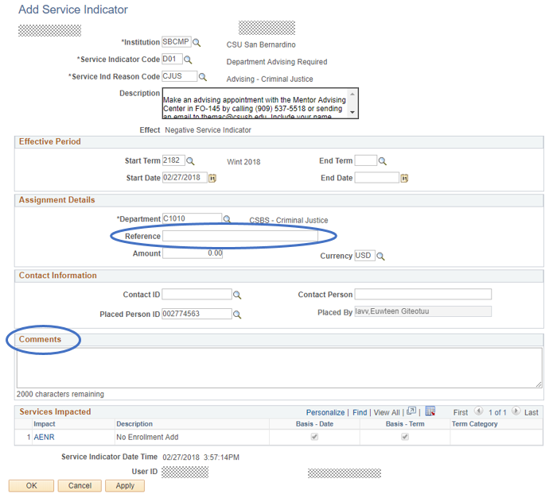

step_note **Optional Information above where circled.**

## Deleting a Service Indicator

1. **Bring up the Manage Service Indicator screen and enter the Student’s Coyote ID (ID).**



1. **Click** search button.
2. **Select the appropriate Service Indicator –** Click on the appropriate code hyperlink to view the Service Indicator you will be removing.

**j0290516[1]** Note there are 5 Service Indicators for this student but for other students there could be more. Pay close attention to the Service Indicator Summary bar. You may need to select “View All” to see additional Service Indicators.

1. **Click** Release button**.**

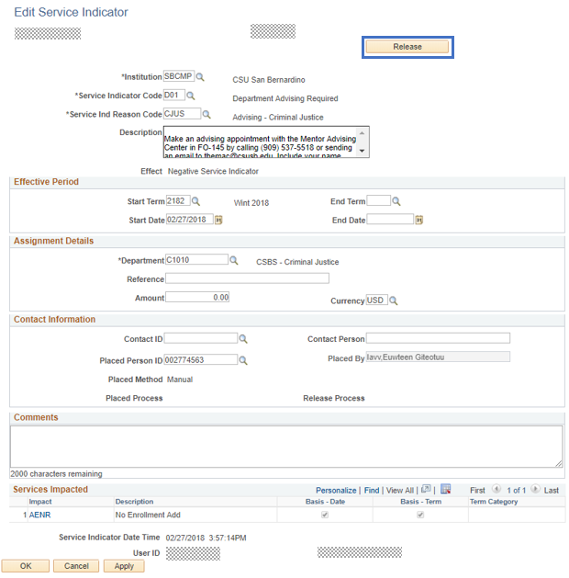

1. **Click** ok button**.**

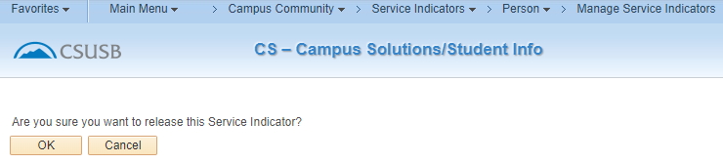

The Service Indicator is now removed.

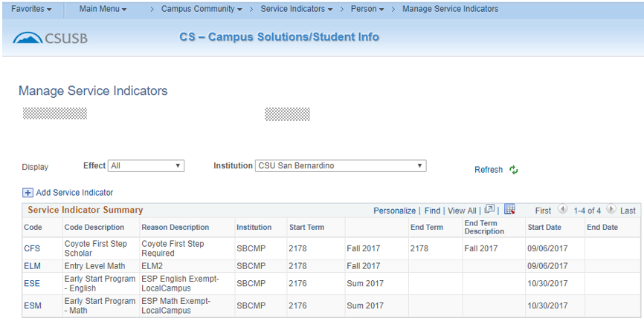

Auditing Service Indicators

A Service Indicator Audit can be run to show the activity of the Service Indicators and who added and deleted them from the system.

Navigation – Main Menu 🡪 Campus Community 🡪 Service Indicators (Student) 🡪 Audit Service Indicators

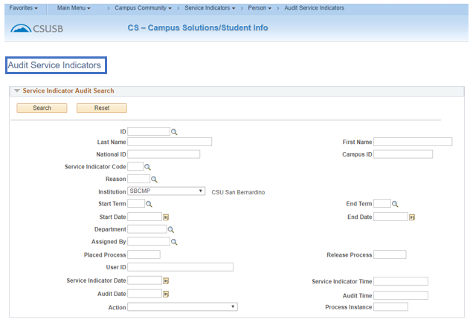

* If only the ID is used, all Service Indicators will display.

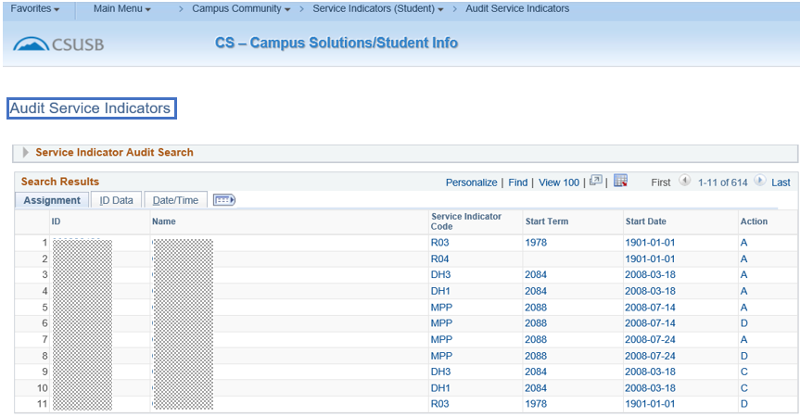

## Program Plan Stacks

*Navigation – Main Menu 🡪 Records and Enrollment 🡪 Career and Program Information 🡪 Student Program/Plan*

1. Enter Student’s Coyote ID (ID) or Last/First Names to find the record.
2. **Click** search button**.**

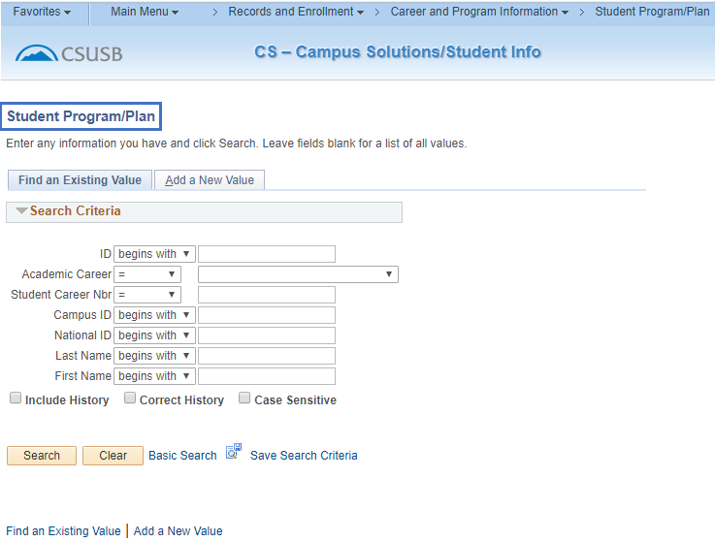

1. **Search Results** **–** A listing of the student’s Program/Plan Stacks will display if there is more than one result for the student. If there is only one Program/Plan Stack, you will go directly to the Student Program/Plan page.
2. **Click on any hyperlink in the row that has the information you want to view.**

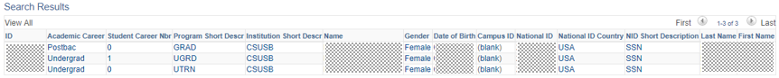

**j0290516[1] To see all of the history for this particular Program/Plan Stack, click Include History. This will show the student’s progress throughout this stack. The most recent information will display first. As a student changes their major, files a graduation check, etc., a row is added** add icon **for each of those Program Actions. This particular student has only four rows – i.e. 1 of 4 will display. To see previous major activity, use the** navigate right icon **to scroll through the pages. You can also select the “View All” option, but the display can be confusing.**

**Student Program Page –**

* Status – Completed Program (COMP) which means a degree has been issued
* Effective Date – 06/16/2012
* Academic Program – UGRD (Undergraduate)
* Admit Term – 2088 (Fall 2008)
* (GE) Requirement Term – 2088 (Fall 2008)
* Expected Grad Term – 2124 (Spring 2012) This is the term for which a graduation check has been filed and since the Status = Completed Program, that is the term the student was graduated
* Campus – MAIN or PALM to designate campus the student indicated on their application and to which they are enrolled.

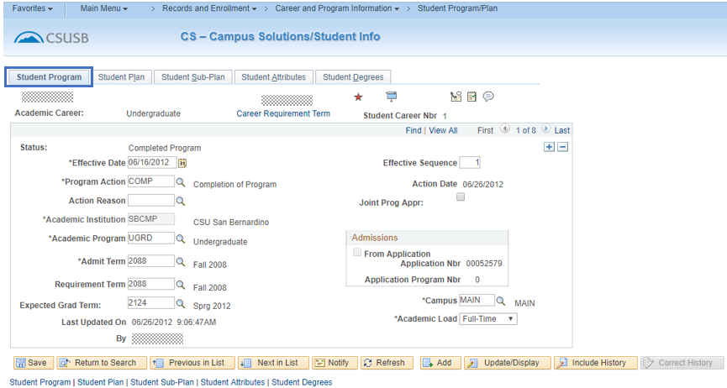

1. **Click on the Student Plan tab.**
2. **Student Plan Page –**

* Academic Plan – **KPPTCNSBSX** – This is the student’s major code - All plan codes are 10 characters in length and consist of the 4-digit major code **and** 3-digit college code (Academic Group) **and** the 3-digit degree objective. If the degree objective has only 2 digits (e.g. BA) we add a 3rd character. For undergraduate coding we add “X” – for postbaccalaureate undergraduate degrees, we add “P”. Refer to Reference Materials – Career/Program Degree Table.
  + Undergraduate student seeking a BS in Kinesiology – Pre-Physical Therapy Concentration = **KPPTCNSBSX**
  + Postbaccalaureate student seeking a BS in Kinesiology – Pre-Physical Therapy Concentration = **KPPTCNSBSP**
* Degree – BS (Bachelor of Science)
* (Major) Requirement Term – Fall 2010 (2108)

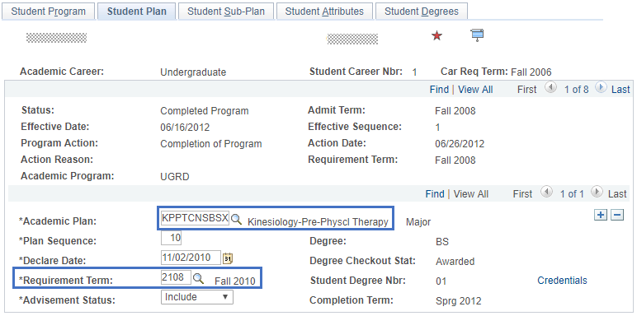

1. **Student Sub-Plan Page –** We do not use this page. All major coding has been combined at the plan level.
2. **Student Attributes –** If this were a Transitory Student (UTRN or PTRN) also known as a visitor, information pertaining to the visitor classification will be indicated. It is strictly internal information for the Office of the Registrar in determining how long a student is allowed to attend at a visitor. Their Program/Plan Stacks are then discontinued in accordance with this status.
3. **Click on the Student Degrees tab.**

**Student Degrees Page –**

* Degree Checkout Status – Once a student files a graduation check, this field will be populated.
  + Applied – graduation check has been filed.
  + Eligible – graduation check has been passed out to a Transfer and Graduation Coordinator (TGC).
  + In Review – graduation check has been completed.
  + Withdrawn – student has cancelled his graduation check.
  + Pending – the graduation check cannot be processed – most often this is for a missing program plan for a student seeking a master degree.

**j0290516[1]**Expected Grad Term – This will be seen on the Student Program Page. (Note – a DATA row will be added to the Student Program page to add the Expected Grad Term)

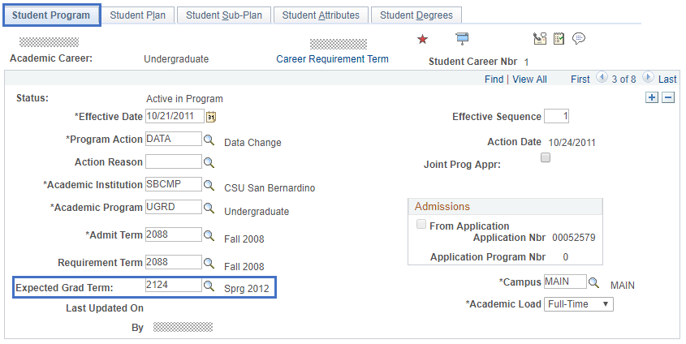

* + Degree Awarded – the student has been graduated – at that time more information will display and the Degree Checkout Status will be grayed out.

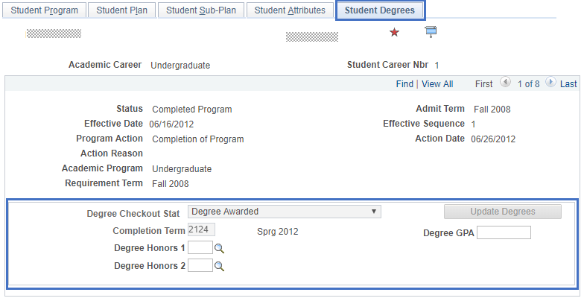

## Enrollment Appointments

*Navigation – Main Menu 🡪 Records and Enrollment 🡪 Term Processing 🡪 Appointments 🡪 Student Enrollment Appointments*

1. Enter Student’s Coyote ID (ID) or Last/First Names to find the record.
2. **Click** search button.

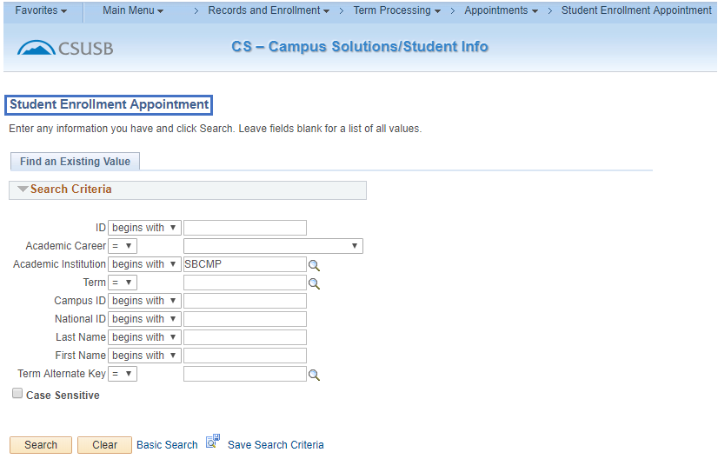

1. **Results –** Click on any hyperlink in the line for the term that you would like to view.

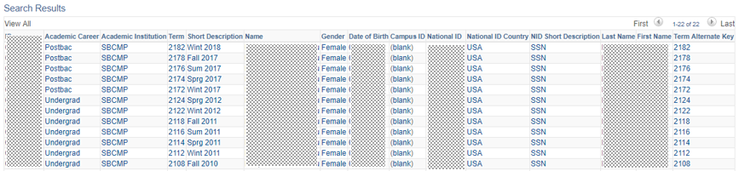

1. **Start Date –** The 1st day the student may register.
2. **Start Time –** The start time of day the student may register.
3. **End Date –** The last day of “Priority Registration”.
4. **End Time –** The last minute of “Priority Registration”.

step_note Students may register any time after their assigned time – open enrollment begins the day after priority registration ends.

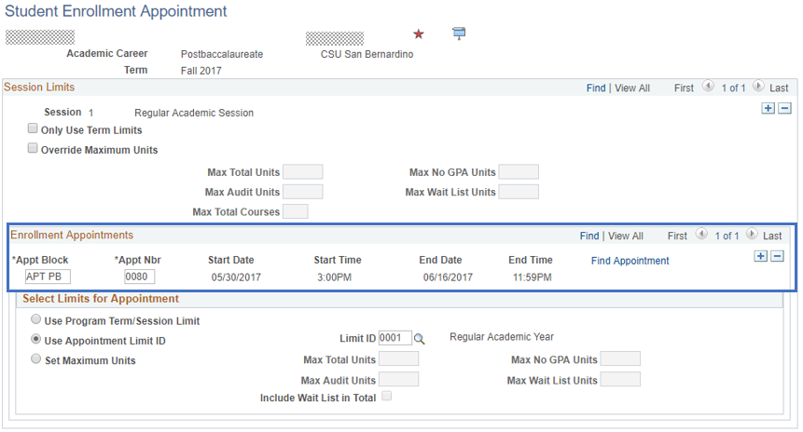

## Class Permissions

*Navigation – Main Menu 🡪 Records and Enrollment 🡪 Term Processing 🡪 Class Permissions 🡪 Class Permissions*

**j0290516[1]** Permissions may override class enrollment limits, requisites and career. If this is an undergraduate you are permitting into a 600-level course (graduate level only), you must first determine if the student has filed a graduation check for that term and then run a PAWS for the student to verify “all requirements met” or “all requirements met with work in progress”. This course cannot be used to fulfill the requirements of an undergraduate degree.

1. **Class Information –** Enter the Academic Institution, Term, Subject Area and Catalog Number.
2. **Click** Search button**.**

Fields used include
academic insitution
term
subject areas
catalog areas

1. Select the Permission to Add tab – The Permission to Drop tab will not be used.

**j0290516[1] When the Class Permission Number page displays, it will be for the first section offered for this course. To see other sections, use the** Class Permissions page  **to scroll through the sections. This example starts with 1 of 6.**

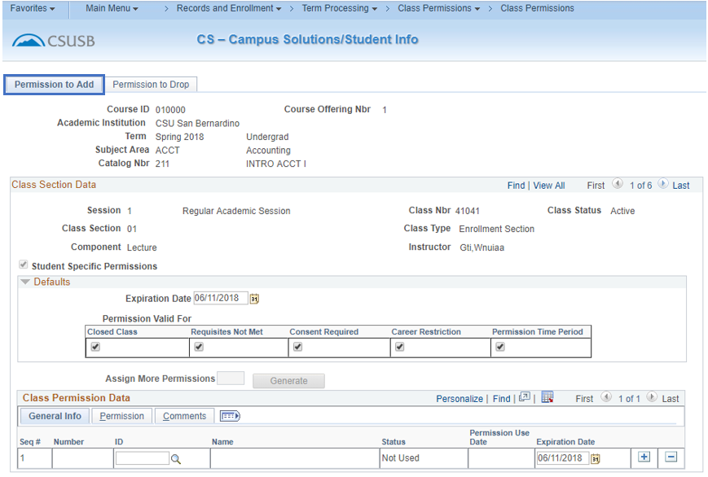

1. **Defaults –** the following defaults can be set here to apply to the students that you are giving permissions to for this particular class. *If you enter the default information here, it will reset each time you enter the permissions and save the data.* Students may require different overrides and those can be set separately per student.

* **Expiration Date –** Initially, this will display the last day of classes for the quarter. When issuing a permit for a student, you should consider how long you want the permission to be available for use. A “Not Used” status is valid for adding the class until the “Expiration Date” is achieved. This is helpful in trying to control the total number of students in the class. Even though it is currently set for the last day of classes, students will only be able to add until Census Date.
* **Permissions Valid For –** Initially, these 5 fields are checked. These are only to be checked for the conditions that you want the class permission to override.
  + **Closed Class –** Select to allow students to enroll in a class that is full. This type of permission also allows students to enroll in a closed combined section or in a class where all available seats are subject to reserve capacity requirements that they might not meet.
  + **Requisites Not Met –** Select to allow students to enroll in a class for which they do not meet the prerequisites.
  + **Consent Required –** Select to allow students to enroll in a class that requires instructor or department consent to add.
  + **Career Restriction –** Select to allow students to enroll in a class that is outside their career. – i.e. Undergraduates in the term in which they will receive their bachelor degree, can be given permission into a 600-level class. This cannot be used to count toward the undergraduate degree and if the student wants to use if toward a master or credential, they need to complete paperwork requesting that the class be considered postbaccalaureate at the completion of the class. Before this can be issued, it must be verified through a current PAWS audit that all courses will be completed in that term for the bachelor degree. *Most often, needs to be unchecked*.
  + **Permission Time Period –** Select to allow student to enroll in the class during the “enroll with permission time period”.

1. **Class Permission Data –**

* **General Info Tab**
  + **ID –** Enter the Coyote ID for the student – when you tab out of this field, the name will populate the Name field.
  + **Status –** (defaults in) This will indicate Not Used and will track the current status of this permission for the student.
  + **Permission Use Date –** (defaults in) The date that the status changed by the student registering or dropping class.
  + **Expiration Date –** This is defaulted to end of classes for the quarter – change according to policy established in the department.

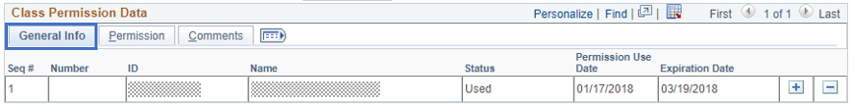

* **Permission Tab**
  + If defaults were set as discussed earlier, the check boxes will mark accordingly
  + If you choose to set them per student or want it different from the defaults, uncheck those areas that are not wanted

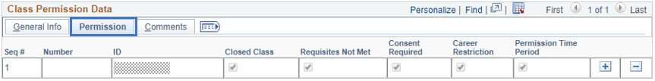

* **Comments Tab**
* A notation can be made in this field if desired

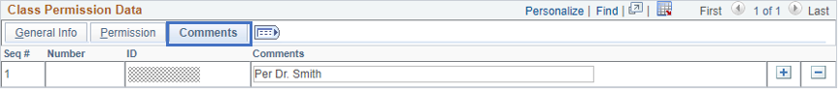

**j0290516[1] The icon View all tabs icon can be used to stretch these three tabs into one for ease in data entry and viewing.**



1. **Click** Add icon to add another student or remove icon to delete a permission given in error.

**j0290516[1] The information regarding placing and removing of permissions as well as the operator who performed the function is captured behind the scenes and as necessary, can be retrieved.**

## Quick Enroll – Add, Drop, Swap

*Navigation – Main Menu 🡪 Records and Enrollment 🡪 Enroll Students 🡪 Quick Enroll a Student*

**Add a New Value Tab**

1. **ID –** Student’s Coyote ID
2. **Academic Career** – UGRD or PBAC – using the lookup search icon will only allow for the careers that the student can be associated with.
3. **Academic Institution** – SBCMP – this will default in if you have set your User Defaults per previous instructions.
4. **Term –** the quarter for which you will be performing the enrollment actions.
5. **Click** add button.

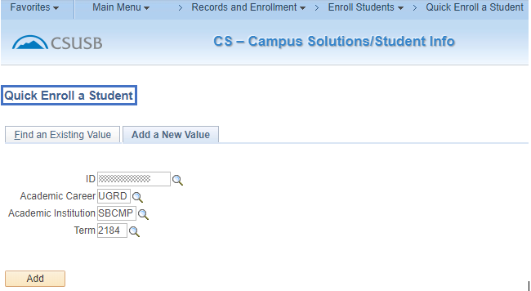

## Adding a Class

1. **Action** – defaults to **Enroll –** this is the action value you need for adding a class.
2. **Class Number** – this is the number that is associated with a particular class section. It is not the course number. If you do not know the class number, you can perform a search search icon to locate the appropriate class number.

**j0290516[1] Note:** Labs, activities, etc. that are required with specific courses are considered related courses. If related courses are required, you will need to select the related courses in Related 1 and/or Related 2.

1. Click on the add icon symbol to add additional course requests at the same time.
2. Click thesubmit buttonbutton.

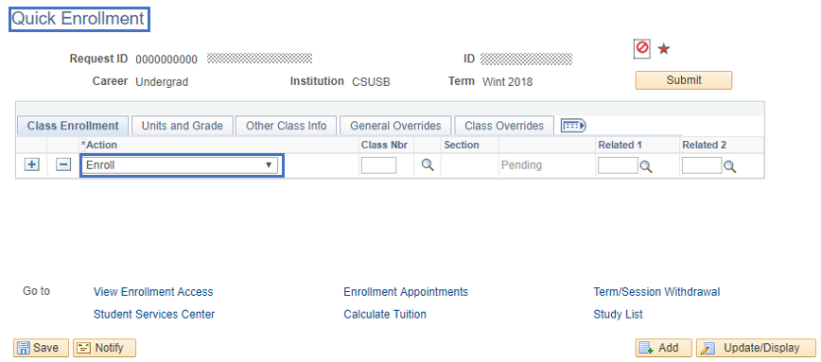

**j0290516[1] Note:** Once you have submitted a request, you should only then make necessary corrections to take care of any errors that occur on the requests. **You should never add additional courses once a request has been successfully submitted.** To add additional courses after submission, you need to click on the Add button button at the bottom of the page to open another enrollment request.

1. Review the status area for a **Success** message. If you see any other messages such as **Errors**, you will need to review the error (the actual word ‘errors’ is a hyperlink which you can click for the error message) in order to make corrections before submitting again.

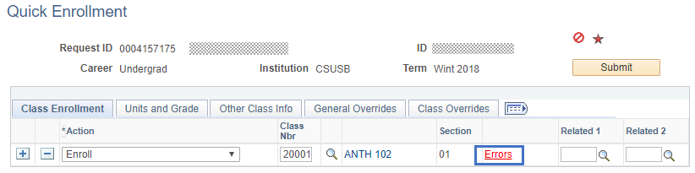

**Enrollment Message Log**

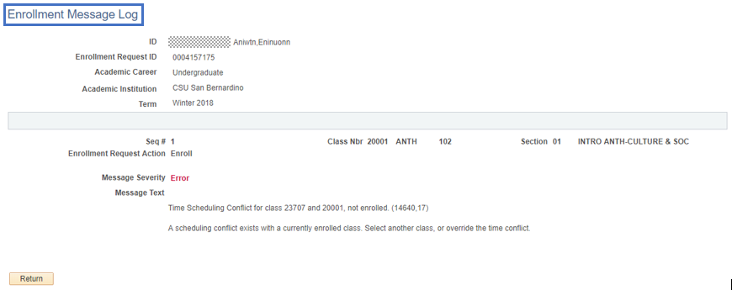

1. If you have the access to fix the error, you can then click the submit buttonbutton to see if it is now a “**Success**”.

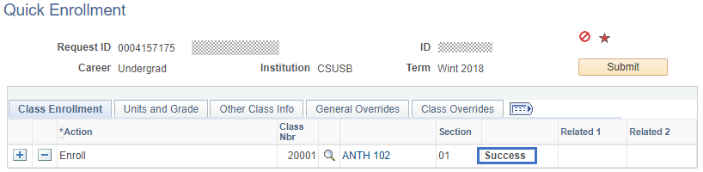

**j0290516[1] Note:** The ‘Quick Enroll’ page contains many other advanced features in addition to enrollment functionality described here. Notice the tabs near the middle of the screen. Each tab houses a separate page with its own flags and fields with which to enter information and set flags. These are for functions that are mainly performed in the Office of the Registrar with appropriate documentation and signatures.

## Dropping a Class

Refer to “Add a New Value tab” on page 33 to start a new enrollment action.

1. **Action** – Change the default action of Enroll to “**Drop**”.
2. **Class Number** this is the number that is associated with a particular class section. It is not the course number. If you do not know the class number, you can perform a search search icon to locate the appropriate class number.
3. When searching search icon you will only see the classes in which the student is currently enrolled. Select the class to be dropped by clicking on the appropriate check box check box to carry the class number to the request screen.

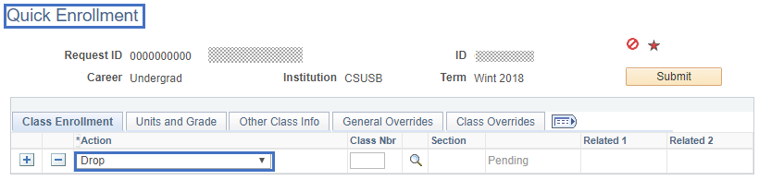

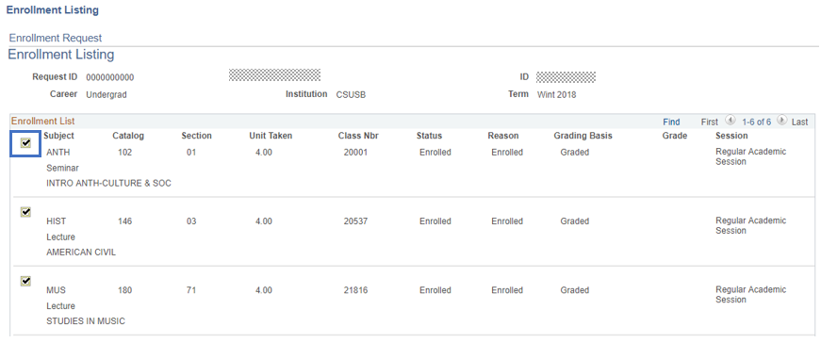

1. Click on theAdd icon symbol to drop additional courses on the same request.
2. Click submit button.

**j0290516[1]Note:** Once you have submitted a request, you should only then make necessary corrections to take care of any errors that occur on the requests. **You should never drop additional courses once a request has been successfully submitted.** To drop additional courses after submission, you need to click on the add button button at the bottom of the page to open another enrollment request.

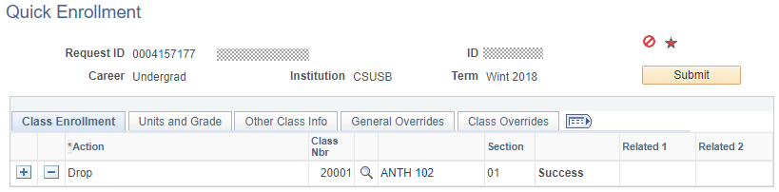

1. Review the status area for a **Success** message. If you see any other messages such as **Errors**, you will need to review the error (the actual word ‘errors’ is a hyperlink which you can click for the error message) in order to make corrections before submitting again.

Swapping a Class

Refer to “Add a New Value tab” on page 33 to start a new enrollment action.

1. **Action** – Change the default action of Enroll to “**Swap Courses**”.
2. **Class Number –** this is the number that is associated with a particular class section. It is not the course number. If you do not know the class number, you can perform a search search icon to locate the appropriate class number.
3. When searching search icon you will only see the classes in which the student is currently enrolled. Select the class to be swapped by clicking on the appropriate check box check box to carry the class number to the request screen.

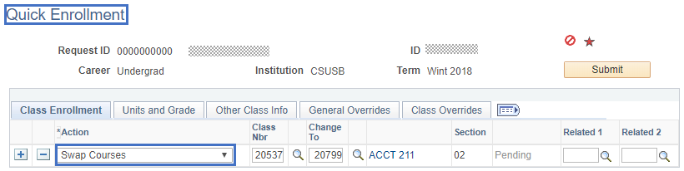

1. **Change To –** enter the class number or click search search icon for the course to which you are swapping.
2. **Click** plus iconsymbol to swap additional courses on the same request.
3. **Click** subsubmit icon.
4. **j0290516[1] Note:** Once you have submitted a request, you should only then make necessary corrections to take care of any errors that occur on the requests. **You should never swap additional courses once a request has been successfully submitted.** To swap additional courses after submission, you need to click on the add button button at the bottom of the page to open another enrollment request.

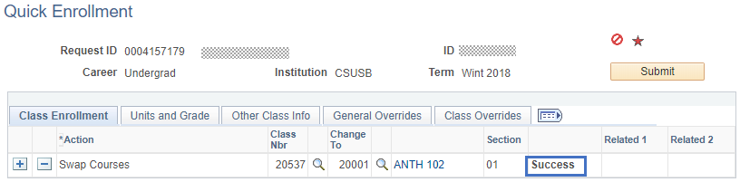

1. Review the status area for **Success** message. If you see any other messages such as **Errors**, you will need to review the error (the actual word ‘errors’ is a hyperlink which you can click on for the error message) in order to make corrections.

## Student Schedule

*Navigation – Main Menu 🡪 Records and Enrollment 🡪 Enroll Students 🡪 Quick Enroll a Student*

1. **Add a New Value (always use this tab) –** All of the four fields must have data for the search to process.
2. **Click** Add button**.**

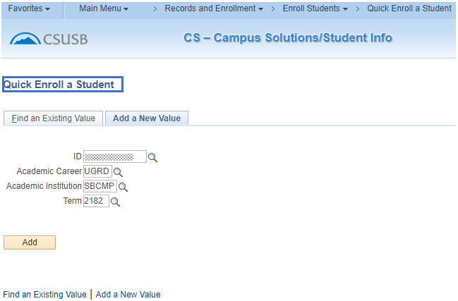

1. **Click on Study List hyperlink.**

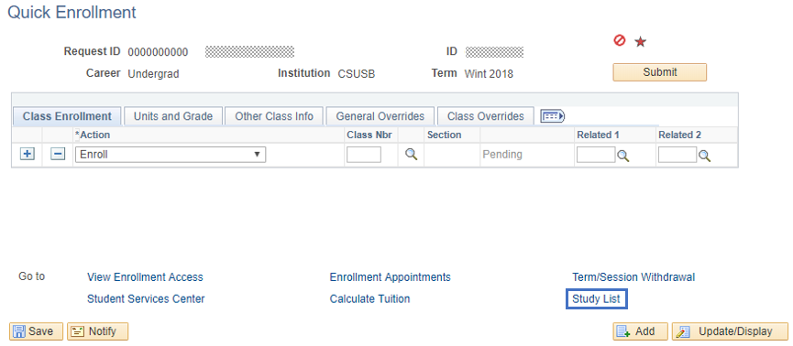

1. **Class Schedule Filter Options –** When the screen displays, the 3 fields will be checked. Uncheck the Show Dropped Classes to display Enrolled Classes only.

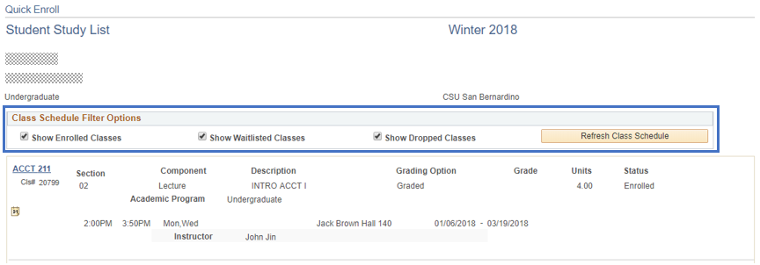

1. **Printer Friendly Page –** Select this hyperlink to see schedule in a cleaner format without the class hyperlinks and calendar link.

**Another way to view the student schedule if you don’t have access to this screen –**

*Navigation – Main Menu 🡪 Records and Enrollment 🡪 Enrollment Summaries 🡪 Enrollment Summary*

1. This version does not provide as much information – missing information includes classroom, dates, times, dropped classes and instructor as well as the links.

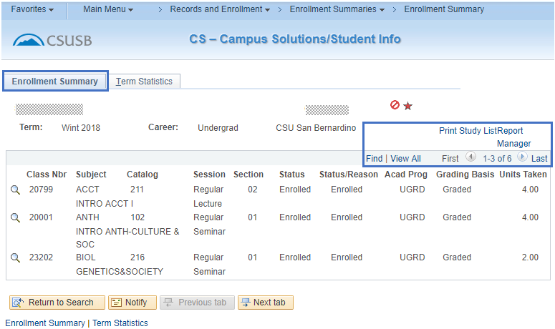

**j0290516[1] This screen will only display 3 classes. Select “View All” to see all 6 classes.**

1. For a more complete report, select Print Study List.
2. Once it shows saved in the upper right hand corner, select Report Manager.
3. Click Refresh button until you see the Details link for the SB Individual Student Study Rp row.
4. Click Details link.

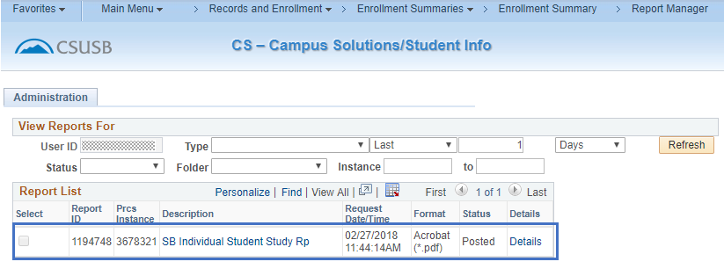

1. Select the PDF link

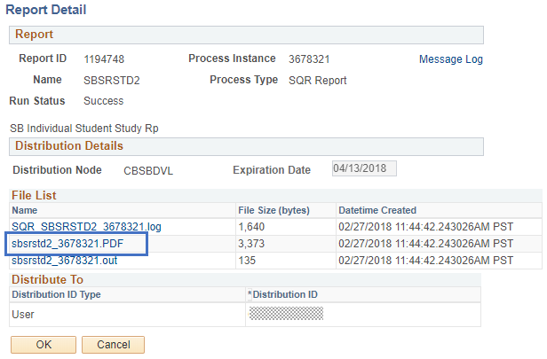

1. Results

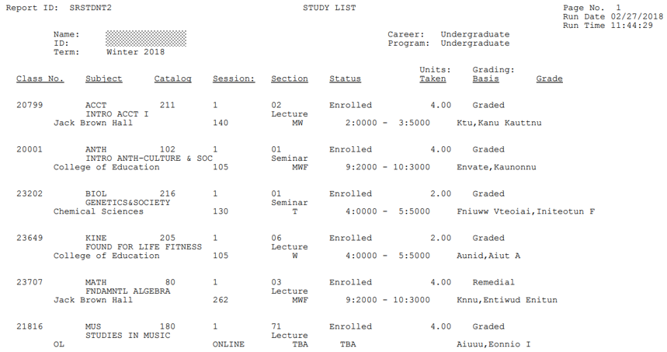

## Transcript Request

Navigation – Main Menu 🡪 Records and Enrollment 🡪 Transcripts 🡪 Request Transcript Report

**j0151699[1] This is not a batch job, but an individual transcript request can be used to process multiple students’ transcripts at one time.**

1. **Select “Add a New Value” tab.**

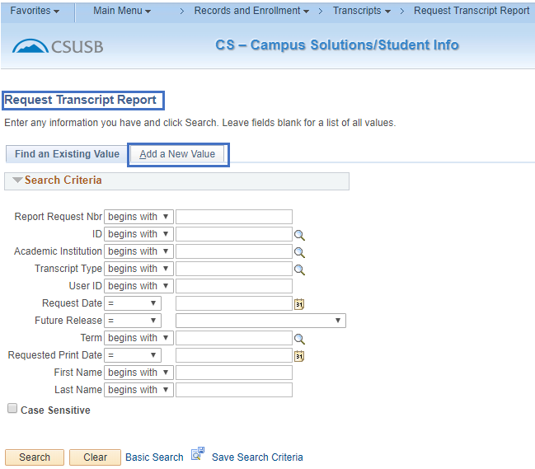

Transcript Request Header

1. **Institution\* –** SBCMP– this value will default.
2. **Transcript Type\* –** UNOFF (unofficial – for department use)

*\*These values will default into the page if you set your User Defaults as described previously in this document.*

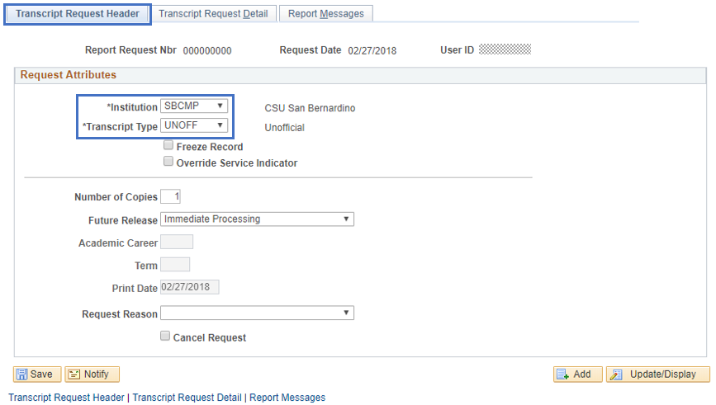

1. **Select the Transcript Request Detail tab.**

## Transcript Request Detail

* + - 1. **ID –** The ID (Coyote ID) of the student for whom the report is to be run. To include more than one student’s transcript on this request, select [Add a new row at row 1 (Alt+7)](javascript:submitAction_win0(document.win0,'$ICField20$new$0$$0');) so another line is available for entry of another ID.

page_note **When you tab out of the ID field, the student’s name defaults onto the page.**

**SINGLE REQUEST**

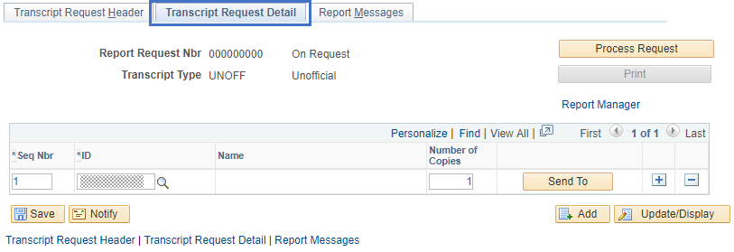

**MULTIPLE REQUESTS**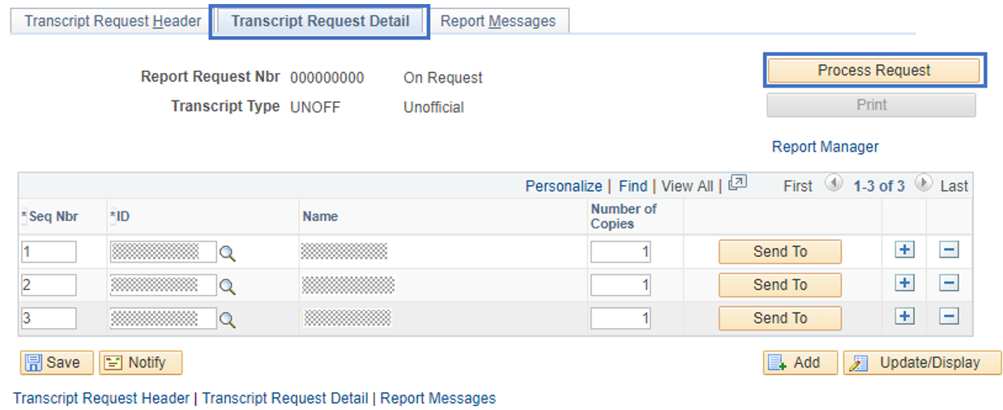 **Process Request –** Select Process Request Button  when you are ready to submit the request for processing. A process commences and, when complete, the system automatically displays the View Report hyperlink on the Transcript Request Detail tab.

## Transcript Report Results

1. **Results –** Click on the View Report hyperlink to view the unofficial transcript.

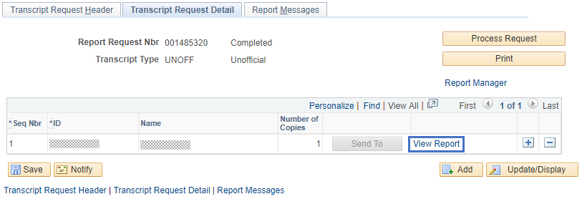

**j0290516[1] VERY IMPORTANT – If you click the View Report hyperlink and nothing seems to happen, make sure that you are allowing pop-ups. If you do not allow pop-ups, then the transcript cannot pop-up into a new tab to be viewed or printed.**

* **Note – if you placed a request for multiple students, the View Report hyperlink will show for each student.**

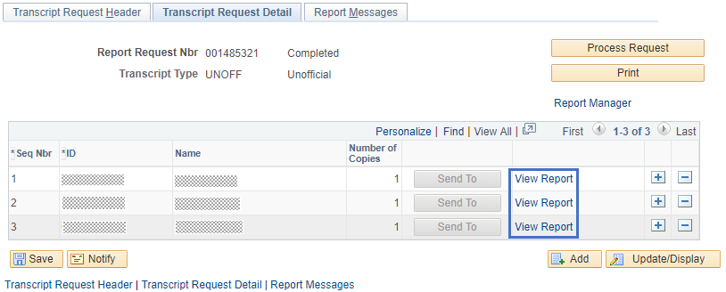

1. **Print –** You can print each transcript one at a time, or you can print all of the requested transcripts at one time. If you want to print a batch set of transcripts, click the Print buttonbutton and the status wil change from “completed” to “printed”.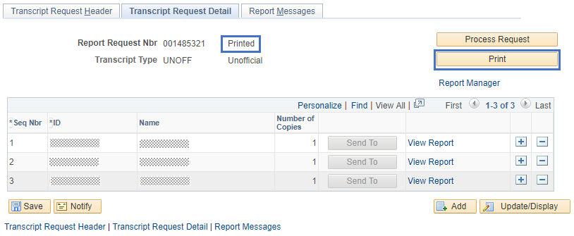
2. **Report Manager –** Click Report Manager to view the results of the reports that have been submitted.

If the report you are requesting is not in the “Posted” status, click the Refresh button button. You may have to do this more than one time, so give it a few seconds between refreshing.

* **Note – there will be two reports that show up once the report is in “Posted” status. Select the Description link on the PDF report SSR\_TSRPT-SSR\_TSRPT.**

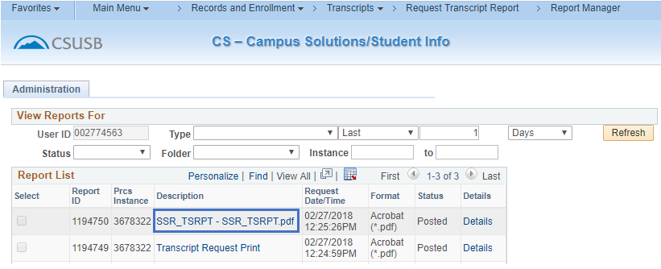

1. The transcripts will display with the unofficial watermark in the background.

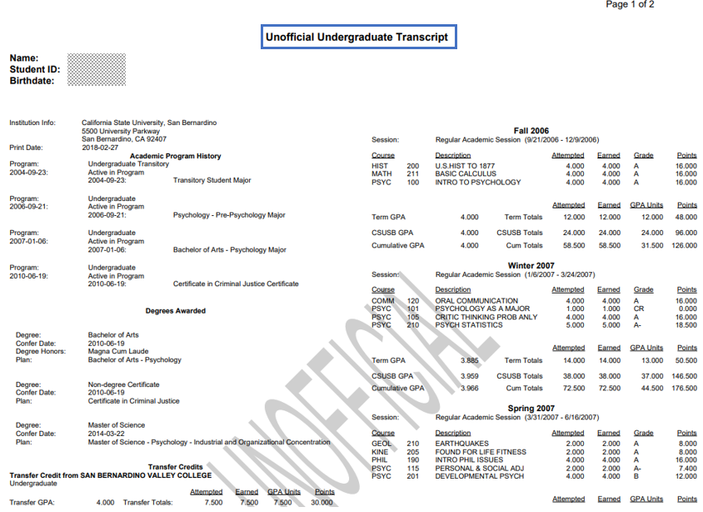

## Degree Audit – PAWS

The degree audit or PAWS (Program Advising Worksheet for Students) is an automated credit summary, for undergraduate degrees, that provides students with a listing of all coursework required for graduation from CSUSB. It allows students to map out their course selection at any point in their academic career by comparing the classes they have taken or are now taking, to those they will need to take in order to complete their undergraduate degree program.  Students will receive an email notification, sent to their **CSUSB Email**, once their PAWS is ready for review. Once notified, students can login to MyCoyote to request and print a copy of their PAWS report.

*Navigation – Main Menu 🡪 SB Custom 🡪 SB SA Custom Menu 🡪 Process 🡪 SB Academic Advisement 🡪 SB DARS Audit Request*

1. Click on the Students icon.



1. Search by either Student ID or Student Name.

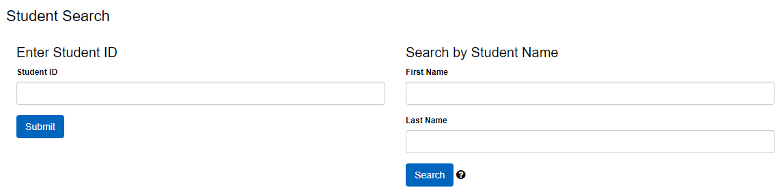

1. Click either submit button or search button.

* If the student is an active undergraduate, a degree program, title, and catalog year will display.
* **Note – if the student is an inactive undergraduate or a graduate student, the student will not have a PAWS report available.**

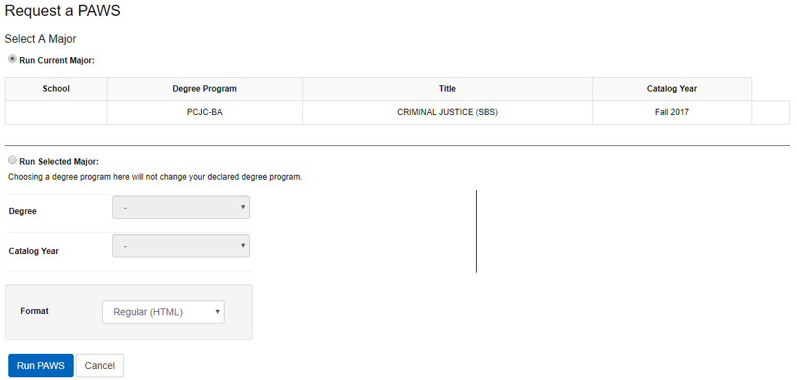

1. Click Run paws button to run an audit (PAWS) for the student’s current major(s). Once the audit has been processed, the audit will show under the Completed PAWS Requests.
2. Click View Audit.

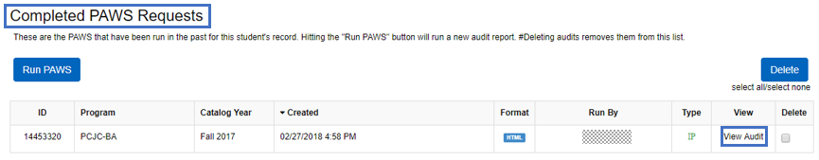

1. Click Open All Sections to view all requirements.

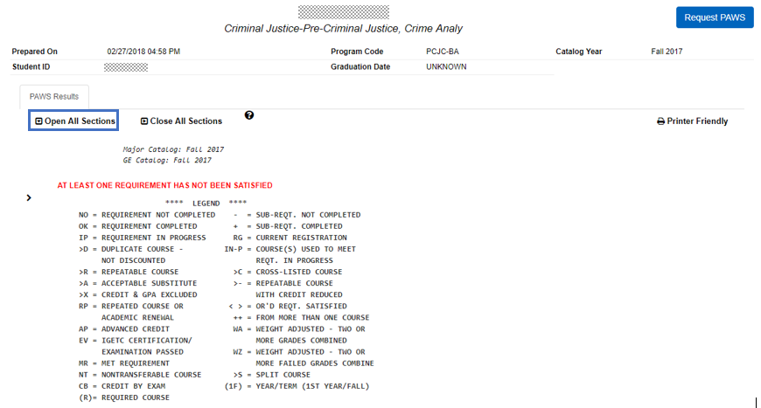

1. Scroll up and down to navigate through the audit.

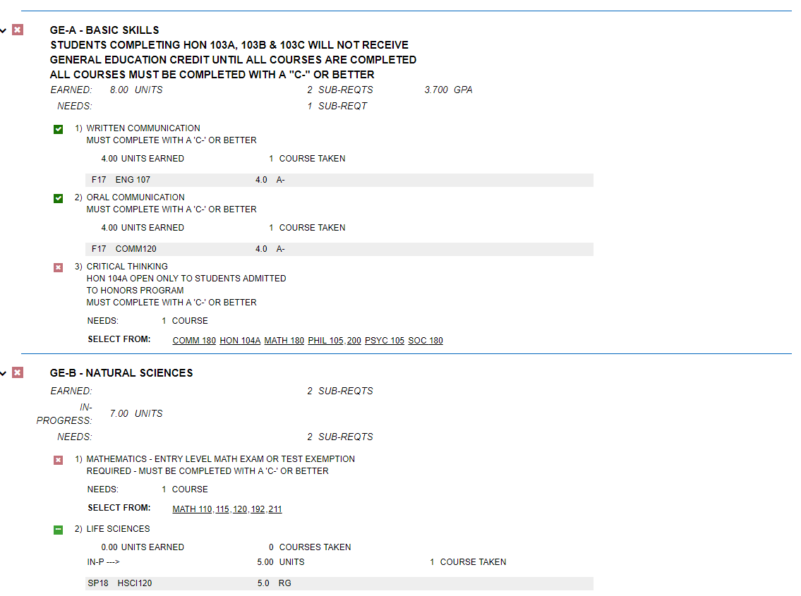

## What If Audit Request

*Navigation – Main Menu 🡪 SB Custom 🡪 SB SA Custom Menu 🡪 Process 🡪 SB Academic Advisement 🡪 SB DARS Audit Request*

1. Click on the Students icon.



1. Search by either Student ID or Student Name.



1. Click either Submit button or Search button.

* If the student is an active undergraduate, a degree program, title, and catalog year will display.
* **Note – if the student is an inactive undergraduate or a graduate student, the student will not have a PAWS report available.**

1. Select Run selected major radio button to run a what-if audit (PAWS). Select the Degree and Catalog Year.

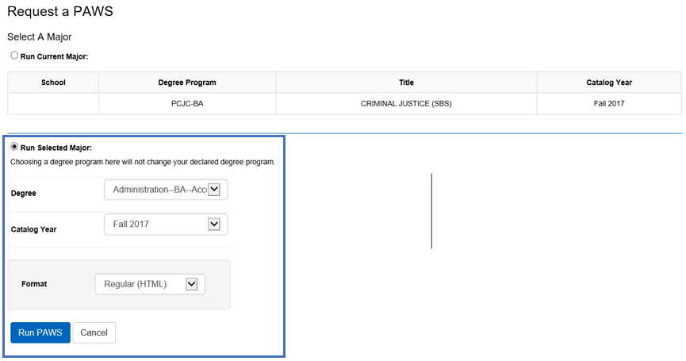

1. Click Run Paws button to run an audit (PAWS) for the student’s selected major. Once the audit has been processed, the what-if audit will automatically load.
2. Click Open All Sections to view all requirements in the what-if audit.

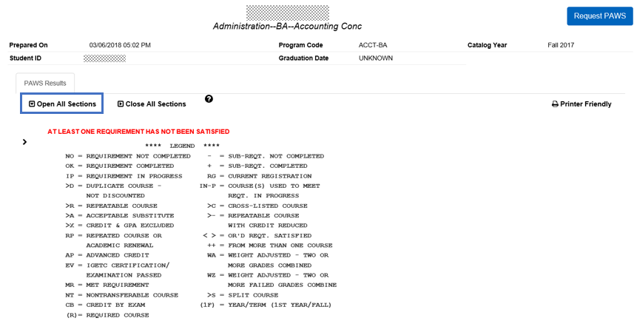

1. Scroll up and down to navigate through the what-if audit.   
   

## Reference Materials

**Term Translation**

**The first number is the millennium.**

**1900 = 1; 2000 = 2**

**The second and third numbers are the years within the century.**

**1999 = 99 2005 = 05 2015 = 15**

**The fourth number is the term.**

**Winter = 2 Spring = 4 Summer = 6 Fall = 8**

**Fall 1999 = 1998 Winter 2006 = 2062**

**College Codes (Academic Groups)**

**CAL – College of Arts and Letters**

**CBP – College of Business and Public Administration**

**CED – College of Education**

**CNS – College of Natural Sciences**

**CSB – College of Social and Behavioral Sciences**

**CUV – College of University Studies**

**CEL – College of Extended Learning**

**FERPA ICON**

[FERPA](javascript:submitAction_win0(document.win0,'DERIVED_CS_FERPA_FLAG');)

**When you see this icon on a page, the student has requested that certain information in their student records be further restricted. The students can update this through My Coyote Student Center. By clicking on this icon, you will see the information the student is allowing as releasable through the Records Office only. This information is seldom released.**

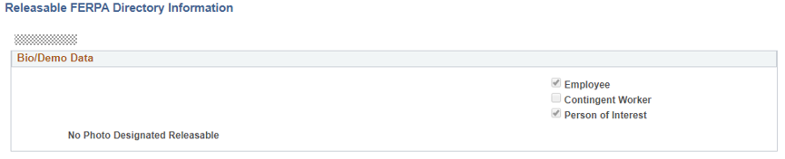

## PeopleSoft 9.2 Quick Navigation

**Academic Standing**

*Main Menu 🡪 Records and Enrollment 🡪 Student Term Information 🡪 Term History*

**Audit Service Indicators**

*Main Menu 🡪 Campus Community 🡪 Service Indicators (Student) 🡪 Audit Service Indicators*

**Campus Community**

*Main Menu 🡪 Campus Community 🡪 Personal Information (Student) 🡪 Add/Update a Person*

**Class Permissions**

*Main Menu 🡪 Records and Enrollment 🡪 Term Processing🡪 Class Permissions 🡪 Class Permissions*

**Course Credits- Manual**

*Main Menu 🡪 Records and Enrollment 🡪 Transfer Credit Evaluation 🡪 Course Credits - Manual*

**CSU ID Search**

*Main Menu 🡪 CSU ID Search*

**Enrollment Page**

*Main Menu 🡪 Records and Enrollment 🡪 Enroll Students 🡪 Enrollment*

**Enrollment Request Search**

*Main Menu 🡪 Records and Enrollment 🡪 Enroll Students 🡪 Enrollment Request Search*

**Enrollment Summary**

*Main Menu 🡪 Records and Enrollment 🡪 Enrollment Summaries 🡪 Enrollment Summary*

**Milestones**

*Main Menu 🡪 Records and Enrollment 🡪 Enroll Students 🡪 Student Milestones*

**PAWS Request**

*Main Menu 🡪 SB Custom 🡪 SB SA Custom Menu 🡪 Process 🡪 SB Academic Advisement 🡪 SB DARS Audit Request*

**Query Viewer**

*Main Menu 🡪 Reporting Tools 🡪 Query 🡪 Query Viewer*

**Quick Enroll a Student**

*Main Menu 🡪 Records and Enrollment 🡪 Enroll Students 🡪 Quick Enroll a Student*

**Service Indicators**

*Main Menu 🡪 Campus Community 🡪 Service Indicators (Student) 🡪 Manage Service Indicators*

**Student Enrollment Appointment**

*Main Menu 🡪 Records and Enrollment 🡪 Term Processing 🡪 Appointments 🡪 Student Enrollment Appointment*

**Student Grades**

*Main Menu 🡪 Records and Enrollment 🡪 Student Term Information 🡪 Student Grades*

**Student Groups**

*Main Menu 🡪 Records and Enrollment 🡪 Career and Program Information 🡪 Student Groups*

**Student Program Plans**

*Main Menu 🡪 Records and Enrolment 🡪 Career and Program Information 🡪 Student Program/Plan*

**Student Repeat/ Withdrawal Inquiry**

*Main Menu 🡪 CSU SA Baseline 🡪 CSU Student Records 🡪 EO1037 🡪 Use 🡪 Student Inquiry*

**Student Services Center**

*Main Menu 🡪 Campus Community 🡪 Student Services Center*

**Student Standing Code**

*Main Menu 🡪 CSU SA Baseline 🡪 CSU Systemwide Reporting 🡪 Enrollment Reporting System 🡪 ERS Student 🡪 Student Reporting Data*

**Term History**

*Main Menu 🡪 Records ad Enrollment 🡪 Student Term Information 🡪 Term History*

**Test Credit- Automated**

*Main Menu 🡪 Records and Enrollment 🡪 Transfer Credit Evaluation 🡪 Test Credits - Automated*

**Transcript Request**

*Main Menu 🡪 Records and Enrollment 🡪 Transcripts 🡪 Request Transcript Report*

**User Defaults**

*Main Menu 🡪 Set Up SACR 🡪 User Defaults*