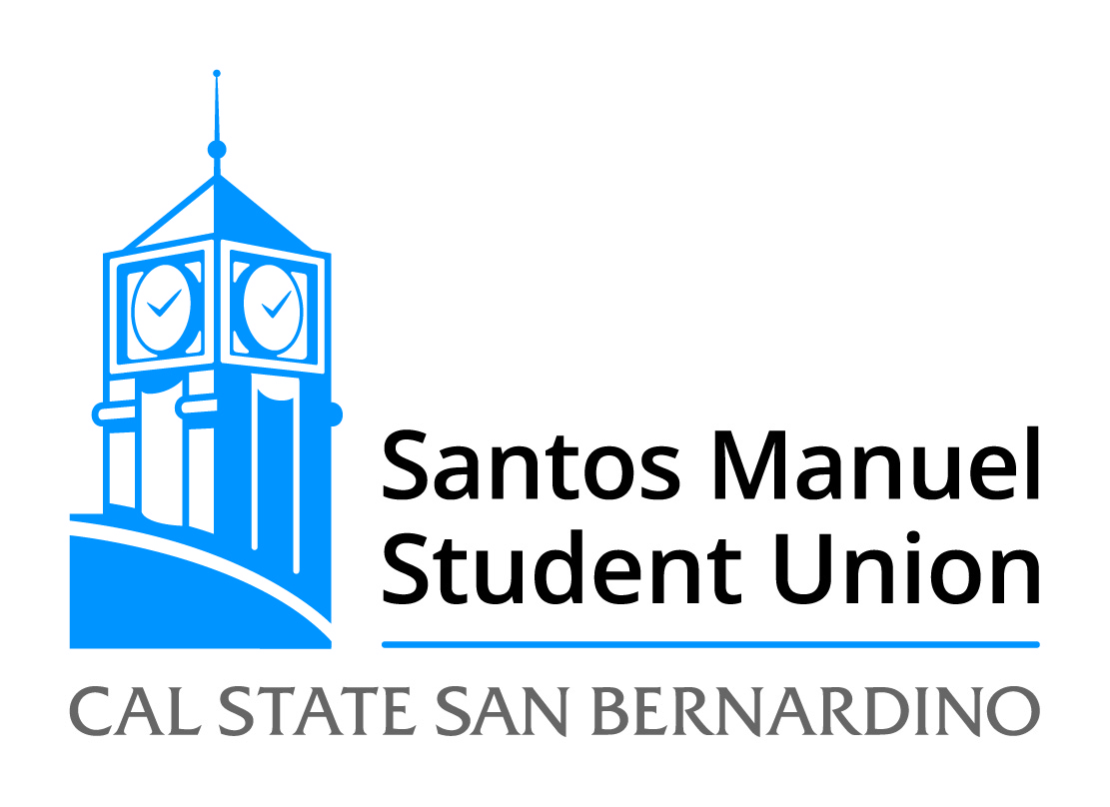
California State University, San Bernardino
Santos Manuel Student Union Board of Directors
Thursday, April 11, 2019
Minutes

Members Present: Bilal Azhand, Tejwant Brar, Aaron Burgess, Ruihan He, Davina Lindsey, Yera Nanan, Prince Ogidikpe, Mellissa Patton, Derick Prince, Yusra Serhan

Members Absent: Dr. Mary Fong, Alejandro Gamboa Montes, Harry Le Grande, Dr. John Reitzel

Staff Present: Francisco Alfaro, Kimberly-Ann Anacleto, Jasmine Bustillos, Elizabeth Corella, Vilayat Del Rossi, Tamara Holder, Jessica Madrigal, Monica McMahon, Raul Maldonado, Maria Najera-Neri, Mario Orellano, Mark Oswood, Michael Palacios, Jennifer Puccinelli, Anthony Roberson, Richard Strawter, Michael Wong, Alicia Ureste

Guests Present: None

Call to Order: The meeting was called to order at 10:15 a.m.

Roll Call: A verbal roll call of attendees was conducted.

Approval of SMSU Board of Directors Minutes from March 14, 2019:

M/S Patton/Azhand to approve the SMSU Board of Directors Minutes from March 14, 2019. The minutes were approved by unanimous consent.

Reports:

Chair: Mr. Prince reported that Committees will meet and report at the May Board meeting.

Executive Director: Mr. Burgess thanked Ms. Lindsey for her service to the Board, replacing Matias Farré as the President’s Designee. Mr. Burgess discussed that he is working with Alumni Affairs to recommend an alumni representative to serve on the Board for the 2019-2020 academic year. Mr. Burgess commended Jenny for her commitment to the organization and agreement to work as the Executive Assistant to the Executive Director. Mr. Burgess reported that the Recreation and Wellness Director search is progressing and will share updates at future meetings.

Marketing and Programs: Ms. Anacleto highlighted the Cross Cultural Center and Latin X event, “Know your Right,” focusing on immigration procedures and referring those with specific questions to the ASI legal clinic. The Marketing Department reviewed 20 applications for spring internships, interviewed eight, and hired four students who will be earning class credit. Ms. Anacleto highlighted the Osher Adult Re-Entry Student Success Center’s collaboration with Recreation and Wellness to host a Family Picnic on April 27th. Program Board hosted a Murder Mystery event and assisted with the LEAD Summit. The Queer and Transgender Resource Center hosted “Living Outside the Binary” which focused on what it means to live beyond the labels of traditional gender norms. The Rancho Mirage Student Center collaborated with the Health Center to lead a discussion on emotional wellbeing following a movie screening of “Inside Out”. Lastly, the Women’s Resource Center hosted Feminist Comedy Night, Vagina Monologues, and will host “Take Back the Night”.
Ms. Anacleto noted the upcoming events outlined in the monthly Marketing and Programs Board Report.

Operations: Ms. Madrigal introduced Mario Orellana, the new Audio Visual Specialist in the Operations Department. Ms. Madrigal noted that the Smart System in the Fourplex was installed and will be previewed by professional staff on April 25th and noted that the Audio Visual team will be provide support for Coyote Cares Day. Ms. Madrigal announced the Yotie Drinkz ribbon cutting ceremony taking place on April 26th. Ms. Madrigal noted that the Information Desk introduced Wayfinding signage and that the IT Department worked on migrating networks to meet campus best practice standards. Ms. Madrigal commended Ms. Puccinelli and Mr. Roberson for completing their CERT training certification program.

Recreation and Wellness: Mr. Del Rossi highlighted the Health HOWL taking place on the library lawn. Mr. Del Rossi noted the conversations surrounding creating a culture of leadership within the department and their representation at NIRSA national and regional conferences. Mr. Del Rossi reported that Adventures has 10 new student leaders in their program and that the Ensenada Trip brought together OSE, Adventures Coordinators, and the Health Center. Mr. Del Rossi reported the highlights taking place in each of the Recreation and Wellness departments including Cosmic Climb, Rockbot music selection, intramural sports’ spring leagues, repairs within the building, intramural championship banners, new equipment at the Palm Desert Campus, and Be Well Yoties marketing.

Open Forum: None

Adoption of Agenda: M/S Serhan/Ogidikpe to adopt the agenda. The agenda was approved by unanimous consent.

NEW BUSINESS:

SMSU 32/19 Student Union Expansion Funding Increase (Action, Patton)

M/S Brar/Azhand to approve Student Union Expansion Funding Increase in the amount of $310,000.

Mr. Burgess explained that the Corporation is intentional about bringing any changes to the expansion project and the scope of work to the attention of the Board. Mr. Burgess noted that the project is $2.2 million over budget and that the costs outlined in the attachment reflect construction costs, but that in addition to those costs there are design costs associated with the expansion. Mr. Burgess highlighted the importance of considering the Pub design component alongside the construction costs. Mr. Burgess recommended approving $310,000 from reserves to contribute to the expansion project. Ms. Najera-Neri confirmed that the corporation is in a financial position to support the funding increase.

Rising Count: 11 – 0 – 0. Motion Passes.

Announcements: Mr. Del Rossi announced that the ACSM recognized CSUSB as a gold level campus and will use CSUSB and CSULB as models throughout the state for implementation across the CSU System. Ms. Patton encouraged those present to attend the VPSA Candidate Open Forums. Mr. Maldonado asked that those present promote Drag Show marketing on social media and Ms. McMahon announced Program Board’s Trivia Night.

Adjournment: The meeting was adjourned at 10:44 AM.

Minutes reviewed and approved by:

____________________________________________________ _____________________
Tejwant Brar, Secretary, SMSU Board of Directors Date

