Compliance Sheriff User Guide
Contents
Compliance Sheriff User Guide 1
The Accessible Technology Initiative at CSUSB 3
Compliance Sheriff 3
Logging into Compliance Sheriff 3
Quick View of Scans 4
Running a New Automated Scan 7
Document Properties 8
Revision Log 8
Approval Control 8

The Accessible Technology Initiative at CSUSB
The Accessible Technology Initiative reflects the California State University’s commitment to provide access to information resources and technologies to individuals with disabilities. This commitment is articulated in Executive Order 1111 (EO 1111), the CSU Board of Trustees Policy on Disability Support and Accommodations. The initiative will facilitate improvements in the following three priorities:
- Web Accessibility
- Instructional Materials
- Procurement of Information & Communication Technologies (ICT)

For more information on the Accessible Technology Initiative at CSUSB email accessibility@csusb.edu or call 909.537.5079. Visit the CSUSB Accessible Technology website for updated information.

Compliance Sheriff
Compliance Sheriff is an automated scanning tool and does not include all of a website’s potential accessibility and usability concerns. However, monthly automated scans are useful to gauge overall trends in you website’s accessibility.

Logging into Compliance Sheriff
Web Developers and Content Editors should regularly log into Compliance Sheriff to check accessibility results.

NOTE: If you are having difficulty accessing Compliance Sheriff, or to reset your password, please contact Rosa.Padilla@csusb.edu .

Access Compliance Sheriff via this URL: [https://hosted11.compliancesheriff.net/CSU001h06/Login.aspx]

Screenshot of login page:

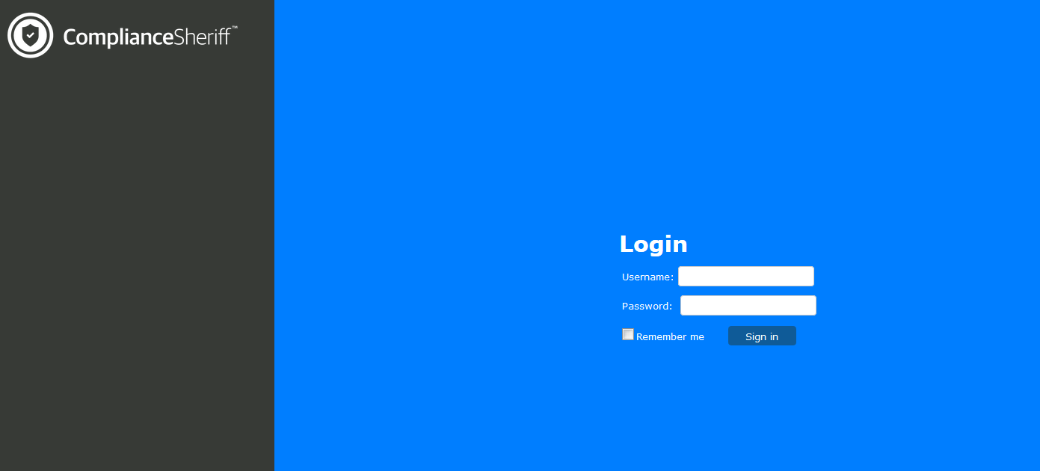

The landing page is the Dashboard that is currently not being used. You will see a message “You are not authorized to create a scan. Please see your administrator”, ignore this message.

Screenshot of landing page:
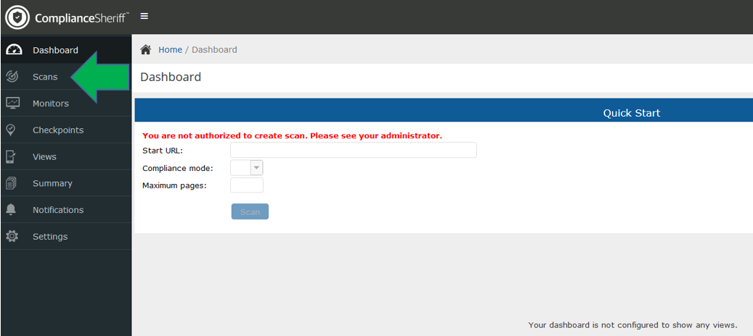

Quick View of Scans
- Navigate to the Scans tab, located on the left panel
- On the far right is a drop down menu, “Scan Group”, select your College/Division
  - AA – AA - Academic Affairs (Academic Affairs related but not within a College)
  - AA – CAL (College of Arts and Letters)
  - AA – CEL (College of Extended and Global Education)
  - AA – CNS (College of Natural Sciences)
  - AA – COE (College of Education)
  - AA – CSBS (College of Social Behavior and Sciences)
  - AA – JHBC (Jack H Brown College)
  - AA – GRAD (Graduate Studies)
  - AA – LIB (Library)
  - AA – PDC (Palm Desert Campus)
  - AA – UGS (Under Graduate Studies)
  - AF (Division of Administration and Finance)
  - ITS (Division of Information Technology Services)
  - Pres - (site MPP reports directly to the President)
  - SA (Division of Student Affairs)
  - UA (University Advancement)
  - CORE (Critical to Student Success or critical in nature)
  - Performance Reporting (Annual ATI CO Reports)
Once you select your group, a quick view of all sites in your College/Division will be listed.

Screenshot of quick view:
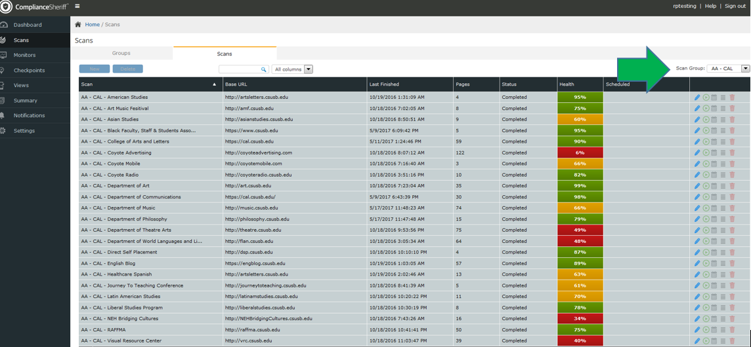

View the details of your report:
- The easiest way to find the results of your scan is to select the “Score Link” located in the “Health” column

Screenshot of Health column, click select the Score you would like to review
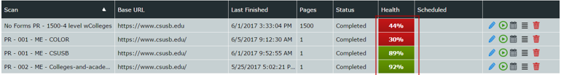

Screenshot of Scan Summary
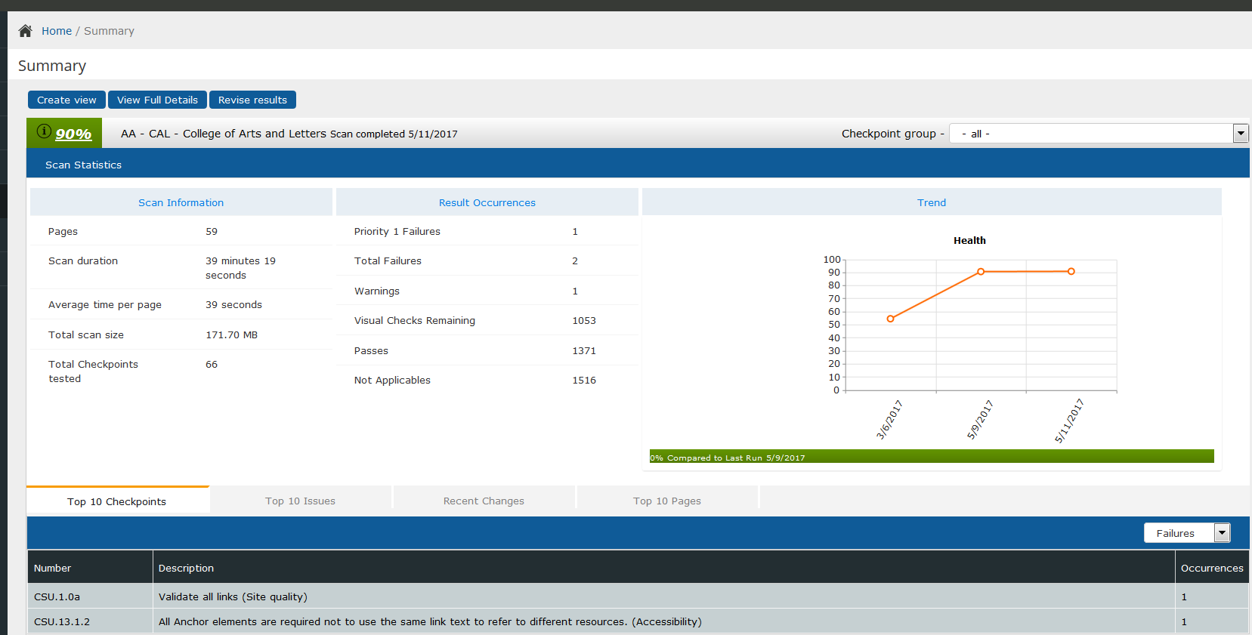

On the top left of the window you can select “View Full Details”

Screenshot of “View Full Details”
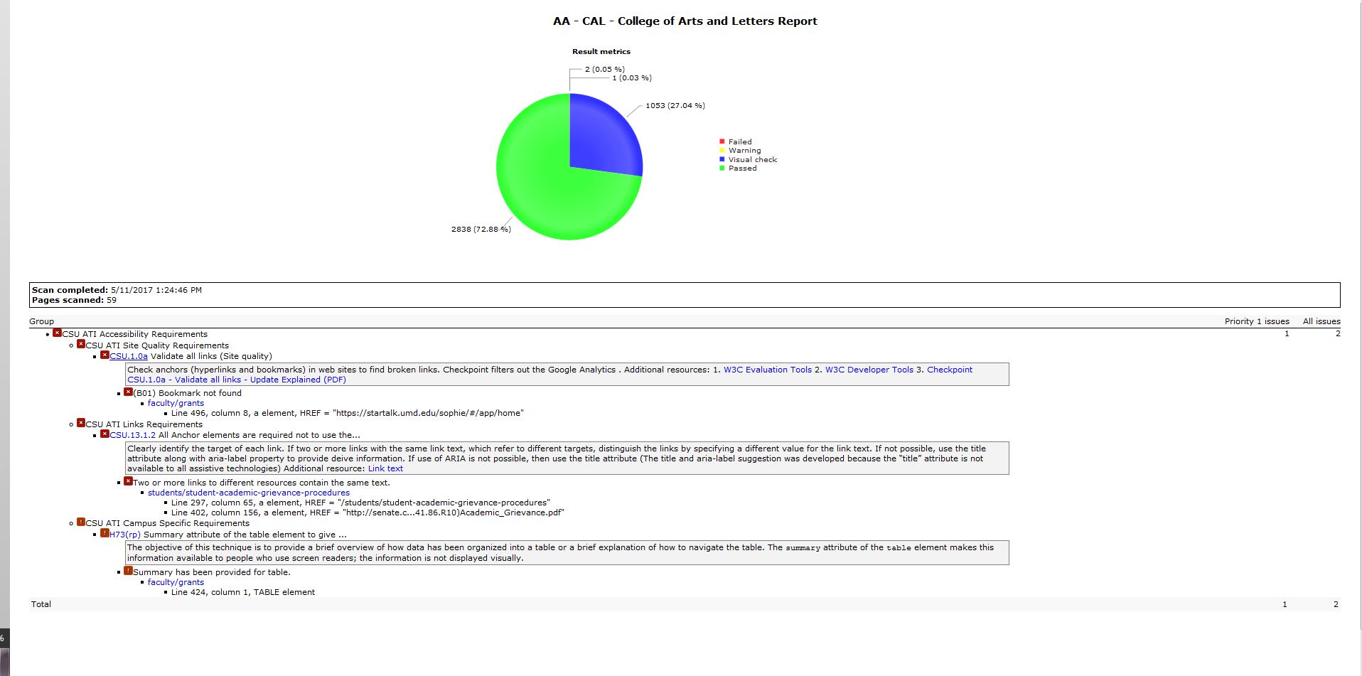

Additional views:
On the bottom left of the screen you can see the errors identified by Compliance Sheriff. The issues are “Failure and/or Warnings”

Screenshot of “Top 10 Issues”
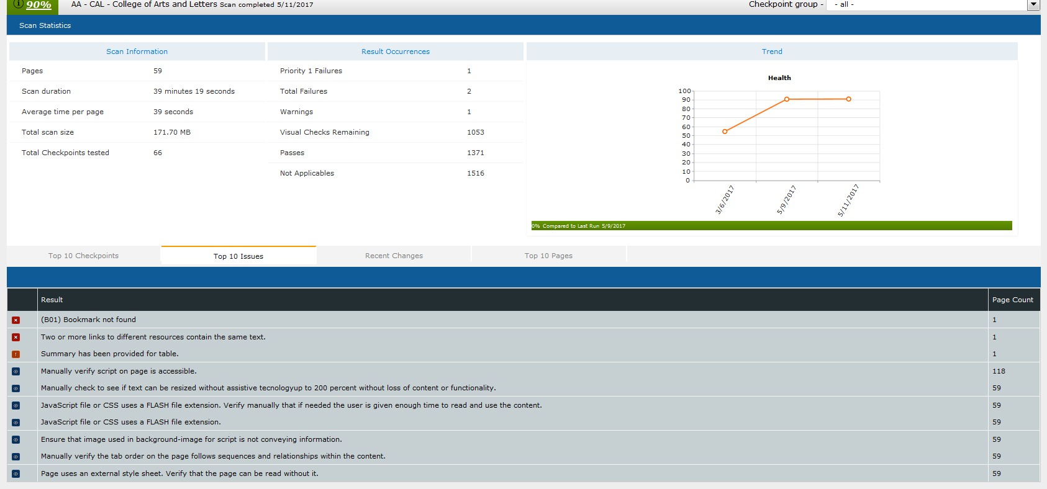

Issues that CANNOT be resolved by a content editor:
Contact webservices@csusb.edu to open a ticket to correct these issues.
- Section C Color
- Section I iFrames
- Section N form control labels
- Adjacent links
- Campus Specific – Empty Headings
- Campus Specific – Empty lists

Issues that CAN be resolved by a content editor:
- Section A Images
- Alt Quality
- Section G Tables
- Link Requirements
- Campus Specific – Headings that are not properly nested
- Site Quality
- Links with the same name different locations

Running a New Automated Scan
Scans are configured to run on a monthly basis. The preferred method to run scans is using the Scan Group Run button. This allows for Cryptzone servers to load balance and avoid performance issues. If you need one or two scans re-run, please contact Rosa.Padilla@csusb.edu .

Document Properties
Last Revision: 06/04/2019
Accessibility: “ComplianceSheriffUserGuide.docx” is fully accessible and suitable for electronic distribution
File location: Network/datastore/Dept/ISO/Web Accessibility/19.20 Documentation/19.20 Standards and Guidelines/ComplianceSheriffUserGuide.docx

Revision Log
Revision Date: 06/04/19
Author: Rosa Padilla
- All pages updated
Revision Date: 11/30/18
Author: Leon McNaught
- Updated campaign graphic
- Updated EO nomenclature
- Updated contact information
- Added Accessible Technology website URL
- Simplified some document language
- Added emphasis on some screen capture graphics
- Revised file location path
- Updated revision log
Revision Date: 07/10/18
Author: Rosa Padilla
- All pages updated
Creation Date: 06/01/2017
Author: Rosa Padilla
- Standardized and documented the Compliance Sheriff User Guide

Approval Control
Next Scheduled Review:
ATI Coordinator Approval: LJM 6/20/19

