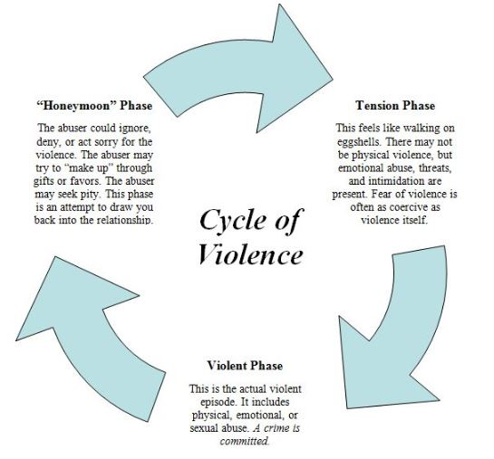
Cycle of Violence
Cycle of Violence
Domestic violence may seem unpredictable; however, it does in fact follow a typical pattern no matter when it occurs or who is involved. The pattern, or cycle, repeats and can happen many times during a relationship. Each phase may last a different length of time and over time the level of violence typically escalates. It is important to remember that not everyone’s experiences within the cycle are the same.
Eventually the honeymoon phase may vanish. This phase typically disappears because the abuser has manipulated, abused, terrified or brainwashed the victim repeatedly over time, to the point where the victim perceives that they cannot leave. Sometimes, the honeymoon phase is called the “manipulation phase” within the LGTBQ community, because the word “honeymoon” implies marriage and not all LGTBQ couples can get married.
Honeymoon Phase:
- Manipulation
- Promises & Lies
- Generosity
- “I’m sorry.”
- Bonding
Tension Building Phase:
- Walking on eggshells
- Appease abuser
- Stress and anxiety
- Unpredictability
Explosion Phase:
- Abusive incident
- Tension fades
- Escalates over time
- Types of abuse vary

