IN-PERSON | MONDAY | TUESDAY | WEDNESDAY | THURSDAY | FRIDAY
9:00 - 10:00 |  | Full Tutoring Schedule | NURSING  Jasmine Rivera |  | BIOLOGY  Diana Santillan  MATH/PHYSICS  Raul Martinez Castaneda
10:00 - 11:00   | MATH/PHYSICS  Raul Martinez Castaneda  NURSING  Lewis Yan |  | NURSING  Esai Brito  Jasmine Rivera  STUDY SKILLS  Ashley Medina (10:30s) |  | BIOLOGY  Diana Santillan  MATH/PHYSICS  Raul Martinez Castaneda  PHYSICS  Saul Ramos-Ramirez
11:00 - 12:00 | MATH/PHYSICS  Raul Martinez Castaneda  NURSING  Lewis Yan  STUDY SKILLS  Ashley Medina | NURSING  Esai Brito (11:30s)  Desmond Oriakhi  Jasmine Rivera  Lewis Yan | NURSING  Esai Brito  Jasmine Rivera  STUDY SKILLS  Ashley Medina |  | BIOLOGY  Diana Santillan  MATH/PHYSICS  Raul Martinez Castaneda  PHYSICS  Saul Ramos-Ramirez
12:00 - 1:00 | MATH/PHYSICS  Raul Martinez Castaneda  NURSING  Lewis Yan  STUDY SKILLS  Ashley Medina | NURSING  Esai Brito  Desmond Oriakhi  Lewis Yan | NURSING  Esai Brito  Desmond Oriakhi  STUDY SKILLS  Ashley Medina (12:30e) |  | BIOLOGY  Diana Santillan  CSE  Andrew Klopping (12:30s)  MATH/PHYSICS  Raul Martinez Castaneda  PHYSICS  Saul Ramos-Ramirez
1:00 - 2:00 | MATH/PHYSICS  Raul Martinez Castaneda  NURSING  Lewis Yan  STUDY SKILLS  Ashley Medina | NURSING  Esai Brito  Lewis Yan | NURSING  Esai Brito  Desmond Oriakhi |  | BIOLOGY  Diana Santillan  CSE  Andrew Klopping  GEOLOGY/CHEM  Diana Pimentel (1:30s)  MATH/PHYSICS  Raul Martinez Castaneda  PHYSICS  Saul Ramos-Ramirez (1:30e)
2:00 - 3:00  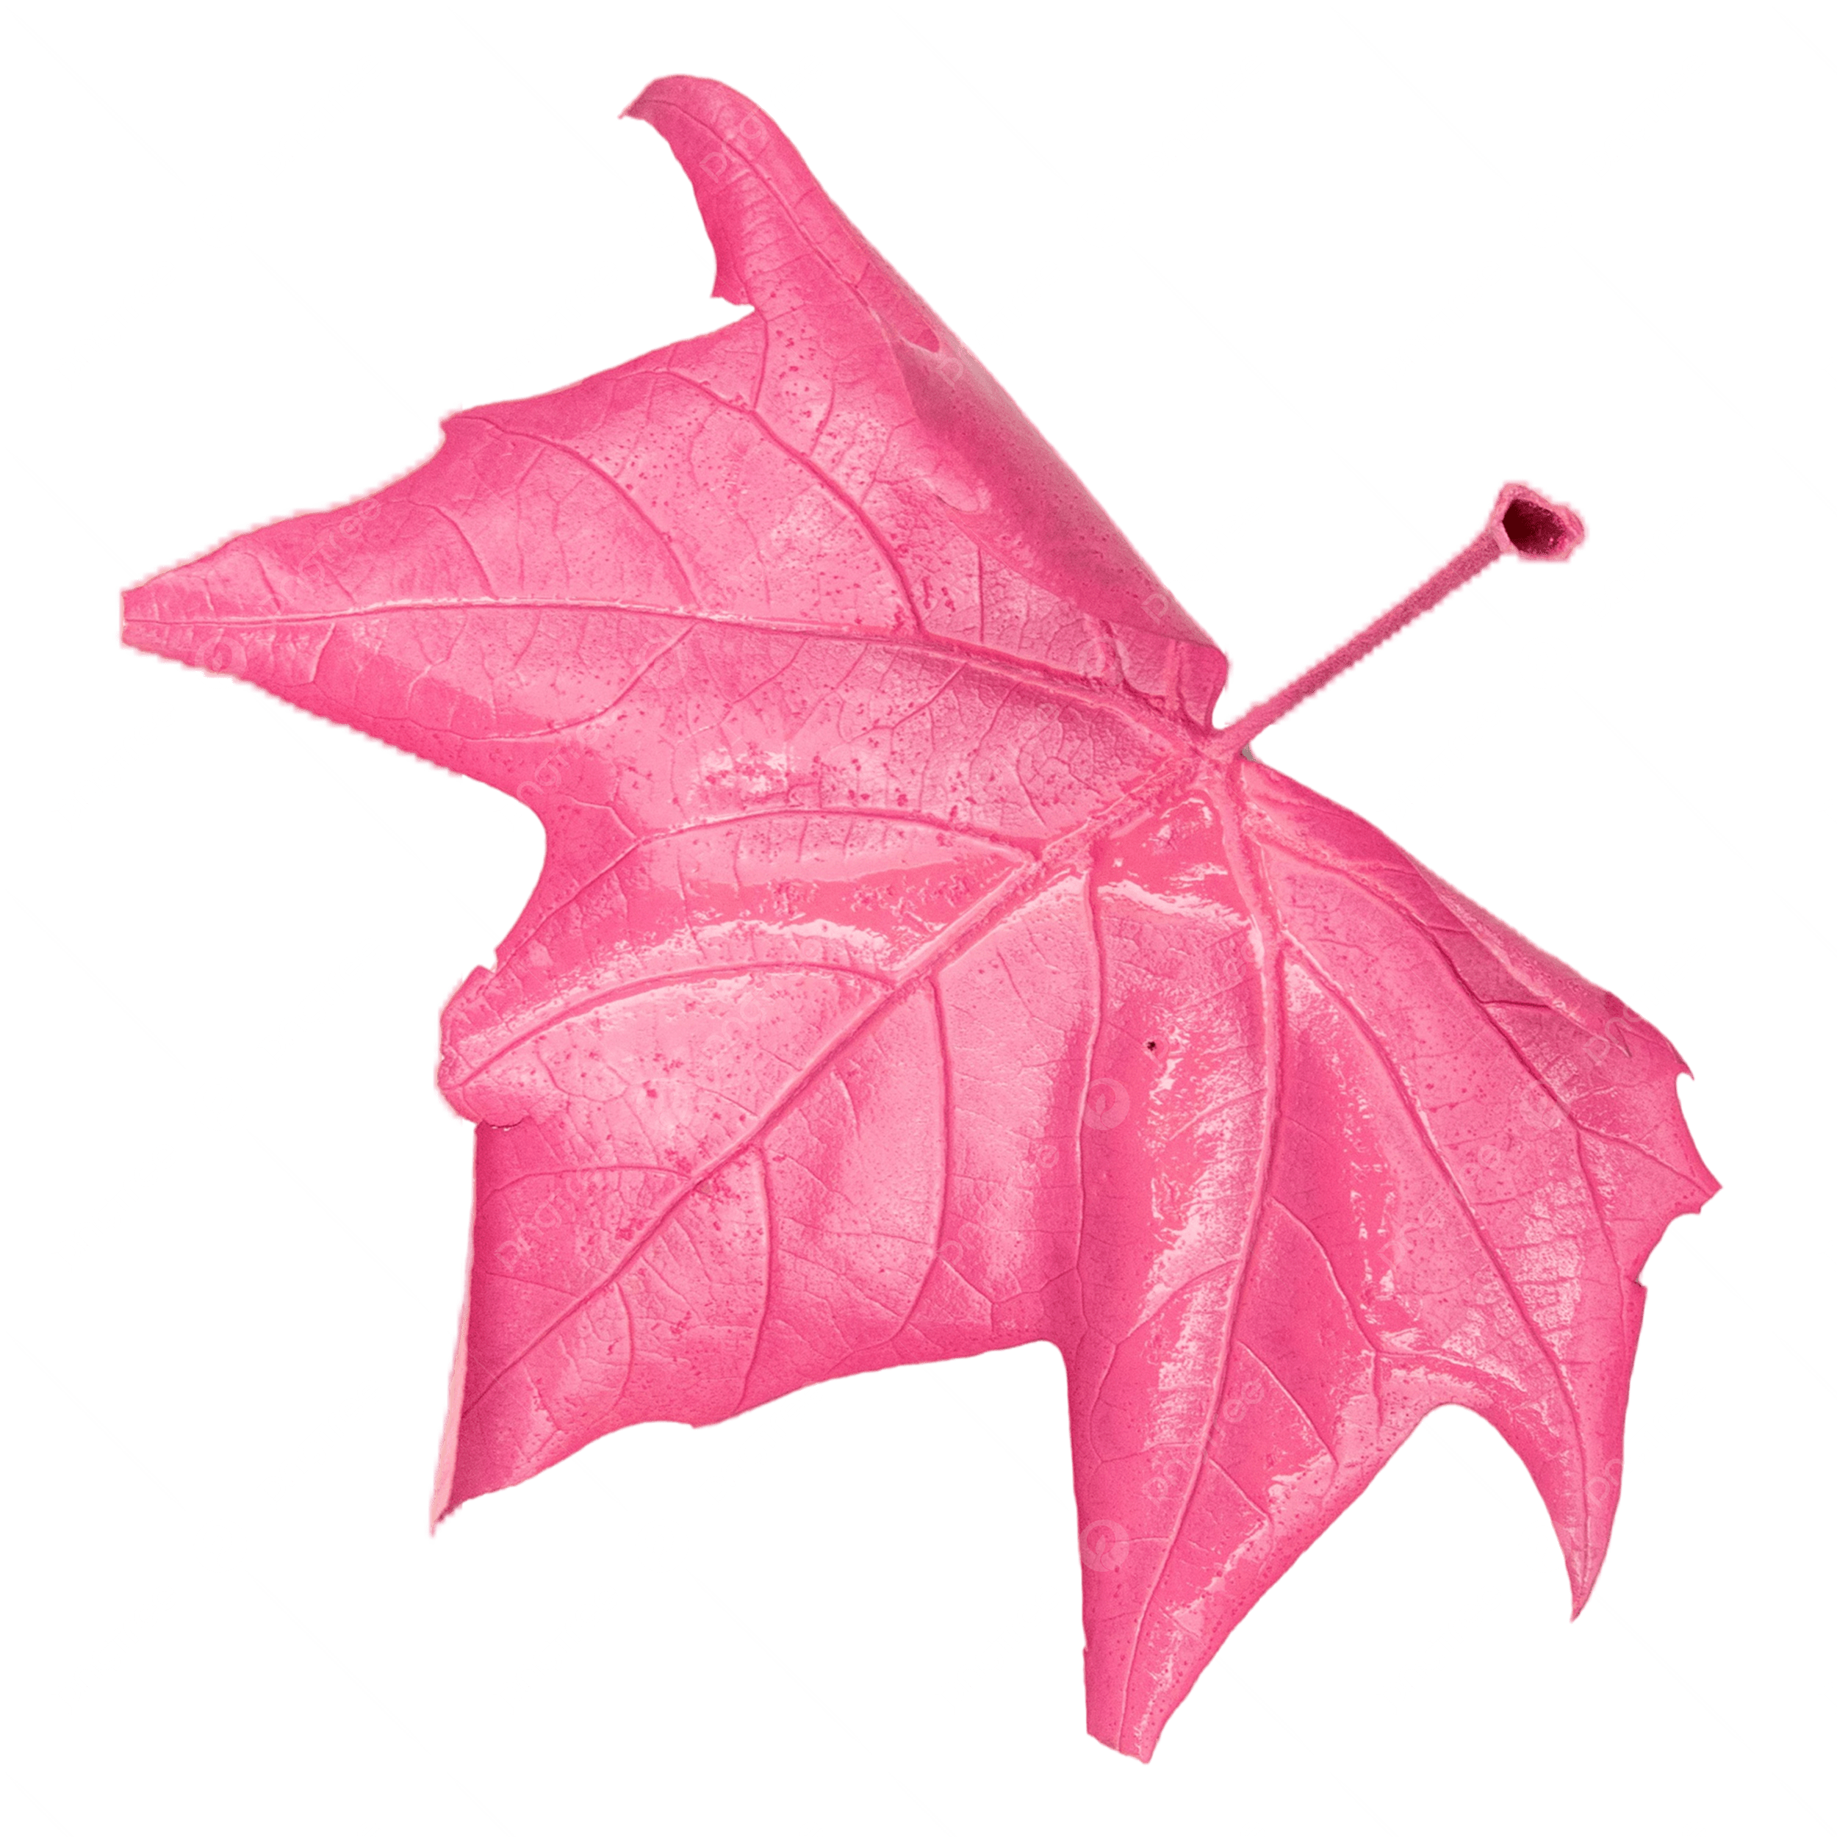 | MATH/PHYSICS  Raul Martinez Castaneda  NURSING  Lewis Yan  PHYSICS  Saul Ramos-Ramirez (2:30s)  STUDY SKILLS  Sam Aguba  Ashley Medina | PHYSICS  Saul Ramos-Ramirez (2:30s) |  |  | CSE  Andrew Klopping  GEOLOGY/CHEM  Diana Pimentel
3:00 - 4:00 | PHYSICS  Saul Ramos-Ramirez  STUDY SKILLS  Sam Aguba  Ashley Medina | PHYSICS  Saul Ramos-Ramirez |  |  | GEOLOGY/CHEM  Diana Pimentel (3:30e)
4:00 - 5:00 | PHYSICS  Saul Ramos-Ramirez  STUDY SKILLS  Sam Aguba | PHYSICS  Saul Ramos-Ramirez |  | 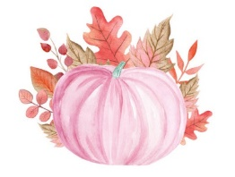
FALL 2026 TUTORING SCHEDULE (UNIVERSITY HALL, UH-350)

