Print/Share Legacy Concur Travel Request
- To login to the legacy Concur system, follow this guide: Concur Legacy Platform Access_4.docx
- From the left navigation select “Manage Requests”.
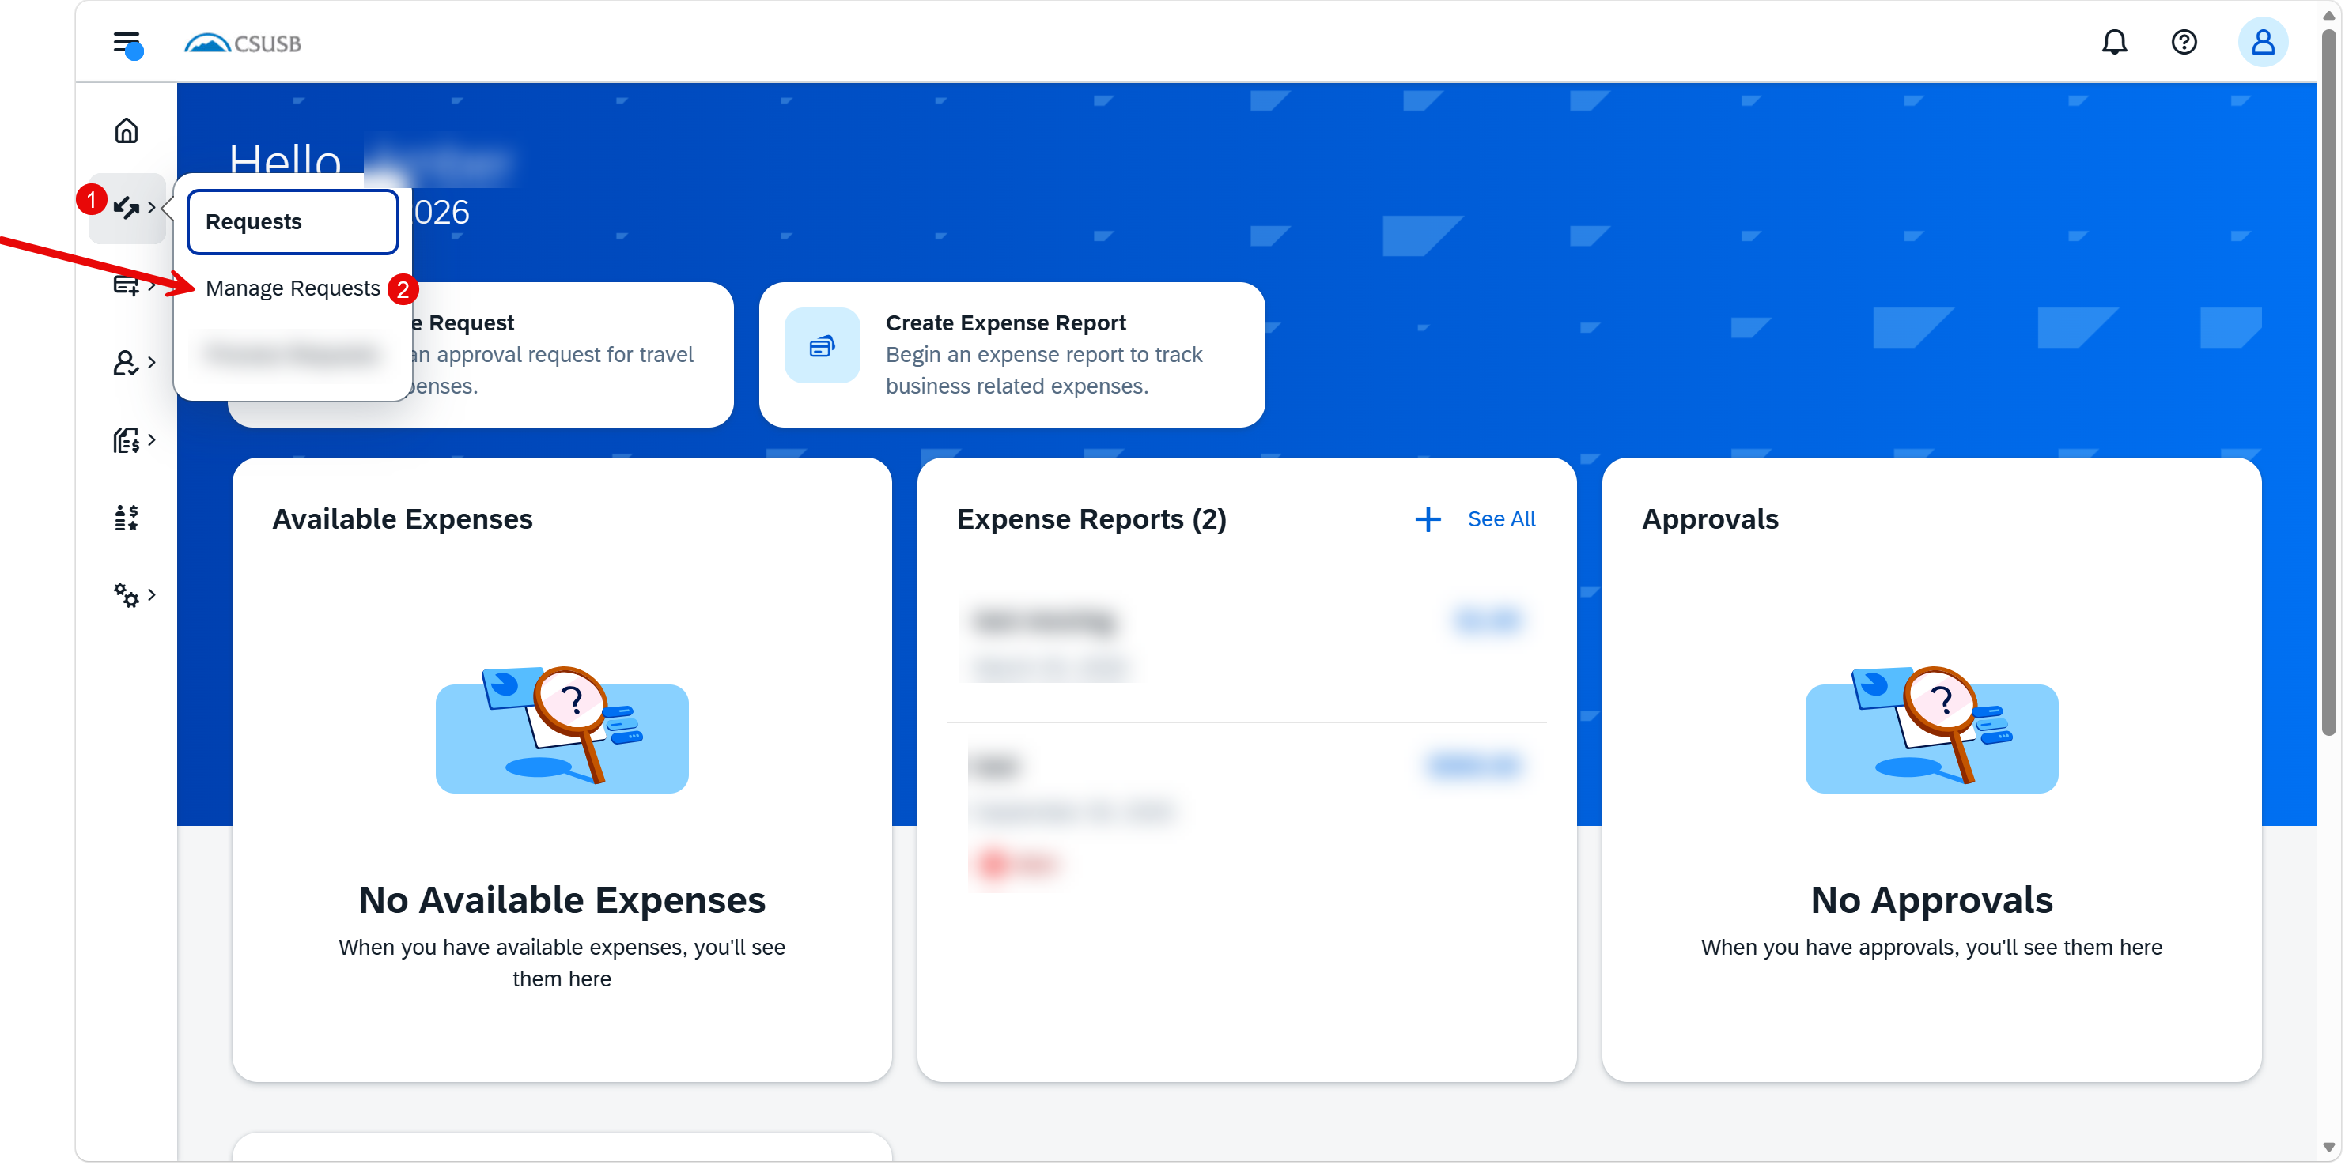
- Select the approved request for the trip to be sourced to an expense report.
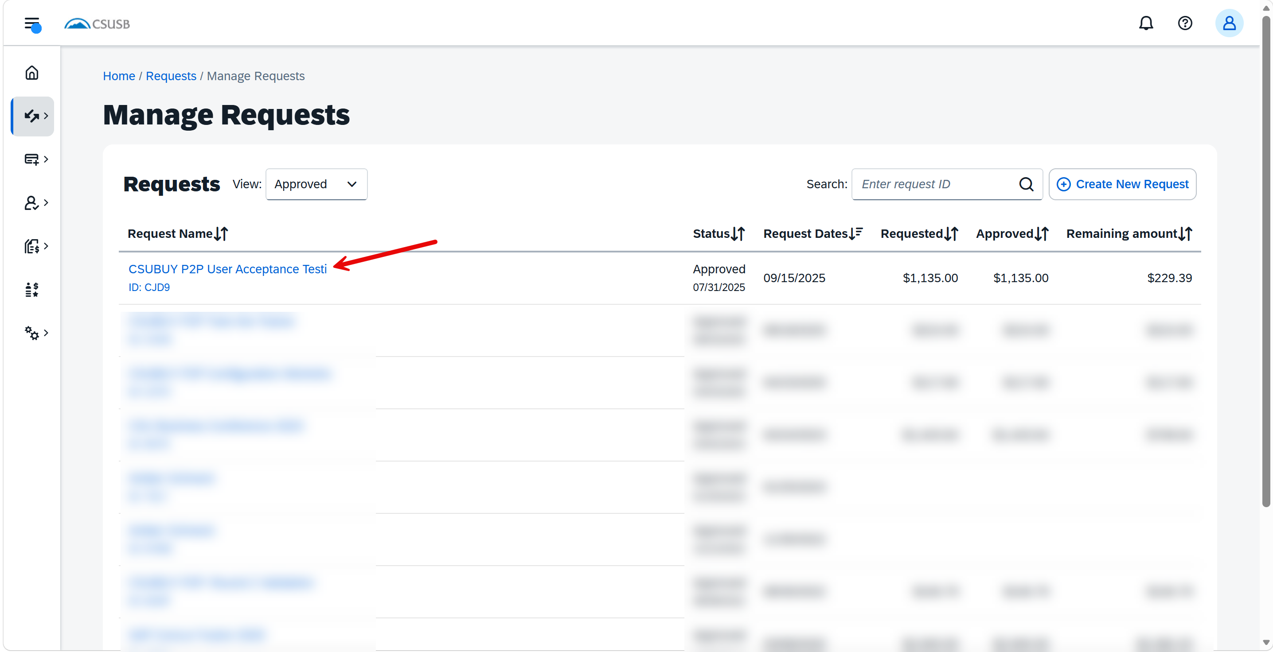
- Select Print/Share. From the Print menu, select the “CSUSB-Request Printed Report” option to save the travel request summary as a PDF or share as deemed necessary. Attachments are not included as part of this saved report. If attachments are needed, save the attachments separately. 