

California State University
San Bernardino

NEW HIRE BOOKLET

2026-2027

College of Arts & Letters

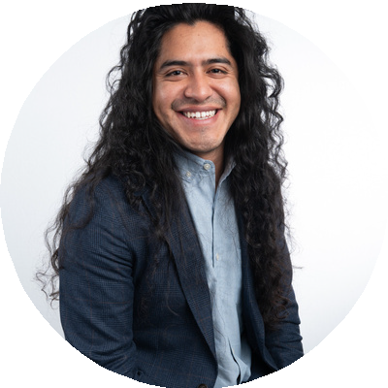
Ezequiel Bautista, MT, MA Associate Professor Department of Music

Ezequiel (he/él) is an indigenous, xicanx music therapist with experience across immigration, medical, psychiatric and community settings. His clinical work, pedagogy and publications are shaped by critical perspectives and anti-oppressive scholarship. His work is rooted in Borderlands theory applications of practice and research. Ezequiel is excited to join the CSUSB faculty to establish our new Music Therapy program and help shape a new generation music therapy professions coming from the Inland Empire!

College of Natural Sciences

Samia Amin, Ph.D.
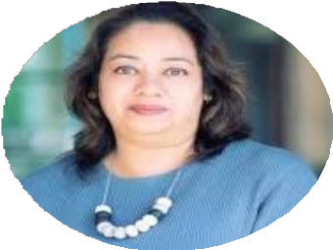
Assistant Professor
Department of Health Science & Human Ecology

Dr. Samia Amin is a physician and public health researcher with a PhD in Public Health from Universiti Putra Malaysia and a PhD in Health Informatics from Macquarie University, Australia. Her research specializes in public health informatics, digital health technologies, tobacco control, health behavior, and the influence of social media on health outcomes.
Dr Amin has held academic and research positions in Bangladesh, Malaysia, Australia, and the United States, including a Postdoctoral Research Fellowship at the University of Hawaii Cancer Center.
Prior to joining California State University San Bernardino, Dr Amin was an Assistant Professor at Southern Arkansas University, where she taught public health and health sciences courses and conducted research in public health informatics, digital health, and emerging healthcare technologies.

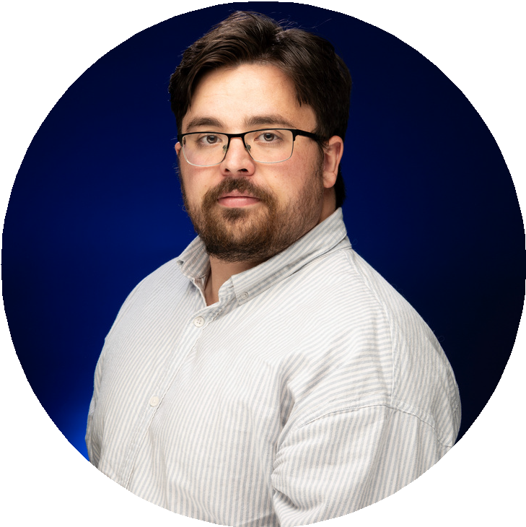
Jonathan Daniel, Ph.D. Assistant Professor Department of Physics

Dr. Jonathan Daniel received his Ph.D. from UC Merced, where he studied quantum optics witha focus on the scalar Aharonov-Bohm effect in atomic vapor. His research specializes in the application of machine learning to nonlinear optics. From 2024 to 2026, he served as a Cal-Bridge Postdoctoral Fellow at California State University, San Bernardino. He is now transitioning to a tenure-track Assistant Professor position in the Department of Physics and Astronomy at CSUSB.

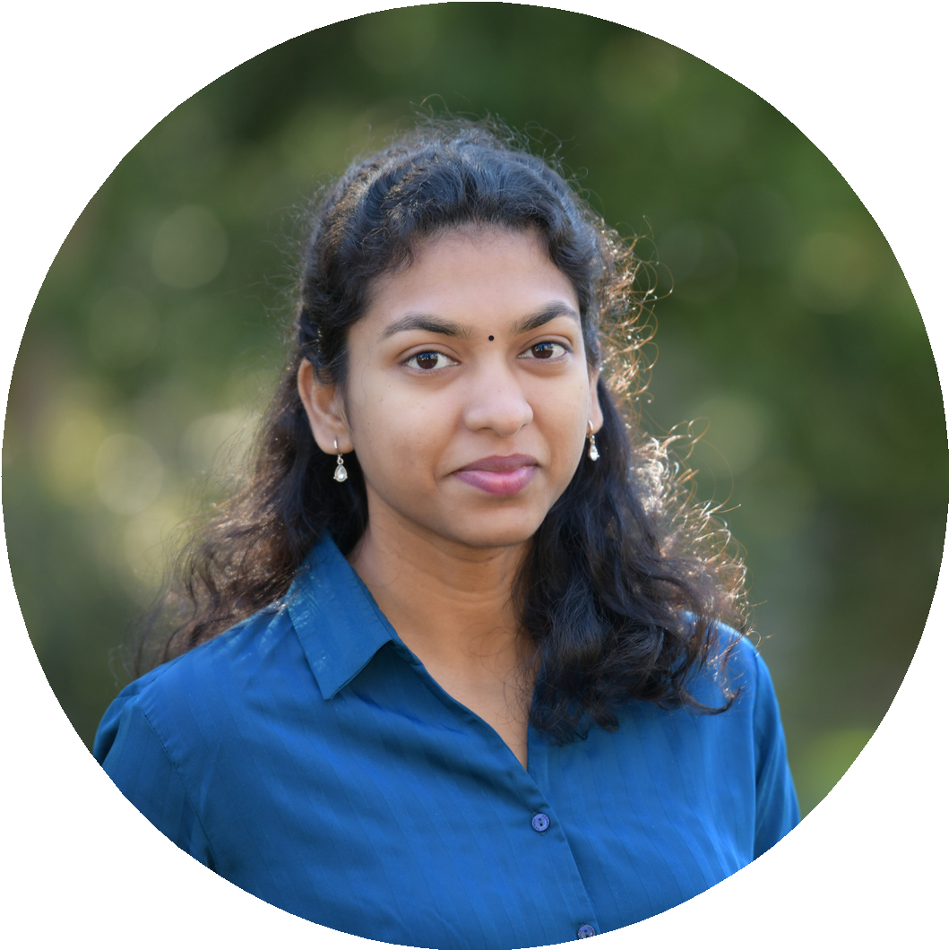
Priyanga Ganesan, Ph.D. Assistant Professor Department of Mathematics

Dr. Priyanga Ganesan is joining California State University, San Bernardino as an Assistant Professor of Mathematics after serving as an
S.E.W. Visiting Assistant Professor at the University of California, San Diego (UCSD). She received her M.Sc. in Mathematics from the National Institute of Science Education and Research (NISER), India, and her Ph.D. in Mathematics from Texas A&M University in 2022. Following her Ph.D., she was awarded the UC President's Postdoctoral Fellowship at UC San Diego and also held a Women in Research (WiRe) Fellowship at the University of Münster, Germany. Her research lies at the intersection of functional analysis, operator algebras, and quantum information theory, with a recent focus on quantum graphs and nonlocal games.

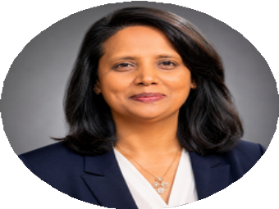
Ragi George, Ph.D. Assistant Professor Department of Nursing

Dr. Ragi George earned her PhD in Nursing from Wilkes University, where her research focused on team-based learning and critical thinking in nursing education. She is a nurse educator and researcher whose scholarship centers on nursing education, simulation, educational technology, artificial intelligence, evidence-based teaching strategies, and the integration of emerging technologies in nursing education. With more than 23 years of nursing experience, including over 15 years in academia, she has taught across undergraduate and graduate nursing programs while leading curriculum innovation, online course development, and faculty initiatives. Most recently, she served as Associate Professor and Department Chair of the Upper Division Transfer Program in the School of Nursing at Azusa Pacific University.

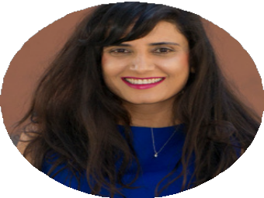
Manpreet Sidhu, Ph.D. Assistant Professor Department of Nursing

Dr. Sidhu is an Emergency Medicine Nurse Practitioner who earned her Bachelor of Science degree from California State University, San Bernardino, and her Master of Science in Nursing with an Acute Care Nurse Practitioner specialization from the University of California, Los Angeles. She subsequently earned her Doctor of Nursing Practice (DNP) degree through the California State University Consortium Program at California State University, Fullerton. Her DNP scholarly project focused on emergency department overcrowding and the implementation of interventions to improve emergency department efficiency and reduce patient wait times and overcrowding. She is currently a lecturer and Assistant Clinical Professor at University of California Los Angeles, JCW School of Nursing teaching theory and clinical courses in the Acute Care Nurse Practitioner Program.

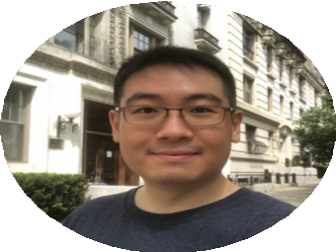
Sungho Park, Ph.D. Assistant Professor Department of Chemistry
Dr. Sungho Park is a synthetic inorganic chemist. Most recently, he was a postdoc at Columbai University, where he investigated the surface chemistry and catalytic reactivity of metal-organci framework nanocrystals with Professor Jonathan Owen. He received his PhD at University of Wisconsin-Madison, where he worked wiht Professor John Berry on the photochemical reactivity of ruthenium and dirmutheniu complexes.

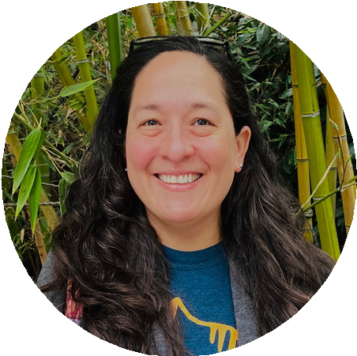
Katia Silvera, Ph.D. Assistant Professor Department of Biology

Katia Silvera is an interdisciplinary plant biologist. She earned a Batchelor of Science in Biology wiht a specialization in Botany from the University of Panama, Master of Science in Plant Systematics from the University of Florida, and a doctorate ni Biochemistry and Molecular Biology from the University of Nevada, Reno. She completeda postdoctoral fellowship at the Smithsonian Tropical Research Institute and most recently served as a lecturer at the University of California, Riverside and California State University, San Bernardino. Her research focuses on elucidating the evolutionary origins of photosynthetci pathways in orchids, and she is passionate about teaching, mentoring students, and conserving Neotropical orchids through research and habitat preservation.

Siritorn Yingrengreung, Ph.D.
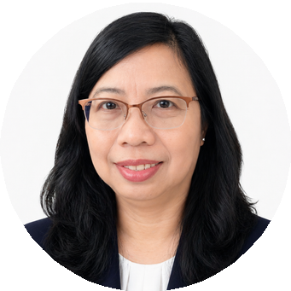
Assistant Professor
Department of Nursing

Dr. Siritorn Yingrengreung earned a Master of Science degree in Child Health Nursing and a PhD in Nursing from the State University of New York at Buffalo. She specializes in pediatric nursing and nursing education, drawing on her experience as a pediatric registered nurse at Children’s Hospital in Thailand and Loma Linda University Children’s Hospital. Her expertise includes child health, family-centered care, and evidence-based teaching strategies that promote student success. Prior to joining California State University, San Bernardino, Dr. Yingrengreung served as an Assistant Professor of Nursing at California State University, Stanislaus.

College of Social & Behavioral Sciences

Kristina L. Hulama, Ph.D.
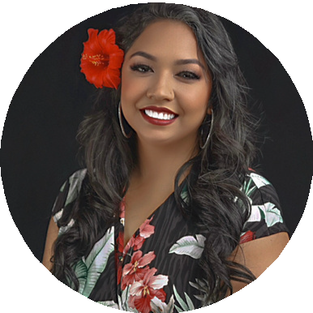
Assistant Professor School of Social Work

Dr. Kristina L. Hulama is a Native Hawaiian and Samoan scholar, poetic interventionist, policy advocate, Native feminist, and licensed social worker from Hawai’i. She recently earned her PhD in Social Work from the University of Denver’s Graduate School of Social Work and holds an MSW and BA in Psychology from the University of Hawai’i at Mānoa, bringing more than a decade of experience in community-based mental health and child welfare to her scholarship. Her research examines how colonialism, patriarchy, discrimination, epistemic injustice, medical gaslighting, environmental injustice, and structural inequities shape Indigenous and women’s health experiences and outcomes through critical, Indigenous, and feminist methodologies, arts-based inquiry, mixed-methods research, and community-engaged approaches.
She developed Poetic Medicine, an Indigenous poetry-based research and healing intervention that integrates Hawaiian-style talk story, ‘ōlelo Hawai’i (Hawaiian language), and mele (poetry).

Tianyu Li, Ph.D.
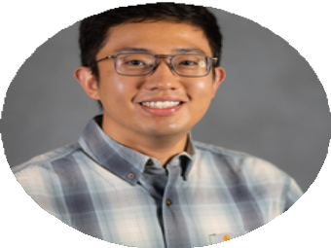
Assistant Professor
Department of Child, Adolescent, and Family Studies

Dr. Tianyu Li earned his Ph.D. in Human Development and Family Sciences from TexaTsech University. His research examines how sociaal nd emotional processes shape studentsa’ cademic engagement, motivation, anadchievement, with a particular focus on teacher-student relationships, school belonging, anadcademic emotions. He also usepssychophysiological and eye-tracking methods tionvestigate students' learning processes. Prior to joining CSUSB, he served as an Assistant Professor of Psychology at Austin Peay State University in Tennessee.

Jiayi Liu, Ph.D.
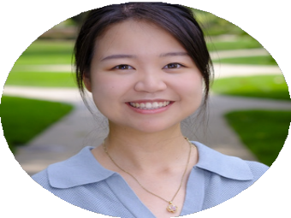
Assistant Professor
Department of Child, Adolescent, and Family Studies

Dr. Jiayi Liu will join the Department of Child, Adolescent, and Family Studies at California StatUe niversity, San Bernardino as an Assistant Professor in Fall 2026. She earned her Ph.D. in Human Development and Family Studies from Michigan State University and her M.A. in Child Study and Human Development from Tufts University. Her research examines how cultural contexts shape family relationships, parentinga, nd adolescent well-being.

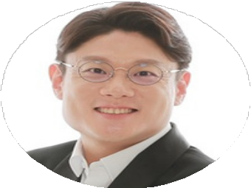
Jin Young Seo, Ph.D. Assistant Professor School of Social Work

Dr. Jin Young Seo is an Assistant Professor in the School of Social Work at CSUSB. Before joining CSUSB, he was an Assistant Professor at Augsburg University in Minneapolis, Minnesota, and his research focuses on family policy and parental leave. He earned his PhD in Social Welfare from the University of Hawaiʻi at Mānoa. Prior to his doctoral studies, he completed his MSW at the University of Hong Kong and practiced as a therapist in South Korea.

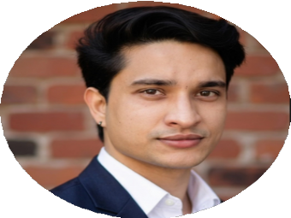
Mohit Tamta, Ph.D. Assistant Professor School of Social Work

Dr. Mohit Tamta earned his PhD in Social Work from Boston University. His research focuses on housing insecurity, forced evictions, homelessness, mental health, and social policy, with particular attention to marginalized communities in both the United States and India. Prior to joining CSUSB, he served as a graduate instructor and research fellow at Boston University. He is excited to join the School of Social Work and contribute to its mission of advancing social justice through teaching, research, and community engagement.

Jack H. Brown College of Business & Public Administration

In Hae Noh, Ph.D.
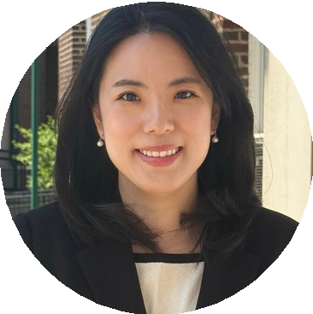
Assistant Professor
Department of Public Administration

Dr. In Hae Noh holds a Ph.D. in Public Administration and Policy from the Rockefeller College of Public Affairs and Policy at the University at Albany, SUNY, and an M.A. in International Studies from Seoul National University. She studies collaborative governance and policy process, focusing on how diverse stakeholders, including public, nonprofit, and community collaborate to make decisions at the local governmental level and how and why these decisions impact policy outcomes. Prior to her doctoral studies, she was a Senior Research Associate at the Korea Development Institute (KDI). Most recently, she taught as an Adjunct Instructor at the University at Albany, SUNY.

John M. Pfau Library

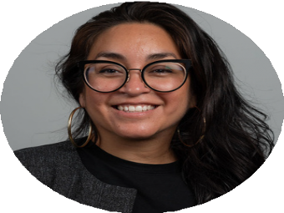
Stef Baldivia, Ph.D. Senior Assistant Librarian Library

Stefani Baldivia joins Pfau Library as the Student Success Librarian (Affordable Course Materials Specialist). Before her current role, Stefani served as the Equity and Outreach Librarian at California State University, Chico. Very much a product of the CSU, she earned her BA in Native American Studies from Cal Poly Humboldt and her MLIS from San José State University. Her academic foundation in Native American Studies continues to shape her approach to librarianship, grounding her work in relational accountability and community-based knowledge practices. Her scholarship focuses on Latine librarianship, 1st Gen- and Hispanic-servingness in librarianship, anticolonial archival methods, and diversifying collections through oral histories and community-based archives.


Mariann Lactaoen, Ph.D. Senior Assistant Librarian Library

