Concur Legacy Platform
We are pleased to inform you that user access to the legacy CSUSB Concur system has now been temporarily restored. You are receiving this message because you have outstanding transactions within the legacy CSUSB Concur system that were incurred prior to the transition to the new Concur system which occurred on April 6, 2026. You may log in to complete any outstanding corporate card and air transactions that were not fully approved and/or reconciled prior to the transition to the new Concur system.
Please see the steps below to log in to the legacy CSUSB Concur system:
Go to www.concursolutions.com
- Enter the username- EMPLID@csusb.edu.old and click Next (see below). Your own employee id number should be inserted within the ‘EMPLID’ portion of the username.
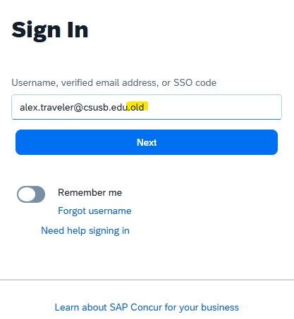
Ensure that you have entered your email address ending in .old for this to work correctly.
Click “Next”
- Click on - Sign in with an Email link:

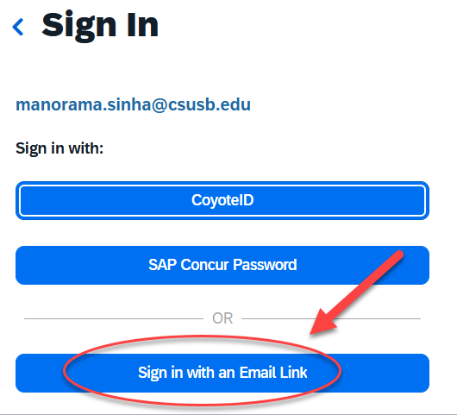
Alex.Traveler@csusb.edu.old

- Wait for the email from Concur in your mailbox. It will say – “Sign-In Request to SAP Concur”
- Click “Sign in to SAP Concur”, within the email. You will then be directed to the legacy Concur system landing page
Please note that the system will time out if you are inactive or step away. If this occurs, you will need to repeat the login steps to access CSUSB Legacy Concur instance again.
Please keep this document for reference.
Please be advised that users are to access the legacy Concur system to complete outstanding transactions (travel expense reports, old corporate card transactions, etc.) which were incurred prior to the transition to the new Concur system on April 6, 2026. All requests for transactions incurred on April 6 or later, should submitted/reconciled within the new system of Concur.
Any approvers who must approve a request within the legacy system of Concur, must also log in by using the instructions noted above. We realize that we may not have captured everyone in this message so we ask that you share this with your colleagues who may need this information.
We appreciate your patience as we navigate the full transition from the legacy Concur system to the new system.
If you have any questions or run into any issues, feel free to reach out.
Corporate Card Assistance: email CorporateCard@csusb.edu
Travel Assistance: Travel@csusb.edu

