California State University, San Bernardino
Business Process Guide
Submitting a Journal Entry Request

Accessing the Journal Entry Request Form ………………………….. Page 2

Completing the Journal Entry Request Form ……………………….. Page 4

Entering Chartfield Information ………………………..………………… Page 6

Upload List Requirements …………………..…………………….. Page 7

Purpose
This guide provides step-by-step instructions for submitting a Journal Entry Request Form through PeopleSoft CS for California State University, San Bernardino (CSUSB).

Scope
This process applies to all departments submitting journal entry requests including Transfer of Expenses (Salary & Benefits), Transfer of Expenses, and Transfer of Funds.

Accessing the Journal Entry Request Form

Step 1: Log in to MyCoyote and select the Administrative Systems icon.

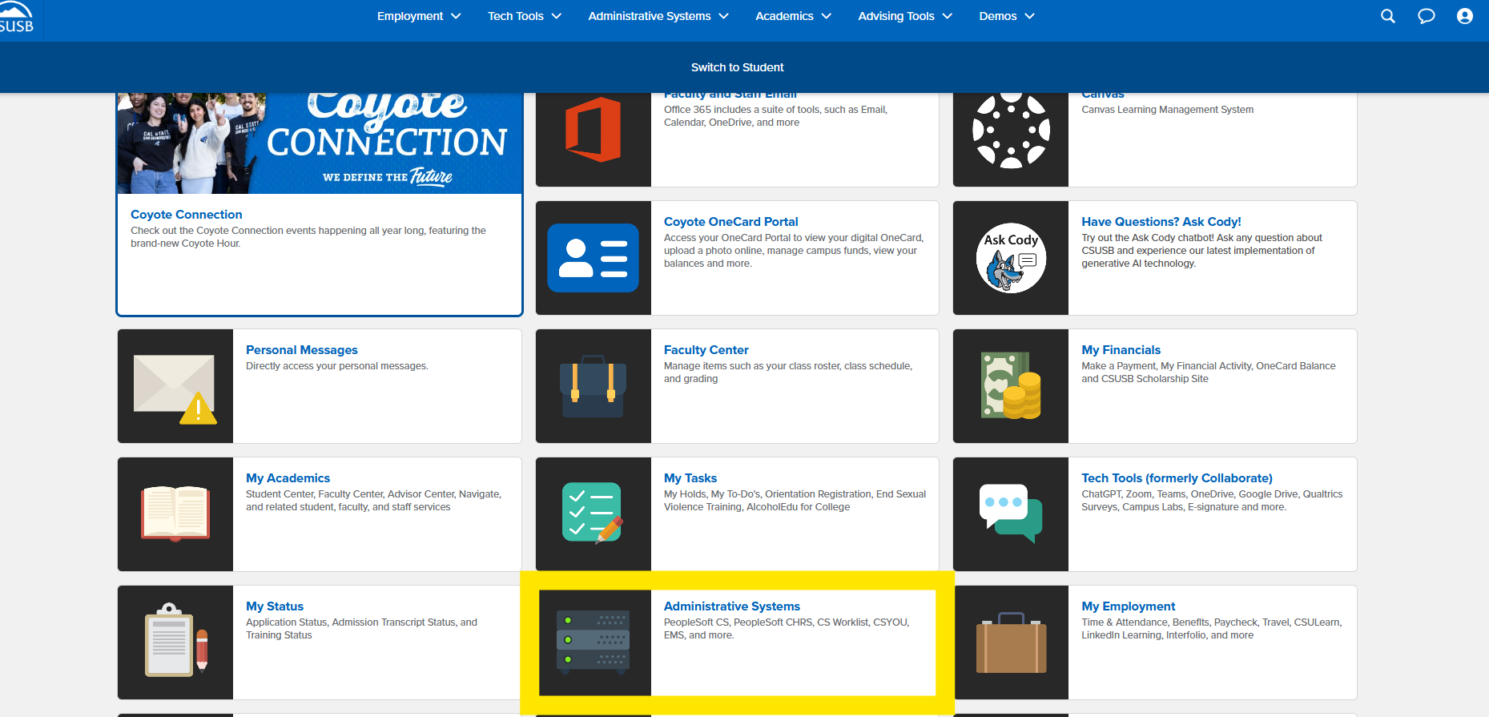
Figure: Step 1: Log in to MyCoyote and select the Administrative Systems icon.

Step 2: Select the PeopleSoft CS icon.

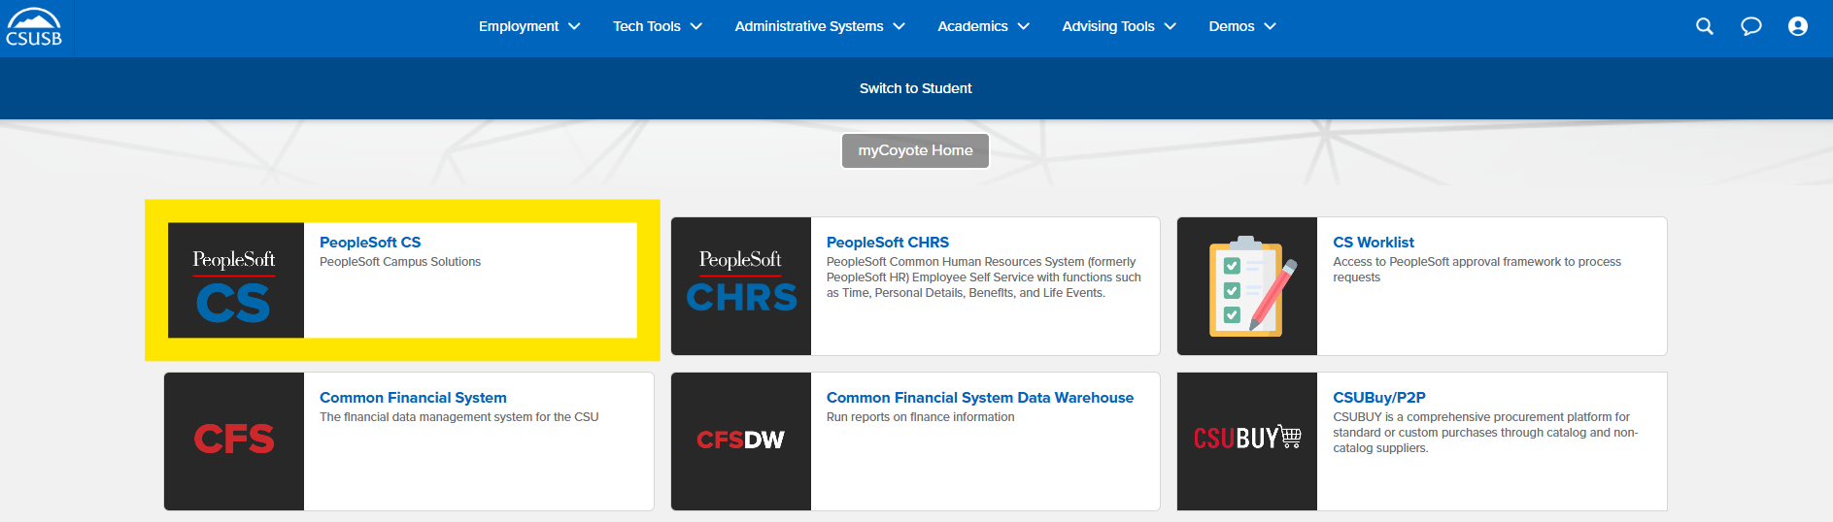
Figure: Step 2: Select the PeopleSoft CS icon.

Step 3: Click the Compass icon, then select the Menu icon.

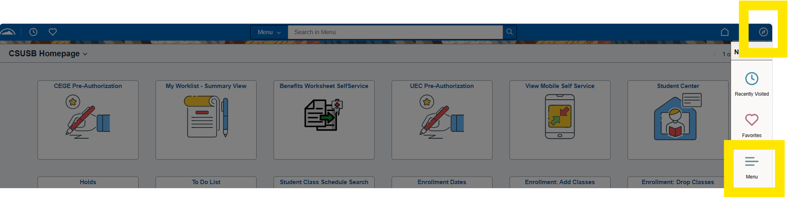
Figure: Step 3: Click the Compass icon, then select the Menu icon.

Step 4: Navigate using the breadcrumb:

Menu → SB Custom → SB SA Custom Menu → Accounting Forms → Submit Accounting Forms.

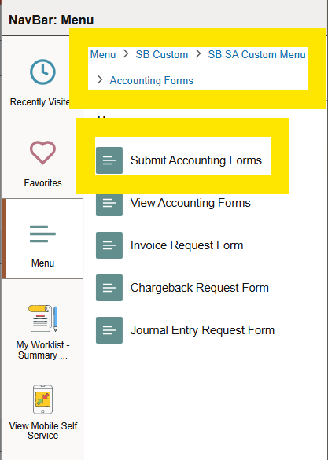
Figure: Step 4: Navigate using the breadcrumb: Menu → SB Custom → SB SA Custom Menu → Accounting Forms → Submit Accounting Forms.

Step 5: Under New Accounting Forms, select 'Journal Entry Request Form'.

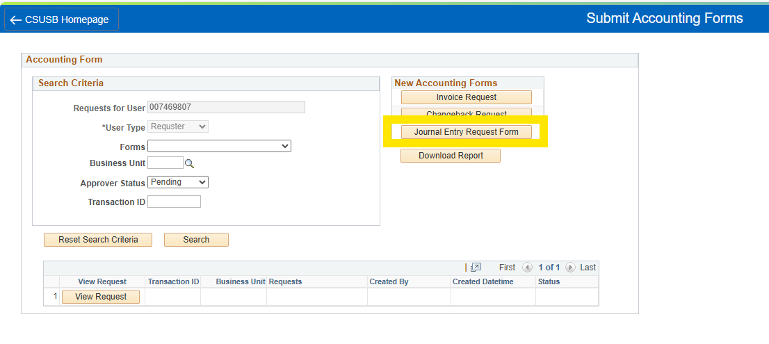
Figure: Step 5: Under New Accounting Forms, select 'Journal Entry Request Form'.

Completing the Journal Entry Request Form

Step 6: From the Business Unit dropdown menu, select 'SBCMP (Stateside)'.

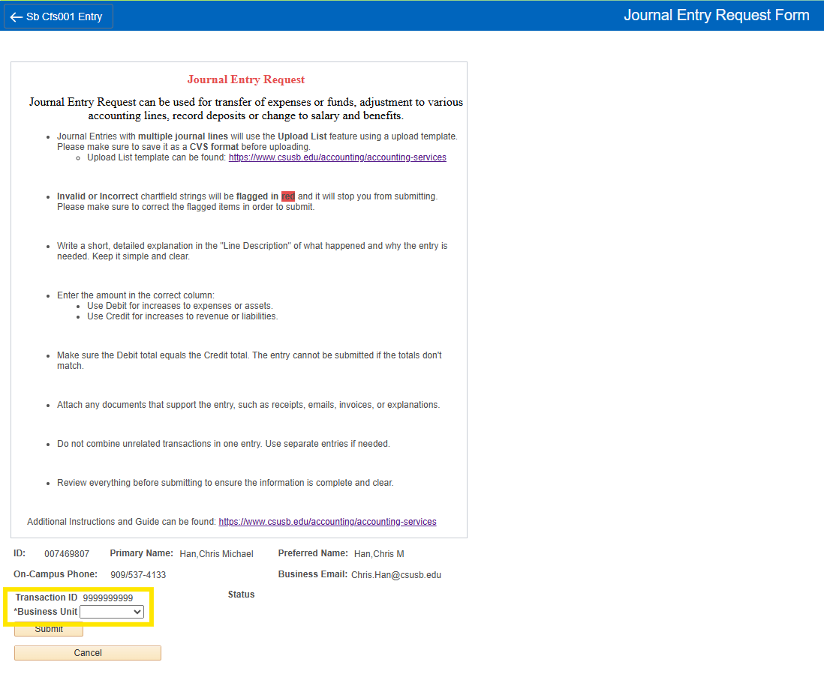
Figure: Step 6: From the Business Unit dropdown menu, select 'SBCMP (Stateside)'.

Step 7: Under 'Request Type', select the appropriate option: Transfer of Expense Salary & Benefits, Transfer of Expense, or Transfer of Fund.

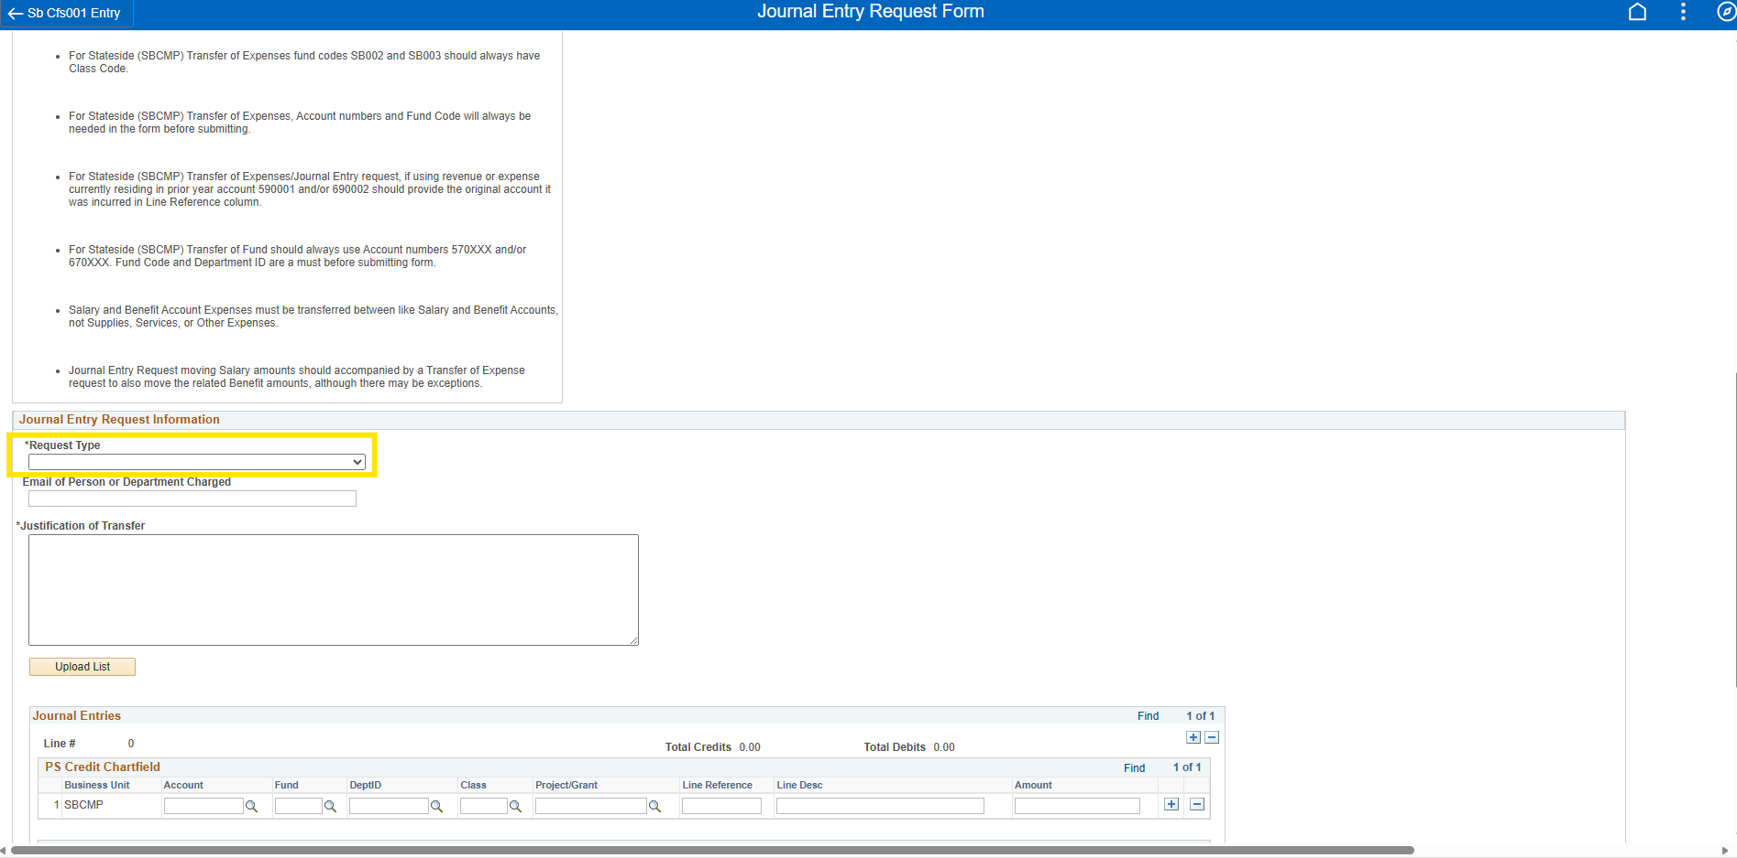
Figure: Step 7: Under 'Request Type', select the appropriate option: Transfer of Expense Salary & Benefits, Transfer of Expense, or Transfer of Fund.

Step 8: Enter the Email of Person/Department Charged and provide a detailed Justification of Transfer.

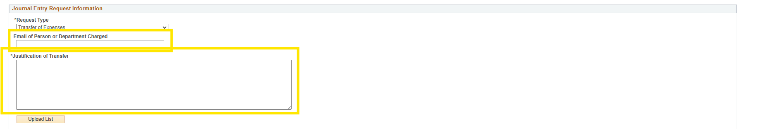
Figure: Step 8: Enter the Email of Person/Department Charged and provide a detailed Justification of Transfer.

Entering Chartfield Information

All journal entry requests must include complete and valid chartfield strings.
- Required fields include: Account, Fund, Dept ID, Class (if fund is SB002 or SB003), Line Desc, and Amount.
  - PS Credit Chartfield Amount: Please add a negative sign (-)
  - PS Debit Chartfield Amount: Please leave as a positive number (+)
- Optional fields include: Class (for other funds), Project/Grant, Line Reference.
Invalid or incomplete chartfields will be flagged in red and must be corrected before submission.

Option 1: Manually enter Debit and Credit chartfield strings. Use the plus (+) and minus (–) icons to add or delete lines.

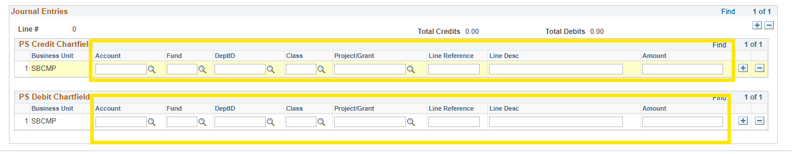
Figure: Option 1: Manually enter Debit and Credit chartfield strings. Use the plus (+) and minus (–) icons to add or delete lines.

Option 2: Use the Upload List feature for multiple journal lines.

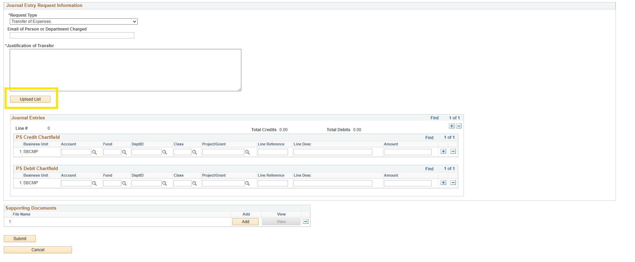
Figure: Option 2: Use the Upload List feature for multiple journal lines.

Upload List Requirements
When submitting multiple journal lines:
• Download the Upload List Template from: https://www.csusb.edu/accounting/accounting-services
• Complete all required fields.
• Save the file in CSV format.
• Upload using the Upload List feature.
Note: The system will not accept non-CSV formats.

Step 9: Add supporting documentation by clicking 'Add'.

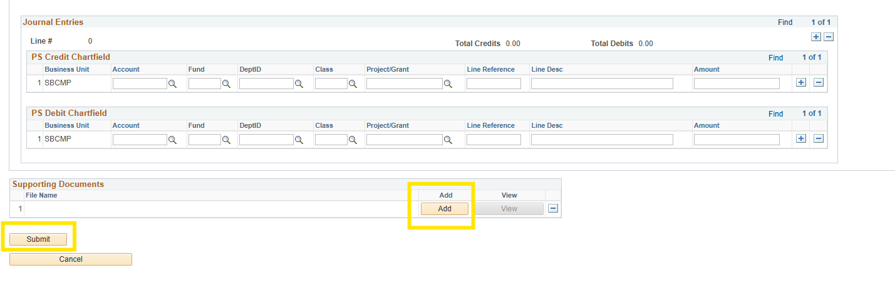
Figure: Step 9: Add supporting documentation by clicking 'Add'.

Step 10: Click 'Submit' to complete your Journal Entry Request.

Figure: Step 10: Click 'Submit' to complete your Journal Entry Request.

6. Support
For questions regarding journal entry submissions, contact Accounting Services or visit https://www.csusb.edu/accounting/accounting-services.

