California State University, San Bernardino
Business Process Guide
Submitting an Invoice Request

Accessing the Invoice Request Form …………………………………… Page 2

Completing the Invoice Request Form………………………………… Page 5

Entering Chartfield Information …………………..…………………… Page 7

Upload List Requirements …………………..…………………….. Page 8

Purpose
This guide provides step-by-step instructions for submitting an Invoice Request Form through PeopleSoft CS for California State University, San Bernardino (CSUSB).

Scope
This process applies to all departments submitting an Invoice Request that is needed for transactions between SBCMP, SBFDN and SBPHL.

Accessing the Invoice Request Form

Step 1: Log in to MyCoyote and select the Administrative Systems icon.

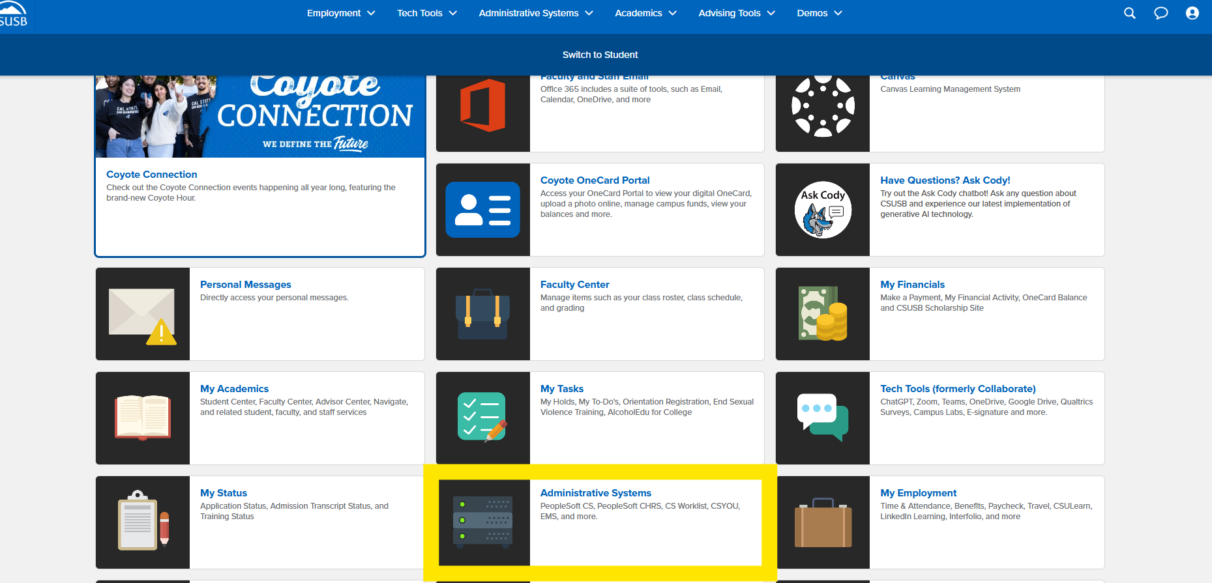
Figure: Step 1: Log in to MyCoyote and select the Administrative Systems icon.

Step 2: Select the PeopleSoft CS icon.

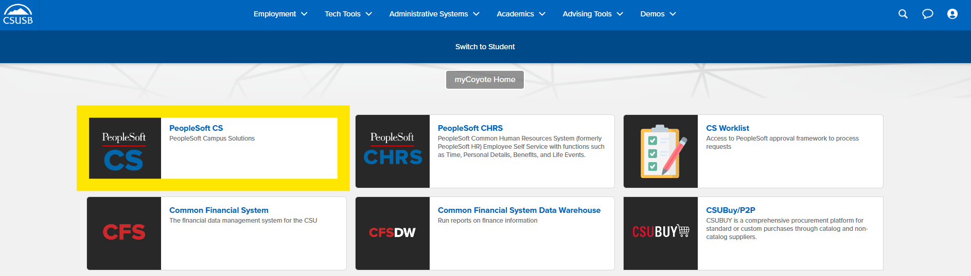
Figure: Step 2: Select the PeopleSoft CS icon.

Step 3: Click the Compass icon, then select the Menu icon.

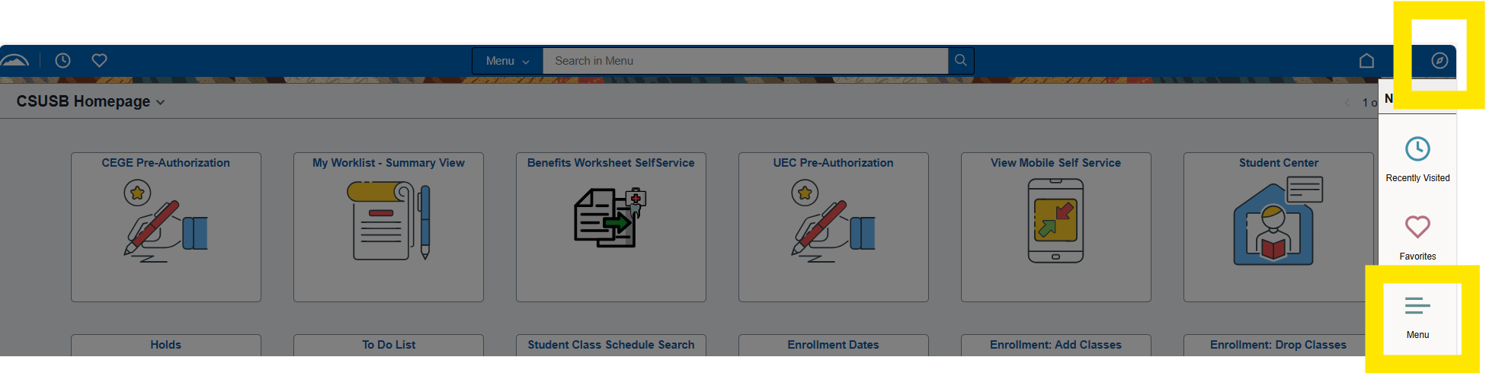
Figure: Step 3: Click the Compass icon, then select the Menu icon.

Step 4: Navigate using the breadcrumb:

Menu → SB Custom → SB SA Custom Menu → Accounting Forms → Use → Submit Accounting Forms.

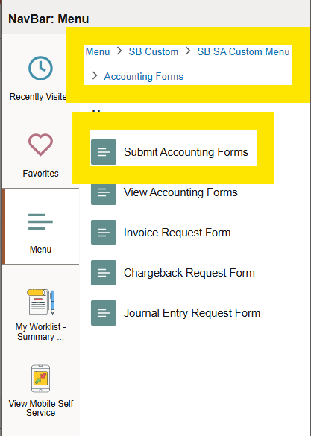
Figure: Step 4: Navigate using the breadcrumb: Menu → SB Custom → SB SA Custom Menu → Accounting Forms → Use → Submit Accounting Forms.

Step 5: Under New Accounting Forms, select 'Invoice Request'.

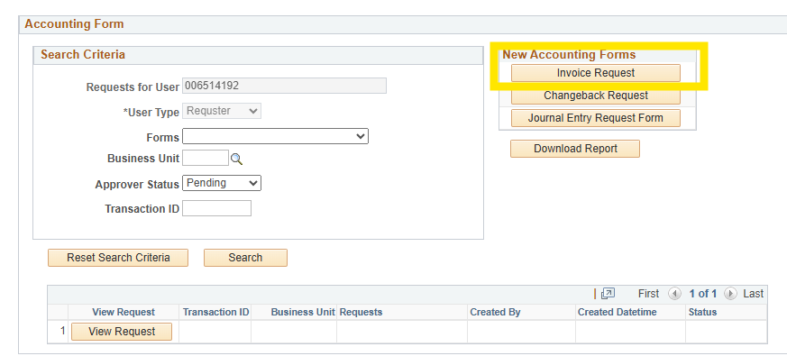
Figure: Step 5: Under New Accounting Forms, select 'Invoice Request'.

Completing the Invoice Request Form

Step 6: From the Business Unit dropdown menu, select 'SBCMP (Stateside)'.
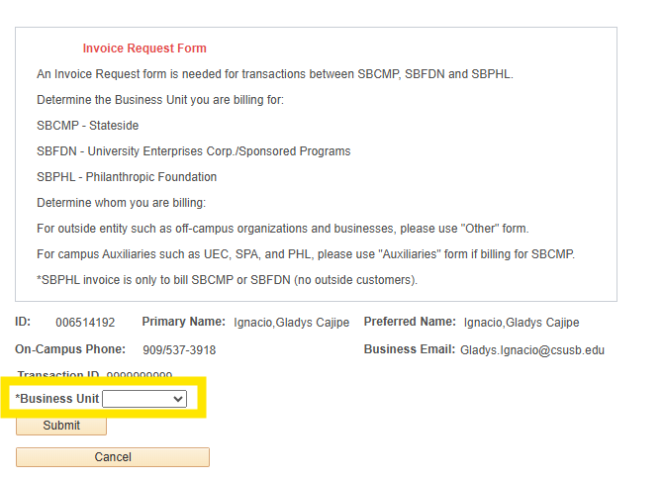

Figure: Step 6: From the Business Unit dropdown menu, select 'SBCMP (Stateside)'.

Step 7: Under 'Form Type', select the appropriate option: Auxiliaries or Other.
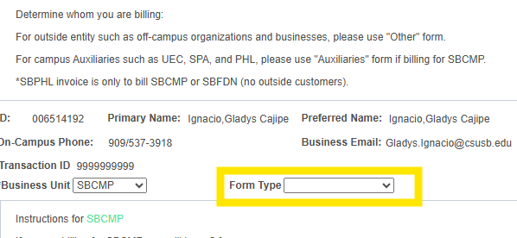

Figure: Step 7: Under 'Form Type', select the appropriate option: Auxiliaries or Other

Step 8: For “Auxiliaries” Form, enter the Customer Name, ID if known, Project/Grant Title, Attention to, Address, and Billing Email Address of anyone who should receive a copy of the invoice.
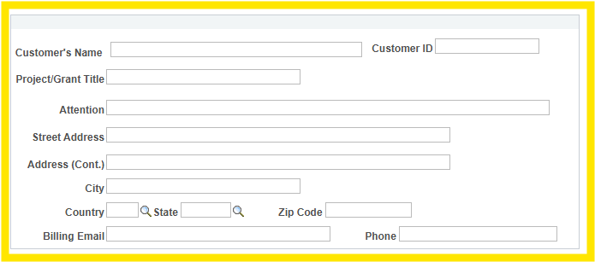

Figure: Step 8: For Auxiliaries Form, enter the Customer Name, ID if known, Project/Grant Title, Attention to, Address, and Billing Email Address of anyone who should receive a copy of the invoice

Entering Chartfield Information

Please enter the complete chartfield string on the Credit Account field. This is where you want the money to go. The Credit Account should always be a revenue account, cost recovery 580094 is an option you may use. Expense accounts can be used only if charges have been posted to the general ledger. Invalid or Incorrect chartfield strings will be flagged in red and it will stop you from submitting. Please make sure to correct the flagged items before submission.
The Identifier will be the Work Order/PO/RT number, if applicable.
The Short Description will be the debit chartfield string, if applicable.
The Journal Line Description will be your long description.
The Explanation box can be used if you need to provide more description.
Please attach any supporting documentation for the invoice.

Option 1: Manually enter the Credit chartfield string. Use the plus (+) and minus (–) icons to add or delete lines.

Figure: Option 1: Manually enter the Credit chartfield string. Use the plus (+) and minus (–) icons to add or delete lines.

Option 2: Use the Upload List feature for multiple customers or credit lines.

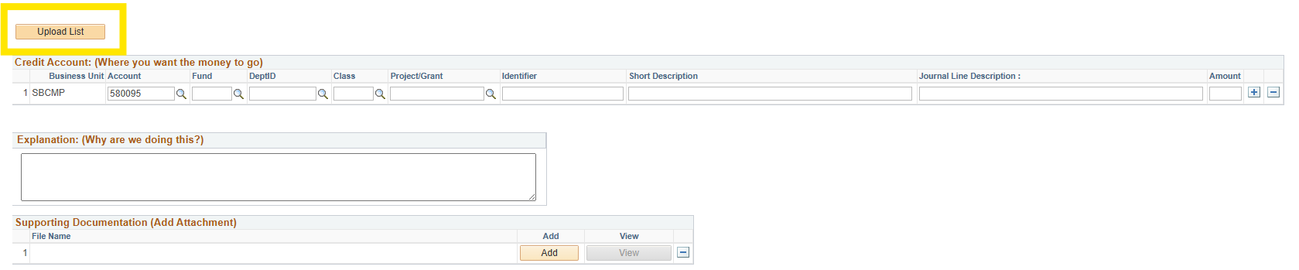
Figure: Option 2: Use the Upload List feature for multiple customers or credit lines.

Upload List Requirements
When submitting multiple customers or credit lines:
• Download the Upload List Template from: https://www.csusb.edu/accounting/accounting-services
• Complete all required fields.
• Save the file in CSV format.
• Upload using the Upload List feature.
Note: The system will not accept non-CSV formats.

Step 9: Add supporting documentation by clicking 'Add'.
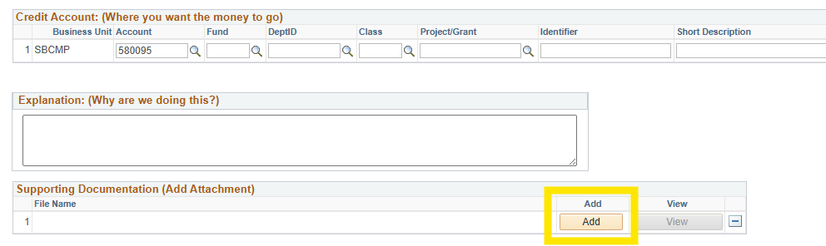

Figure: Step 9: Add supporting documentation by clicking 'Add'.

Step 10: Click 'Submit' to complete your Invoice Request.

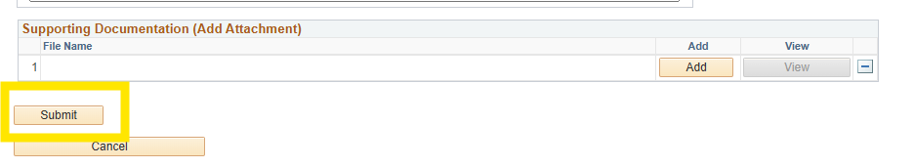
Figure: Step 10: Click 'Submit' to complete your Invoice Request.

For “Other” Form, please follow the same instructions. This form is for billing off-campus organizations and businesses.

6. Support
For questions regarding Invoice Request submissions, contact Accounting Services or visit https://www.csusb.edu/accounting/accounting-services.

