California State University, San Bernardino
Business Process Guide
Submitting a Chargeback Request

Accessing the Chargeback Request Form ………………………….. Page 2

Completing the Chargeback Request Form ……………………….. Page 4

Entering Chartfield Information ………………………..………………… Page 6

Upload List Requirements …………………..…………………….. Page 7

Purpose
This guide provides step-by-step instructions for submitting a Chargeback Request Form through PeopleSoft CS for California State University, San Bernardino (CSUSB).

Scope
This process applies to all departments submitting a Chargeback. A Chargeback is used to record the transaction between campus departments for goods/services provided. One department is charged for the products/services provided by another department.

Accessing the Chargeback Request Form

Step 1: Log in to MyCoyote and select the Administrative Systems icon.

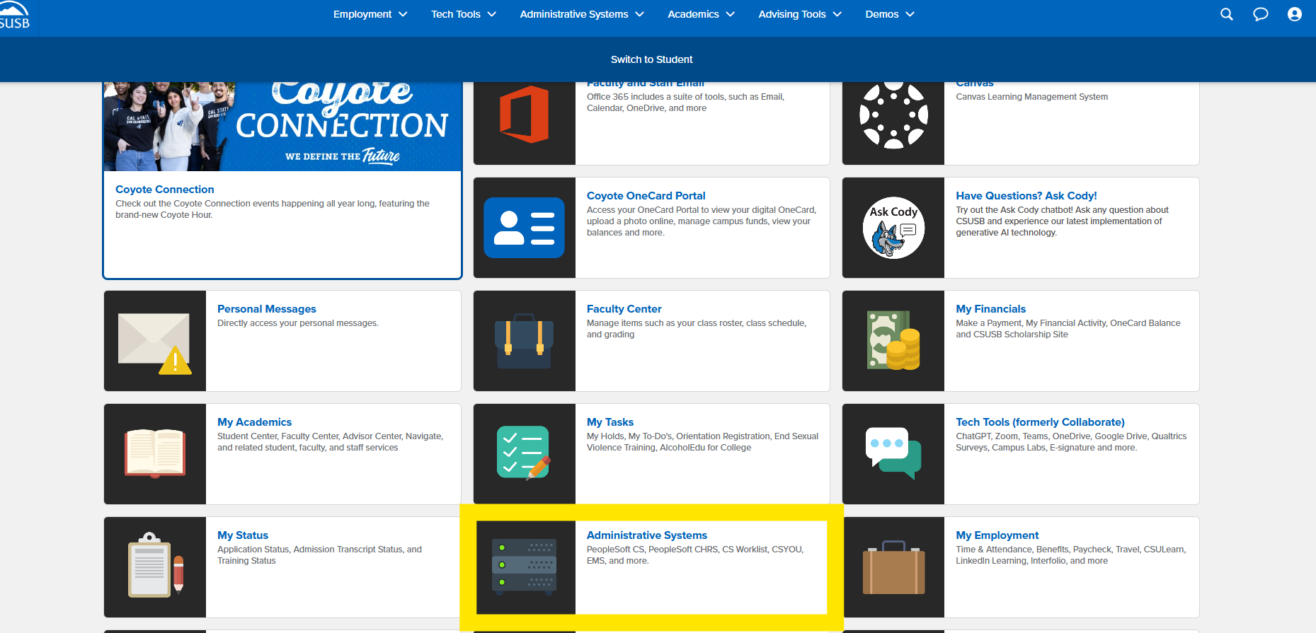
Figure: Step 1: Log in to MyCoyote and select the Administrative Systems icon.

Step 2: Select the PeopleSoft CS icon.

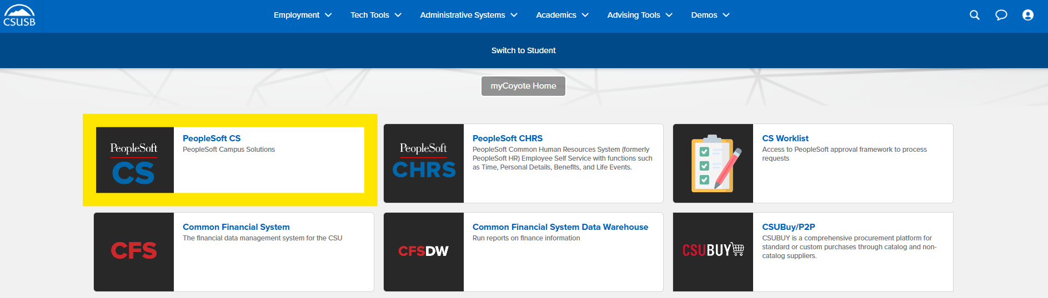
Figure: Step 2: Select the PeopleSoft CS icon.

Step 3: Click the Compass icon, then select the Menu icon.

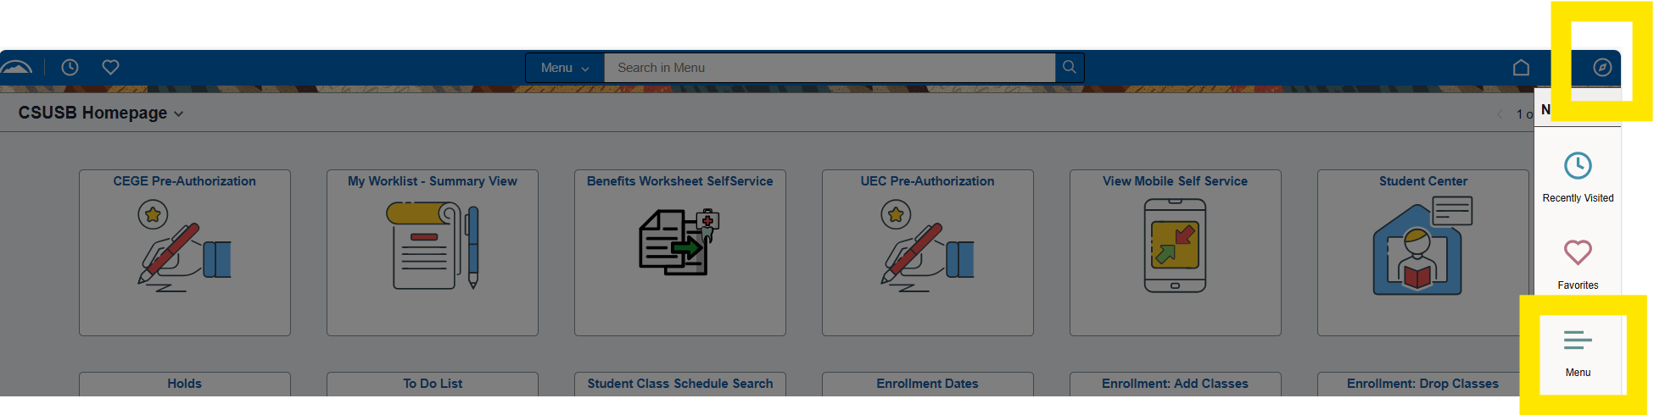
Figure: Step 3: Click the Compass icon, then select the Menu icon.

Step 4: Navigate using the breadcrumb:

Menu → SB Custom → SB SA Custom Menu → Accounting Forms → Use → Submit Accounting Forms.

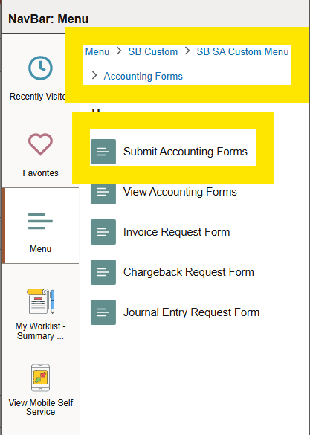
Figure: Step 4: Navigate using the breadcrumb: Menu → SB Custom → SB SA Custom Menu → Accounting Forms → Use → Submit Accounting Forms.

Step 5: Under New Accounting Forms, select Chargeback Request Form.

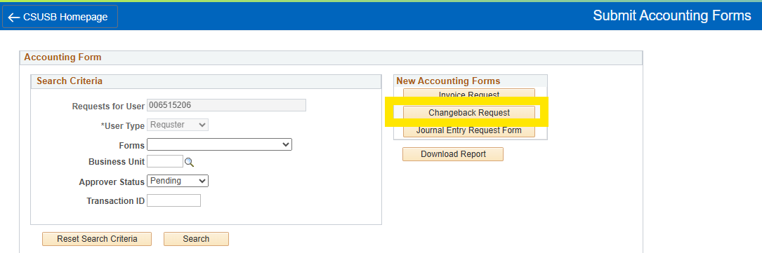
Figure: Step 5: Under New Accounting Forms, select Chargeback Request Form.

Completing the Chargeback Request Form

Step 6: From the Business Unit dropdown menu, select “SBCMP” for Stateside or select one of the following: “SBFDN, SBPHL, SBASI, SBSUN” for Auxiliaries.

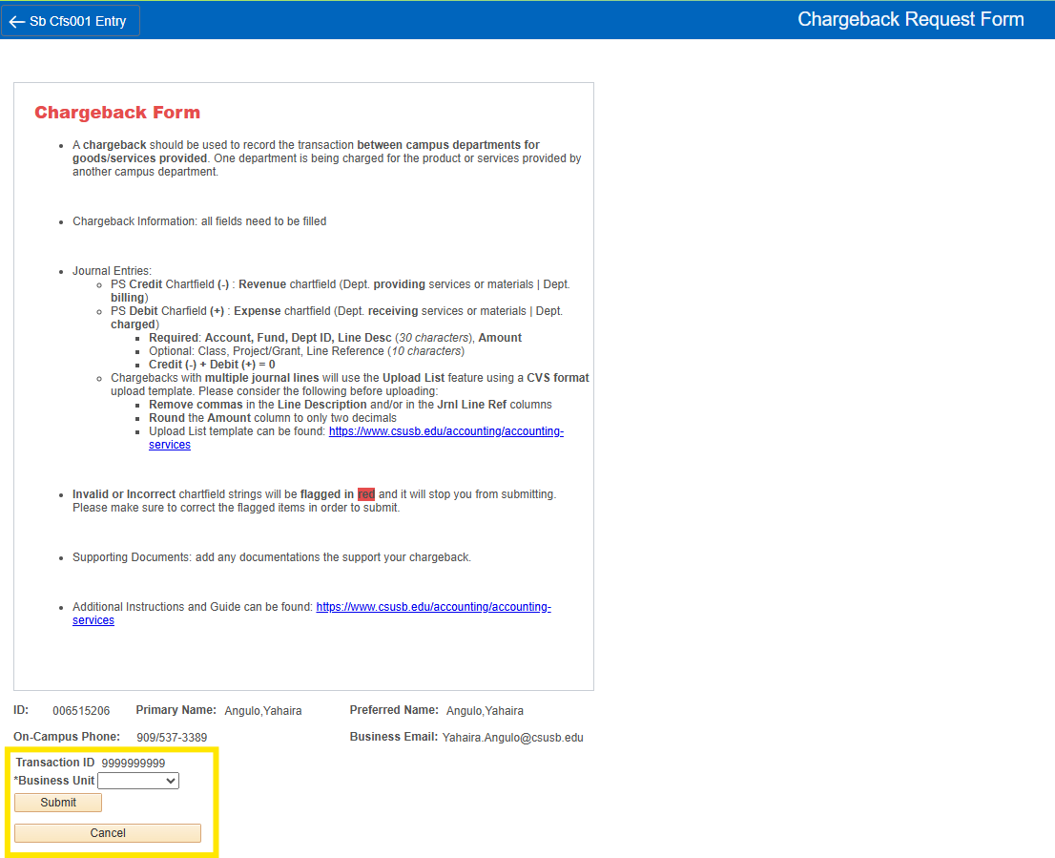
Figure: Step 6: From the Business Unit dropdown menu, select “SBCMP” for Stateside or select one of the following: “SBFDN, SBPHL, SBASI, SBSUN” for Auxiliaries.

Step 7: Enter a Short Journal Line Description, the Email of Person/Department Charged, and provide a detailed Justification of the Chargeback.

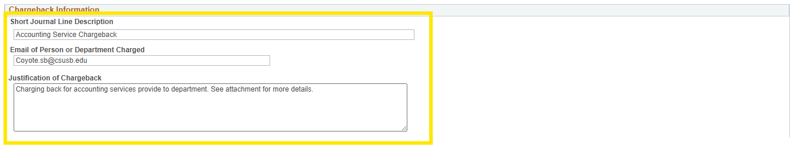
Figure: Step 7: Enter a Short Journal Line Description, the Email of Person/Department Charged, and provide a detailed Justification of the Chargeback.

Entering Chartfield Information
All Chargebacks must include complete and valid chartfield strings.
- Required fields include: Account, Fund, Dept ID, Class (if fund is SB002 or SB003), Line Desc, and Amount.
  - PS Credit Chartfield Amount: Please add a negative sign (-)
  - PS Debit Chartfield Amount: Please leave as a positive number (+)
- Optional fields include: Class (for other funds), Project/Grant, Line Reference.

Option 1: Manually enter Debit and Credit chartfield strings. Use the plus (+) icon to add and minus (–) icon to delete journal lines.

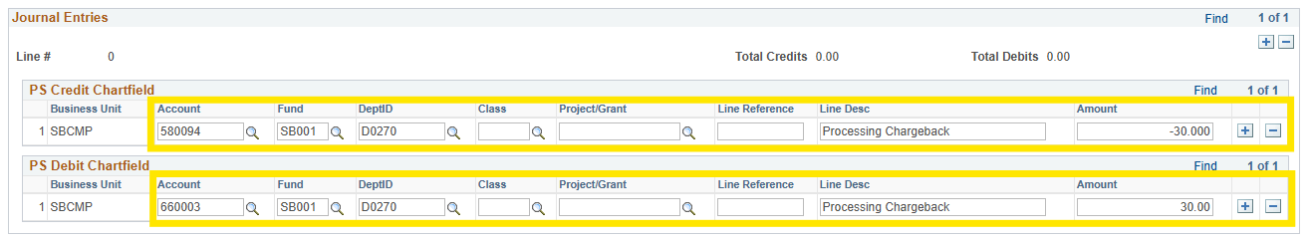

Figure: Option 1: Manually enter Debit and Credit chartfield strings. Use the plus (+) icon to add and minus (–) icon to delete journal lines.

Option 1: Invalid or incomplete chartfield strings will be flagged in red and must be corrected before submission.

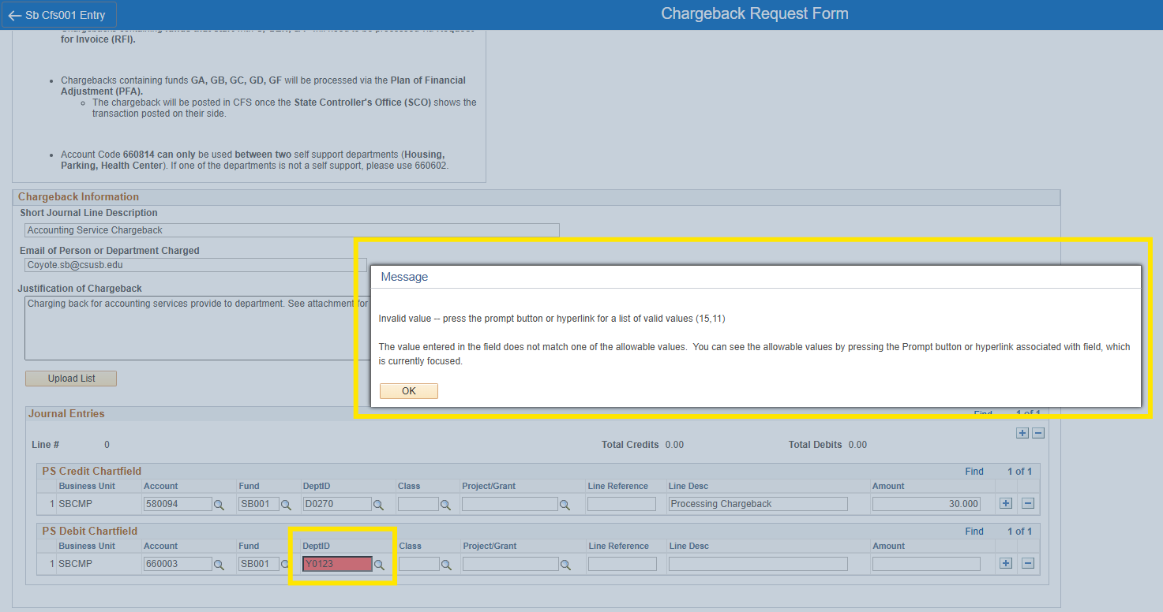

Figure: Option 1: Invalid or incomplete chartfield strings will be flagged in red and must be corrected before submission.

Option 2: Use the Upload List feature for multiple journal lines.

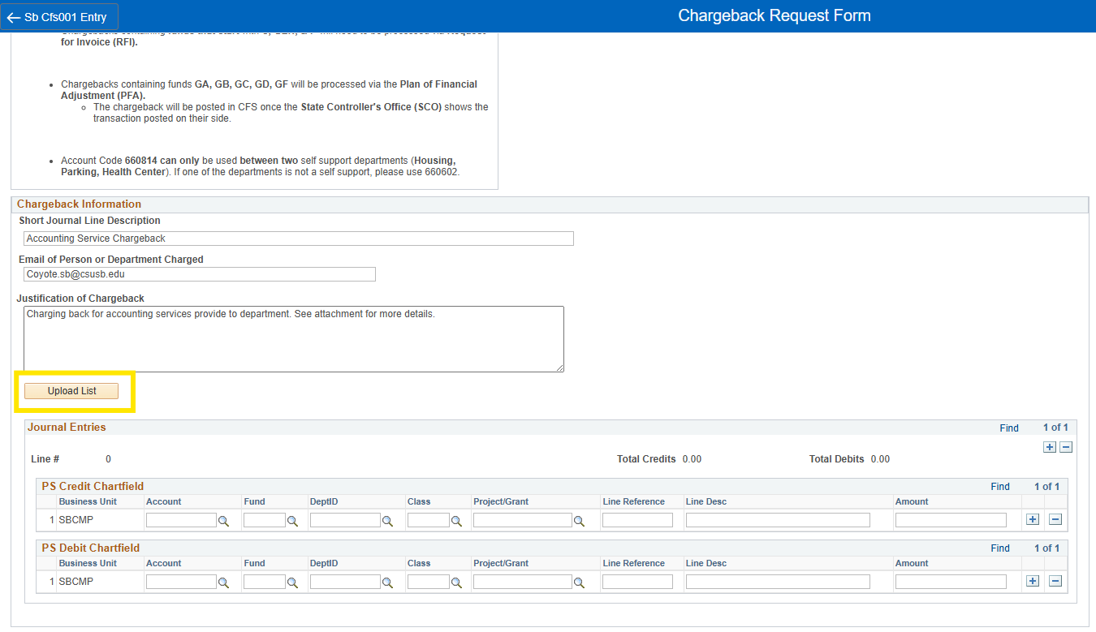

Figures: Option 2: Use the Upload List feature for multiple journal lines.

Option 2: Upload List Requirements and Process
- Download the Upload List Template from: https://www.csusb.edu/accounting/accounting-services
- Complete all required fields.
  - Stateside depts. charging ASI & SMSU chartfield strings, please add the journal lines to the bottom rows.
  - Please make sure the data in the “Amount” column is in a number format and rounded to the second decimal.
- Save the file in CSV format.
- Upload using the Upload List feature.
  - Note: The system will not accept non-CSV formats.

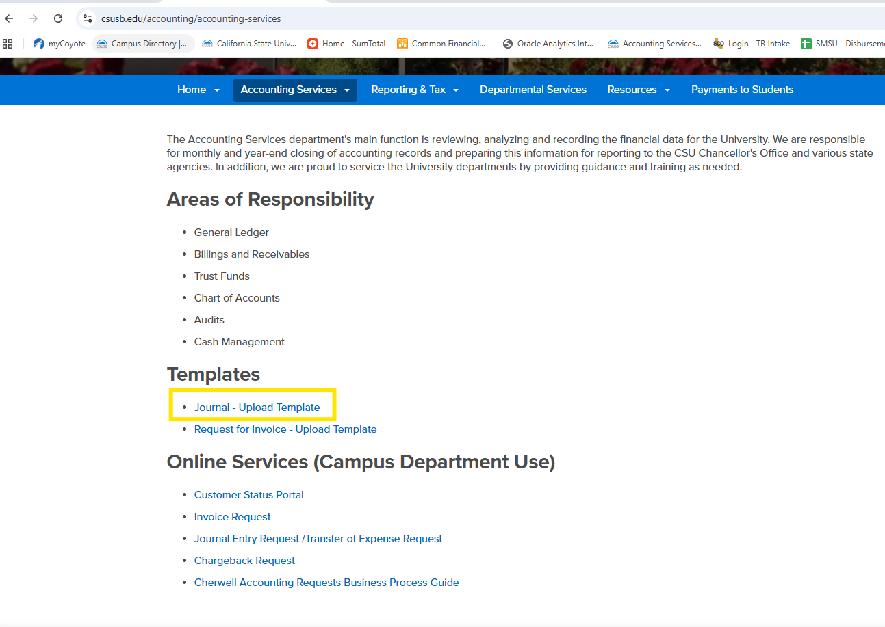
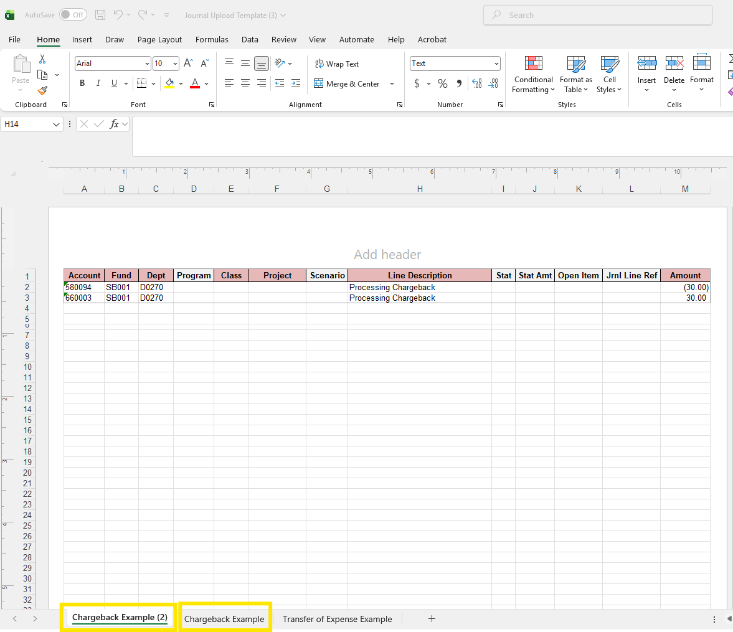
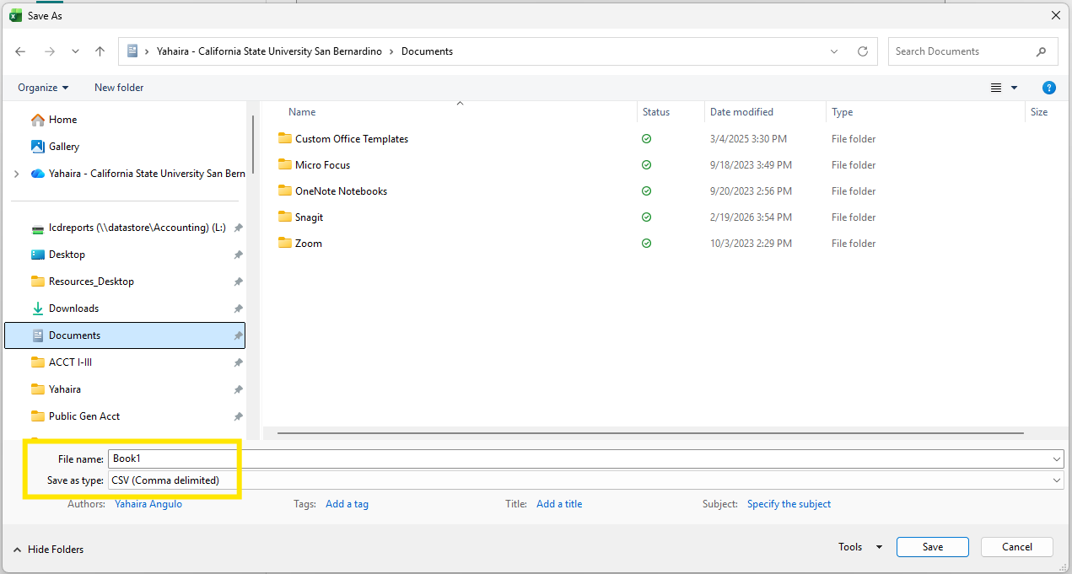

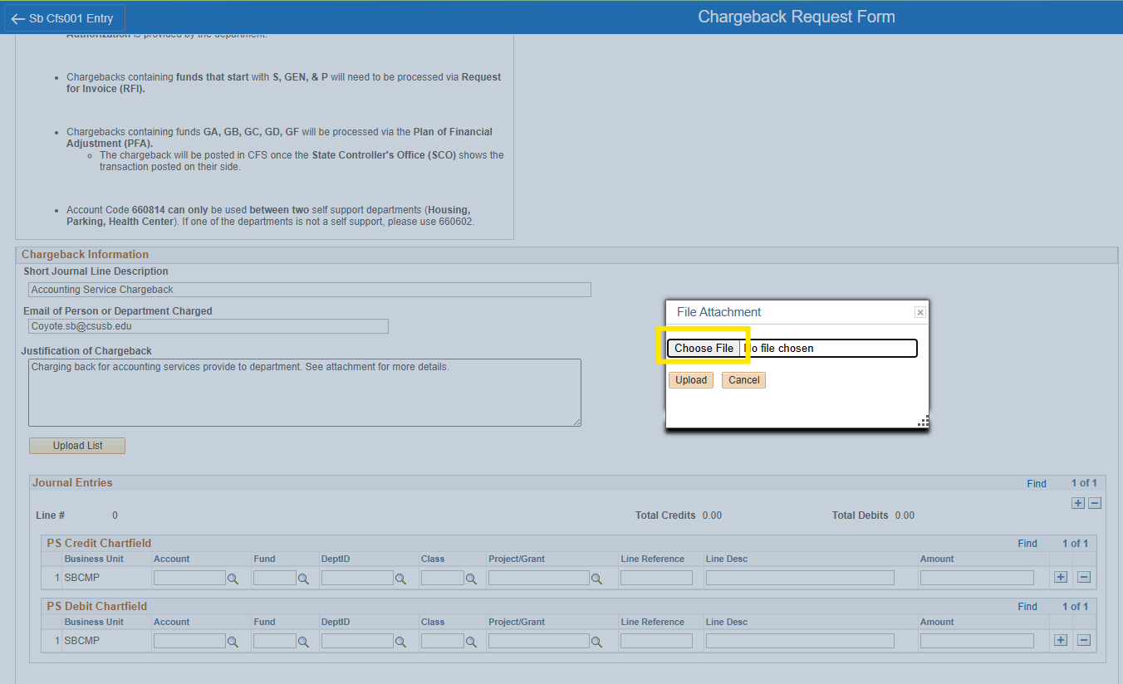

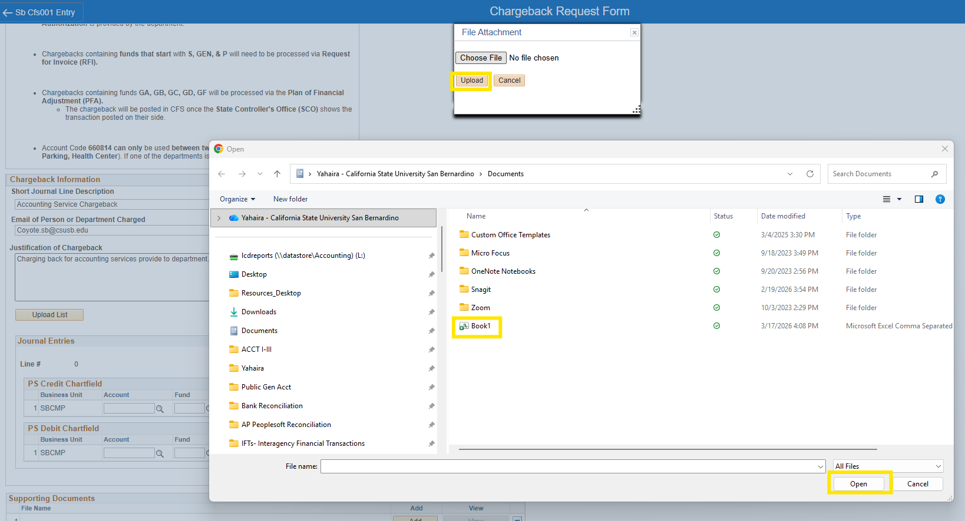

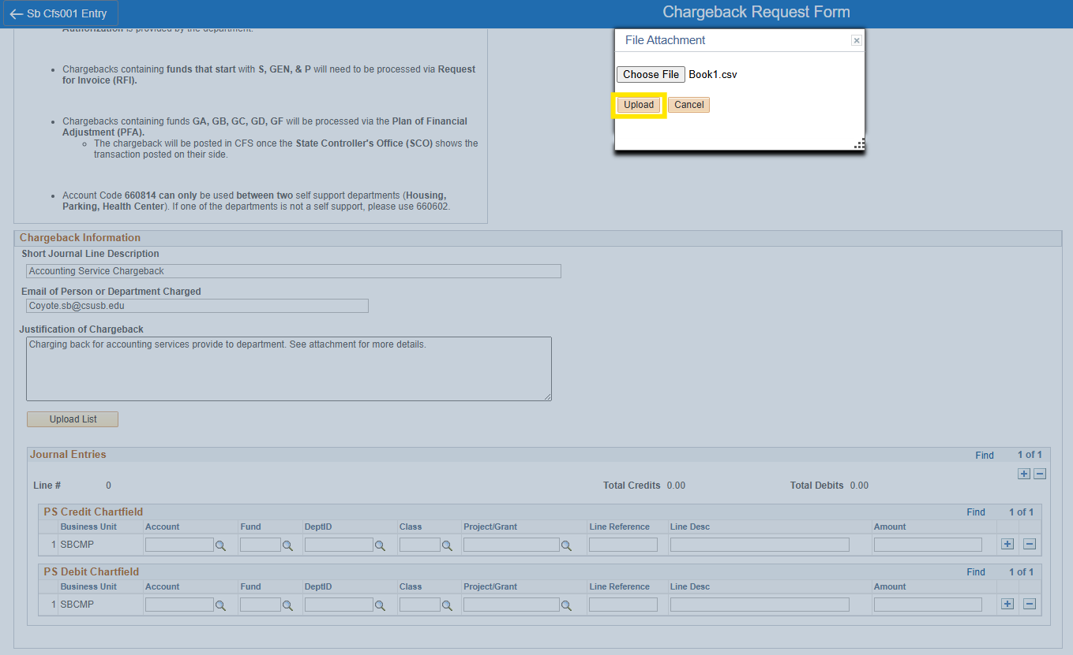

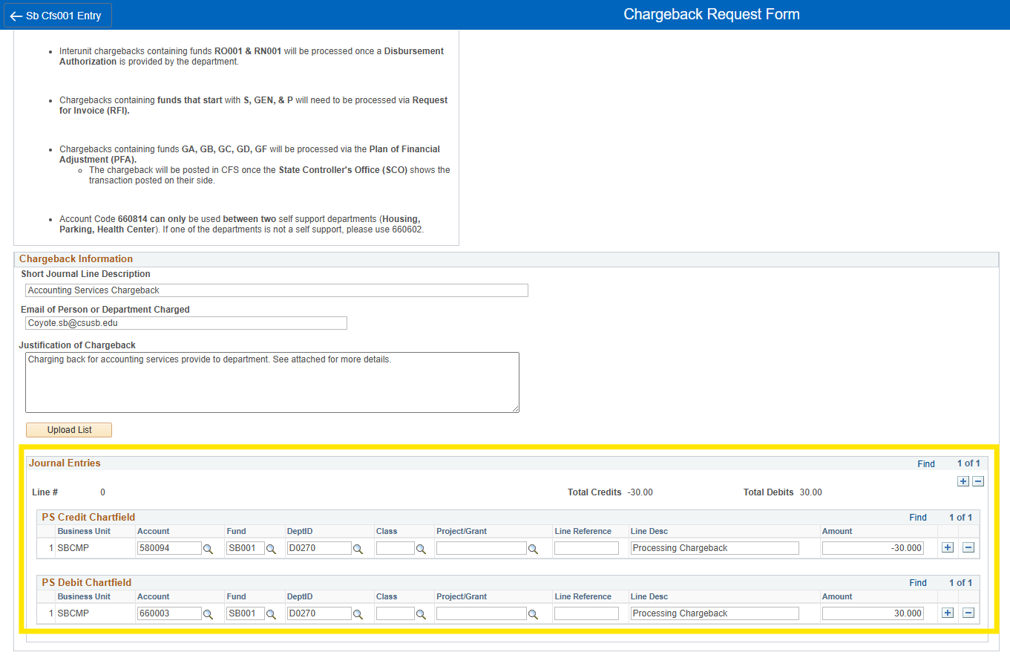

Figures: Option 2: Upload List Requirements and Process

Step 8: Add supporting documentation by clicking Add.

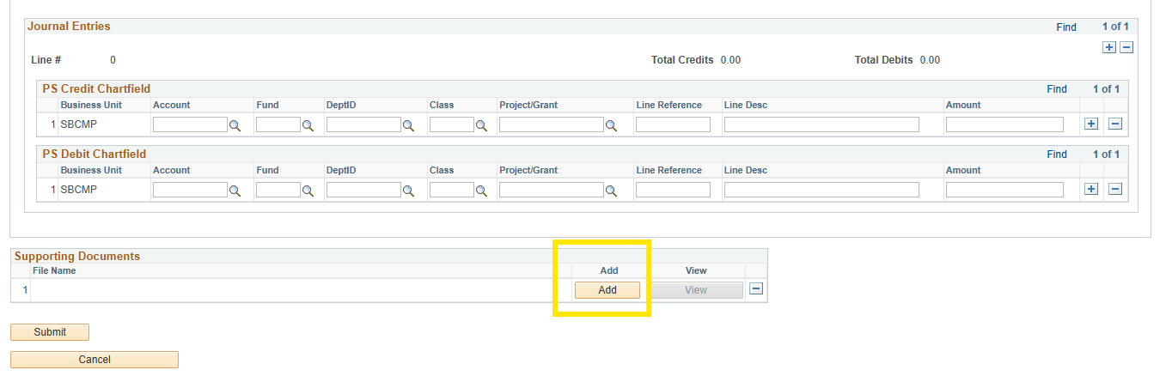
Figure: Step 8: Add supporting documentation by clicking Add.

Step 9: Click Submit to complete your Chargeback Request.

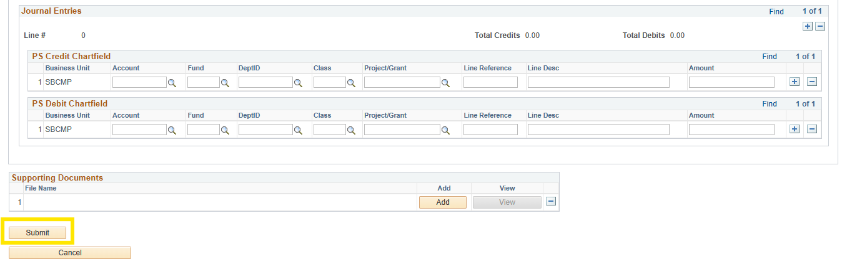
Figure: Step 9: Click Submit to complete your Chargeback Request.

6. Support
For questions regarding Chargeback Request submissions, contact Accounting Services or visit: https://www.csusb.edu/accounting/accounting-services.

