SPAN 5557: Study Abroad and International Experience
Summer 2026: Summer Session 1: June 2 – July 7 (July 8)*?

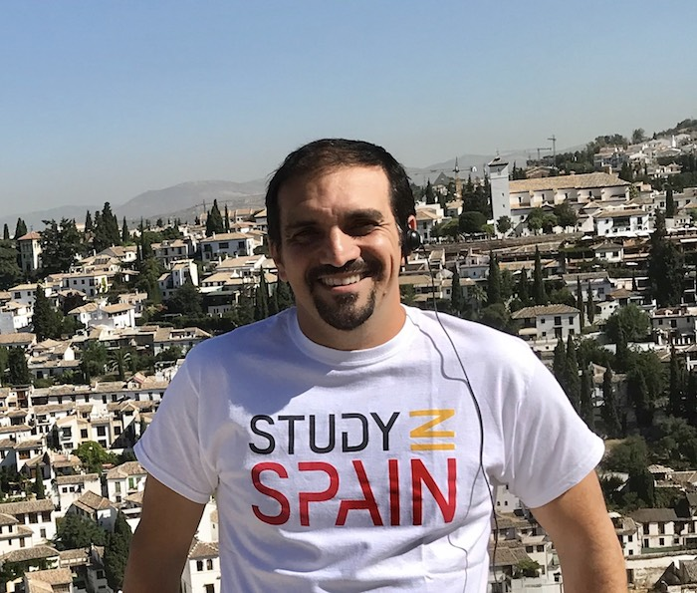 | Your professor: J. David Jerez-Gómez  Office: UH 201.45  Contact: 909-537-5851; jdjerez@csusb.edu  Office Hours: virtual and by appointment (TBD)  Professor Jerez-Gómez specializes in Medieval and Early Modern Spanish Literature and Humanities courses at CSUSB since 2006. He has coordinated Study Abroad programs in Spain for the World Language and Literatures and for Business and Management Administration with the Mediterranean Studies Academy.

COURSE TITLE: “El Camino de Santiago”/ “The Way of Saint James”: a journey of business and culture in Spain.

COURSE DESCRIPTION
The main objectives of this course are to enable you to enhance your learning in a study abroad location and to help you to better understand and reflect upon the experience as relevant for your professional career in Business Management, Public Administration and Spanish. The course will provide you with tools for analyzing your learning process and identifying cultural patterns, differences, similarities, and values. Ultimately it will navigate you towards perhaps becoming a global citizen while remaining an ambassador for your own culture.
COURSE FORMAT:
- This course is taught entirely in Spanish (with the only exceptions of this page, the START HERE module, and the syllabus).
- This course is graded credit/no credit.
- This course is taught partially online in synchronous format and partially face-to-face in Comillas and Santiago de Compostela as part of a study-abroad program.
- The first three weeks (June 2-23) are online. We will meet on Zoom every Tuesday (11-12pm) and you will work on your first assignment in preparation for the trip to Spain.
- The remaining two weeks (June 27-July 11)* are taught in Spain during face-to-face morning sessions Monday-Friday as well as through excursions and cultural visits. You will have a second assignment to complete during the stay in Spain.
*Tentative dates : June 23-26 window for flight and arrival to Spain

COMMUNICATION
- Email or office hours is the best way to contact me. I will try to answer your email inquiries within two working days (Mon-Fri). Please make sure to write “STUDY ABROAD” in the subject of the emails so I don’t miss them. We will use SLACK, an app for group work and communication, during this course.

COURSE PREREQUISITES
Instructor consent.

COURSE OBJECTIVES
1) Enhance students’ preparation for studying abroad through i) learning basic information about the host culture, ii) setting goals for the study abroad experience, iii) developing an awareness of students’ own cultural values, iv) developing an understanding of the concept of intercultural competence and, v) preparing students to interact with people in the host country and their own peers.
2) Enable students to reflect upon and deepen the study abroad experience while it is happening through i) structured reflections, ii) the development of an awareness of cultural difference, iii) the development of an understanding of culture’s role in shaping beliefs, practices and perceptions as related to the field of Business Management, iv) the development of new perspectives on students’ own culture, v) provide intercultural communication tools that will develop students’ ability to communicate competently in Spanish, and vi) explore the stages of cultural adaptation, especially focusing on culture shock.
3) Prepare students for a successful re-entry into their home culture through i) enabling them to develop a recognition of possible issues connected to re-entering the home culture, and ii) encouraging practical application of their experiences in academic and professional goals.
4) Support students in the reentry process by i) providing information on reverse culture shock and how to manage the re-adaptation process, ii) providing an outlet for student reflection on the personal impact of study abroad, and iii) presenting practical, on-campus involvement with international students and/or incoming study abroad students.

REQUIRED TEXTS: All materials will be provided at zero cost.

GRADING SCALE: This course is graded credit/no credit, based on the successful completion of the activities scheduled.

COURSE REQUISITES
Physical attendance in all activities in Spain 50%
Travel Diary 30%
Informational flyer and presentation (pre-departure) 20%

1. PHYSICAL ATTENDANCE IN SPAIN (50%)
It is expected that you attend all cultural activities, site visits, and excursions.

3. TRAVEL DIARY (30%)
Based on the cultural activities, site visits, and excursions during your study-abroad stay in Spain, you will complete a Travel Diary using PowerPoint or GoogleSlides. Details on this assignment will be given in class and will be posted on Canvas.

3. INFORMATIONAL FLYER AND PRESENTATION (PRE-DEPARTURE) (20%)
During the first three weeks of the course you will work in groups of 3 to develop an informational flyer on an assigned topic. You will then present the flyer orally to the rest of the class. Details on this assignment will be given in class and will be posted on Canvas.

PLAGIARISM AND CHEATING WILL NOT BE TOLERATED
Plagiarism is the presentation as one’s own, the ideas and writing of another. Plagiarism is academically dishonest and subjects the offending students to penalties up to and including expulsion. Students must make appropriate acknowledgements of the original source where material written or compiled by another is used. Plagiarism and cheating are violations of the Student Discipline Code (see Bulletin of Courses) and may be dealt with by both the instructor and the Judicial Affairs’ Officer. Procedures for addressing cheating and plagiarism are found in the Bulletin.

STUDENTS WITH DISABILITIES
If you are in need of an accommodation for a disability in order to participate in this class, please let me know, and also contact the Services to Students with Disabilities office at UH-183, (909) 537-5238. (ssd@csusb.edu)

CARE PROGRAM FOR STUDENTS
To help our students in need, CSUSB has implemented a number of Coyote Basic Needs resources. The Obershaw DEN, the PDC DEN, emergency housing, and the emergency loan program assist students when it is needed most. For more information, please see the website here: https://www.csusb.edu/basic-needs .

Statement of Inclusion, Diversity, and Equity
It is my intent that students from all diverse backgrounds and perspectives be well served by this course, that students’ learning needs be addressed both in and out of class, and that the diversity that students bring to this class be viewed as a resource, strength, and benefit. All students are welcome and all students belong in this class regardless of race, ethnicity, gender identity, political stance, religion, citizenship, or immigration status whether the status is documented or undocumented. If your name and/or pronouns differ from those on your college record, please let me know. If anything in the course content, lectures, or discussions prevents you from engaging in the course in the richest way possible, please let me know by email or other method.

COURSE CALENDAR: Detailed information of activities will be posted on Canvas.
The due dates for the assignments are the following:
- Presentation of the informational flyer: Tuesday, June 17, on Zoom (11-12pm)
- Informational flyer: submission on Canvas by Tuesday, June 17, by 11.59pm
- Travel Diary: submission on Canvas by Saturday, July 7, by 11.59pm

