|  |  |  |
| --- | --- | --- |
|  |  | Position Management QueryPROCESS GUIDE |

|  |  |
| --- | --- |
| **DATE CREATED** | **PROCESS NAME** |
| 4/25/25 | Position Management Query |
| **PROCEDURE NO.** | **PROCESS OWNER** |
|  | University Budget Office |
| **DATE OF LAST UPDATE** | **LAST UPDATED BY** |
|  | Danelle Apodaca |

INTRODUCTION

Follow the guide to run the Position Management query. The query will bring back positions for departments you are authorized to view.

PROCESS

1. Log into myCoyote
2. Click on Administrative Systems

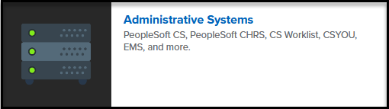

1. Click on PeopleSoft Campus Solutions (CS)

1. Menu > Reporting Tools > Query Viewer

1. Menu > Reporting Tools > Query Viewer

1. Run Query to Excel

