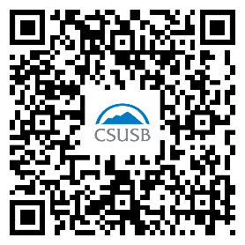
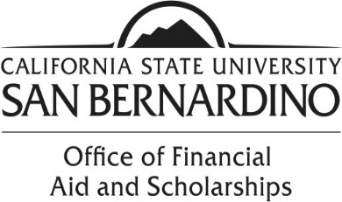

Loan Acceptance Instructions

If you are interested in your Federal Direct Student Loans, you need to complete several steps in order to ensure you receive your loan funds.

- You must accept your Direct Loans.
  - Log on to your MyCoyote.
  - Click on “Student Center”.
  - Scroll down to “Finances”.
  - Click on “Accept/Decline Awards” link.
  - Click on the year designated for your award year.
    - For example, click the “2025” link for the 2024-2025 Award.
  - You may now click the “Accept” button for the loan you would like to accept.
    - You may reduce the amount you would like to accept.
    - If you decline your loan(s), you must submit a Loan Adjustment Request form to request your loan(s) be reinstated.

- You must complete an “Electronic Master Promissory Note” (MPN).
  - You will need your FSA ID Username and password.
  - You will need the name and full address of two references.
  - This requirement must be met if you are a first time borrower or have not used a government MPN for ten years.
  - Log on to studentaid.gov

- You must complete an “Online Entrance Loan Counseling”.
  - You will need your FSA ID Username and password.
  - This requirement must be met if you are a first time borrower.
  - Log on to studentaid.gov

Additional Resources:

Log in to the Federal Student Aid website at https://studentaid.gov for the following:

- Locate and monitor your student aid history.
- Complete the required Exit Counseling before departing from the University.
- Complete a Financial Awareness Counseling session to help you manage your finances.

