CSUSB’s Zoom tool for hosting and attending video conferences is a great way to connect with multiple audiences. Page 2 provides your Zoom MENU.
Zoom allows groups of up to 200 students to join and host online meetings, conferences, and chats. With Zoom, you can virtually rehearse projects and record meetings to view later. From anywhere, students, faculty and staff can meet using their laptop, desktop, and tablet, or smartphone. Zoom is compatible with iOS, Mac, Android, and PCs.

Requesting a Zoom Session
If you are planning an on-campus meeting/event using one of the campus conference rooms or classrooms, it is imperative that you follow the instructions below.
Planning ahead is highly recommended.
Equipment required for a successful Zoom meeting include:
A computer webcam (camera) and microphone (most cameras will come with a built in microphone but always double check).

Campus computers in classrooms (are not equipped with basic equipment - refer to contact list below for assistance).

Conference rooms should be equipped with basic needs (refer to contact list below for assistance).

Locations to host a session for groups larger than 3 attendees:
- On-campus Conference Room locations
  - Contact your department Administrative Support Coordinator to see if your conference room is equipped for Zoom.
- On-campus Classroom/ Lab (PL-013, PL-025, PL-045)
  - Contact Joeleen Monclova, ATI Distance Learning Tech at 73469 or joeleen@csusb.edu
- On-campus Training Lab (PL-1104)
  - Contact ITS Training Services at 77425
- PDC Campus
  - Contact Jack McFarlane, Director of Campus Operations PDC at 78105 or jack.macfarlane@csusb.edu

Select the Collaborate icon then the Zoom Icon from MyCoyote Portal.

Select Host a Meeting to begin. Open URL: Zoom Launcher

(Zoom will establish a connection).
Figure 2 image Zoom Header how to join a meeting and host a meeting link

Navigating through the Meeting Menu

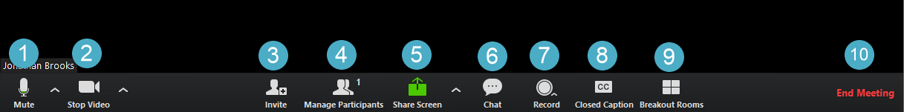
Figure 3 image Zoom in meeting navigation tools

- Mute/Unmute: allows you to quickly mute/unmute your microphone. The arrow button to the right brings up the audio options to select a different microphone if one is connected.
- Start/Stop Video: allows you to quickly turn your video camera on/off. The arrow button to the right brings up the video options to select a different camera if one is connected.
- Invite: brings up an option to email an invitation using “Default email, Gmail, or Yahoo mail”. You can also simply copy the join link from here and send it to the participants.
- Manage Participants: opens a new window (either attached or free floating) that allows you see all of the people currently in the meeting. It also allows you to manage the participants by muting/unmuting, making host, removing from the meeting etc.
- Share Screen: allows you to share your screen with the others in the meeting. You will have a few options, you can either share your entire desktop (allowing people to see everything as it appears on your computer screen), or you can share a specific program or window which will only share that window and if you move to a new program the meeting participants will not see the new program.
- Chat: opens a new window and allows you to text chat with the participants in the meeting. You can send a message either privately to a specific person or to the entire meeting.
- Record: allows you to record the meeting. If your settings allow for both local and cloud recording you will be asked which one you would like to use. Local will record the files directly onto your computer. The cloud recording will record the meeting into Zoom’s cloud video hosting and a link will be sent to your email after the meeting has ended. The links will include a share link that will allow you to watch the recording and a link to download the file to your computer.
- Closed Caption: allows you to set a particular person in the meeting as a closed captionist (someone to write down everything that is being said).
- Breakout Rooms: allows you to break the meeting participants into groups. Once in groups, the participants will go into a separate Zoom meeting room, and the host will have the option to join any of these new rooms or stay in the larger room until the groups return.
- End Meeting: closes and ends the Zoom meeting.

