Zoom Basics for Students
Michael Chao

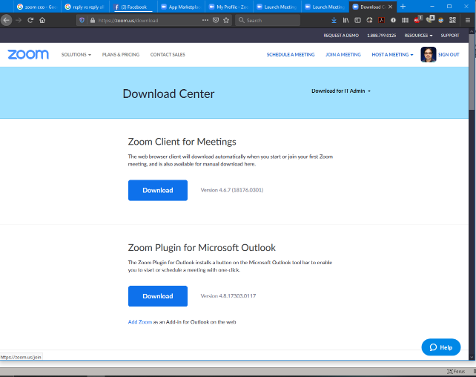
1) Download the Zoom app. From a computer you can obtain it from here using your web browser:
Figure 1. Download Zoom.

https://zoom.us/download

The download link you want to use is titled "Zoom Client for Meetings" (Fig. 1). You can also download it from your mobile device's app store.

2) Launch the app and sign in. The first time you launch Zoom it should look something like Fig. 2. IMPORTANT: At this time, do NOT enter your personal email or university email. Instead, click the button on the right that says, "Sign in with SSO".
Once you click this, you should see the SSO sign in screen (Fig. 3). In the blank space that says, "Enter your company domain", enter "csusb". This should launch your web browser and bring you to the familiar my.csusb.edu login screen; login as usual.

3) Using Zoom for the first time: Once you have logged in, you should see something that looks like Fig. 4. If it looks different, click the "Home" icon at the top. As a participant, the function you will use the most is the "Join" button.
Figure 2. Zoom login screen.
4) The next screen looks like Fig. 5. Your professor should have provided you with a meeting ID# (e.g., 123-456-789). Enter that number into the box and hit join. Or, they might provide a meeting link through email or a Blackboard announcement that looks like "https://csusb.zoom.us/j/123456789". Your professor may also provide a telephone dial-in number to connect, in case you don't have an internet connection. Finally, in most cases your professor will record his class and will post a link to it on your course website (usually Blackboard), so that you can view it later when you can get to a computer and internet connection.
5) Zoom has a lot of other more advanced features that you can (and should) explore on your own. These are the basics to get you up and running.
Figure 5. Join a meeting.
Figure 4. Zoom home screen.
Figure 3. SSO sign in screen.

