Zoom Basics for Instructors
Michael Chao

These instructions are meant to get you up and running at a bare minimum level. Zoom has a ton of more advanced features that you can and should explore on your own. Importantly, there is almost nothing you can do to mess up Zoom, so experiment! If you have more than one device in your household (e.g., a computer and a cell phone), you can actually connect with your account twice; one connection acts as a host, and the other as a participant. The host connection works better on a computer. Your other device (e.g., perhaps an iPad or another computer) gives you a "student view", so to speak.

This handout assumes you have read the "Zoom for students" handout, which has login instructions for first-time users. It also assumes you are using a computer (either laptop or desktop) for the host connection, although in principle you can also use a mobile device such as a cell phone or tablet to host. The interface for mobile devices will be a little different.

The diagram to the right is the Zoom home screen. There are two ways to start a Zoom meeting. You can use the red "New Meeting" button, or the "Schedule" button. Each method has pros and cons.

Each Zoom meeting has a unique ID#: a 9-digit number that looks like 123-456-789. When you start a New Meeting, Zoom automatically generates a new ID#. This is the fastest way to start a new meeting. However, since the ID# is generated randomly, it can be a little difficult to send that information to students in a timely way. If you are using Zoom only to record lectures and plan to teach asynchronously, then starting meetings this way is the preferred method. On the other hand, if you are planning on at least partially doing synchronous (i.e., "live" real time) meetings, you might want use the "Schedule" function instead.
The "Scheduling Meeting" window is shown to the right. There are a ton of options here - I will try to focus on the important ones. First is Meeting ID. Each Zoom user has a unique Personal Meeting ID, which is analogous to your personal phone number. You can have all your Zoom meetings use your Personal Meeting ID; the advantage is that students can now easily find your Zoom meetings by just joining this number. The disadvantage is that they can "call" you at any time they want - when they try to start a meeting with you using this number you will get an email notification, which I imagine can get irritating outside of designated meeting times. On the other hand, if you choose the "Generate Automatically" option, each meeting will have a different ID number. Although this has the advantage of not giving away your "personal phone number", this also means that you need to distribute each meeting ID ahead of time. Obviously, use your judgement as to what you think will work best for your class.

I don't recommend requiring a password. The "Video" option refers to you and your student's webcams or selfie cameras on their devices. The on/off selection only determines what happens when you start the meeting; once the meeting starts, participants can turn their cameras on or off at will.

For "Audio", I recommend using "Telephone and Computer Audio". This means that students can connect through the internet, but they can also call in through a regular phone (either a land line or cell) in a second-to-worst case scenario (the worst case being they don't even have a phone). If they want to call in, they still need to know the Meeting ID#. We'll leave other options alone for now.
If you used the "New Meeting" red button option above, then you are already looking at the main meeting interface (see below). However, if you used the "Schedule" option, you should see your meetings listed beneath the clock, as seen to the right. You can start a meeting at any time, even if scheduled time has not started yet. Just hit the start button.

The above diagram shows the main meeting interface of a meeting that just started. You should choose "Join with Computer Audio". In general, most laptops and iMacs will have built-in speakers and microphones that should work just fine, and you can use the "Test Speaker and Microphone" function to see if they work. If you have a PC, then your mileage may vary. The easiest way to get working "speakers" and microphone is to get a headset with a built-in mic and 3.5 mm audio jack. Cheap ones run around $20 on Amazon, but if you anticipate using them for long periods of time, I recommend getting one that is at least $50 with foam cups for long term wearing comfort. If you are a gamer or know of a gamer in your life, get their recommendation for a nice gaming headset! Gaming headsets are known for their audio quality and comfort (but they may look a little garish and cost a little more). Unless you are technically savvy, I do not recommend Bluetooth headsets. Get your dean to pay for a nice headset - online is NOT CHEAP! :)

The above meeting window has a black bar along the bottom, and this is where the majority of your controls are. If you accidentally closed the "Join with Computer Audio" dialogue box above, don't worry - you can just click the "Join Audio" button on the bottom left. You can also turn on your video camera now by clicking "Start Video". The most important stuff on this screen are the green "Share Screen" button, the "Invite" button, and the "Record" button.

Record: Zoom can record all meetings for asynchronous viewing buy students. When you hit the record button, it gives you two options: Record on this Computer (NOT RECOMMENDED) or Record to the Cloud (YES DO THIS). Once you hit the button, everything you do is being recorded. This includes "oh sh*t" utterances when you inevitably do something wrong, so be careful.
Once a recording starts, you will see two new buttons replace the original record button. Pause will pause the recording (for instance, if you are taking a break), but remember to re-start it again when appropriate. Stop recording will give you a confirm dialog; if you confirm "yes", then Zoom will save the recording to their cloud server. It may take awhile for this conversion process, so be patent. Zoom will send you an email when the conversion is complete.

The "Invite" button provides information on how others can join the meeting. As described earlier, if students already know the Meeting ID# they can join that way. When you press "Invite", the dialog shown to the right pops up. The button on the bottom left "Copy URL" copies the URL for the meeting to your clipboard (you can paste into other programs). More importantly, "Copy Invitation" creates text that has information on how to join the meeting through a phone (that connection would be voice only, obviously, but could be better than nothing).

Share Screen: Here is the meat of an online presentation. when you click the green "Share Screen" button, this brings up this window. You are now choosing what you want to share with your participants (students). If you want students to see exactly what you are seeing, then you should choose "Screen". This mirrors everything you are doing on the screen. If you have other windows open with private info (such as a gradebook), this will display EVERYTHING so be careful with this. Most of us will want to share a Powerpoint, for instance. In this case, click on the Powerpoint presentation thumbnail shown (in my example, it's the one that says "05 - cell cycle and cancer.pptx"). If you don't see the Powerpoint you want to share, it's probably because you haven't opened the file yet; close this dialog box (click the x in the upper right hand corner) and from your desktop environment, open the file. Switch back to Zoom and "Share Screen" and try again. Note that you don't HAVE to use Powerpoint; for instance, if you have been a blackboard/whiteboard "chalk-talker", you can share a Word document and type notes as you lecture.

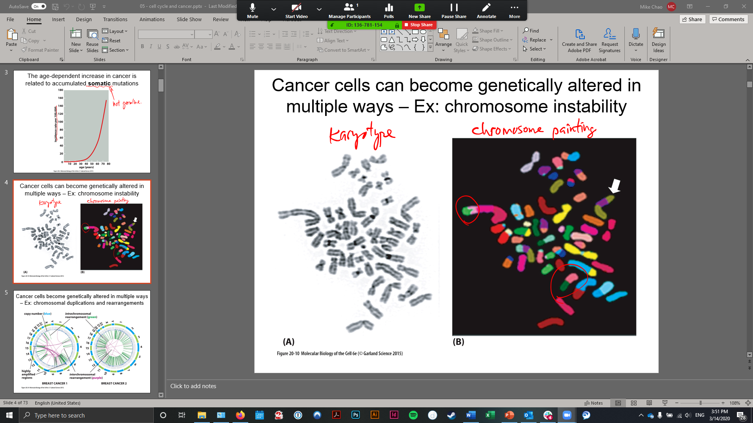

Once you have selected to share your Powerpoint (or other file), you should see something like the figure above. Zoom should automatically switch to Powerpoint, and at this time you can do anything you want in Powerpoint you usually do, including editing the file, using the slideshow function, etc. Your students can see anything you are doing. What we want to focus on is the toolbar at the top, which is an overlay that Zoom superimposes over your application (in this case, Powerpoint). The green highlighted area shows your meeting ID#, and the red "Stop Share" stops sharing your screen with students and takes you back to the previous screen. You can also click "New Share" and switch to a different window or application to share. Two things to highlight:

Under New Share, you can share a virtual whiteboard. This brings up a blank screen with various annotation tools, including the ability to type and to draw with your mouse. You can use this to have a simulacrum of a real classroom with a projector and a whiteboard - the only caveat is you have to switch between them, you cannot display them at the same time.

Under Annotate, there are several tools that allow you to annotate the screen with markers, labels, typed text, marker drawings, etc. There is also a virtual laser pointer there.

Once you stop sharing your screen, you will go back to the main meeting page. To end the meeting, there are big red letters on the bottom right that say, "End Meeting". Pretty self explanatory.

Those are the basics! You can get a lot fancier, but this should get you up and running. Again, the best way to figure this out is to get two devices and play with it - do things on the host computer as a presented and see what the output display looks like on the participant device. One thing you should learn on your own is how to view the Participant List and mute/unmute participants. You can login on different devices at the same time with the same login credentials. If you have an iPad or Surface with a stylus, you will be able to do things like write on your virtual whiteboard (useful for things like diagrams and equations). Get your dean to buy you an iPad :)

