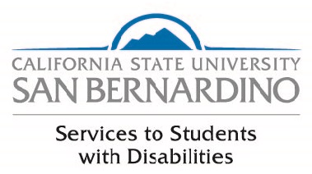

Student Resource Guide

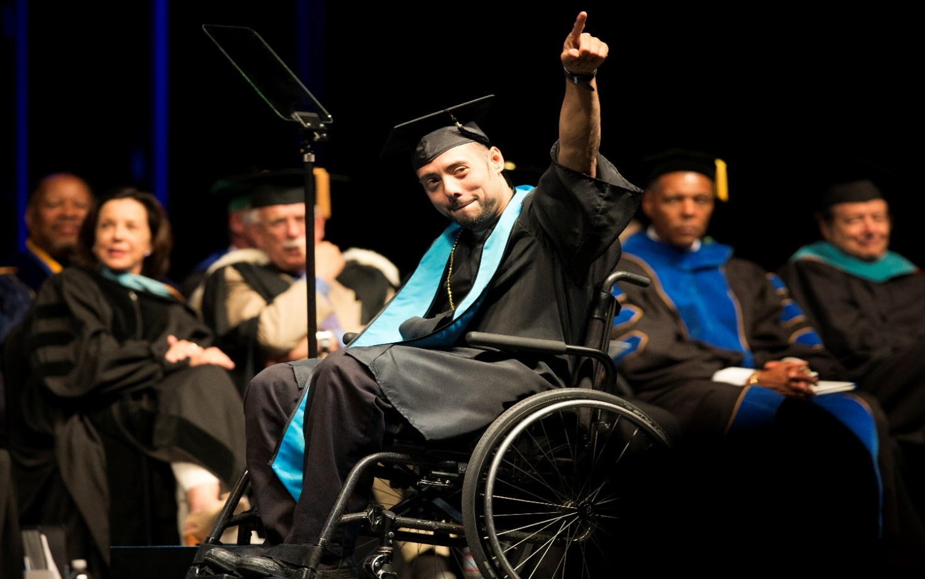
SSD student points toward crowd at graduation.

Acknowledgements
We would like to acknowledge two students for their dedication in the completion of the Student Resource Guide: Naomi Schmierer for her work on the first edition, and Max Bulgatz for his tireless persistence in the completion of the second edition of the Student Resource Guide.

Contact
5500 University Pkwy University Hall, Suite 183 909.537.5238 (Voice)
909.537.7230 (TTY)
909.537.7090 (Fax)

Revised August 2019

Mission Statement
The office of Services to Students with Disabilities (SSD) strives to empower students with disabilities by fostering skills of self-advocacy, resourcefulness, and independence. The SSD office works collaboratively with the campus community to remove barriers and promote an enriched learning environment where students with disabilities can utilize their skills and pursue their academic and personal development goals.

Subject to Change Disclaimer
The policies and procedures in this Student Resource Guide are subject to change without prior notice, if necessary, to be consistent with SSD policies and procedures and to maintain compliance with University policies, California State University policies, and State and Federal laws.
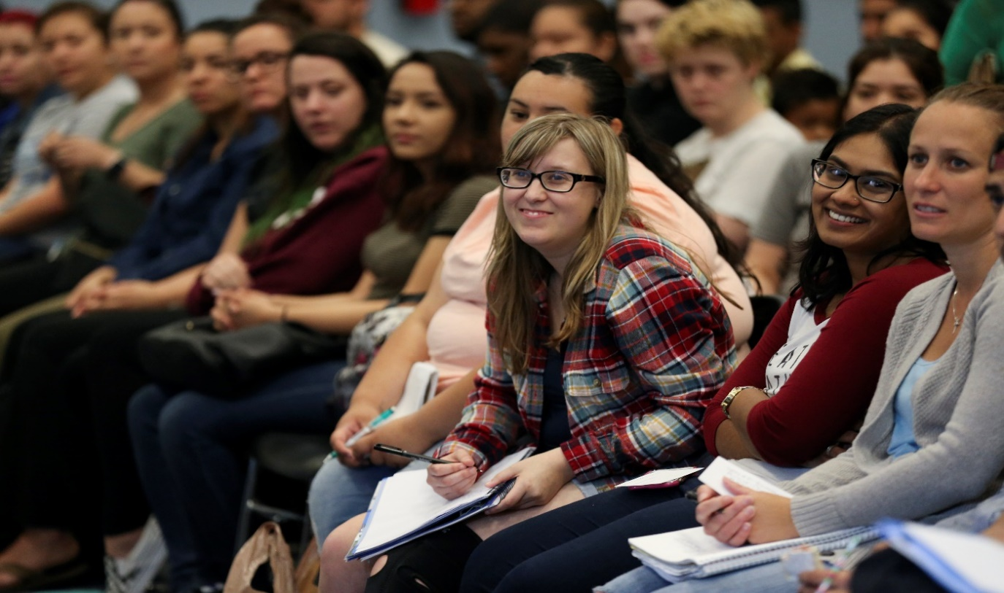
Student attentively listens and takes notes during presentation at the Ability Awareness event.

Table of Contents

Acknowledgements ii
Contact ii
Mission Statement iii
Subject to Change Disclaimer iii
Table of Contents iii
Introduction 1
Student Rights and Responsibilities 1
Laws that Protect the Rights of Students with Disabilities 3
Differences Between High School and College 7
What is a Disability? 8
What is a Functional Limitation? 10
How do I Become Eligible for Services? 11
Accessibility 15
Accommodations/Support Services 15
Accessible Furniture 16
Alternate Media 17
Assignment Accommodations 18
Assistive Listening Device 18
Cart Service 18
Class Aide 19
Exam Accommodations 20
Notetaking Services 21
Priority Registration 21
Real Time and Remote Captioning 21
Sign Language Interpreters 22
SmartPen Program 23
Visual Impairment Orientation 23
Policies, Guidelines, and Procedures 24
University Policies and Procedures 24
General SSD Procedures and Guidelines 25
Confidentiality 27
Conflict Resolution Procedure 29
Nepotism 39
Lobby Guidelines 39
Gift-Giving Guideline 40
Accommodation Related Procedures and Guidelines 40
Accessible Furniture 40
Alternate Media 42
Captioning Services 44
Class Aide 49
Exam Accommodations 50
ASL Interpreting Services 53
Notetaking 55
SmartPen 57
Visual Impairment Orientation 59
Student Involvement 61
Student Listserv 61
SSD Advisory Board 61
Campus Accessibility Advisory Board (CAAB) 62
Instructional Materials Sub-Committee (IMAP) 62
University Partners 63
Academic Services and Advising 64
ADA Compliance Officer 64
Assistive Technology and Accessibility Center (ATAC) 65
Associated Students Incorporated (ASI) 66
Campus Safety (UPD) 67
CARE Team 67
Career Center 68
Counseling and Psychological Services (CAPS) 68
Coyote PLUS (Peer Led Undergraduate Success) Programs 69
Early Start Program (ESP) and Coyote First Step (CFS) 71
Educational Opportunity Program (EOP) 72
Helene A. Hixon Information Resource Center 73
Housing Needs 73
John M. Pfau Library (Disability Resources) 73
Math Coaching 74
Multimedia Language Center 75
Obershaw DEN 75
Office of Financial Aid and Scholarships 76
Office of Graduate Studies 76
Office of Student Engagement 77
Ombuds Services 77
Parking Services 77
Recreation and Wellness Center 78
SMSU Identity Centers 79
Student Assistance in Learning (SAIL) 79
Student Employment 80
Student Health Center 80
Student Success and Equity Programs 81
Undergraduate Studies Computer Lab 81
University Honors Program 82
Veterans Success Center (VSC) 82
Web Accessibility 83
WorkAbility IV (WA-IV) 83
Writing Center 84
Off-Campus Resources 86
211 86
Ability Tools 86
The Braille Institute 86
California Department of Rehabilitation (DOR) 87
Children & Youth Services SBC 87
Community Access Center 88
Community Action Partnership SBC 88
Crisis Services SBC 89
Homeless Outreach Support Team (HOST) 89
The Inland Empire Lighthouse for the Blind 90
Path of Life 90
Recovery Based Engagement Support Team (RBEST) 91
Riverside Transit Agency 91
Sahaba Initiative 92
VTrans-Omnitrans 93
Sources 95
Appendices 96
Accommodation Deadlines 97
Application for Services 98
California State University, San Bernardino 100
Services to Students with Disabilities 100
Student Information Center 100
Disability Verification Request 102
Documentation of Disabilities 104
Documentation Guidelines for Learning Disabilities 105
WorkAbility IV 108
Records Access Request Form 109
Maps 111

Introduction

Student Rights and Responsibilities

Every student with disabilities at California State University, San Bernardino (CSUSB) has the right to:
- Equal access to courses, programs, services, jobs, activities, and facilities available through the University.
- Reasonable and appropriate accommodations, academic adjustments, and/or auxiliary aids determined on a case-by-case basis.
- Appropriate confidentiality of all information pertaining to his/her disability with the choice of whom to disclose their disability to except as required by law.
- Information reasonably available in accessible formats.

Each student must meet or exceed the essential requirements of California State University, San Bernardino (CSUSB) and its programs with or without accommodations. Although the Americans with Disabilities Act Amendments Act of 2008 (ADAAA) protects the civil rights of qualified students with disabilities, it also affirms their right to refuse any accommodation. Thus, students are not required to register with SSD, identify themselves to instructors, staff, or other students as having a disability, or accept accommodations they do not need or want. However, if students wish to compete with their peers on a level playing field and if they wish to enjoy their right to access and equality, they must advocate for those rights.

Every student with a disability has the responsibility to:

- Meet the University’s qualifications and essential technical, academic, and institutional standards.
- Identify themselves in a timely manner as individuals with a disability when seeking an accommodation.
- Engage in an interactive process to determine appropriate academic accommodations.
- Provide documentation from an appropriate professional source that verifies the nature of the disability, functional limitations, and the need for specific accommodations.
- Follow specific procedures for obtaining reasonable and appropriate accommodations, academic adjustments, and/or auxiliary aids.

Aerial shot of the CSUSB campus including the library, student union, and clock tower.

Laws that Protect the Rights of Students with Disabilities

SSD abides by California statutes, national legislation, and California State University executive orders that pertain to individuals with disabilities.

California Education Code
California Legislative Information

California law consists of 29 codes that cover various subject areas, which includes the Education Code. All California State Universities (CSU) are accountable to the regulations and statutes stated in the California Education Code that pertain to post-secondary institutions.

Section 504, Rehabilitation Act of 1973
Section 504

The Rehabilitation Act of 1973 was the first “rights” legislation to prohibit discrimination against people with disabilities. This law, however, applied only to programs conducted by federal agencies, those receiving federal funds, such as colleges participating in federal student loan programs, federal employment, and employment practices of businesses with federal contracts. Additionally, this legislation authorizes the formula grant programs for vocational rehabilitation, supported employment, independent living, and client assistance. Among the sections that pertain to individuals with disabilities is Section 504.

Section 504 states that “no qualified individual with a disability in the United States shall be excluded from, denied the benefits of, or be subjected to discrimination under any program or activity that either receives federal financial assistance or is conducted by any executive agency or the United States Postal Service.”¹

“Qualified” with respect to post-secondary educational services means “a person who meets the academic and technical standards required for admission or participation in the education program or activity, with or without reasonable modifications to rules, policies or practices; the removal of architectural, communication or transportation barriers; or the provision of auxiliary aids and services.”¹

Section 508, Rehabilitation Act of 1973, as amended
Section 508

Section 508 of the Rehabilitation Act of 1973, as amended, was originally an amendment passed in 1998, which specifies that federal agencies must make their electronic information (EIT) accessible to people with disabilities. According to the Section 508 website, “This law applies to all federal agencies when they develop, procure, maintain, or use electronic information technology. Under Section 508, agencies must give disabled employees and members of the public, access to information that is comparable to the access available to non-disabled people.”²

Americans with Disabilities Act of 1990 (ADA)
ADA Website

The Americans with Disabilities Act of 1990 (ADA) is the most comprehensive federal civil rights legislation protecting the rights of individuals with disabilities. The ADA addresses the barriers and discrimination that people with disabilities have traditionally faced. According to the ADA, “a person with a disability means any person who 1) has a physical or mental impairment which substantially limits one or more major life activities [including walking, seeing, hearing, speaking, breathing, learning, and working], 2) has a record of such an impairment, 3) is regarded as having such an impairment.”³ Disabilities covered by the legislation include, but are not limited to: AIDS, cancer, cerebral palsy, diabetes, epilepsy, head injuries, hearing impairments, specific learning disabilities, multiple sclerosis, muscular dystrophy, psychiatric disorders, speech impairments, spinal cord injuries, visual impairments, and loss of limbs.

Americans with Disabilities Act Amendments Act of 2008 (ADAAA)

EEOC ADAAA Website

In 2008, the ADA of 1990 was amended and renamed the Americans with Disabilities Act Amendments Act of 2008 (ADAAA). The amendment was added to broaden the definition of a disability to provide wider coverage for individuals, and establishes that extensive analysis of an individual’s disability shall not be required for proving the disability.

“The Act makes important changes to the definition of the term ‘disability’ by rejecting the holdings [court decisions] in several Supreme Court decisions and portions of the U.S. Equal Employment Opportunity Commission ADA regulations. The effect of these changes is to make it easier for an individual seeking protection under the ADA to establish that he or she has a disability within the meaning of the ADA.”⁴

Family Educational Rights and Privacy Act (FERPA)
U.S. Dept. of Education (FERPA)

The Family Educational Rights and Privacy Act (FERPA) (20 U.S.C. § 1232g; 34 CFR Part 99) is a federal law that protects the privacy of student’s education records. The law applies to all schools that receive funds under an applicable program of the U.S. Department of Education.

Executive Order 1111
EO 1111

Executive Order 1111, issued on May 23, 2018 by California State University (CSU) Chancellor Timothy P. White relates to disability support and accommodations across all CSUs. This order supersedes Executive Order 926, and contains critical information regarding the specifics on how CSU campuses must comply with ensuring physical access to programs, accessibility of information resources as well as technology access, disability support & accommodations for students, disability support & accommodations for students in employment, and disability support & accommodations for students in contracting.

Differences Between High School and College
High School | College
Support by the individualized Education Program (IEP) team, which includes parents & faculty. | Students must request accommodations from the Disability Services (DS) Office.
School is responsible for accommodations in order to provide the least restrictive environment (LRE). | Students must self-advocate for and request accommodations from DS provider.
Parents have access to students’ records/grades until age 18. | Parents have no access to students’ records without written consent beginning at age 18.
IEP advocates for students. | Students advocate for themselves with support as needed from DS provider.
Team meets periodically with teachers and parents to discuss students’ educational progress. | Faculty members, seldom, if ever, interact with parents. Students are expected to address issues with them directly.
Section 504 of the Rehabilitation Act of 1973 in the public schools includes “Free and Appropriate Public Education.” | Section 504 upholds the institution’s right to maintain their academic standards, and no accommodations may be permitted to reduce that standard for any student. Student must meet all entrance and academic requirements.
Public schools, for the most part, are responsible for appropriate assessment of a student’s disability. | Equal access to education is the order of the day – no one is entitled to anything, but rather students have civil rights and they must advocate for themselves.
Some subjects may have been waived for a student if they relate to the student’s disability. | “Waivers” for requirements are never granted. Substitutions are typically granted after the student has provided adequate verification to SSD of their disability.
Assessment, physical or other therapy, or personal care provided by school. | Care can be requested by students at the Health Center or Counseling and Psychological Services.
Students often receive “un-timed tests” if they have a disability. | All tests are timed, while some receive certain time extensions depending upon the disability.

High School | College
Education is a RIGHT and must be accessible. | Education is NOT a right. Students must go through an admissions process and meet certain criteria to be admitted.
The Individuals with Disabilities Education Act (IDEA) entitles or guarantees disabilities services and accommodations to students with disabilities. | The applicable laws are the Americans with Disabilities Act Amendments Act (ADAAA) and Sections 504 and 508 of the Rehabilitation Act.
IDEA is about success in the LRE. | ADAAA/504 & 508 is about ACCESS.
Fundamental modifications of curricula possible. | Modifications are not required.
The school district is responsible for identifying the disability and developing an IEP. | Students must self-disclose disability and request accommodations. An IEP is not recognized.
Personal services (i.e. personal care attendant, OT, SPL, aide) are required and funded by the school. | Personal services are not required.
The school district is responsible for the evaluation process leading to the development of an IEP. | Students are responsible for providing their own evaluations/documentation.
https://www.paper-clip.com/Main/Product-Catalog.aspx

What is a Disability?
California State University, San Bernardino adheres to the civil rights definition of disability. Eligibility for civil rights protection requires the applicant to meet one of the following three criteria in the civil rights definition of disability:
- Have a physical or mental condition that substantially limits one or more major life activities;
- Have a record of such a physical or mental condition; and/or

- Be regarded as having such an impairment, whether actually having the impairment or not.
Examples of disabilities include, but are not limited to:

Arthritis, Attention-Deficit/Hyper-Activity Disorders, blindness/low vision, cerebral palsy, communication disorders, deafness/hearing impairments, emotional/psychological disabilities, multiple sclerosis, seizure disorders, specific learning disabilities, spinal cord injuries, temporary disabilities, traumatic brain injuries, and other health impairments.
Each student must provide current written documentation that verifies the existence of a temporary or permanent disability. Verification of the disability should include diagnosis, medication, a description of the functional limitations that may affect academic performance, a rating of severity, and a recommendation for accommodations. The documentation must contain the printed and signed name of a licensed physician, psychologist, social worker, or any authority qualified or certified to assess the disability. This person cannot be related to the student. For learning disabilities, students may review the documentation procedure online at the following link: LearningDisabilityDocumentation.
Doctor discusses medical information with patient.

What is a Functional Limitation?
A disability must limit functioning in the academic setting before a student can receive an accommodation. SSD refers to the effects of a disability on program access as a functional limitation. A disability, in and of itself, does not necessarily require accommodation. There must be a logical link between the functional limitation stemming from the disability and the accommodation requested.
SSD counselors identify functional limitations through discussion with the student and a review of documentation. For example:
- A blind student may have text available in an accessible format (e.g. electronic or Braille). In this case, the disability — blindness — causes the functional limitation — an inability to read printed text.
- Visual impairment, however, does not necessarily prevent one’s ability to take notes during a course lecture. Therefore, a visually impaired student may not be eligible for notetaking services because the functional limitations of some degrees of visual impairment do not affect the ability to take notes.
To facilitate the prompt provision of reasonable accommodations, it is best to have documentation of a disability, which details functional limitations. Should the documentation provide inadequate information about functional limitations, the SSD Counselor may require additional documentation that describes them.

How do I Become Eligible for Services?

Responsibilities of the SSD Counselor/Specialist Include:

    - Determine the student’s eligibility for SSD services based upon a review of appropriate documentation.
    - Determine appropriate accommodations for each student through an interactive process based on the individual’s need and a review of documentation.
- Ensure the student receives appropriate accommodations.

Responsibilities of Students Include:

- Filling out and submitting the Student Information Form (SIF) to SSD, which is available through the SSD Website (See Appendix A).
    - Provide the SSD office with appropriate medical, psychological, psychoeducational, or neuropsychological documentation indicating the student’s disability, resultant functional limitations, and impact of the disability in a post-secondary environment.
If eligibility is determined, the student will meet with the appropriate SSD Counselor/Specialist to complete an intake, at which resources and accommodations will be discussed and arranged.
Steps to Determining Eligibility

Step 1: Contact SSD

Contact the SSD office for registration materials. You must provide documentation of disability directly to SSD — not to your program or the Office of Admissions and Student Recruitment. All contact with SSD is confidential. Disability-related information is not released except on a need-to-know basis.

Step 2: Complete and Submit

Fill out and submit the Application for Services packet, including documentation of the disability, to the SSD office at ssd@csusb.edu. Without submission of documentation, the processing of the student’s application may be delayed.

Step 3: Review of Materials

An SSD Counselor will review the documentation for eligibility and a brief introduction (Meet and Greet) will be scheduled either in person or by phone. Most reasonable accommodations may be arranged within 10 business days. Students receiving reasonable accommodations have a responsibility to notify the appropriate university personnel of their recommended accommodations in a timely manner.

Step 4: Verification of Enrollment

Upon verification of enrollment in classes, the intake will be scheduled. For students enrolled in online only programs, requests for alternative arrangements for the intake appointment will be considered. During the intake, the SSD Counselor will discuss and assign the appropriate accommodations and the student will sign the necessary paperwork.

Please Note: Temporary disabilities (i.e. broken leg, sprained ankle) may be visually verified by staff to authorize on-campus mobility accommodations. The accommodation will remain in effect for the quarter. Students who are found to be non-disabled will be referred to other campus and community resources for assistance. Pending receipt of documentation, SSD reserves the right to deny services or accommodations.

Figure 1: Intake Process for Admitted Students (Includes Early Start)

Admission to the University
Student receives their acceptance letter to CSUSB
Student Self-Identifies
Student obtains the Application for Services
Enrollment in Classes
Student obtains the Application for Services
Student Submits Application for
Services
An Application for Services has been completed and submitted to SSD
Meet and Greet
A brief meeting between an SSD Counselor and the student will be conducted within 10 business days upon receipt of application. SSD services and functional limitations will be discussed.
Intake
A meeting between the SSD Counselor and the student to determine the assignment of accommodations, policies, and guidelines will be reviewed and signed. An intake is conducted upon verification of enrollment of classes and can be included in the Meet and Greet.

Other CSUSB Related Programs/Functions and Non-CSUSB Students
Students seeking accommodations for other CSUSB related programs and functions as well as non-CSUSB students can request accommodations by submitting their documentation of a disability or simply contacting the SSD office and asking about accommodations for the event.

Figure 2: Process for CSUSB Events and Non-CSUSB Students
Student Seeking Accommodations
Student is seeking accommodations for CSUSB related programs or functions. Student does not have to be admitted.

- Student needs accommodations for CSUSB hosted event.
- Student notifies SSD that they need acco- mmodations for an event.
Accommodations Recommended
Based upon the nature of the event and disability, SSD coordinates with the department hosting the event to provide accommodations.

Accessibility
California State University, San Bernardino is committed to providing accessible university information to all CSUSB students, faculty, staff, and interested parties regardless of disability. The CSU strategic plan’s first and primary goal is student success. In addition, a major initiative within the CSU is the Accessible Technology Initiative (ATI). Each of these activities seeks to provide our students, faculty, and staff with the most productive campus experience. Providing materials and products that are accessible adds value to this experience.
The Accessibility Website provides information on campus resources as well as accessibility information for all CSUSB students.
Facilities Management and Planning offers updates to current construction projects. For more information, please visit the Facilities Campus Disruptions website.
The Campus Accessibility Guide provides important information pertaining to the services available to students with disabilities as well as safe campus navigation paths and accessible entrances to campus buildings.

Accommodations/Support Services
It is the role of SSD to determine the eligibility of the student for an accommodation based upon the educational limitation of the disability. SSD provides support services for students with disabilities that include, but are not limited to: mobility limitations; learning disabilities: psychological impairments; deaf/hard-of-hearing; and visual and functional limitations. Memorandums to faculty are prepared in order to identify the accommodation(s) each student is eligible to receive.
Reasonable accommodations depend upon the nature and degree of severity of the documented disability. Although the ADA requires that priority consideration be given to the specific method requested by the student, it does not imply that a particular accommodation must be granted if it is deemed not reasonable and other suitable alternatives are available.
Students with disabilities have a variety of accommodations available in order to provide them with equal access. Accommodations are determined and approved by counselors based upon an interactive process and the documentation submitted with the student’s application packet. The following are the more commonly assigned accommodations, but it does not mean that a student receives all of them and assignment is done on a case-by-case basis. For more specific information on the procedures and guidelines for these services, please refer to the section on Policies, Guidelines and Procedures.

Accessible Furniture
Accessible furniture may be provided to students for whom the standard desks and chairs in classrooms are inaccessible due to disability. There are many different types of furniture that may be assigned depending on the student’s needs and disability. To request this accommodation, the student must first meet with their counselor and then submit the Accessible Furniture Request.

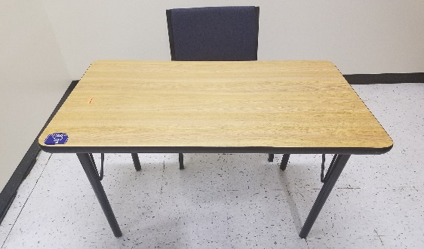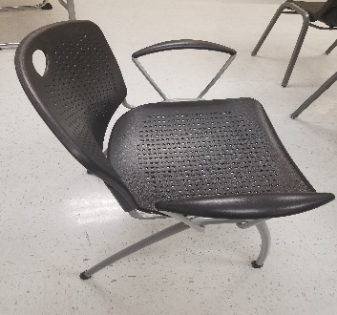
If there are any questions regarding this accommodation, please contact the office at ssdaltfurniture@csusb.edu.

Alternate Media
The Alternate Media Production team for the SSD office provides quality products in accessible formats to our students in a timely and efficient manner. The production team provides textbooks and additional course materials in various accessible formats including, but not limited to: Adobe PDF’s, Microsoft Word documents/Docx files, Plain/Rich text files or MP3 audio files (when necessary). This accommodation must be approved by a SSD Counselor and will depend on the symptoms and severity of the student’s disability. Students may also be eligible to receive their materials in an enlarged print or Braille format.
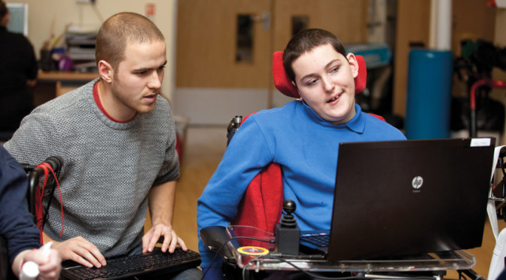
Student with a disability receives computer assistance.

If there are any questions regarding this accommodation, please contact the SSD office at altmedia@csusb.edu.

Assignment Accommodations
Students may be determined eligible for the accommodation of extended time on out-of-class writing assignments on a case-by-case basis under the following concurrent conditions: 1) The narrative description of substantial limitations to major life activities, and current functional limitations relating to academic performance provided in disability verification documentation indicate a need for such accommodation, and 2) discussion between the SSD Counselor and faculty finds that the provision for extended time on a given writing assignment will not interfere with essential course requirements. If you have questions regarding this accommodation, please e-mail the office at ssd@csusb.edu.

Assistive Listening Device
SSD has available sound amplification systems. The amplification system is used to facilitate the student’s hearing as a disability related accommodation by amplifying the sound directly into the student’s ears. It is a two-piece system consisting of the transmitter with lapel microphone and receiver with headphone set. This accommodation is approved on a case-by-case basis by the SSD Counselor. If you have questions regarding this accommodation, please e-mail the office at ssd@csusb.edu.

Cart Service
Students with a permanent or temporary physical disability may have access to cart services. The services are individualized and scheduled upon a first-come, first-serve basis. Mobility services are provided through the use of four carts, three are wheelchair accessible, and a van. Both scheduled and unscheduled rides are permitted, and the request form can be submitted through the Cart Service Request form.

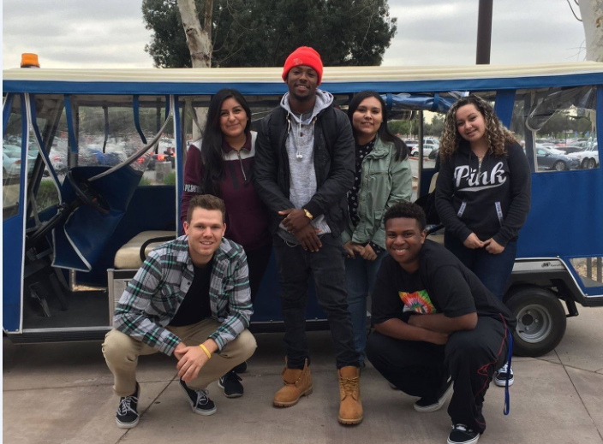

SSD student assistants pose in front of a mobility cart.

If you have questions regarding this accommodation, please email the office at ssdmobil@csusb.edu.

Class Aide
Class aides are provided by SSD based on individual needs and situations. Class aides assist students with in-class assignments and other classroom activities that the student cannot carry out on their own, based on their disability. If a student believes that they may need a class aide, they should contact their SSD Counselor to make a request. The counselor will then determine the need for a class aide based upon the student’s needs and course requirements. This accommodation is approved by the SSD Counselor. If you have any questions regarding this accommodation, please email the office at ssd@csusb.edu.

Exam Accommodations
The purpose of exam accommodations is to provide an equal testing opportunity based on the educational limitation of the student. “Test”, as used in this context, refers to quizzes and examinations taken during the quarter, in conjunction with an academic class, as well as graded lab demonstrations.
Exam accommodations are determined on a case-by-case basis and may include, but are not limited to:

    - Extended testing time (1.5x or 2x)

    - Reduced distraction environment (RDE) or distraction free environment (DFE)
    - Readers and/or scribes

    - Accessible formats (i.e. enlarged exams)

    - Assistive technology (i.e. WYNN, JAWS, Dragon)

Other exam accommodations may be determined and approved by the SSD Counselor. To request to take exams in the SSD office, students must submit the Exam Accommodation Request.
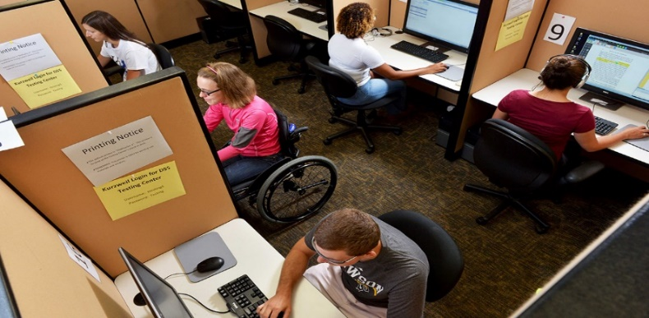
Students take exams in a distraction-reduced environment (testing room).
If you have questions regarding this accommodation, please email the office at ssdproctoring@csusb.edu.

Notetaking Services
For eligible SSD students whose disability prevents them from taking effective notes, the SSD office will recruit a volunteer from the class to take notes. Another option for students seeking this service is to recruit their own notetaker such as a friend who is also taking the class. This accommodation must be approved by an SSD Counselor. If you have any questions regarding this accommodation, please contact the office at ssdnotetaking@csusb.edu.

Priority Registration
This accommodation is offered to students enrolled in SSD services to enable them to register for the classes they need in order to complete their academic goals. The accommodation must be approved by an SSD Counselor. This accommodation is used to ensure other accommodations such as alternate media are completed prior to the commencement of the quarter. Students enrolled in the Over 60 program or have a temporary disability are not eligible for priority registration. If you have any questions regarding this accommodation, please contact the office at ssd@csusb.edu.

Real Time and Remote Captioning
A real time captionist is a stenographer who brings with him/her a stenograph machine, which is connected to a laptop computer. All verbal communication which transpires during the course of the class will be transcribed via the stenograph, translated into English, and printed onto the screen of the laptop computer. The student sits next to the captionist and reads the lecture via the laptop. This can also be done remotely where the captionist transcribes the lecture and transmits it to the laptop for the student to read. This accommodation must be approved by an SSD Counselor. If you have any questions regarding this accommodation, please contact Deaf Services at ssddeafservices@csusb.edu.

Sign Language Interpreters
American Sign Language (ASL) Interpreters provide translation services to students requiring this accommodation to ensure that effective communication takes place between two different parties. Interpreters are communication mediators and facilitate integration of the student into the classroom environment such as class lectures or other class-related activities. This accommodation must be approved by an SSD Counselor. To request this accommodation, students must submit the Interpreter Request Form. If you have any questions regarding this accommodation, please contact Deaf Services at ssddeafservices@csusb.edu.

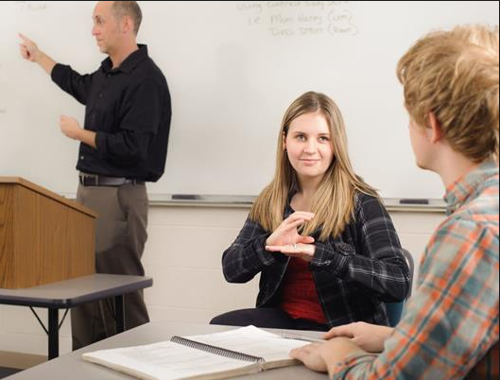
Student receives ASL interpreting during a class.

SmartPen Program
The SSD office provides Livescribe SmartPens to help facilitate the notetaking process for students. Through the use of the SmartPen and special notebook paper, students are able to record spoken content in class and link the audio to the notes on the page of a specialized notebook. Students can listen to their audio lectures at a later time by tapping on the written words to jump to specific parts of the lecture. For convenient access, students can also upload their notes into a digitized format and take advantage of other SmartPen features using Echo Desktop, a software used in conjunction with a SmartPen. This accommodation must be approved by an SSD Counselor. If you have any questions regarding this accommodation, please contact the office at ssdsmartpen@csusb.edu.

Visual Impairment Orientation
This accommodation is utilized for students who have visual impairments and need an assisted tour of the campus and the buildings, as well as requested classroom locations. If you have any questions regarding this accommodation, please contact the office at ssd@csusb.edu.
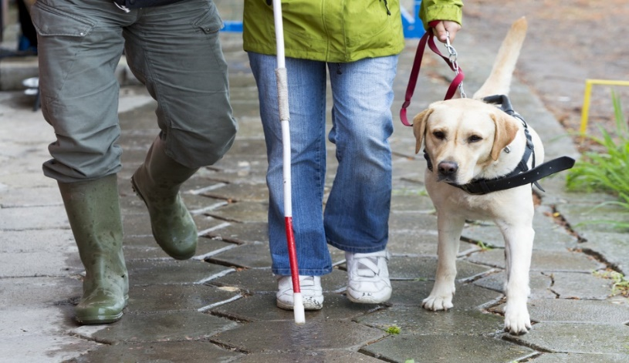
Guide dog and a person assist a visually impaired person.

Policies, Guidelines, and Procedures
The policies and procedures listed have been approved by the CSUSB Administrative Council. Also included are SSD general office procedures and guidelines.

University Policies and Procedures
University administrative policies and procedures, which have been approved by the CSUSB Administrative Council, are available for viewing at the Policies and Procedures website. Examples of relevant policies and procedures include, but are not limited to:
    - ADA Procedures and Guidelines

    - Animals on Campus

    - Discrimination Policy

    - Emergency Communication Notification Procedures

    - Parking Policy

    - Student Leave of Absence Policy

    - Student Non-Academic Grievance Policy and Procedures

    - Student Records

    - Title IX

General SSD Procedures and Guidelines

Privacy Rights of Students in Education Records

SSD follows the University’s policy regarding the confidentiality of student records. SSD regards the information it keeps about students as educational records. Educational records fall under different rules than medical records (HIPAA), and SSD advises students to note the difference. Thus, SSD prefers that documentation of disabling conditions provided by students be limited to that which is necessary to establish the disability and the right to an accommodation in an educational setting. Please refer to the section “What is a Disability?” for more details on verifying a disability and the right to accommodation.
The following information summarizes the University’s policy on student records: The federal Family Education Rights and Privacy Act of 1974 (20 U.S.C. 1232g) and regulations adopted thereunder (34 C.F.R. 99) set out requirements designed to protect student’s privacy in their records maintained by the campus. The statute and regulations govern access to students’ records maintained by the campus and the release of such records. The law provides that the campus must give students access to records directly related to them, and must also provide opportunity for a hearing to challenge such if the student claims they are inaccurate, misleading, or otherwise inappropriate. The right to a hearing under this law does not include any right to challenge the appropriateness of a grade determined by the instructor. The law generally requires the institution to receive a student’s written consent before releasing personally identifiable data about the student. The institution has adopted a set of policies and procedures governing implementation of the statutes and regulations on the campus. Copies of these policies and procedures may be obtained at the Office of the Vice President for Student Affairs. Among the types of information included in the campus statement of policies and procedures are: 1) the types of student records maintained and the information they contain; 2) the official responsible for maintaining each type of record; 3) the location of access lists indicating persons requesting or receiving information from the record; 4) policies for reviewing and expunging records; 5) student access rights to their records; 6) the procedures for challenging the content of student records; 7) the cost to be charged for reproducing copies of records; and 8) the right of the student to file a complaint with the Department of Education. The Department of Education has established an office and review board to investigate complaints and adjudicate violations. The designated office is: Family Policy Compliance Office, U.S. Department of Education, Washington, D.C. 20202-4605. The campus is authorized under the act to release “directory information” concerning students. Directory information may include the student’s name, address, telephone listing, electronic mail address, major field of study, participation in officially recognized activities and sports, dates of attendance, degrees and awards received, and the most recent previous educational agency or institution attended by the student. The above designated information is subject to release by the campus at any time unless the campus has received prior written objection from the student specifying information which the student requests not be released. Written objections should be sent to the Office of the Vice President for Student Affairs. The campus is authorized to provide access to student records to campus officials and employees who have legitimate educational interests in such access. These persons have responsibilities in the campus’s academic, administrative or service functions, and have reason for using student records associated with their campus or other related academic responsibilities. Student records may also be disclosed to other persons or organizations under certain conditions (e.g. as part of accreditation or program evaluation, in response to a court order or subpoena; in connection with financial aid, or to other institutions to which the student is transferring).

Confidentiality

All medical records are strictly confidential. Information from records will not be released to anyone without the written authorization of the patient, except as required by law. The staff at the Student Health Center can assist you with the following services:
    - Requesting copies of your medical records
    - Sending copies of your medical records to an outside provider
    - Clearing immunization holds
    - General Standards of Patient Rights and Responsibilities (PDF)
Health information is confidential, and access is restricted to authorized CSUSB Student Health Center personnel ONLY. Information in the health record will not be released to parents (except in the case of minors), professors or anyone else without written consent or when required by law, court order, or when subpoenaed.
    - Advance Directive (PDF) An Advance Directive is a written document in the form of a living will or Durable Power of Attorney prepared by a competent individual that specifies what, if any, extraordinary procedures, surgeries, medication, or treatments the patient desires in the future, when he or she can no longer make such decisions about medical treatment.
    - Release of Medical Records (PDF) Consent is required to release medical records to another facility or provider. Proof of identity is required to pick up records in person. Records cannot be mailed or faxed directly to students. Please indicate specific dates needed and allow 7-10 working days to process.
    - Request for Medical Records (PDF) Consent is needed to release any medical records from an outside physician or health care facility that is mailed directly or faxed to the CSUSB Student Health Center.
    - Consent for Medical Treatment of a Minor (PDF) Parental consent is required to provide health care to minors. *Exceptions – California Law: Request for contraception services or an Emancipated Minor.
    - Immunization Exemption Declaration (PDF) A signed waiver is required to decline immunization requirements due to personal, medical or religious beliefs. Bring the verification form with proof of identity to the Student Health Center. NOTE: This waiver may bar students from campus in an outbreak situation for their own protection or that of the campus community.
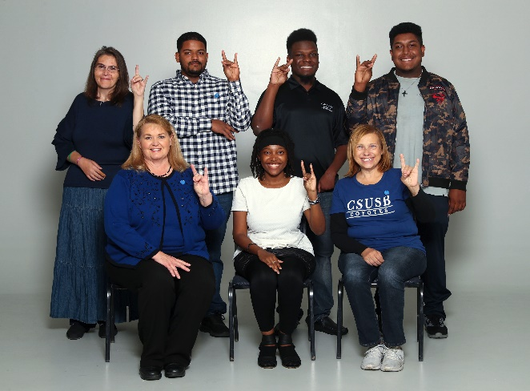
    - HIPAA Complete Notice of Privacy Practices (PDF) Notice discussing how medical information may be disclosed and how you can get access to the information. Discusses rights of individuals when disclosing personal information such as medical records and other data, and how the individuals may receive electronic or paper versions of personal records submitted.

SSD Student Advisory Board doing a Coyote hand gesture.

Conflict Resolution Procedure

Purpose

The Services to Students with Disabilities (SSD) office is committed to ongoing and open communications between its students and its office staff. It is SSD’s experience that open communication is essential to providing the best quality level of services to its students. SSD believes that questions, concerns, problems, or complaints that are left unresolved will negatively impact a student’s educational experience as well as the mission and goals of the office.

Procedure

This procedure encourages students to communicate directly with the office regarding any matter and summarizes clear choices/options available to resolve conflict. Below are procedures regarding A) complaints about disability accommodations, B) complaints about decisions made by SSD about delivery of disability accommodations, C) complaints about staff, and
- complaints about alleged discriminatory practices and decisions regarding eligibility.

A. Complaints about Disability Accommodations

    - Informal Review (optional for students)

A student registered with SSD may bring a complaint about disability accommodations to the SSD Director. If the accommodation decision was made by the SSD Director, then the complaint may be brought to the Assistant Vice President for Student Services (AVP). The complaint may be verbal or in writing and must describe the matter to be resolved. The SSD Director or the AVP will first seek to resolve the complaint by informal means. The SSD Director or his/her designee will agree to meet in person with the complaining student within five (5) working days of receipt of the complaint. For verbal complaints, the SSD Director or AVP must provide a verbal response to the complainant within five (5) working days of receipt of the complaint. For written complaints, the SSD Director or AVP must provide a written response to the complainant within 5 working days of receipt of the complaint. This step, if successful, can provide a speedy resolution to the dispute.
    - Mid-level Review (interactive process)

If a student elects to use the Informal Review process but the complaint is not resolved in the Informal Review, a mid-level review can be initiated by the student, the SSD Director, or the AVP. The SSD Director will be responsible for notifying the Americans with Disabilities Act (ADA) Compliance Officer that a mid-level review has been initiated. In addition, during the process described below, the SSD Director or the student’s SSD Counselor will be responsible for discussing with the student any interim remedies that may be necessary during the mid-level review process.

A student who has elected not to participate in the Informal Review process may initiate a mid-level review by filing a written complaint describing the matter to be resolved with the ADA Compliance Officer at Sierra Hall, Suite 110. The ADA Compliance Officer will convene a panel within 10 working days of receipt of notification from the SSD Director that an informal resolution was not successful or receipt of a complaint under this process from a student.

The Review Panel will consist of the ADA Compliance Officer, one faculty member who is knowledgeable in the area of learning and other disabilities, the SSD Director, and a professional staff member of SSD who is knowledgeable about the specific disability, the requested aids or accommodations and available options, and, depending on the issues, other academic or administrative personnel as may be appropriate. If one of the SSD staff members on the panel determined the accommodation for the student, that staff member will not participate in the review of that accommodation and will be temporarily replaced by another staff member designated by the SSD Director.

The panel will use a problem solving approach that will include the following steps: 1) an analysis of the particular class or activity for which the accommodation is being sought; 2) consultation with the student with a disability to ascertain the particular limitations of his or her disability and what is being requested as accommodation(s) to overcome the limitations; 3) consultation with the student with a disability to identify options and assess the effectiveness each would have in enabling the student to have an equal opportunity to participate; and 4) consideration of the preference of the student to be accommodated and selection and implementation of the accommodation that is most appropriate for the student and University.

The Review Panel will make a determination within five (5) working days. The timeline may be extended for good cause by the ADA Compliance Officer in writing to the student. The written notification to the student must explain why the timeline for determination has been extended, and address the need, if any, for interim remedies. In determining whether or not good cause exists to justify extending the timeline for determination, the ADA Compliance Officer will strongly consider the impact such a timeline extension may have on the student’s current ability to effectively participate in his/her University education. The ADA Compliance Officer has the authority in these matters and is the impartial arbitrator who assures prompt and equitable determinations. The written notification to the student will describe the process for filing a formal grievance if the student continues to feel aggrieved.
    - Formal Grievance

The student will be notified of his or her right to follow the University’s Procedure for a Discrimination Complaint by a Student and of the timelines for filing. This document is available from the Office of the Vice President of Student Affairs in University Hall, Suite 231 or online here.

B. Complaints about Decisions made by SSD about Delivery of Disability Accommodations

1) Informal Review (optional for students)

A student registered with SSD may bring a complaint about the delivery of accommodations to the SSD Director. If the decision about delivery of disability accommodations was made by the SSD Director, then the complaint may be brought to the AVP. The complaint may be verbal or in writing and must describe the matter to be resolved. The SSD Director or AVP will first seek to resolve the complaint by informal means. The SSD Director or her designee will agree to meet in person with the complaining student within five (5) working days of receipt of the complaint. For verbal complaints, the SSD Director or AVP must provide a verbal response to the complainant within 5 working days of receipt of the complaint. For written complaints, the SSD Director or AVP must provide a written response to the complainant within five (5) working days of receipt of the complaint. This step, if successful, can provide a speedy resolution to the dispute.
2) Mid-level Review (interactive process)

If a student elects to use the Informal Review process but the complaint is not resolved in the Informal Review, a mid-level review can be initiated by the student, the SSD Director, or the AVP. The SSD Director will be responsible for notifying the Americans with Disabilities Act (ADA) Compliance Officer that a mid-level review has been initiated. In addition, during the process described below, the SSD Director or the student’s SSD Counselor will be responsible for discussing with the student any interim remedies that may be necessary during the mid-level review process.

A student who has elected not to participate in the Informal Review process may initiate a mid-level review by filing a written complaint describing the matter to be resolved with the ADA Compliance Officer at Sierra Hall, Suite 110. The ADA Compliance Officer will convene a panel within ten (10) working days of receipt of notification from the SSD Director that an informal resolution was not successful or receipt of a complaint under this process from a student.

The Review Panel will consist of the ADA Compliance Officer, one faculty member who is knowledgeable about the delivery of disability accommodations, the SSD Director, and a professional staff member of SSD who is knowledgeable about the specific disability, the requested aids or accommodations and available options, and, depending on the issues, other academic or administrative personnel as may be appropriate. If one of the SSD staff members on the panel participated in the delivery of accommodations, that staff member will not participate in the review of that accommodation and will be temporarily replaced by another staff member designated by the SSD Director. The panel will use a problem solving approach that will include the following steps: 1) an analysis of the particular class or activity for which the accommodation is being sought; 2) consultation with the student with a disability to ascertain why the delivery of accommodations does not meet the needs of the student; 3) consultation with the student with a disability to identify options and assess the effectiveness each would have in enabling the student to have an equal opportunity to participate; and 4) consideration of the preference of the student to be accommodated and selection and implementation of the accommodation that is most appropriate for the student and University.

The Review Panel will make a determination within five (5) working days. The timeline may be extended for good cause by the ADA Compliance Officer in writing to the student. The written response to the student must explain why the timeline for determination has been extended, and address the need, if any, for interim remedies. In determining whether or not good cause exists to justify extending the timeline for determination, the ADA Compliance Officer will strongly consider the impact such a timeline extension may have on the student’s current ability to effectively participate in his/her University education. The ADA Compliance Officer has the authority in these matters and is the impartial arbitrator who assures prompt and equitable determinations. The written notification to the student will describe the process for filing a formal grievance if the student continues to feel aggrieved.

If the student is not satisfied with the Review Panel’s response, then the student must use the Procedure for a Discrimination Complaint. There are timelines for filing. This document is available from the Office of the Vice President for Student Affairs in University Hall, Suite 231 or is available online here.

C. Complaints about Staff

1) Informal Review (optional for students)

A student registered with SSD may bring a complaint about staff service and/or attitude to the SSD Director. The complaint may be verbal or in writing and must describe the matter to be resolved. The SSD Director or her designee will agree to meet in person with the complaining student within five (5) working days of receipt of the complaint. The SSD Director will first seek to resolve the complaint by informal means. If the SSD Director made the decision, then the complaint may be brought to the AVP. For verbal complaints, the SSD Director or AVP must provide a verbal response to the complainant within five (5) working days of receipt of the complaint. For written complaints, the SSD Director or AVP must provide a written response to the complainant within five (5) working days of receipt of the complaint. This step, if successful, can provide a speedy resolution to the dispute.
2) Mid-level Review

If the student elects to use the Informal Review process but the complaint is not resolved in the Informal Review, a mid-level review can be initiated by a student, the SSD Director, or the AVP. The AVP will agree to meet with the student within five (5) working days of receipt of the complaint. If the AVP made the response in C (1), a designee will agree to meet with the student within five (5) working days of receipt of the complaint. A student who has elected not to participate in the Informal Review process may initiate a mid-level review by filing a written complaint describing the matter to be resolved. The AVP will agree to meet with the student within five (5) working days of receipt of the complaint. If the AVP made the response in C (1), a designee will agree to meet with the student within five (5) working days of receipt of the complaint.
3) Administrative Review

If the complaint is not resolved, the student may next bring the matter to the Vice President of Student Affairs (VSPA) and/or to the Provost. The VPSA or Provost or their designee will agree to meet with the student within five (5) working days of receipt of the complaint. If the VPSA or Provost designates a representative to meet with the student, such a designee cannot be the same person designated to meet with the student pursuant to Section C (2) of this agreement.

D. Complaints about Alleged Discrimination Practices and Decisions

Regarding Eligibility

1) Informal Review (optional for students)

A student registered with SSD may bring a complaint about an alleged discriminatory practice or decision regarding eligibility to the SSD Director. If the SSD Director is alleged to have discriminated, then the complaint may be brought to the AVP. The complaint may be verbal or in writing and must describe the matter to be resolved. The SSD Director or the AVP will first seek to resolve the complaint by informal means. The SSD Director or AVP will agree to meet in person with the complaining student within five (5) working days of receipt of the complaint. For verbal complaints, the SSD Director or AVP must provide a verbal response to the complainant within five (5) working days of receipt of the complaint. For written complaints, the SSD Director or AVP must provide a written response to the complainant within five (5) working days of receipt of the complaint. This step, if successful, can provide a speedy resolution to the dispute.
2) Mid-level Review (interactive process)

If a student elects to use the Informal Review process but the complaint is not resolved in the Informal Review, a mid-level review can be initiated by the student, the SSD Director, or the AVP. The SSD Director will be responsible for notifying the Americans with Disabilities Act (ADA) Compliance Officer that a mid-level review has been initiated. In addition, during the process described below, the SSD Director or the student’s SSD Counselor will be responsible for discussing with the student any interim remedies that may be necessary during the mid-level review process.

A student who has elected not to participate in the Informal Review process may initiate a mid-level review by filing a written complaint describing the matter to be resolved with the ADA Compliance Officer at Sierra Hall, Suite 110. The ADA Compliance Officer will convene a panel within ten (10) working days of receipt of notification from the SSD Director that an informal resolution was not successful or receipt of a complaint under this process from a student.

The Review Panel will consist of the ADA Compliance Officer, one faculty member who is knowledgeable in the area of learning and other disabilities, the SSD Director, and a professional staff member of SSD who is knowledgeable about the specific disability, eligibility for disability services, and, depending on the issues, other academic or administrative personnel as may be appropriate. If one of the SSD staff members on the panel made the eligibility decision, that staff member will not participate in the review of that accommodation and will be temporarily replaced by another staff member designated by the SSD Director.

The panel will use a problem solving approach and will include the following steps: 1) review of the disability verification information;
2) review of the intake report and other related documentation produced by SSD; and 3) consultation with the student to ascertain the nature and particular limitations of his or her purported disability.

The Review Panel will make a determination within five (5) working days. The timeline may be extended for good cause by the ADA Compliance Officer in writing to the student. The written notification to the student must explain why the timeline for determination has been extended, and address the need, if any, for interim remedies. In determining whether or not good cause exists to justify extending the timeline for determination, the ADA Compliance Officer will strongly consider the impact such a timeline extension may have on the student’s current ability to effectively participate in his/her University education. The ADA Compliance Officer has the authority in these matters and is the impartial arbitrator who assures prompt and equitable determinations. The written notification to the student will describe the process for filing a formal grievance if the student continues to feel aggrieved. If the student is not satisfied with the mid-level review process, the student must use the Procedure for a Discrimination Complaint. There are timelines for filing. This document is available at the Office of the Vice President for Student Affairs in University Hall, Suite 231, 909-537-5185, or available on-line at the Student Affairs website.

Nepotism
Consistent with the CSUSB policy on nepotism FAM 010 found on the Policy for the Administration of Grants and Contracts in Support of Sponsored Programs website, SSD adopts this guideline:
SSD does not support provision of services/accommodations to SSD affiliated students by any relative or significant other. Relatives are defined as, but not limited to, parents, children, husbands, wives, brothers, sisters, boyfriends, and girlfriends.

Lobby Guidelines
It is the goal of SSD to provide a safe, welcoming environment for those who come through our doors. To that end, we have established the following:
Confidentiality is to be respected, yours and that of others. Seating is reserved for those who are here to conduct SSD/WorkAbility (WA-IV) business. Chairs are provided for those that may have difficulty standing. If you see someone in need, please consider offering your seat. CSUSB has places on campus where tables and chairs are provided for dining purposes, waiting for transportation, or for studying. If you need directions to a suitable area, we would be glad to provide them.

Gift-Giving Guideline
We appreciate your gratitude; however, we are unable to accept personal gifts from students associated with SSD. Thank you for your cooperation.
Wide-shot aerial picture of the CSUSB campus, displays the Student Union, Pfau Library, and University Hall.

Accommodation Related Procedures and Guidelines

Accessible Furniture

PROCEDURES:

- Submit a completed Accessible Furniture Request after course registration has been completed. The request may be submitted through the Service Request module on the SSD website.
2. New students are required to meet with their SSD Counselor at least ten (10) working days prior to the start of the quarter to review their request. Current students are required to resubmit their requests ten (10) working days prior to the start of the quarter if the request is the same as the prior accommodation and twenty (20) working days prior to the quarter if the request is a modification of a prior furniture accommodation or a new request.
3. Establish and maintain communication with SSD regarding changes in class schedules and locations.
4. Any questions or concerns regarding the request should be immediately directed to the SSD office at ssdaltfurniture@csusb.edu.

GUIDELINES:

- The student’s SSD Counselor determines Accessible Furniture services as an accommodation.

- SSD will work with Facilities Services to ensure that accessible furniture is available and in place in classrooms on the first day of instruction, provided that the student follows the request timelines. For late requests, SSD and Facilities Services will make their best efforts to have accessible furniture in place as soon as possible.

- The SSD Counselor will determine the appropriate furniture after meeting with the student and reviewing the medical and other related documentation.

- SSD Counselors will work with students to determine if accessible furniture needs to be placed in specific locations or specific configurations in the classroom(s).

- In cases in which an SSD Counselor, in consultation with the student, has determined specific locations within the classroom are needed for the accessible furniture, the SSD Counselor and Facilities Services will conduct a walk-through with the student in all of his/her classrooms to identify the appropriate location for furniture placement.

- Students will receive a copy of the work order sent to Facilities Services regarding their request and an email notification when the work order has been completed.

- Faculty will receive notification via student’s completion of a Memo Request Form that if they do move, disassemble or relocate the furniture, they must return the furniture to its original location and configuration.

- Problems reported to SSD will be corrected by Facilities Services in a reasonable timeframe. If problems continue, SSD will consult with Facilities Services and the student to ensure that problems are resolved and steps are developed to ensure that the problem does not recur.

Alternate Media

PROCEDURES:

- Submit a completed Alternate Media Textbook Request each quarter immediately after course registration is completed. This request may be submitted through the Alternate Media and Additional Materials Request service submission link. The standard production timeline is six (6) weeks following the student request.

- Submit course materials as soon as available.

- Submit course syllabi for all courses each quarter.
- Submit textbooks when requested by SSD. Timely submission will ensure faster delivery of alternate media.

- Check CSUSB email regularly for alternate media communication.

- Contact SSD immediately regarding changes in course registration.

- Sign the Alternate Media Copyright Agreement prior to release of alternate media.

GUIDELINES:

- Requests will be acted upon according to the order in which they are received; however, requests cannot be guaranteed to be completed in that order.

- Students may request alternate media for optional or recommended course materials, but required materials will be given priority.

- Each request is unique in that the availability, formatting, and editing of course materials vary greatly.

- Every effort will be made to obtain the student's preferred format. If this format is not available, however, available formats will be supplied given that they provide equal access to the student.

- SSD communicates with students about alternate media requests through their CSUSB email accounts. SSD notifies students of the status of their requests and delivery through email.

- If requested materials are not available from in-house libraries or publish-ers, students will be notified by campus email and may need to provide the materials to SSD for in-house scanning.

- For students who choose to rent textbooks, their accessible files will be available via the use of an SSD provided USB drive. Please note that students will be required to return the USB device to the SSD office at the end of the quarter or once their rental agreement has expired. Students are not permitted to keep or download the files after the rental agreement has expired.

- Students will be notified as requests are completed and are available for pick up via campus email. Every effort will be made to meet the six (6) week standard production timeline. SSD will work with students and faculty if students do not have alternate media due to a delay in production.

- Any questions or concerns regarding alternate media accommodations, formats provided, or difficulties accessing provided files should be directed to the Alternate Media Coordinator.

- Alternate media is intended solely for the educational purposes of the student. According to Copyright Revisions Act of 1976, as amended [17 U.S.C.
Sec. 101 et seq.], students may not copy, duplicate or distribute the alternate media.

Captioning Services
PROCEDURES:

- Submit a completed Captioning Service Request form to SSD at least thirty
(30) days before the start of the quarter for returning students or as soon as they are enrolled for new students. The request can be submitted at the Service Request link.

- All one-time requests must be submitted by email to ssddeafservices@ csusb.edu as soon as the student becomes aware of the need with at least three (3) working days advance notice. For conferences, field trips and any other functions, please contact the Deaf Services Coordinator or designee as soon as possible as arranging for services may take weeks to coordinate.

- All email communication regarding captioning services must be submitted to ssddeafservices@csusb.edu.

- Cancellations, if known, need to be submitted at least two (2) working days in advance or as soon as possible. Services may be suspended if two (2) or more classes/events are missed without prior notification. Students will need to meet with the Deaf Services Coordinator or designee before services are reinstated.

- All communication regarding requests for services, late notifications, extensions on requests, or cancellations, etc. need to be made between students and SSD. Students are not to communicate to captionists directly regarding scheduling issues or make any personal schedule(s) with the captionist(s).

- Captionists will leave after twenty (20) minutes if the student does not attend class or the event.

GUIDELINES:

- The Deaf Services Coordinator or designee will determine the student’s eligibility for captioning services based upon review of documentation of the disability, past use of services, the type and format of classes, and other events.

- Students who receive captioning notes agree not to share the transcripts with others. These transcripts are solely for the students’ personal academic use and may not be shared with any other student or be used for any other purpose other than class study notes without the express consent of the instructor. Students are advised to destroy the transcripts at the conclusion of the academic quarter.

- It is the student’s responsibility to submit their Captioning Service Request form in a timely fashion. The form must be filled out completely and as accurately as possible. All fields must be filled in. Blank fields may result in delays in processing the request.

- It is the student’s responsibility to contact SSD for any changes regarding their class schedule. They may be required to submit a new Captioning Service Request form reflecting the changes.

- It is the student’s responsibility to notify the SSD office for any questions, concerns, cancellations, etc.

- Requests for captioning services can be made up to the last official day of classes. Final exams are not included.

- It is the student’s responsibility to notify SSD if they require captioning services for final exams. Students are to submit the date, time, and location via email to ssddeafservices@csusb.edu as soon as they receive the class syllabus.

- For any classes that may be teamed with an interpreter, the student will need to submit the Interpreter Request form for those classes. The interpreter and captionist will switch off so at no time are they both working simultaneously.

A captionist sits in on a student’s class to take notes.

Cart Service
PROCEDURES:

- Submit a completed Cart Service Request form each quarter after course registration has been completed.

- The Accommodations Support Coordinator or designee will review the requested drop-offs and pick-ups at the times requested. The student will be notified via email of the approval or to make modifications.

- New students are required to meet with their SSD Counselor at least ten (10) working days prior to the start of the quarter to review their requests. Current students are required to submit their requests thirty (30) business days prior to the start of the quarter.
- Priority will be given to students who submit their requests early.

- Scheduled cart rides will begin within five (5) business days after approval. Unscheduled cart rides will be provided on an as needed basis by telephone or in person at the time the student calls for service.

- Scheduled cart rides will have priority over unscheduled (one-time) cart rides.

- Notify SSD regarding changes in cart ride schedules and locations as soon as possible.

- Students must be at the designated pick-up locations at the scheduled times to ensure pick-up.
GUIDELINES:
- The SSD Counselor (or designee) determines Cart Services as an acco- mmodation.

- Priority registration should be utilized to ensure adequate time between classes.

- Cart Service will be available at the times during which there are classes, including evening and Saturday classes.

- Scheduling of cart rides will occur by submission of the Cart Service Request form. Unscheduled (one-time) cart rides will occur on an as needed basis at the time the call is made.

- All pick-up/drop-off locations are indicated on the Cart Service Map, which can be found in the Appendix and on the SSD website.

- SSD will do its best to notify students via email or telephone if carts are out of service. Only students who are on the current Cart Schedule will be notified.

- If carts are out of service, SSD will contact students’ faculty regarding the situation and encourage them to work with students in making alternate arrangements for class instruction, assignments, and testing. Only faculty for those students on the current Cart Schedule will be contacted.

- Two consecutive no shows for any specific pick-up may result in a cancellation of services for that pick-up only. Reinstatement of the cancelled pick-up is subject to review, approval, and availability.

- Any questions or concerns regarding Cart Service should be immediately directed to the SSD office in person or at ssdmobil@csusb.edu.

Class Aide

PROCEDURES:

- Submit a completed Class Aide Request at least thirty (30) days prior to the first day of classes each quarter. The request can be submitted through the Service Request link.

- Notify SSD regarding changes in class schedules and locations as soon as possible.

- A SSD student assistant will serve as the Class Aide.

GUIDELINES:

- The student’s SSD Counselor determines Class Aide as an accommodation on a case-by-case basis.

- Priority registration should be utilized by students to ensure timely submission of Class Aide requests and recruitment efforts.

- Class Aides will leave after 20 minutes if the student with a disability does not attend class.

- Any questions or concerns regarding requested Class Aides should be directed to the SSD office in person or at ssd@csusb.edu.

Exam Accommodations

PROCEDURES:

- Instructors or course departments may handle exam arrangements directly. If instructors or departments provide exam accommodations, they must do so according to the accommodations determined by the SSD office. If the instructor refers the student to SSD for testing, the student submits the completed Exam Accommodation Request Form to SSD according to the deadlines posted in the SSD office and it is then emailed to the SSD testing e-mail. This form may be obtained from the SSD office during normal business hours or on the SSD website.

- For students who receive testing accommodations after the beginning of the quarter, submit the completed Exam Accommodation Request Form to SSD at least five (5) working days prior to the requested exam date.

- Students will take regularly scheduled exams on the same schedule as their nondisabled classmates. When scheduling conflicts occur, exams may be scheduled at an alternate time the same day or the following business day. Such conflicts will be handled on a case-by-case basis.

- Students will take final exams on the schedule established by SSD, which differs from the schedule published in the Class Schedule. A completed Exam Accommodation Request Form for finals must be turned in three (3) weeks prior to the exam date. Schedule and confirm dates and times of all exams with SSD according to the deadlines posted in the SSD office and emailed to students.

- Establish and maintain communication with SSD and instructors regarding exam arrangements, including informing the office of “pop” (unscheduled) quizzes/exams or timed in-class assignments. Students must bring their syllabus to SSD for copying if “pop” quizzes/exams or timed in-class assignments as soon as it is available after the first class meeting. SSD will make every effort to accommodate according to the student’s class schedule. Take-home exams will be handled on a case-by-case basis.

- For exams that are rescheduled by the instructor, students must inform SSD as soon as they know so that rescheduled exams can be administered on the same schedule as other students or as soon as possible. Rescheduled exams require instructor permission or verification.

- Complete an optional Exam Accommodation Feedback Form at the end of each exam session to rate the effectiveness of the proctor, reader, or scribe.

- Report any problem with exam administration to the Accommodations Support Coordinator or proctor immediately. Time to investigate and correct a problem is not taken out of the student’s exam time.

- Any questions or concerns regarding exam accommodations should be immediately directed to the SSD office in person or at ssdproctoring@ csusb.edu.

GUIDELINES:

- Students taking exams are expected to follow any special instructions provided by the instructor (e.g., open books, closed notes, etc.).

- SSD will review the student’s Exam Accommodation Request Form for completeness and scheduling arrangements. The student’s signature on the form indicates that the student has read and agrees to student responsibilities, including academic integrity. Incomplete or unsigned forms will be returned to the student for completion before acceptance by SSD.

- SSD will contact the student’s instructors to obtain the necessary exam information prior to the provision of accommodations.

- Only approved items are allowed in testing rooms. No backpacks, purses, electronic devices, food, or drinks are allowed in the testing rooms unless they are approved by SSD. SSD has a secure place to store these items. Students’ personal laptops are not allowed in the testing rooms.

- Once exams begin, students may not leave the testing room unless permission is given by a proctor. Time allotted for an exam begins at the scheduled start time determined by the instructor and SSD. If a student arrives late for an exam, the scheduled ending time remains the same. Late arrivals may require that an exam be rescheduled and approved by the instructor. Makeup of missed final exams is at the instructor’s discretion.

- Exam activity will be monitored via video camera and proctors. All exam activity will be documented on the Exam Cover Sheet/Receipt and a copy provided to the instructor.

- Any conflicts, discrepancies, or other irregularities related to the exam will be documented on the Exam Cover Sheet/Receipt and a copy will be provided to the instructor.

ASL Interpreting Services

PROCEDURES:

- Submit a completed Interpreter Request form to SSD at least thirty (30) days before the start of the quarter for returning students or as soon as they are enrolled for new students. The request can be submitted through the Service Request link.

- All one-time requests must be submitted by email to ssddeafservices@csusb.edu as soon as the student is aware of the need with at least three (3) working days advance notice. For conferences, field trips and any other functions, please contact the Deaf Services Coordinator or designee as soon as possible as arranging for services may take weeks to coordinate.

- All email communication regarding interpreting services must be submitted to ssddeafservices@csusb.edu.

- Cancellations, if known, need to be submitted at least two (2) working days in advance or as soon as known. Services may be suspended if two (2) or more classes/events are missed without prior notification. Students will need to meet with the Deaf Services Coordinator or designee before services are reinstated.
- All communication regarding requests for services, late notifications, extensions on requests, or cancellations, etc. need to be made between students and SSD. Students are not to communicate to interpreters directly regarding scheduling issues or make any personal scheduling arrangements with the interpreters.

- Interpreters will leave after twenty (20) minutes if the student does not attend class or the event.

- Students who use interpreting services need to request a notetaker per the Notetaker Procedures and Guidelines.

GUIDELINES:

- The Deaf Services Coordinator or designee will determine the student’s eligibility for interpreter services based on an interactive session with the student as well as review of documentation of the disability, past use of services, and the type and format of classes.

- Students who use interpreting services will also receive notetaking as an accommodation.

- It is the student’s responsibility to submit their Interpreter Request form in a timely fashion. The form must be filled out completely and as accurately as possible. All fields must be filled in. Blank fields may result in delays in processing the request.

- It is the student’s responsibility to contact SSD for any changes regarding their class schedule. He/She may be required to submit a new Interpreter Request form reflecting the changes.
- It is the student’s responsibility to notify the SSD office about any questions, concerns, cancellations, etc.

- Requests for interpreter services can be made up to the last official day of classes. Final exams are not included.

- It is the student’s responsibility to notify SSD if they require interpreting services for final exams. They are to submit the date, time and location via email to ssddeafservices@csusb.edu as soon as they receive the class syllabus.

- For any classes that may be teamed with a captionist, the student will need to submit the Captionist Request form for those classes. The interpreter and captionist will switch off so at no time are they both working.

Notetaking
PROCEDURES:

- Submit a completed Notetaker Request form at least thirty (30) days prior to the first day of classes each quarter. The request may be submitted through this Service Request link.

- Notify SSD regarding changes in class schedule and locations as soon as possible.

- Students are encouraged, but not required, to select their own notetaker from the students in the class. If the student selects a notetaker, the student should email ssdnotetaking@csusb.edu to notify SSD that a notetaker has been recruited.

- It is the student’s responsibility, if they select their own notetaker, to ensure the notetaker receives a Notetaker Information Packet.

- SSD will recruit a notetaker from the student’s class.

- If needed, carbonless (NCR) paper is available at the SSD office during normal business hours.

- Class notes may be photocopied at the SSD office during normal business hours within a timely manner.

GUIDELINES:

- The student’s SSD Counselor determines notetaking as an accommodation.

- Priority registration should be utilized by students to ensure timely submission of notetaker requests and to allow for recruitment time.

- Students who attend class that day will have the notes made available the following school day.

- If the student does not attend class after the first twenty (20) minutes, the notetaker is not obligated to stay and take notes for the class. It will be the student’s responsibility to make arrangements for the notes.

- As an incentive, students who are serving as a notetaker will receive priority registration for the following quarter. One notetaker per class is allowed priority registration unless approval has been authorized by the student’s SSD Counselor.

- If the student chooses to select their own notetaker, the student is responsible to ensure that the notetaker receives the Notetaker Information Packet (available at the SSD office). The notetaker must review and sign the agreement and return it to SSD.

- Any questions or concerns regarding requested notetaker services should be directed to the SSD office or at ssdnotetaking@csusb.edu.

SmartPen

PROCEDURES:

- Submit a completed SmartPen Request form at least thirty (30) days prior to the first day of classes each quarter. The request can be submitted through the Service Request link.

- First-time users are required to watch a SmartPen tutorial and initial a verification form. Before initial checkout, the student must meet with the Notetaking Support Coordinator to discuss lending policies and sign a SmartPen Release form.

- Sign a SmartPen Return form when equipment is returned. All equipment must be returned before the last day of final exams unless otherwise specified.

- First-time users must complete a survey upon return of SmartPen equipment.

GUIDELINES:

- The student’s SSD counselor must approve the SmartPen as an accommodation.

- First-time SmartPen users will be permitted a notetaker and a SmartPen for the first quarter. If the student chooses to utilize a SmartPen thereafter, the student cannot submit a request for a notetaker unless otherwise approved by their SSD Counselor.

- Students can check out the SmartPen no earlier than five (5) business days prior to the first day of a new quarter.

- The student will be provided a single subject notebook for each class the student is enrolled in. If the student is enrolled in three classes, the student will be given a three subject notebook; any additional classes after the three, the student will receive a one subject notebook. It is the student’s responsibility to purchase and or print additional paper if needed.

- The student will not be provided a new notebook if the student swaps or changes classes.

- It is the student’s responsibility to always ensure the SmartPen is charged. The student will be responsible for getting notes from a classmate if the pen is not charged or left at home, work, etc.

- It is the student’s responsibility to print out any additional SmartPen control settings stickers, if needed at ssdsmartpen@csusb.edu.

- It is the student’s responsibility to notify the SSD office immediately of any pen malfunction issues.

- It is the student’s responsibility to notify the SSD office immediately if the equipment is damaged at ssdsmartpen@csusb.edu.

- If the equipment is returned in a damaged condition or is missing parts, the student will be responsible to pay to replace the damaged or missing equipment. The student will also be responsible to pay to replace lost or stolen equipment. Failure to do so will result in a hold on the student’s account.
- The student will utilize the equipment for school purposes only.

- The student will not sell, reproduce, or redistribute the equipment or pencasts to anyone in any manner. These pencasts are solely for the student’s personal academic use and may not be used for any other purpose or shared with anyone other than the student and SSD.

- The student will not use the SmartPen during a quiz or exam. Any electronics used during quizzes/exams will be considered as academic dishonesty and will be handled according to university policy.

Visual Impairment Orientation

PROCEDURES:

- Submit a completed Visual Impairment Orientation Request form at least thirty (30) days prior to the first day of classes each quarter. The request may be submitted in person at the SSD office.

- Notify SSD regarding changes in class schedules and locations as soon as possible.

- Submit a Visual Impairment Orientation Request form and schedule an orientation appointment with an SSD designee for orientation to student’s classrooms, campus buildings, or other on-campus locations.

Guidelines:
- Priority registration should be utilized by students to ensure timely submission of a Visual Impairment Orientation request and arrangements of tour prior to the commencement of classes.
- Any questions or concerns regarding orientations should be directed to the SSD Office at ssd@csusb.edu.

Visual Impairment Orientations offered by SSD do not take the place of Orientation and Mobility Training provided by professional trainers through the Department of Rehabilitation. Students who require Orientation and Mobility Training will be referred to the Department of Rehabilitation.

Visually impaired student receives assistance during a lab.

Student Involvement

Student Listserv
The SSD listserv has been established to provide SSD students with relevant up-to-date information that pertains to them as well as updates on campus functions that may affect accessibility. All students who register with SSD are automatically added to the listserv using their CSUSB issued Coyote email.

SSD Advisory Board
The SSD Advisory Board works with CSUSB faculty in addition to SSD staff and counselors to raise campus-wide awareness of issues related to disability, accessibility, and equity. The purpose of the board is to provide student input and guidance on SSD’s direction, programs, services, and university/ community relations regarding equal access.

Students listening to a lecture.

Campus Accessibility Advisory Board (CAAB)
The Campus Accessibility Advisory Board (CAAB) has been established to assist the University to identify and resolve barriers to individuals with disabilities. Students, staff, faculty, and members of the community can communicate directly with the CAAB regarding any accessibility barriers and the CAAB will work with the necessary departments to resolve them. If you are interested in being a student representative, please contact the SSD office.

Instructional Materials Sub-Committee (IMAP)
The CSUSB ATI Steering Committee includes three teams that work together with the campus community to accomplish goals in ATI priority areas. The Instructional Materials Sub-Committee (IMAP) is one of the three committees and provides resources, tools, training, and expertise to faculty and staff to ensure that all documents and media are accessible to all. The IMAP committee is responsible for: Preparing the ATI Annual Report, maintaining an updated Accessibility Plan, conducting risk assessments, reviewing standards and guidelines annually, and ensuring the posting of all approved reports, plans, assessments, and/or standards and guidelines on the Accessibility website.
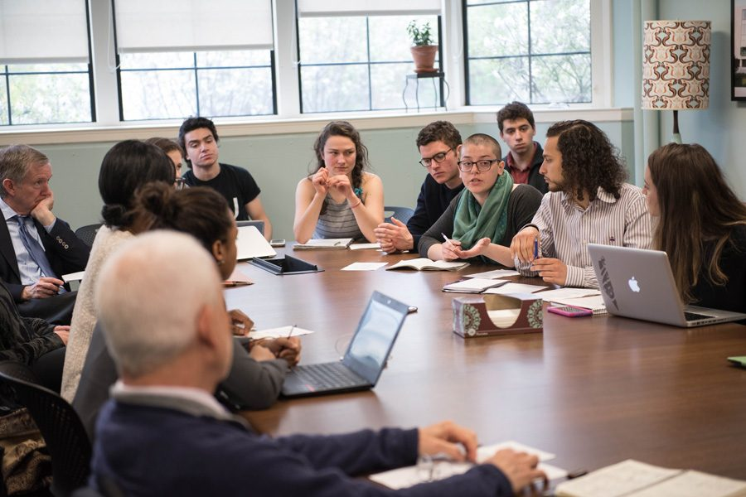
Student committee discussing some topic.

University Partners
SSD coordinates with many departments on campus as well as refers students to additional resources they may need while attending CSUSB. These services are available to students to help them succeed academically and personally.

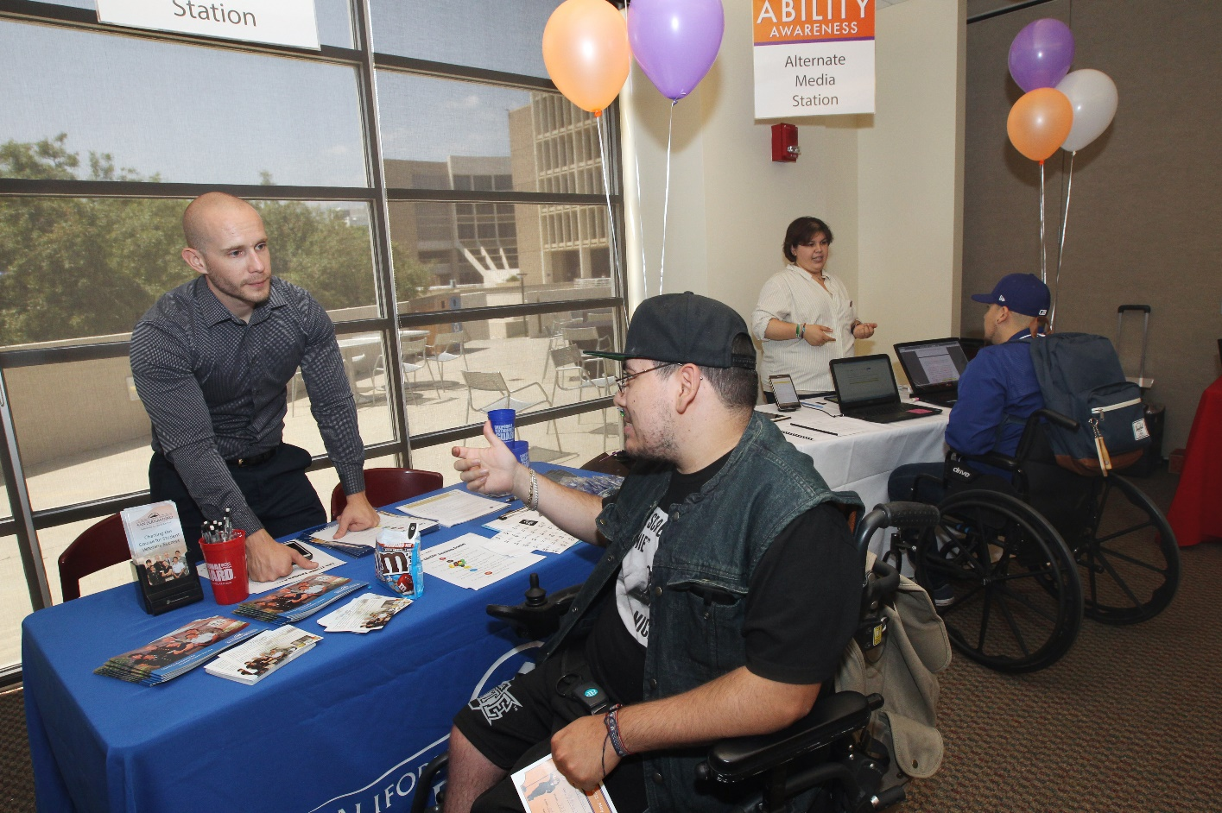
Mobility impaired student talks with a staff member tabling at the Ability Awareness event.

Academic Services and Advising
Aids undergraduate students in the development and implementation of educational plans, including assistance in reviewing general education requirements and PAWS.

Locations:
SBC - University Hall (UH), Room 380
PDC - Indian Wells Center (IW), Rooms 103, 105, 107

Phone:
SBC - (909) 537-5034 or (909) 537-5035
PDC - (909) 537-8253

Web:
SBC Advising website PDC Advising website Who is My Advisor?

ADA Compliance Officer
CSUSB has a responsibility to comply with ADA regulations for faculty, staff, students, and visitors. The ADA procedures and guidelines are available for viewing here. The ADA Compliance Officer helps to ensure that CSUSB complies with all ADA regulations.
ADA Compliance Officer: Alex Najera, AVP Human Resources

Location:
Sierra Hall (SH), Room 110

Phone:
(909) 537-5138

Web:
ADA Compliance website

Assistive Technology and Accessibility Center (ATAC) and Other Campus Adaptive Workstations
ATAC is a specialized assistive technology computer lab that provides access and training to students, faculty, and staff in the use of software including WYNN, OpenBook, JAWS, Dragon, and ZoomText. Other services include reduced cost printing, iPad and SmartPen loan program, Braille embossing, and a mobile accessible workstation. The lab is open to all students on campus for homework, studying, web-based research, etc., Monday through Thursday from 7:30 AM to 9 PM, and until 5 PM on Fridays. No appointment is required. The lab provides access and training on the following accessible technology:
    - Zoomtext (magnification software)
    - JAWS (screen-reading software)
    - Kurzweil 3000 (scanning software with speech output)
    - Dragon Speech Recognition (speech recognition software)
    - WYNN (tool to enhance success for individuals with reading challenges and writing difficulties)

Location:
Pfau Library (PL), Room 1109D (Main Campus)
Rogers Gateway (RG), RG-105, RG-107, and RG-109 (Palm Desert Campus)
Adaptive Workstations
Other CSUSB Adaptive Workstations are located across the campus. Students can access the computers by logging in with their Coyote ID and password. Any CSUSB member may use the computers on a walk-in basis.
Adaptive Workstation Locations:
CSUSB
Jack Brown Hall, Room 123
Social and Behavioral Sciences, Room 107
College of Education, Room 205
Santos Manual Student Union, Room 202
Pfau Library (7 workstations): 1st floor by reference computers; 1st floor, Room 1011; 2nd floor by new elevators; 2nd floor, Room 2005; 3rd floor by new elevators; 4th floor by new elevators; and 5th floor by new elevators.
PDC
Health Sciences, Room 103

Phone:
SBC - (909) 537-5079
PDC - (909) 537-8117

Email:
atac@csusb.edu

Associated Students Incorporated (ASI)
ASI is the recognized voice of the students at CSUSB. They represent the interests, needs, and concerns of over 20,000 students to the CSUSB administration, faculty, and staff. ASI presence is evident in many of the committees that they serve on, the programs and services supported across campus, and student representation at the state and national levels.
Location:
SBC: Santos Manuel Student Union (SMSU), Room 108
PDC: Mary Stuart Rogers Gateway Building (RG), Room 101

Phone:
SBC: (909) 537-5932
PDC: (909) 537-8155
Web:
SBC ASI website
PDC ASI website

Campus Safety (UPD)
The CSUSB Police Department is a state law enforcement agency which employs 18 sworn police officers and an active support staff for 24-hour protection for the campus community. The CSUSB Police Department offers programs such as Community Service Officers (CSO’s), a Chaplain Program, and campus escorts.
Location:
University Police (UP), Room 101
Phone:
(909) 537-5165
Web:
CSUSB University Police website

CARE Team
The CARE (Campus Assessment, Response, and Education) Team is a multidisciplinary group of professional staff members who come together to provide support and resources to students. The CARE Team receives, assesses, responds to, and monitors behavior on campus that may be disruptive, concerning, or threatening.

Phone:
(909) 537-2273
Web:
CSUSB CARE Team website

Career Center
The Career Center at California State University, San Bernardino empowers students and recent alumni to develop a lifelong skillset for an ever-changing labor market through exploration, programming, and experiential learning opportunities to meet their personal and professional goals. The center provides resources and programs as well as future employment and/or internship opportunities, and offers counseling and professional development workshops to assist with preparation of resume, interview skills, and internship opportunities.

Location:
SBC - University Hall (UH), Room 329
PDC - Indian Wells Center (IW), Room 102

Phone:
SBC - (909) 537-5250
PDC - (909) 537-8236

Web:
SBC Career Center website PDC Career Center website

Counseling and Psychological Services (CAPS)
CAPS offers counseling and psychological services for individuals, couples, and groups. Services are funded through student health fees. No other fees apply.
Appointments may be scheduled in person or by telephone. In emergencies, counselors are available by telephone Monday through Thursday, 8 AM to 6:30 PM, and Fridays, 9:30 AM to 5 PM.

Locations:
SBC - Student Health Center (SHC), Room 162
PDC - R.D. & Joan Dale Hubbard Student Health Center and Counseling and Psychological Services, Room 119

Phone:
SBC - (909) 537-5040
PDC - (760) 341-2883
Crisis line - (951) 686-4357

Web:
SBC Counseling and Psychological Services website PDC Counseling and Psychological Services website

Coyote PLUS (Peer Led Undergraduate Success) Programs
CSUSB Plus is committed to student success by providing a space for impactful learning and creating collaborative peer-to-peer communities. Coyote PLUS student leaders serve as mentors, tutors and supplemental instruction facilitators and work collaboratively with undergraduate students.
- Student Mentoring Program
The Student Mentoring Program offers peer support programs that encourage academic excellence, campus connectedness and engagement, and the personal growth and development of participating students.

Hours of operation:
Regular Hours:
Monday to Friday, 8 AM to 4:30 PM
Summer Hours:
Monday to Thursday, 7 AM to 5:30 PM, and Closed on Friday
Location:
Pfau Library, Room 202
Phone:
(909) 537-4499
Web:
Student Mentoring Program website
- Tutoring Program
The Tutoring Program supports registered students in CSUSB courses on a “walk-in” basis with challenging concepts, strengthening study skills, and building academic confidence. To achieve optimal results, students should bring course materials (syllabus, assignment prompts, etc.) and have a few questions in mind.
Location:
SBC - University Hall, Room 350
PDC - IW, Room 351
Phone:
SBC - (909) 537-4499
PDC - (760) 341-2883
Web:
SBC - Tutoring Program website
PDC - Student Success Studio website
- Supplemental Instruction
Coyote PLUS offers Supplemental Instruction (SI) as a method to help students who are enrolled in challenging courses by providing additional guidance, support and subject matter, and learning strategies. SI sessions last 50 minutes twice a week, and classroom size is limited to 20 students to maintain a small group learning environment.
Phone:
(909) 537-7355
Web:
Supplemental Instructions website

Early Start Program (ESP) and Coyote First Step (CFS)

CSUSB’s Early Start Program (ESP) strives to prepare first-time freshmen to acquire skills in written communication and/or quantitative reasoning before their first term, which increases their chances of successful completion of a baccalaureate degree in a timely manner. ESP participation is recommended for students determined by the Early Assessment Program, College Board SAT®, ACT® test, high school course work and grades.
A list of all courses to complete Early Start Program (ESP) at any CSU can be found at http:// earlystart.csusuccess.org/csu_early_start.
The Coyote First Step (CFS) program has been created to meet CSU Early Start Program requirements. The six-week intensive summer math program makes it possible for students to live on-campus for the first two weeks of the program, where students will take free math courses and engage in activities designed to promote college success.
Hours of operation:
Regular Hours:
Monday to Thursday, 8 AM – 6 PM and Friday, 8 AM – 5 PM
Summer Hours:
Monday to Thursday, 7 AM – 5:30 PM, and Closed on Friday
Phone:
(909) 537-4457
Web:
ESP and CFS website

Educational Opportunity Program (EOP)
EOP provides academic and personal counseling, tutoring, and financial assistance to first-generation college students who are California residents (or who qualify for AB 540 resident exemption), and those who are economically-disadvantaged with a history of low-income, need support, and demonstrate the potential to obtain a baccalaureate degree.
Requires an application submitted between October 1 and November 30 of each academic year.

Location:
University Hall, Room 395

Phone:
(909) 537-5042

Web:
Educational Opportunity Program (EOP) website
For the Palm Desert Campus, please contact Mario Baeza at (909) 537-5042 or by email at mbaeza@csusb.edu.

Helene A. Hixon Information Resource Center
The Helene A. Hixon Information Resource Center is the Palm Desert Campus’s library and provides a variety of accommodations for people with disabilities including adaptive workstations, e-books, and enlarged text displays. Hours of operation are Monday through Thursday, 9 AM to 7 PM, Friday, 9 AM to 5 PM, and closed on Saturday and Sunday.

Location:
Health Sciences (HS), Room 103

Phone:
(909) 537-8112

Web:
Helene A. Dixon Library website

Housing Needs
The CARE Team and the Department of Housing and Residential Education (DHRE) work together in order to identify both on-campus and off-campus housing resources. DHRE may be able to assist with on-campus housing if space is unavailable and/or depending on the particular situation.

Email:

housing@csusb.edu

Phone:

(909) 537-4155

Web:

CSUSB Housing website

John M. Pfau Library (Disability Resources)
The Pfau Library offers a variety of accommodations for people with disabilities including audio books, e-books, adaptive workstations, Sorenson Videophone, and enlarged text displays. There is also a laptop program, where laptops may be borrowed for a four-hour period. They may be renewed only once for an additional four-hour period. Renew in person at the Check-Out Desk or online via My Library Account. In addition to these services, books from the Textbook Collection may be checked out for two hours at the Checkout Desk.

Hours of operation:
Monday through Thursday, 8 AM to 11 PM Friday, 8 AM to 5 PM
Saturday, 9 AM to 2 PM
Sunday, 1 PM to 5 PM

Phone:
SBC - (909) 537-5091
PDC - (909) 537-8112

Web:
Users with Disabilities Resources website

Math Coaching
The Office of Undergraduate Studies offers math coaching to students in need of assistance. Services offered are 1:1 math tutoring and group math coaching/tutoring both lead by an instructor. Students can walk-in during office hours or call 909-537-3035 to request an appointment. Coaching hours are regularly updated on the website.
Location:
University Hall, Room 348 (inside Computer Lab UH-347)

Phone:
(909) 537-3035
Web:
Math coaching website

Multimedia Language Center
The Multimedia Language Center for the Department of World Languages and Literatures (MLC) provides resources to students studying world languages. A variety of programs and software are available to assist with the studying of many languages.

Location:
University Hall (UH), Room 314

Phone:
(909) 537-5847

Web:

Multimedia Language Center

Obershaw DEN
The DEN/CSUSB Food Pantry provides free meals and snacks as well as personal hygiene items that students can take with them. The DEN staff can also assist students in applying for CalFresh benefits and other food related assistance.

Location:
Faculty Office Building (FOB), Room 237

Phone:
(909) 537-FOOD

Web:

Obershaw DEN website

Office of Financial Aid and Scholarships
The Office of Financial Aid and Scholarships offers student loans, grants, scholarships, and work-study in order to help students meet the financial needs of obtaining a college education.

Location:
University Hall (UH), Room 150

Phone:
SBC - (909) 537-5227
PDC - (760) 341-2883, Ext 78143

Web:

SBC Financial Aid & Scholarships website

PDC Financial Aid & Scholarships website

Office of Graduate Studies

The Office of Graduate Studies assists graduate students from application to graduation. They also coordinate a number of fellowships and grants for those considering doctoral studies, as well as research and travel opportunities.

Locations:

SBC – Chaparral Hall (CH), Room 123

Phone:
SBC - (909) 537-5058
PDC - (760) 341-2883

Web:
SBC Graduate Studies
PDC Graduate Studies

Office of Student Engagement
The Office of Student Engagement provides, creates, and supports an inclusive student experience by offering social and co-curricular opportunities that foster student involvement and build affinity to CSUSB.

Location:
Santos Manuel Student Union (SMSU), Room 203

Phone:
(909) 537-5234

Web:

Student Engagement website

Ombuds Services
Ombuds Services works with the university community to help resolve university-related problems in a fair and civil manner. Ombuds Services is a confidential, independent, impartial, and informal resource.

Location:
Pfau Library (PL), Room 268

Phone:
(909) 537-5635

Web:
Ombuds Services website

Parking Services
Parking & Transportation Services offer free exclusive CSUSB carpool matching, vanpool coordination, additional transportation information, a Guaranteed Ride Home program and much more. Parking permits may be purchased here: Parking Permits. The campus parking fee may be waived for students with disabilities who meet the eligibility standards based on financial need. To qualify, students must have a DMV disabled placard/plate and meet the federal guidelines for financial aid. Students must fill out and submit the ‘Request for Waiver of Campus Parking Fee’ form at the Financial Aid Office.

Location:
SBC - University Hall (UH), Room 039
PDC – Mary Stuart Rogers Gateway Building (RG), Room 203

Phone:
SBC - (909) 537-5912
PDC - (909) 537-8138

Web:
SBC Parking Services website
PDC Parking Services website

Recreation and Wellness Center
CSUSB Recreation and Wellness is an auxiliary unit of the Santos Manuel Student Union (SMSU) within the Division of Student Affairs at CSUSB. The Recreation and Wellness Department provides a variety of safe and enjoyable programs and facilities to meet the diverse needs of the CSUSB community by creating a healthy social environment. Many activities and programs are offered to enhance physical fitness, learn new skills, engage in friendly sports competition, expand one’s knowledge base/comfort level, relieve stress, and to have fun.

Phone:
SBC - (909) 537-2348
PDC - (760) 610-1172

Web:
SBC - Recreation and Wellness website
PDC - Student Fitness Center website

SMSU Identity Centers
The Santos Manuel Student Union (SMSU) houses several centers that provide campus and community resources: Undocumented Student Success Center, LatinX Center, PanAfrican, Asian/Pacific Islander, First People, Queer and Transgender Resource Center, Osher Adult Re-entry Center, and Women’s Resource Center.

Location:
Santos Manuel Student Union (SMSU), Room 386

Phone:
(909) 537-5940

Web:
SMSU website

Student Assistance in Learning (SAIL)
SAIL offers a variety of services including academic advising, financial aid counseling, supplemental instruction, and graduate school preparation to undergraduate students who are low-income, first-generation college students or students with disabilities. Requires application and supporting documentation. Enrollment is from September 1 to September 30 of each academic year.

Location:
University Hall, Room 386

Phone:
(909) 537-5921

Web:
Student Assistance in Learning (SAIL) website

Student Employment
Student Employment at CSUSB provides a limited number of part-time, on-campus positions for eligible CSUSB students, providing students the ability to earn money as well as develop new skills to ensure professional success.

Location:
Sierra Hall, Room 110

Phone:
(909) 537-5138

Web:
Student Employment website

Student Health Center
The Student Health Center provides clinical care, immunizations, and health education and is conveniently equipped with a pharmacy and laboratory. In addition, the Student Health Center offers free pregnancy tests and female personal hygiene products. Health Center staff help students apply for Cal Fresh and Family Pact benefits which include free birth control for qualified students.

Locations:
SBC - Student Health Center (SHC)
PDC – Palm Desert Health Science Building (HS), Room 119

Phone:
SBC - (909) 537-5241
PDC - (909) 537-8177

Web:
SBC Student Health Center website
PDC Student Health Center website

Student Success and Equity Programs

The programs focus on retaining, supporting and facilitating the timely graduation of all CSUSB students through advising, community building, academic success programs, personal growth and awareness opportunities and targeted graduation campaigns.
Location:
University Hall, Room 352
Phone:
(909) 537-5032
Web:
Student Success and Equity Programs website

Undergraduate Studies Computer Lab
The Undergraduate Studies Computer Lab provides CSUSB students an opportunity to browse through the internet and check their e-mails. Students can also use the high quality laser printing service available at the lab by signing in on the computer with their Coyote ID and using their Coyote One card to print. Cost per page is 16 cents for black and white and 60 cents for color.
Location:
University Hall, Room 347
Hours of operation:
Regular Hours:
Monday - Thursday, 7:45 AM to 6:30 PM and Friday, 7:45 AM to 4:30 PM
Summer Hours:
Monday - Thursday, 7 AM to 5:30 PM, and closed on Friday
Phone:
(909) 537-5032
Web:
UGS-Computer Lab

University Honors Program

The Honors Program provides students from all majors with a community of peers equally passionate about learning, and it gives them opportunities to participate in community, academic, creative and service experiences that enhance their learning in classrooms, labs and studios.
Location:
Cajon Hall, Coyote Village, Room 135
Phone:
(909) 537-7472
Email:
honors@csusb.edu
Web:
University Honors Program website

Veterans Success Center (VSC)
The Veterans Success Center provides support and resources for student veterans, service members, and their families, including tutoring, computer work stations, and advocacy services.

Hours of operation:
Monday – Friday: 7:30 AM to 5:30 PM
Monday – Friday: 7:30 AM to 8 PM (two weeks prior to finals)

Location:
SBC - Bookstore (BK), Lower Level, Room 006A PDC - Health Sciences Building (HS), Room 105 Phone:
SBC - (909) 537-5195
PDC - (909) 537-8129

Web:
SBC Veterans Success Center (VSC) website
PDC Veterans Success Center (VSC) website

Web Accessibility
Web Accessibility is responsible for evaluating and assisting the campus community with adherence to the CSUSB Information Technology Accessibility Policy.

Location:
Pfau Library (PL), Room 520

Phone:
(909) 537-5075

Web:
Web Accessibility website

WorkAbility IV (WA-IV)
WA-IV provides prospective or current students who are clients of the California Department of Rehabilitation (DOR) with career services including: one-on-one career counseling; assistance in acquiring internships, volunteer opportunities, and/or part-time jobs; resume and cover letter development; interview coaching; and connections to regional employers. WorkAbility IV also offers a variety of workshops and events throughout the year including: resume development, job fair preparation, career planning, transferrable skills, stress management, social security benefits, and more.

Hours of operation:
Monday through Friday, 8 AM to 5 PM

Location:
SBC - University Hall, Room 401.02
PDC – Indian Wells Center for Educational Excellence, Room 112

Phone:
SBC - (909) 537-7207
PDC - (909) 537-8146

Web:
WorkAbility IV website

Writing Center
The Writing Center assists students at all stages of the writing process to discover topics, expand ideas, clarify organization, incorporate counter-arguments, cite references, edit, and proofread.

Hours of operation:
Monday – Thursday: 8:30 AM to 8 PM
Friday: 8:30 AM – 4:30 PM
Saturday: 10 AM – 4 PM

Location:
College of Education, Room 310 (Writing Center)
College of Education, Room 311 (Graduate Writing Center)

Phone:
Main Writing Center - (909) 537-5232
Graduate Writing Center - (909) 537-3127

Web:
Writing Center website
Graduate Writing Center website

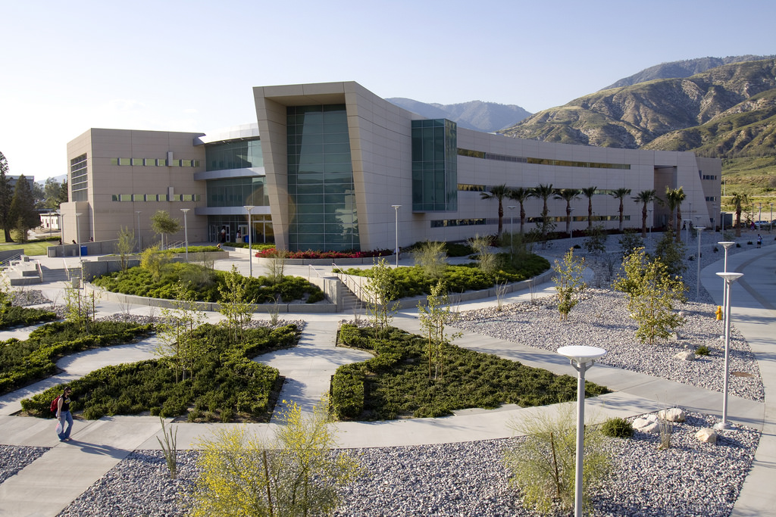
Photo taken at CSUSB displays the College of Education building.

Off-Campus Resources

211
211 is a toll-free, 3-digit phone number and service that provides information about many community resources including: employment resources, low-cost or free health clinics, free eyeglass replacement for the elderly, affordable parenting classes and other counseling services. 211 is a database and directory with a 24-hour call center staffed by highly trained specialists.
Phone:
211
Website:
211 website

Ability Tools
Ability Tools, located in San Bernardino, is a device lending library and reuse center that loans out or distributes assistive technology devices for free or at a low cost.
Location:
1955 S. Hunts Lane, San Bernardino, CA 92408
Phone:
(800) 390-2699 or (800) 900-0706
Website:
Ability Tools website

The Braille Institute
The Braille Institute, located in Rancho Mirage, CA, provides mainstream technology and adaptive devices such as magnifiers, CCTVs, and computer training with blind/low-vision software.
Location:
70-251 Ramon Road, Rancho Mirage, CA 92270
Phone:
(760) 321-1111 or 1-800-BRAILLE (272-4553)
Website:
Braille Institute website

California Department of Rehabilitation (DOR)
DOR is an employment and independent living resource for people with disabilities. Services include assistance with applications for State employment, support for recipients of SSI/SSDI, an assistive technology loan program, and financial assistance. Application is required.

Phone:
(916) 324-1313

TTY:
(844) 729-2800

Web:
California Department of Rehabilitation website

Children & Youth Services SBC
The Children’s System of Care offers an array of services for young people who are not benefitting from traditional mental health services. Services range from crisis intervention to life skills, and educational services for young people aged 0 to 26 years old.

Location:
658 E. Brier Drive, #150, San Bernardino, CA 92415

Phone:
(909) 387-5300

Web:
Children & Youth Services SBC website

Community Access Center
The Community Access Center, located in Riverside, CA, provides free services including systems advocacy, individual advocacy, peer counseling, assistive technology, ADA compliance reviews, and disaster planning.
Location:
6848 Magnolia Ave #150, Riverside, CA 92506
Phone:
(951) 274-0358
Website:
Community Access Center website

Community Action Partnership SBC
The Community Action Partnership of San Bernardino County (CAPSBC) is part of a National Community Action Network established under President Lyndon B. Johnson’s “War on Poverty” movement. CAPSBC offers many programs for homeless and low income individuals including food bank and soup kitchen services, as well as family development and environmental services.
Location:
696 S. Tippecanoe Ave., San Bernardino, CA 92408-2607
Phone:
(800) 635-4618 (toll free)
(909) 723-1500 (telephone)
Website:
CAPSBC website

Crisis Services SBC
The Crisis Walk-In Clinics (CWIC) provide urgent mental health services to residents of San Bernardino County. CWIC provides crisis intervention, crisis risk assessments, medications, referrals to county, contract and community resources, education, and when necessary evaluations for hospitalization. In collaboration with the Community Crisis Response Teams (CCRT), the CWICs work to reduce hospitalizations and improve the quality of life for individuals residing in San Bernardino County.
Location:
850 E. Foothill Boulevard, Rialto, CA 92376
Phone:
(909) 421-9495
Website:
Crisis Services SBC website

Homeless Outreach Support Team (HOST)
Homeless Outreach Support Team (HOST) provides outreach and engagement services to individuals and their families in an effort to obtain permanent supportive housing. Wrap-around services are provided by case managers to assist the individuals to maintain housing and become resilient in the community. Services include outreach, intensive case management, advocacy, and empowerment for self-sufficiency, as well as linkage and referrals.

Location:
850 E. Foothill Boulevard, Rialto, CA 92376
Phone:
(909) 421-4633
Website:
Homeless Outreach Support Team (HOST) website

The Inland Empire Lighthouse for the Blind
The Inland Empire Lighthouse for the Blind, located in San Bernardino, CA, provides free services such as: classes, instruction, materials, meals, transportation, and referral services to the completely and legally blind.
Location:
359 E Parkcenter Cir S, San Bernardino, CA 92408
Phone:
(909) 884-3121
Website:
Inland Empire Lighthouse website

Path of Life
The Path of Life Ministries is a non-profit organization based in Riverside, CA, that is committed to assisting the Riverside homeless population and low income individuals with a goal to rescue, restore, and rebuild lives in the community. They provide community shelter and family shelter programs as well as numerous other resources for the homeless.

Location:
2840 Hulen Place, Riverside, CA 92507 (individuals)
2530 Third St., Riverside, CA 92507 (families)

Phone:
(951) 462-9822 (individuals)
(951) 462-9822 (families)

Web:
Path of Life website

Recovery Based Engagement Support Team (RBEST)
The Recovery Based Engagement Support Team (RBEST) project provides community (field-based) services in the form of outreach, engagement, case management, family education, support, and therapy for adult clients in the community who suffer from untreated mental illness in an effort to connect them to the mental health system to receive appropriate services.
Phone:
(909) 421-9452
Website:
Recovery Based Engagement Support Team (RBEST) website

Riverside Transit Agency
Riverside Transit Agency is responsible for coordinating transit services throughout the approximately 2,500 square mile service area, providing driver training, assistance with grant applications, and development of Short Range Transit Plans (SRTPs). RTA provides both local and regional services throughout the county with 37 fixed routes, eight CommuterLink routes, and Dial-A-Ride services using 334 vehicles. The Dial-A-Ride service is an origin-to-destination reservation transportation service for persons with disabilities. Dial-A-Ride vehicles travel to areas within three-quarters of a mile of an RTA local fixed route. These areas are called the “Dial-A-Ride service area”, and trips can begin and end in these service areas. To learn more about RTA and Dial-A-Ride services, call the phone number or visit their website listed below.

Location:
2840 Hulen Place, Riverside, CA 92507 (individuals)
Phone:
(951) 565-5002
Website:
Riverside Transit Agency website
Rolling Start
Rolling Start, Inc., located in San Bernardino, CA, provides several resources to meet the technological needs of the disabled community with a device lending library program, voice options program, reuse program and assistive technology consumer training.
Location:
1955 S. Hunts Ln., San Bernardino, CA 92408
Phone:
(909) 890-9516
Website:
Rolling Start website

Sahaba Initiative
Sahaba Initiative aims to develop healthy individuals and families through social services and community efforts which include mental health, mentorship, and direct services. Some of the services provided include: food pantry, resource center for drug and alcohol support as well as financial assistance, youth programs, and more.
Location:
1887 Business Center Dr Ste 3, San Bernardino, CA 92408
Phone:
(909) 381-3002
Website:
Sahaba Initiative website
Service Center for Independent Life
Service Center for Independent Life, located in Claremont, CA, provides free services such as assistive technology coordination, advocacy, transition assistance, computer skills training, resume building and SSI benefits help.
Location:
107 S. Spring St., Claremont, CA 91711
Phone:
(909) 621-6722
Website:
Service Center for Independent Life website

VTrans-Omnitrans
VTrans-Omnitrans is located in San Bernardino, CA. The ADA requires public transit agencies that provide fixed-route service to provide “complimentary para-transit” services to people with disabilities who cannot use the fixed-route bus or rail service.
Location:
1700 W. Fifth Street, San Bernardino, CA 92411 (headquarters)
599 W. Rialto Avenue, San Bernardino, CA 92401 (transit center)

Phone:
(909) 379-7100
Website:
VTrans-Omnitrans website

Sources

- United States - Department of Justice, Civil Rights Division (Disability Rights Section). A Guide to Disability Rights Laws, “A Guide to Disability Rights Laws.” Retrieved from www.ada.gov/cguide.htm.

- GSA Government-Wide Section 508 Accessibility Program, “Section 508 Law.” Retrieved from www.section508.gov/section508-laws.

- The ADA: Questions and Answers, Equal Employment Opportunity Commission, “The ADA: Questions and Answers.” Retrieved from www.1.eeoc.gov/eeoc/publications/adaqa1.cfm?rederforprint=1.

- Information about the Americans with Disabilities Act Amendments Act (ADAAA), “The Americans with Disabilities Act Amendments Act of 2008.” Equal Employment Opportunity Commission, Retrieved from www.eeoc.gov/laws/statutes/adaaa_info.cfm.

Appendices

- Accommodation Deadlines

II. Application for Services

III. Disability Verification Request

- Documentation of Disabilities

- Documentation Guidelines for Learning Disabilities

IV. Department of Rehabilitation Information

V. Records Access Request Form

Accommodation Deadlines

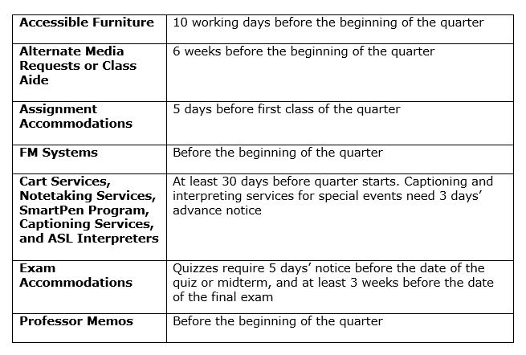
Services to Students with Disabilities 5500 University Parkway University Hall, Room 183
San Bernardino, CA 92407
(909) 537-5238 Voice (909) 537-7230 TTY (909) 537-7090 Fax
E-mail: ssd@csusb.edu Web: http://ssd.csusb.edu

Application for Services

This office provides academic support services to students with temporary or permanent disabilities. Both prospective and current CSUSB Coyote First Step students are encouraged to contact Services to Students with Disabilities (SSD) early in their educational program.

Step 1 Complete the Student Information Form

Step 2 Provide documentation of disability

Step 3 Meet with the appropriate SSD staff member

Attached: Student Information Form

Documentation of Disability Guidelines
Documentation Guidelines for Learning Disabilities Disability Verification Form
Department of Rehabilitation Form

California State University, San Bernardino

Services to Students with Disabilities

STUDENT INFORMATION FORM

TO BE COMPLETED BY STUDENT
IMPORTANT: Students are responsible for providing the Services to Students with Disabilities (SSD) Office with documentation verifying their disability. SSD Staff will review documentation to determine eligibility for program participation. Filling out this form does not guarantee eligibility.

GENERAL INFORMATION

Last Name: First Name: M.I.

Coyote ID: Date of Birth:

CSUSB Email: @coyote.csusb.edu

Street Address:

P.O. Box: Apt #:

City: State: Zip:

Phone Number: ( ) Circle One: Home Work Cell

Phone Number: ( ) Circle One: Home Work Cell

CATEGORY OF DISABILITY (Check all that apply)

Cognitive Office Use Only

Hearing

Learning

Physical

Psychological

Speech

Visual
Received

Other

Disability Status: ☐ Temporary ☐ Permanent

SCHOOL INFORMATION

Last School Attended: Dates of Attendance:

CSUSB INFORMATION

1st Quarter of Attendance at CSUSB: Major: Expected Graduation Date: Degree: Career Goal:

EMERGENCY CONTACT

Name: Phone: Relationship to Student:

Student Signature: Date:

Parent/Guardian Signature: Date: (If under 18 years of age)
Updated: 5/2/14

Disability Verification Request

Services to Students with Disabilities

CALIFORNIA STATE UNIVERSITY, SAN BERNARDINO

Student Name: DOB#:
This form is to be completed in full by a licensed professional.

Diagnoses (Including ICD/DSM-IV codes): Date:
1.
2.
3.

Severity: Mild Moderate Severe Partial remission Residual state
Condition: Permanent Temporary until Date of last visit: List current medications:
Medication | Dosage | Frequency | Patient Reported Side Effects

Describe how the disability limits major life activities:

State the impact and specific functional limitations relating to academic performance:

Signature of Licensed Professional Date of Verification

Print Name/Title License Number

Address Phone Number

5500 University Parkway, UH183, San Bernardino, CA 92407 Phone 909.537.5238 ~ Fax 909.537.7090
Received

California State University, San Bernardino

SERVICES TO STUDENTS WITH DISABILITIES

DOCUMENTATION OF DISABILITIES
The following guidelines are to be used to verify and describe your patient’s disabling conditions. Please be clear as to how these conditions constitute “an impairment which substantially limits one or more major life activities.” Detail the impact on your patient’s ability to function as a California State University, San Bernardino (CSUSB) student without specific accommodation of his/her disability.

Functional Impairment: Provide a current diagnosis and description of related functional limitations resulting from your patient’s disabling condition.
Hearing Impairment: Provide a copy of your patient’s most recent audiogram, along with detailed diagnosis and description of disability.
Mobility Impairment: Provide a current diagnosis and description of related functional limitations resulting from your patient’s disabling condition.
Psychological Disability: Provide complete DSM-IV/V diagnosis, summary of evaluation results and any additional psychological and/or neurological testing results. Past and present symptoms should be stated clearly.
Visual Impairment: Provide documentation of your patient’s most recent most recent visual acuity and/or visual field examination results, along with a detailed diagnosis and description of disability.
Learning Disability: See separate form.

CALIFORNIA STATE UNIVERSITY, SAN BERNARDINO
Services to Students with Disabilities 5500 University Parkway, University Hall, Room 183 San Bernardino, CA 92407
909-537-5238 Voice ~ 909-537-7230 TTY ~ 909-537-7090 Fax
Email: ssd@csusb.edu ~ Web: http://ssd.csusb.edu

Documentation Guidelines for Learning Disabilities

To participate in the assessment process, students must present appropriate documentation of their disability. Test instruments used must have been normed on an adult population.
  - The evaluation must be performed by a professional whose education, training and experience render that person qualified to diagnose learning disabilities in adults. Examples of such professionals include the following:
    - Licensed Educational Psychologist
    - Licensed Clinical Psychologist
    - School Psychologist
    - Learning Disability Specialist
    - Neuropsychologist

  - The documentation must be representative of the student’s current level of functioning as it pertains to the academic environment and must include all of the following:
    - The name, title, license, certification or credential information of the evaluator (The diagnostician should not be a family member)
    - Date of assessment
    - Summary of procedures and assessment instruments used
    - Summary of test results including all behavioral observations, standard scores for all subtest, composite, and index standard scores compared to same age peers
    - Summary of relevant history
    - Statement of severity
    - Statement of impact on the student’s academic performance
    - Recommendations for academic adjustments and accommodations to minimize the impact of the learning disability on the student’s performance
    - Narrative reporting including a clear statement of the presence of a processing disorder or learning disability, discussion of possible alternative explanations for results, a statement of strengths and functional limitations, and suggestions for reasonable accommodations which must be directly linked to the stated limitations and supported by standard scores

  - Documentation must include at least one each from A and B:
    - Tests of aptitude/cognitive ability such as:

      - Wechsler Adult Intelligence Scale-III (WAIS-IV)
      - Woodcock-Johnson Psycho-Educational Battery-III (WJ-III)- Cognitive Battery (preferred)
      - Stanford-Binet Intelligence Scale-V
      - Kaufman Adolescent & Adult Intelligence Test

    - Tests of achievement such as:
      - Woodcock-Johnson Psycho-Educational Battery-III (WJ-III)- Achievement Battery
      - Wechsler Individual Achievement Test-II or III
      - Optional: Specific subject area achievement tests can be administered in addition to those above to clarify individual strengths and weaknesses when the results are interpreted within the context of other diagnostic information. These tests include:
        - Nelson-Denny Reading Skills Test
        - Stanford Diagnostic Mathematics Test
        - Stanford Test of Academic Skills
        - Scholastic Abilities Test for Adults
        - Test of Written Language-III (TWOL-3)
        - Woodcock Reading Mastery Tests Revised

Note: The Slosson Intelligence Test, the Kaufman Brief Intelligence Test, the Wide Range Achievement Tests, and the Nelson-Denny Reading Tests are not considered to be comprehensive measures and thus are not adequate if used as the sole measure.

  - Special assessment requirements for a mathematics disorder minimally must include the following:
A. WJ-III Cognitive Tests: 1,3,4,5,6,7,9,11,15,16,17
B. WAIS-IV Tests: VCI + PRI + GAI + MR + VP + FW + ARI + BD + PC

  - Special assessment requirements for a reading disorder minimally must include the following:
    - WJ-III Cognitive Tests: 1,6,7,9,11,16,17
    - WAIS-IV Tests: VCI + PRI + GAI + Sim + Voc + Comp + Inf + Ari

  - Information processing acceptable instruments include:
    - Detroit Tests of Learning Aptitude- Adult (DTLA-A)
    - Woodcock-Johnson Psycho-Educational Battery-III (WJ-III)- Cognitive
    - Bender Gestalt Visual Motor Test
    - WAIS-IV FSIQ + PSI + Cancel + FW + VP + PC + Cd + SS

These Documentation Guidelines for Learning Disabilities are taken from the Guidelines of a Learning Disability in Adolescents and Adults established by the Association on Higher Education and Disability (AHEAD www.ahead.org) and from the Policy Statement for Documentation of a Learning Disability in Adolescents and Adults established by the Educational Testing Service (www.ets.org/distest/ldpolicy).

DEPARTMENT OF REHABILITATION INFORMATION

WorkAbility IV (WA-IV) is an interagency program between the California State University, San Bernardino (CSUSB) and the California State Department of Rehabilitation (DOR). The WA-IV Program is designed to create career options and opportunities for students with disabilities who are supported by DOR and complete their degrees at CSUSB.
There are two requirements for participation in WA-IV:

- You are enrolled at CSUSB, and

- You receive services from DOR.
Yes
No
Are you a client of the California State Department of Rehabilitation?
Yes
No
If yes, are you interested in finding out more about WorkAbility IV?

Name: SID #:

Address:

Phone Number: CSUSB Email Address:

Your DOR Counselor’s Name:

Your DOR Counselor’s Office Location:

Your Signature and Date:

California State University, San Bernardino 5500 University Parkway, San Bernardino, CA 92407
(909) 537-7207 Voice Fax (909) 537-7755
Email:WAIV@csusb.edu http://WorkAbilityIV.csusb.edu

Records Access Request Form

I, ____________________________________, request to view my Services to Students with Disabilities file for my personal use. I am aware that I may have a third party present, who is not licensed to practice law.

Please mark one box:

I request to view and/or copy (in accordance with the University Policy & Procedures for Student Records Administration) my student records in the presence of my Services to Students with Disabilities Counselor or the Director. Reviewing my records with my Counselor or the Director affords me the opportunity to have my Counselor or the Director explain information and to answer my questions.

I request to view and/or copy (in accordance with the University Policy & Procedures for Student Records Administration) my student records without the presence of a representative from Services to Students with Disabilities. I understand that a representative from Student Affairs will be present during my review, but will not answer any questions that I may have about my student records.

________________________________________________________________________
I request to view and/or copy documentation that SSD has received from third parties (in accordance with the University Policy & Procedures for Student Records Administration). I understand that I must obtain and bring written permission (signed and dated on letterhead) from the originator of the documentation before access will be granted.

109

Records Access Request Form (Page 2 of 2)

Date of Review: ___________________

Student
Student Signature:
Student Name (please print):

Third Party
I certify that I am not licensed to practice law.
Third Party Signature:
Third Party Name (please print):

SSD Counselor or Director
SSD Counselor or Director Signature:
SSD Counselor or Director Name (please print):

110

