October 2011

In an effort to better understand the current and potential role of the Southern California region as it relates to the concentration of Hispanic Serving Institutions, the Southern California Consortium of Hispanic Serving Institutions (SCCHSI) undertook a profile study. As of May 2011, there were 63 HSI identified by the Federal Department of Education in the region. This is the largest concentration of HSIs in the nation.

The SCCHSI’s belief is that there is a tremendous wealth of knowledge to be shared between institutions and there is great need to advocate for the needs of the students we serve.

Out of the 63 institutions in the Southern California Region, 25 campuses submitted their institutional profiles. The information contained herein is a descriptive gathering of the data which, when appropriate, is broken down by the categories of community colleges, CSUs/UC, and private colleges/universities. There are 14 community colleges, 6 CSU/UCs, and 5 private institutions included in this sample.

Understandably the profile is not complete, but it nevertheless offers a substantive cross-section of the regional HSIs. The collection of the data has been an on-going effort and we are incredibly appreciative of those institutions that took the time to submit. In the future, we will continue to solicit the profiles from other campuses to better complete the regional profile.

Many thanks to the SCCHSI Executive Board for their work in the Institutional Profile study. Victor M. Rojas, First Vice President, Dr. Marilyn Martinez-Flores, Second Vice President, Juliette Cagigas, Treasurer, and Leticia Guzman-Scott, Secretary. Also, special thanks to Rosalilia Gradilla, Kristen Pleasant, and Paola Rivera for compiling the data.

This work is a work in progress…

Sincerely,

Daniel Loera
Daniel Loera
SCCHSI President

Southern California Consortium of Hispanic Serving Institutions (SCCHSI) Institution Profile

California State Polytechnic University, Pomona  California State University, Fullerton  California State University, Los Angeles  California State University, San Bernardino  Citrus College  College of the Desert  CSUSB Palm Desert  Imperial Valley College  Los Angeles Mission College  Moreno Valley College  Mount St. Mary’s College  Mt. SAC  Mt. San Jacinto College | Norco College  Occidental College  Oxnard College  Pacific Oaks College  Rio Hondo College  Riverside City College  San Bernardino Valley College  Santa Barbara City College  Santa Clarita Community College District  UC Riverside  University of La Verne  Whittier College
Participants (25 Institutions)

*Institutions are invited to still submit data.

- Institutional Information

- Status as a Hispanic Serving Institution-per U.S. Department of Education

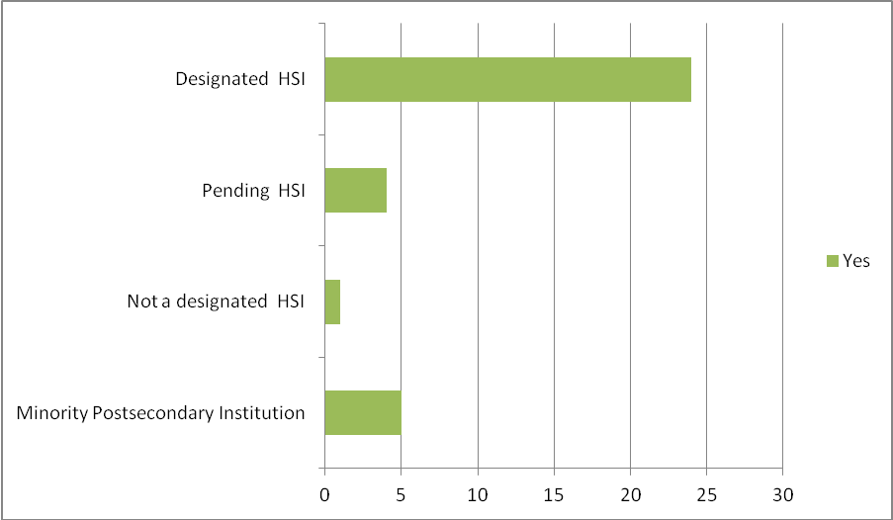
Designated HSI  Yes= 24 | Pending HSI  Yes=4 | Not Designated HSI  Yes=1 | Minority Postsecondary Institution  Yes=5

- Percentage of Hispanic/Latino Enrollment

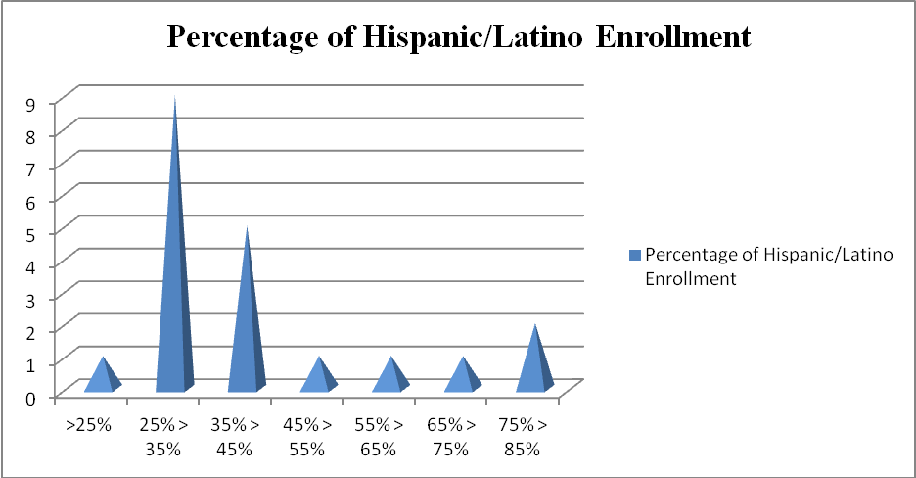
Total participants=21 institutions
(4 institutions did not specify percentage of Hispanic/Latino Enrollment)

- Campus Service Status

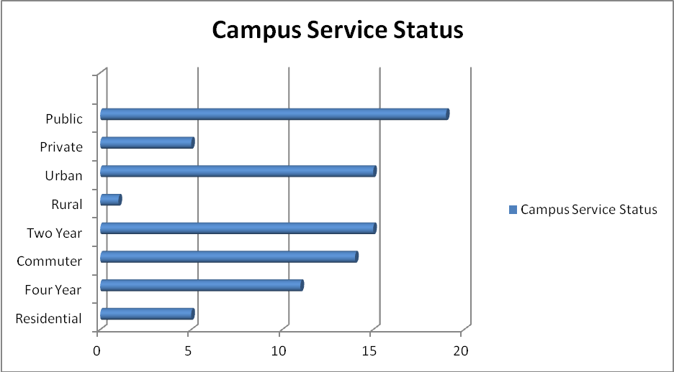
Total participants=25 institutions

- Largest Cities/Communities in the Institution’s Primary Service Area
PRIVATE
- Long Beach  - Los Angeles (2)  - Ontario  - Pasadena | - Pomona  - Rancho Cucamonga  - San Diego

 | CSU/UC
- Anaheim  - Cathedral City/ La Quinta  - Indio  - Los Angeles (2)  - Moreno Valley (3)  - Palm Desert |  | - Pasadena  - Riverside (3)  - San Bernardino (3)  - San Gabriel Valley  - Santa Ana

COMMUNITY COLLEGE
- Azusa  - Baldwin Park  - Brawley  - Calexico  - Canyon Country  - Carpinteria  - Cathedral City  - Corona (2)  - El Centro  - El Monte  - Glendora  - Glendora  - Goleta  - Hemet  - Indio  - Moreno Valley (2)  - Murrieta  - Norco | - Oxnard  - Pacoima  - Palm Desert  - Perris  - Pomona  - Redlands  - Rialto  - Riverside (3)  - San Bernardino  - San Fernando  - Santa Barbara  - Santa Fe Springs  - Saugus  - Sylmar  - Temecula  - Valencia  - West Covina  - Whittier

- Largest Business/Industry in service area
*numerical ranking signifies ranking by individual campus
PRIVATE
- Avery Dennison (2)  - Construction (5)  - Education Services, Health Care, and Social Assistance (1,1,2)  - GPL (3)  - Huntington Hospital (5)  - Manufacturing (4) | - Parsons (1)  - Professional Scientific Management and Administrative, and waste management services (3,4)  - Public Administration (3)  - Retail trade (2)

 | CSU/UC
- Accommodation and Food Services (5)  - Agriculture (3)  - Construction (3)  - Education/Health Services(3)  - Finance Insurance (5)  - Government (4,1)  - Health Care (4,2)  - High Tech |  | - Industries (4)  - Higher Education (4)  - Hospitality (2)  - Inland Empire Economic  - Partnership (5)  - Manufacturing (2,4,3,5)  - Manufacturing (5) |  | - Military (2)  - Non Durable Goods  - Retail (1,2,1,3,1)  - Services (1)  - Small and Medium Size Business (1)  - Trade/Transportation/Utilities (4)  - Wholesale sector (2,2)

COMMUNITY COLLEGE
- Aeronautics Industry (1)  - Aftermarket Auto Industry (2)  - Agriculture (2)  - Air Transportation (4)  - Community Hospital (3)  - Community of San Bernardino (1)  - Construction (5,4,5)  - Distribution (3)  - Education and Health Services (2,3,1,1,5,4,4)  - Farming (5)  - Financial Activities (5)  - Food Industry (3)  - Freight Transportation (5)  - General Fright Trucking (2) | - Government (1,1,1,5,3)  - Hospitality/Tourism (1)  - Law Enforcement (1)  - Leisure and Hospitality (3)  - Leisure and Recreation (3)  - Loma Linda University (3)  - Manufacturing (4,5,4,3,4,4)  - Medical Technology (4)  - Other services except public administration (5)  - Postal Services/Couriers (1)  - Private Sector (1) | - Professional and Business Services (3,4,2,5,2)  - Public Sector (3)  - Renewable Energy (4)Retail (2,2,3,2,1,3)  - Rialto School Unified School Dist (5)Services (2)  - Trade (4)  - Trade Transportation and Utilities (1,2)  - Utilities (2)  - Warehouse and Storage (3)

- Academic Area

- Institution’s Main Academic Area

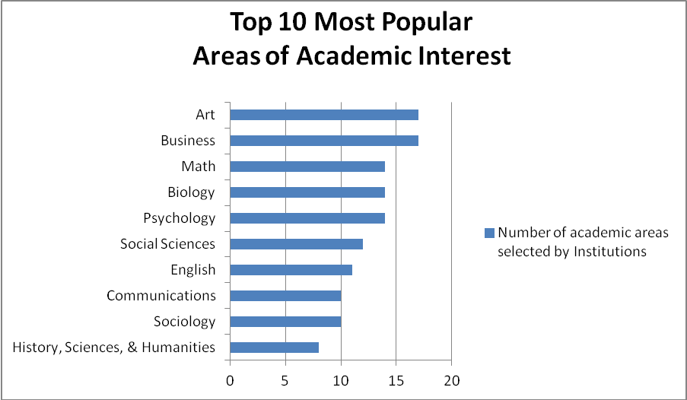

Total Participants=25 institutions

- Specialty Academic Programs and Resources
- Institution’s Specialty Academic Programs
PRIVATE
- African American Studies  - Athletic Training  - CAPA (Campus Accelerated Program for Adults)  - Center for Teaching and Learning  - Center for Collaboration with the Arts | - Center for Community Based Learning  - Center for Food and Justice  - Center for Science, Health and Technology  - Curriculum Lab  - Film and Social Justice | - International Studies Institute  - Latino/Latina Family Studies Learning Enhancement Center  - Migration Policy and Resource Center  - Urban and Environmental Policy Institute

CSU/UC
- Advanced Technology Partnerships Institute  - Agriculture Experiment Station  - Ahimsa Center-Social Change and Non-Violence  - Air Pollution Research  - ALPHA Center-Academy of Learning through Partnerships for higher Achievement  - American Communities Program  - Apparel Technology & Research Center  - Applied Gerontology Institute  - California Forensic Science Institute  - Center for Antimicrobial Research & Food Safety  - Center for Bibliographic Studies/Research  - Center for California Native Nations  - Center for Demographic Research  - Center for Education and Equity in Mathematics, Science, & Technology  - Center for Environmental Research/Tech  - Center for Geographic Information Research (GIS)  - Center for Ideas & Society  - Center for Information Assurance Business  - Center for Macromolecular Modeling and Material Design | - Center for Nan-scale Science/Eng.  - Center for Promotional Development Business  - Center for Study of Genders and Sexualities  - Center for the Study of Hate and Extremism  - Center for the Study of the Center for Turf, Landscape & Irrigation Technology  - Center or Equity in Education  - Centre for Conservation Biology  - Child Abuse and Family Violence Institute  - Coachella Valley Health Collaborative  - Colorful flags Program (Flags)  - Community-University Partnership Institute  - Edmund G. “Pat” Brown Institute of Public Policy  - Edwards\ Blakely Ctr. For Sustainable Suburban Devel.  - Fire Protection Administration and Technology Program  - Hertzberg-Davis forensic Science Center  - Industrial Research Institute for Pacific Nations (Business)  - Information Assurance and Security Management Center Inland Empire  - Inland Empire Center for Entrepreneurship  - Institute for Child Development and Family Relations | - Institute for Integrative Genome Biology  - Institute of Applied Research and Policy Analysis  - Institution for Great Leaders for Great Schools  - Leonard Transportation Center  - Lyle Center for Regenerative Studies  - Motor Development Clinic (Class)  - NASA University Research Center  - NSF CRST Center for energy and Sustainability  - Office of Technology Transfer and Commercialization  - Palm Springs Institute for Environmental Sustainability  - Professional Development Institute  - Real Estate Research Council Business  - SEARCH-Family Autism Res. Ctr.  - Stem Cell Center  - UC Institute for Mexico & US  - University Center for Developmental Disabilities  - University Center for Developmental Disabilities (Autism)(2)  - W.K. Kellogg Arabian Horse Center Agriculture  - Water Resources Institute  - Watson and Associates Literacy Center

COMMUNITY COLLEGE
- Administration Of Justice/ Business and Law  - Allied Health  - Automotive/Alternative Fuels  - Ben Clark Training Center Public Safety Program (Fire, Sheriff, and EMT academics)  - Bridge Program  - California Regional Consortium for Engineering Advance in Technological Education  - Career Academic  - Center for Applied Competitive Technologies  - Center for Applied Competitive Technologies  - Center for Child Development Studies  - Center for Green Technology  - Center for Sustainability  - Center for Training and Development  - Center of Excellence  - CFTE  - Child Development  - Child Development Careers  - Community Education and Professional Development  - Computer Aided Drafting, Engineering, Architecture  - Computer Applications and Office Technologies  - Construction  - Cosmetology  - Culinary Arts Institute | - Dental Assistant  - Dental Hygiene  - Dental Hygiene/ Dental Assistant  - Digital Photography/Animation  - Employee Training Institute  - Engineering Architecture  - Environmental Science  - Esthetician  - Family and Consumer Studies  - Fire Academy  - Fire Technology/Fire Academy  - Gaming Technology (2)  - Health Fitness and Athletics  - Honda Pact  - Intensive English Academy  - Interior Design  - Kinko’s Early Learning Center  - Logistics  - Manufacturing/ Machine Shop  - Marine Center and Aquarium  - Marine Diving Technology Program  - Media Incubator  - Medical Assistant Program  - MESA  - Middle College High School  - Mobile Media Institute  - Multimedia | - Multimedia Studies  - Nursing Lab  - Physicians Assistant Program  - Police Academy  - Professional Development Center  - Project Success (STEM)  - Psychiatric Technology  - Regional Health Occupation Resource Center  - Regional Information Systems security Center  - Scheinfeld Center for Internship  - Serious Gaming Institute  - Sheriff’s Academy  - STEM Center (2)  - Student Assistance Center (SAP) Community Block Grant  - Summer GIS Program  - Teacher Preparation Institute  - Toyota Partnership (T-10)  - Turf Management  - USDA Soil Science Certification Program  - Viticulture and Enology  - Water and Technology  - Water Supply  - Wild land Fire Academy  - Work Source Center  - Writing Center

- Institution’s Unique Resources in Facilities and Equipment
PRIVATE
- Microscopy Imaging Center  - Montana Research Center  - Greenhouse and Animal Care Facility (AICU)  - Jaeger Museum  - Leo FM, LVTV-3, Campus Times, La Verne Magazine | - Darkroom and Digital Editing (2)Multiple Theater stages and scene shop (3)  - Multiple Art Galleries (Harris, Carlson, Tall Wall) (3)  - Honors Center  - Children’s School (3) | - Ruth B. Shannon center for the Performing Arts  - Superconducting Magnet  - Moore Mythology Collection

 | CSU/UC
- AGRIscapes  - Automated Manufacturing and Robotics Laboratory (2)  - Bio Behavior Lab  - Biological Sciences Imaging Lab  - Center for Electron Microscopy (SEM.TEM/EDS)  - Distance Learning Labs  - Environmental Engineering Laboratory (2)  - Exercise and Human Performance  - Flow Cytometry and Cell Sorting  - Genomics/ Gene Expression  - Health Science Stimulation Labs | - Heavy Duty Engine  - Dynamometer  - Human Performance Lab  - Indian Wells Theatre  - John T. Lyle Center for Regenerative Studies  - Luckman Fine Arts Complex  - Mass Spectrometry  - Mobile Emissions Lab  - Mobility Gym  - Nanofabrication Clean room Facility  - Natural History of Collections and Herbarium  - Neutra VDL Research House  - Nuclear Magnetic Resonance  - Facility (400 and 600 MHz) | - Observatory (under Construction)  - Photonics Laboratory  - Plant Transformation  - Proteomics Mass Spectrometry  - Rain Bird Ethonobotany Center  - Research Greenhouse  - Robert V. Fullerton Art Museum  - Supply Chain Management and Logistic Lab  - Sustainable Land Development Laboratory  - Vehicle Emissions Research Lab  - Vivaria

COMMUNITY COLLEGE
- 250 Aare Farm  - Argi Gardens  - Automotive Repair Service Shop  - Campus Under Wireless Courage  - Center for Faculty Development/ Professional Development  - Child Development Center  - Chumash/ Ethno Botanical Presence  - CISCO  - Clean Room  - Dental Hygiene/ Dental Assistant  - Desert Institute  - EBSCO Online Research Database/Library  - Edustream  - Elumen Software (SLO tracking software)  - Evening and weekend college  - Fire Science Facility (2)  - Football Stadium  - Full RN program  - Gaming (2)  - Golf Driving Range | - Greenhouse  - Greenhouse two practical Gardens  - Indoor Basketball Court and Running Track  - Instructional Media Center  - Interactive TV Courses  - KSAK radio station  - Language Lab  - LED Certified Buildings  - Life Science Museum San Jacinto Campus  - MAC Computer Labs  - Marine Diving Teach Training Facility  - Math Center Lab  - Moore Online Course Management Delivery System  - Nursing Lab (2)  - Nursing Simulation LAB  - Observatory (2)  - On Site Farmers Markey  - Organic Chemistry Lab with IR spectrometer and gas chromatographs  - Oxnard College Television  - Panopto Streaming Media Server  - Performing Arts Center  - Performing Arts Center (2) | - Photo Voltaic Solar Paneled Parking Structure  - Pipeline Campus Web Portal  - Planetarium  - Planetarium  - Police academy Ranger/ Public Safety (2)  - Radio Station  - Recording Arts Program  - SBCC Lifescape (outdoor Horticulture Lab)  - Smart Classrooms  - Software (Mathematics, Statistics, Social Works)  - State of the Art Culinary Arts Building and equipment  - Steam Center  - Stimulated dig sites for archeology classes at the Western Center  - Swimming Pool (Handicapped Accessible)  - University Center  - Wi-Fi Campus  - Writing Reading Center Lab (2)

- Student and Academic Support Services (exclude student clubs and organizations that are not fully institutionalized)

- Student and Academic Support Services

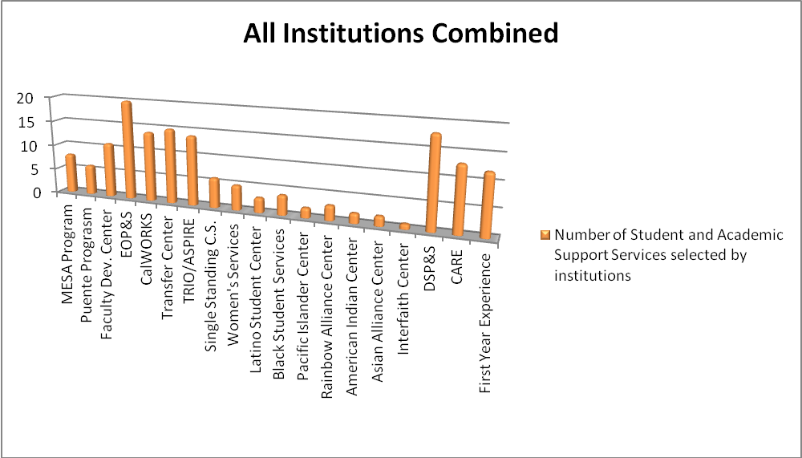
Total Participating Institutions: 24

- Private, CSU/UC, and Community College

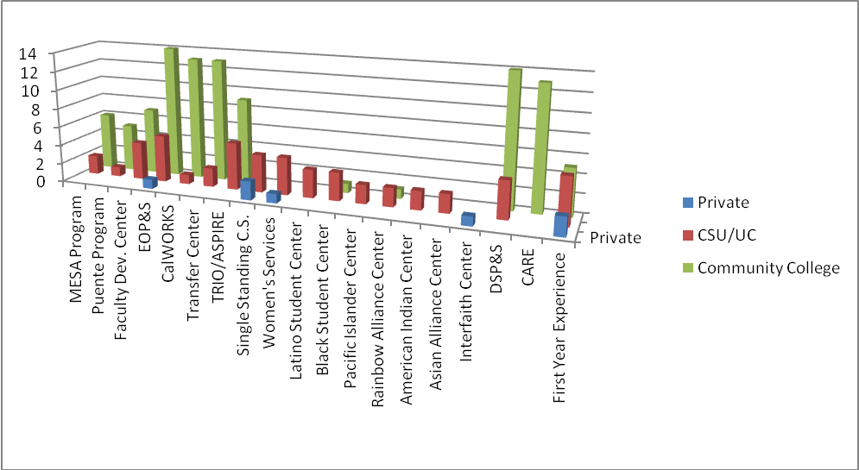
Total Participants: 24
(Two Private, Six CSU/UC, and Sixteen Community College)

- Other Student Support Service Programs
PRIVATE
- Center for Cultural Fluency  - Center for Student Achievement, Resources and Environments (CARE)  - Community Literacy Center  - First Year Resource Program | - GEAR UP  - Honors Program/Honors Center  - Learning Assistance Program  - Learning Resource Center  - Upward Bound

 | CSU/UC
- Adult ReEntry  - Associated Student Moreno Valley College  - Associated Student Organization (ASO)  - Career Academy  - Center for Teacher Excellence  - Cooperative Title V HSI  - Early Decision  - Early Alert System  - Engagement Centers  - Financial Aid Advising  - Foster Kinship | - International Students  - Latina Leadership Network  - Learning Communities-Community for Academic Progress (CAP)  - Outreach Center  - Outreach Counselor  - Rancho Mirage Student Center  - STEM Center  - STEM Student Success Center  - Student Clubs and Organizations | - Student Employment  - Student Equity  - Student Health Center  - Supplemental Learning/Instruction Program  - Title V HSI  - Transfer and Retention Advisor  - Tutorial Services  - Umoja Program  - USTD 100b “Transfer Seminar”  - Valley Bound

COMMUNITY COLLEGE
- ACES  - Academic Skills Center/Tutoring  - At risk and GE Learning Communities  - Bridge Program and Learning Communities  - International Educational Program  - Language Learning Center  - Learning Assistance Center  - Math Activities Resource Center | - McNair Scholars Program  - Psychological Services  - University Tutorial Center  - University Writing Center  - Upward bound  - Veterans Services  - WIN Program for Athletes  - Writing Center

- Support-Currently OR Previously Funded
- Projects that are currently funded or were funded within the past 5 years

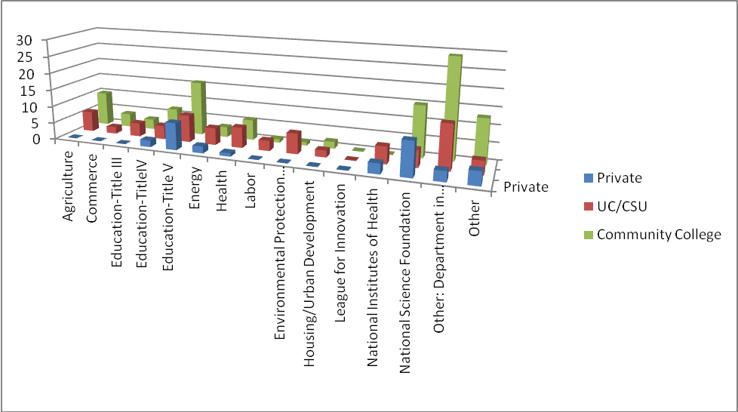

- Examples of Successful Partnership and/or Collaborations
Title | K-12 | CC | 4-yr | Grad School | Comm. | Industry | Church | Health  Org. | Advisory Group | Parent Involvement | Social Service  Org | Hispanic Advising Group | Other
2+2 Articulation | X
A.V.I.D. | X |  | X |  |  |  |  |  | X
AB 540 |  |  |  |  |  |  |  | X |  |  |  | X
Academy for Literacy | X |  |  |  |  |  |  |  |  | X
Alternative Energy Institute | X | X |  |  |  | X
American Indian Nations |  |  |  |  |  |  |  |  |  |  |  |  | Tribes
AOC | X | X
Articulation |  |  | X
ARTS Block |  |  |  |  | X |  |  |  |  |  |  |  | City of Riverside
B.U.I.L.D. | X |  | X |  | X |  |  |  | X
Banning Unified School District |  | X |  |  |  |  |  |  |  |  |  |  | ESL Classes
Bilingual Parent Education Conference | X |  |  |  |  |  |  |  |  |  |  | X
Boys and Girls Clubs | X |  | X |  | X |  |  |  | X |  | X
Bronco Advancing Service Excellence (BASE) | X |  |  |  | X |  | X |  |  |  | X | X
Calif. Dept. of Energy B-GREEN Grant |  | X |  |  |  | X |  |  | X |  |  |  | Workforce Investment Board
Career Academy |  | X |  |  |  | X
CCRRA/STEM | X | X | X
Center for Student Opportunity (CSO) | X |  | X |  |  |  |  |  | X
City of Claremont-Psych Services for older Adults, Youth, and Families
City of Temecula Community Center |  | X |  |  |  |  |  |  |  |  |  |  | ESL & Citizen-ship Classes
Coachella  Valley Health Collaborative |  |  |  |  | X |  |  | X
Title | K-12 | CC | 4-yr | Grad School | Comm. | Industry | Church | Health  Org. | Advisory Group | Parent Involvement | Social Service  Org | Hispanic Advising Group | Other
College Pathways to High Wage Careers | X | X |  |  |  | X
Community Service by Students | X |  |  |  | X |  |  | X |  |  | X
County of Riverside Job Training |  |  |  |  |  |  |  |  |  |  | X | X | Chancellor’s Office
DisAbility Sports Festival | X |  | X | X | X | X |  | X | X | X | X |  | Veterans
Dual AP Alternative | X |  |  |  |  |  |  |  | X
Educational Consortium |  |  |  |  |  |  | X | X | X |  |  | X
EMPIRE |  |  | X |  | X | X
EPOCHS  (Title V) |  |  |  | X
Financial Aid Outreach | X
Foundation for College Education | X |  | X |  | X |  |  |  | X |  | X
Fulfillment Fund | X |  | X |  | X |  |  |  | X
Gear Up (Various Locations) | XX |  | X |  | XX |  |  |  | X | X | X |  | Federal Government
Gluck Fellows | X | X |  |  | X |  |  | X
Goodwill Industries-Partnering for Job Placement |  |  |  |  | X |  |  |  |  |  | X
Hispanic Scholarship Fund | X |  | X |  | X |  |  |  |  |  |  | X
I Have A Dream Foundation | X |  | X |  | X |  |  |  | X |  | X
Inner City Struggle (East Los Angeles) | X |  | X |  | X |  |  |  | X |  | X
MLA Partner | X |  | X |  |  |  |  |  | X
MLB Urban Youth Academy | X |  | X |  | X |  |  |  | X | X | X
Mt. SAC Agriculture Pathways Program (U.S. Dept of Agriculture, HIS Education Programs grant) | X | X | X |  | X | X |  |  | X | X
National Hispanic College Fairs | X |  | X |  | X |  |  |  |  | X |  | X
NuView Unified School District Evenstart | X | X |  |  |  |  |  |  |  | X |  |  | Literacy ESL Classes
Title | K-12 | CC | 4-yr | Grad School | Comm. | Industry | Church | Health  Org. | Advisory Group | Parent Involvement | Social Service  Org | Hispanic Advising Group | Other
Oasis Perris Youth Center |  |  |  |  |  |  |  |  |  |  | X |  | GED Classes
OC Program | X | X |  |  |  |  |  |  | X
Palm Springs Institute for Environmental Sustainability |  |  |  |  | X |  |  | X
Parent |  |  |  |  | X |  |  |  |  | X
Parent Institute for Quality Education (PIQE) |  |  |  |  |  |  |  |  |  | X
Pathways to Success |  | X | X
Puente Program | X |  | X
Real Estate Research Council (RESC) |  |  |  |  | X | X
Regional Info Systems Security |  | X | X
Regional Information Systems Security Center (National Science Foundation, Advanced Technological Education grant) | X | X | X |  |  | X |  |  | X |  |  |  | X
RH College Early College Academy
RHPC (RH Partnership for College) | X | X | X |  |  |  |  |  | X
Riverside County (Hemet) Workforce Development Center |  | X |  |  |  |  |  |  |  |  |  |  | ESL Classes, GED & Citizenship classes
Running Start (summer “bridge” program | X
San Jacinto Unified School District | X | X |  |  |  |  |  |  |  |  |  |  | Literacy ESL Classes
SB 70 | X | X |  |  |  | X |  |  |  |  |  |  | IUROP
Title | K-12 | CC | 4-yr | Grad School | Comm. | Industry | Church | Health  Org. | Advisory Group | Parent Involvement | Social Service  Org | Hispanic Advising Group | Other
Scholarships in Science, Technology, Engineering, and Mathematics (National Science Foundation grant) |  | X | X |  |  | X |  |  | X
Southern California Forum for Diversity in Graduate Education |  |  | X
St. Anthony’s Catholic Church |  |  |  |  |  |  | X |  |  |  |  |  | ESL Classes
ST. Hugh’s Episcopal Church |  |  |  |  |  |  | X |  |  |  |  |  | ESL Classes
STEM Grant/Program | X | X | XX | X | X | X |  | X | X | X
Student Ambassadors | X
Student Internships | X |  |  |  | X |  |  | X |  |  | X
Talent Expansion in Science and Technology: An Urban Partnership (National Science Foundation STEP grant) | X | X | X | X |  | X |  |  | X
Talent Search | X | X | X
Teacher Preparation Pipeline (California Community Colleges Chancellor’s Office grant) | X | X | X |  |  | X |  |  | X
TELACU Educational Foundation | X |  | X |  | X |  |  |  |  | X | X | X
TES | X
THINK Together | X |  | X |  | X |  |  |  | X |  | X
Tiger Woods Foundation (Orange County) | X |  | X |  | X |  |  |  | X |  | X
Title III |  | X |  |  |  |  |  |  | X
Title V 2+2 Program |  | X | X |  |  |  |  |  | X
Title V Co-Grant |  | X | X |  |  |  |  |  |  |  |  | X
Title V Coop Grant |  | X | X |  | X |  |  |  | X |  |  | X
Title | K-12 | CC | 4-yr | Grad School | Comm. | Industry | Church | Health  Org. | Advisory Group | Parent Involvement | Social Service  Org | Hispanic Advising Group | Other
Title V Cooperative Grant w/ CSUSB-PDC |  |  |  |  |  |  |  | X | X
Tutoring & Guided Learning | X |  |  |  | X |  |  |  |  | X
UECC-Univ. Eastside Comm. Collaborative | X |  |  |  | X |  |  |  |  |  |  |  | City of Riverside
United Friends with Children | X |  | X |  | X |  |  |  | X |  | X
University Center |  | X | X | X
University Center for Developmental Disabilities (Autism) |  |  |  |  | X |  |  | X
University Preparatory Program | X
Upward Bound | XXX | XX | XXX |  | X | X |  |  | X | XX | X | X | Professional Associations
Various Los Angeles church groups, charter schools, and youth groups | X |  | X |  | X | X | X |  |  | X | X | X
VNIA Grant Protective Services TIIP Set Pipe, etc. |  |  |  |  | X | X |  |  |  |  |  |  | Workforce Investment Board
Vocational Ed/WIB |  |  |  |  |  | X |  |  | X |  | X
Volunteer Income Tax Assistance |  |  |  |  | X |  |  |  |  |  | X |  | Federal Government
WorkSource Center | X | X |  |  | X | X |  | X |  | X | X | X
Yess-ILP |  | X |  |  |  |  |  |  |  |  | X
Young Scholars Program | X

Total Participants=25

- Organizations

- Is the institution a member of the Hispanic Association of Colleges and Universities (HACU)?

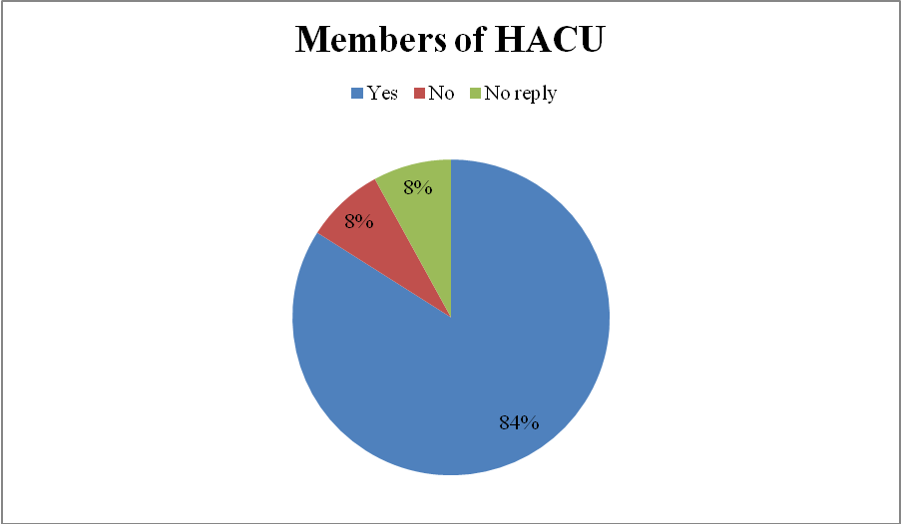
Total Participants: 25 institutions

- Institution’s membership with others (in addition to HACU)
- AACRAO  - AACU (American Association of Colleges and Universities)  - AAWW  - ACE  - AGB  - AICCU & NAICU (Independent Colleges & Universities)  - American Association for Paralegal Education  - American Association of Colleges for Teacher Education (AACTE)  - American Association of Collegiate Registrars and Admissions Officers  - America Association of Community Colleges  - American Association for Higher Education and Accreditation (AAHE)  - American Association of Hispanic Higher Education (AAHHE)  - American Association of State Colleges and Universities (AASC&U)  - American Association of University Women (AAUW)  - American Bar Association  - American College Personnel Association  - American Council on Education (ACE)  - American Psychological Association  - American Society for Public Administration  - AmeriCorps  - APA  - Association for Children and Adults with Learning Disabilities, California (ACAKLD-California)  - Association of American Colleges and Universities (AAC&U)  - Association of California Community College Administrators (ACCCA)  - Association of College and University Housing Officers  - Association of College and University Housing Officers-International  - Association of Governing Board of Colleges and Universities  - Association of Independent California Colleges and Universities  - Association of Public & Land Grant Universities  - Bellweather College Consortium  - Bellweather College Consortium  - C4-California Community College Collaborative  - CAEYC  - California Access Foundation/Hispanic Scholarship Fund/CSU/UCR partnership  - California Association of Post Secondary Educators of the Disabled  - California Campus Compact (CCC)  - California Collegiate Association  - California Collegiate Athletic Association (CCAA)  - California Community College Athletic Association  - California Community College Council for Staff Development (CCCCSD)  - California Community College Educators of Older Adults  - California Community College Student Financial Aid Administrators Association (CCCSFAAA)  - California Council on Teacher Education  - California Indian Manpower Consortium  - Cal-State San Bernardino Gear-up Program  - Campus Compact  - CHEA (Council for Higher Education Accreditation)  - Coachella Workforce Development Partnership thru the Center for Training and Development  - Counsel for Opportunity in Education  - Counsel for Resource Development  - CIS (Council of International Schools)  - Citrus Genomics Consortium  - City if San Bernardino Workforce Investment Board  - City of San Bernardino Employment  - Coalition of Urban & Metropolitan Universities (CUMU)  - College and University Personnel Association  - College Board  - Community College Consortium on Immigrant Education  - Community College League of California  - Consortium of Southern California Colleges and Universities | - Corporation for Research and Educational Networking  - Council for Advancement and Support of Education (CASE)  - Council for Opportunities in Education (COE)  - Council for Resource Development (CRD)  - Council of Colleges of Arts and Sciences  - Council of International Education Exchange  - Council on Legal Education Opportunity  - County of San Bernardino Workforce Investment Board  - CSRDE (Consortium Student Retention Data Exchange)  - EDCO-Economic Development Corporation of Oxnard  - HACU Leadership Group  - Higher Education Recruitment Consortium  - Hispanic Chamber of Commerce  - Hispanic faculty recruitment  - Hispanic student recruitment  - Inland Action  - Inland Empire Economic Partnership (IEEP)  - Inland Empire Scholarship Fund  - Kiwanis of Greater San Bernardino  - Latina Leadership Network  - League of Innovations  - Mathematical Association of America  - Mayors Green Advisory Committee  - McNair Scholars Program  - NAEYC  - NAICU  - National Association for College Admission Counseling  - National Association of Independent Colleges and Universities  - National Association of Legal Professionals  - National Association of Schools of Public Affairs and Administration  - National Association of Student Financial Aid Administrators  - National Association of Student Personnel Administrators  - National Black Law Students Association  - National Collegiate Honors Council  - National Community College Hispanic Council  - National Council of Colleges of Arts and Sciences  - National Council of Schools and Programs of Professional Psychology  - NCAA (National Collegiate Athletic Association)  - North American Association of Commencement Officers  - Pacific Association of Collegiate Registrars and Admissions Officers  - Ph.D. Project Association  - Riverside Chamber of Commerce Business and Educational Group  - San Fernando Chamber of Commerce  - SCCHSI  - Scribes American Society of Legal Writers  - South Coast Higher Education Council  - Southern California Consortium of International Studies  - Southern California Intercollegiate Athletic Conference  - St. Bernadine’s Hospital/San Bernardino Community Hospital  - State of California EDD (Employment Development Dept.)  - Statewide California Electronic Library Consortium  - Student retention  - Sun Valley Area Chamber of Commerce  - The College Board  - The Valley Economic Alliance of San Fernando  - UCAN (University & College Accountability Network)  - UCR/China Consortium  - Upward Bound  - Valley Industry and Commerce Association (VICA)  - Ventura County P-16 Council  - Vistage International  - WASC (Western Association of Schools and Colleges)  - Western Association of College and University Housing Officers

- Challenges

- Institution’s Greatest Challenges to Student Success
(*i.e. the requirement to take remedial courses in math or English; Some institutions selected more than one challenge as their greatest challenge)

Total participants= 23 institutions

- Institution’s Greatest Challenge to Faculty Recruitment and Development

Total Participants=23 institutions

- Institution’s Greatest Challenge to Staff/Administration

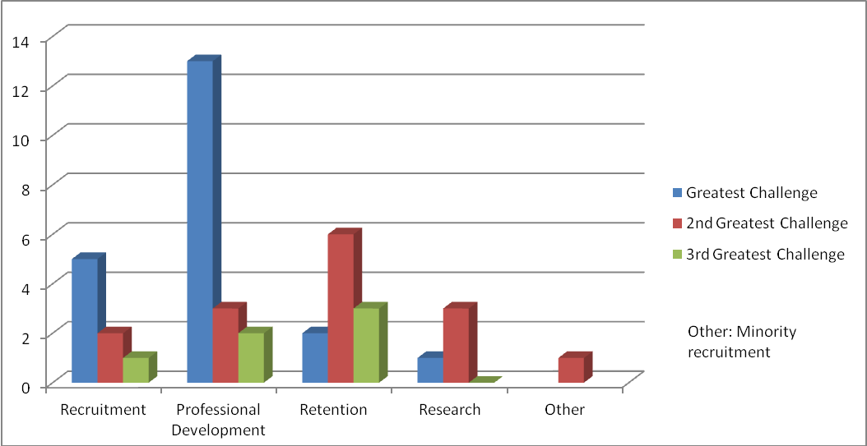
Total Participants=20 institutions

- Strategic Program Development
- Specific Areas for Program Development
- 2-4 year and 4 year collaboration  - A summer academic Bridge program, paid research internships, workshops and other continuing support once the students are on campus, to help them succeed. “The programs are about feeling welcome, feeling encouraged, and feeling they can do it.”  - B.A. in Early Childhood Education  - Basic Skills Initiative  - Business and industry partnerships –meeting immediate needs  - Certificate in Pupil Personnel Services  - Certificate in Therapeutic Companion  - Collaboration with the local small business community  - Connections with 4 year colleges for student transfer  - Curriculum development  - Developing more effective models for achieving greater student success in development courses  - Developing more effective models for creating sense of community/community engagement on a commuter campus  - Developing strategies for engaging parents of first generation students in their children’s educational experience  - Development of STEM undergraduate research program that bridges the community college and university that includes a corporate/professional/business mentoring component  - Discipline dialogues about curriculum  - Effective grant writing strategies  - Effective institutionalized professional development  - Effective learning strategies/development of excellent online education opportunities  - Effective teaching and learning strategies for students of color  - Enrichment Activities  - Establishment and effective VESSEL programs  - Excellence in Research and Creative Activities  - First Year Experience  - Hispanic faculty recruitment  - Hispanic Student Graduation Rates  - Hispanic student recruitment  - Hispanic student retention and transfer | - Hispanic women in Non-traditional Careers  - H.S. Retention  - Improving the college readiness of students particularly in English and math  - Improving the pipeline (collaboration with k-12)  - Increase business and community partnerships  - Increase Hispanic student transfer and in course success/retention rates  - Increasing the number of better prepared students in STEM disciplines  - Increasing Transfer rate from Community Colleges  - Intensive outreach programs that will place UCR teams on the six Southern California community college campuses—College of the Desert, Pasadena City College, Mt. San Antonio College and the Riverside, Moreno Valley and Norco campuses of Riverside Community College District—reaching up to 1, 200 students weekly.  - K-12 and 4-Year Pathways  - Language Acquisition for students  - M.A. in Educational Leadership  - M.A. in higher education  - M.A. in Leadership in Early Childhood Education  - Mentorships with industry/businesses  - Online Services  - Pedagogy and teaching strategies  - PH.D. in Early Childhood Education  - Pipeline to professional and Graduate School of Education  - Professional development  - Recruitment of faculty, staff and administration reflective of student population  - Remediation for English Language Learners  - Serving Spanish-speaking students/ESL  - Signed contracts that will guarantee Hispanic or low-income transfer students admission to UCR as science, technology, engineering or math majors.  - Strengthen the Campus Community  - Student Access  - Student research opportunities  - Student retention  - Student Success  - Teaching and Learning Excellence  - Vocational retraining  - Vocational training  - Vocational Training for Returning Veterans

