CSUSB RISK ASSESSMENT: Generic

Campus units are responsible for conducting risk assessments and incorporate appropriate mitigation steps when hazards that can cause harm are identified. On occasion there are not specified policies and procedures or trainings which outline how to prevent injury or illness. This risk assessment template helps employees responsible for staff and/or programs assess, plan, implement measures to control risks, and evaluate its effectiveness. It is up to the Department or Program to consider the various types of hazards that may be encountered and identify controls to reduce them. Risk Management has developed this template as a guide and is available for collaboration if assistance is needed.

- Briefly describe the program and context for this assessment:

- Complete the table in entirety. Submit another sheet of paper as needed.
  - What are the activities involved in your learning site?
  - What are the hazards associated with the activity listed? Hazards can be Environmental (Heat, Fire, Noise), Physical (Heights, Moving Parts, Office work, patient care) Specific to the program: – (weapons, minors), Biological/Chemical – (Infectious Disease, Allergens, Access to Drugs, Food Consumption)
  - Choose safety control methods that can reduce the hazard. Safety controls are discussed extensively below.
  - Identify the person who is responsible for implementing the control and/or spot checking it at the event.

- Activity Type:  Example: Counseling Children | - Identify Hazard:  Example: Infectious Disease | C. Safety Controls:  Example: Vaccine or weekly testing and mask | - Responsible Person:  Student Name and Field Supervisor

Safety Controls
You can identify safety controls specific to the hazard of the activity that you’ve listed. It will not always be possible to eliminate risks, but it is expected that an assessment is conducted to identify the hazards elimination, substitution and engineering controls whenever possible. The best time to consider security methods is in the design of the worksite or program. Redesign offers the best way to design out hazards in the planning or construction phase. NIOSH’s prevention through design (PtD) program highlights design as the most effective tool to address safety hazards, followed by the Hierarchy of Controls which allows safety measures to be classified as most to least effective
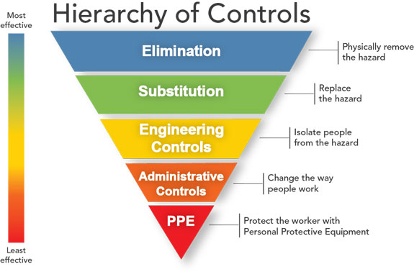
Elimination: preventing access to the hazard such as rescheduling, removal
Substitution: replacing the materials, machinery or process for less hazardous ones
Engineering: designs that reduce exposure to risk: fume hood, fall protection, lifting device, controlled space
Administrative: training sessions, procedures,
PPE: providing personal protective equipment (PPE) and make sure workers wear it

