How to Access Adobe Sign Forms
Quick Start Guide

Version 1-08-27-20.1
If you are having trouble trying to access a Form in Adobe Sign this document was written to help you. The document is subject to change as we make improvements to it, so any comments/suggestions on how it can be made more helpful can be emailed to me, the document Author at

Shaun Geer

Email:sgeer@csusb.edu

Thank You

Step 1: Verify Email Address

Note: It will never be CoyoteID@coyote.csusb.edu as this is not your Business email address.

Go to:
https://my.csusb.edu/default/mycoyote/_/my_personal_information

Select Email Addresses
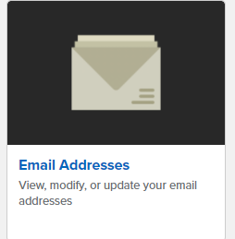

You should see a Business email listed for you, here is my example where it shows my Business email.
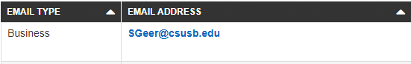

This is the email address you will use to login to Adobe Sign
Note: If you do not have a Business Email Listed, Use your On-Campus Email if it is the only one listed.

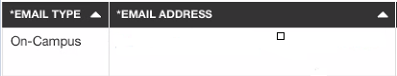

Step 2: Login to Adobe DashBoard

Go to the following Link and type in the Business Email address you looked up in Step 1, and press

on the page as shown below. DO NOT SELECT ‘Continue with Google’ or ‘Continue with Facebook’ or ‘Continue with Apple’
https://csusbsign.na2.documents.adobe.com/account/homeJS

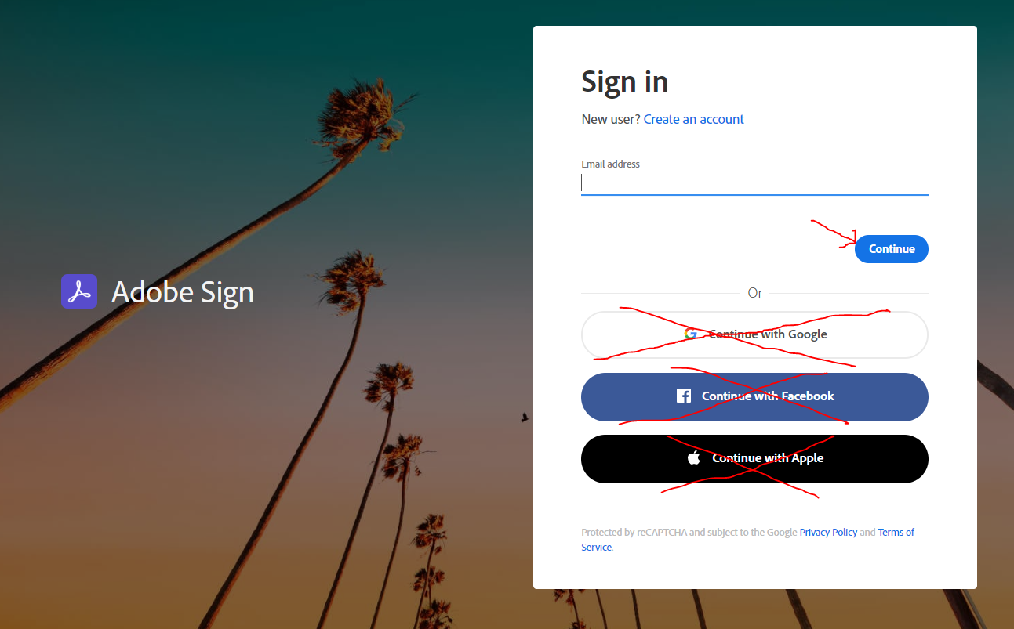

If presented with:
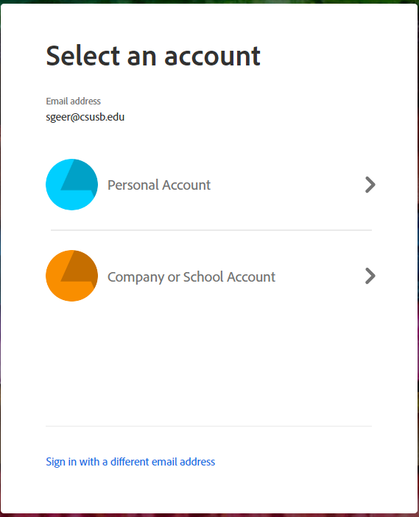

Always select “Company or School Account”

You will then be directed to, if you had not logged in already the CSUSB Single-Sign-On Page
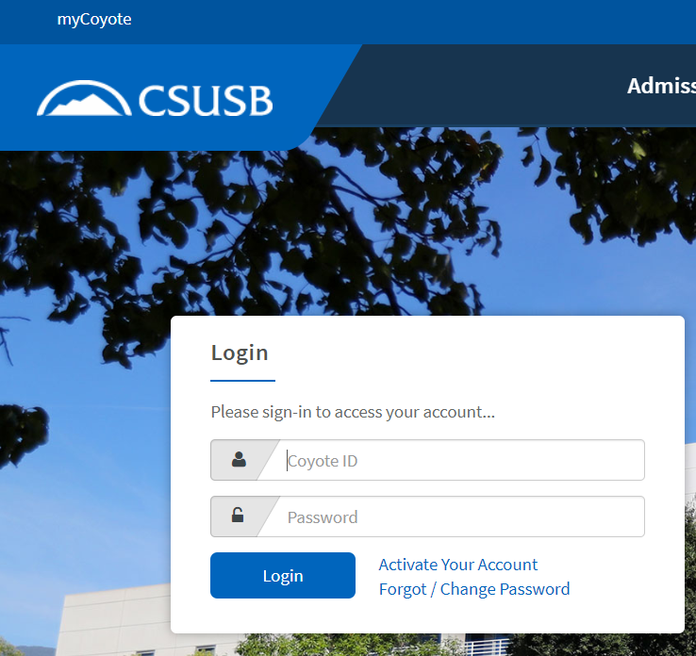

Enter your Coyote ID and Password to complete your logon.

You should then see the Adobe Sign Dashboard
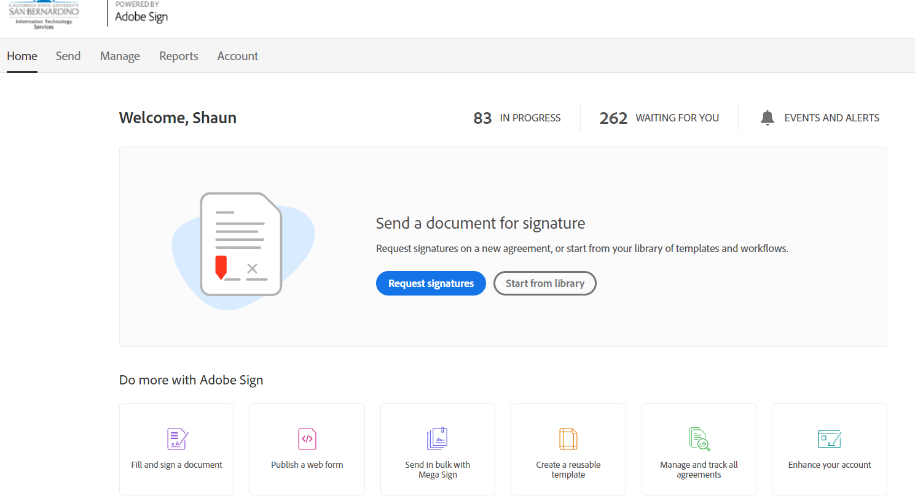

Step 3: Load Form

Now simply copy and paste the link you were provided to get to an Adobe form you need into this window and it should appear.

If you leave this browser open you will not have to login again and should have access to any form link as it will recognize you are already logged on.

Things you might see:

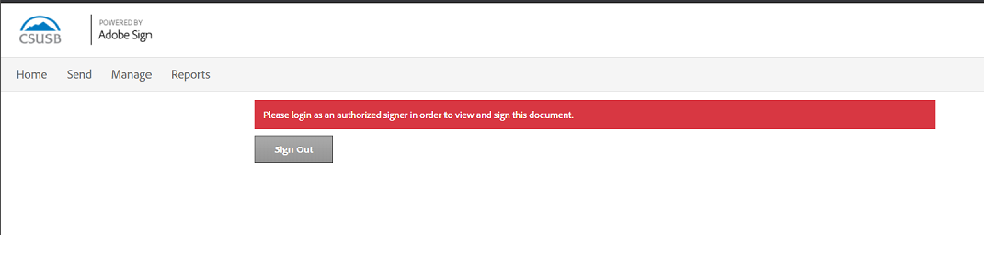

If you see this message, it most likely means that the email the document was sent to for you to sign does not match your Adobe Sign Business email.

If this occurs and you know you are logged in using your business account or Campus Account, as provided in Step 1 of this document, contact the original person who sent you the form and let them know that they need to use your Business email so you can sign it. You can provide this to them to use.

