

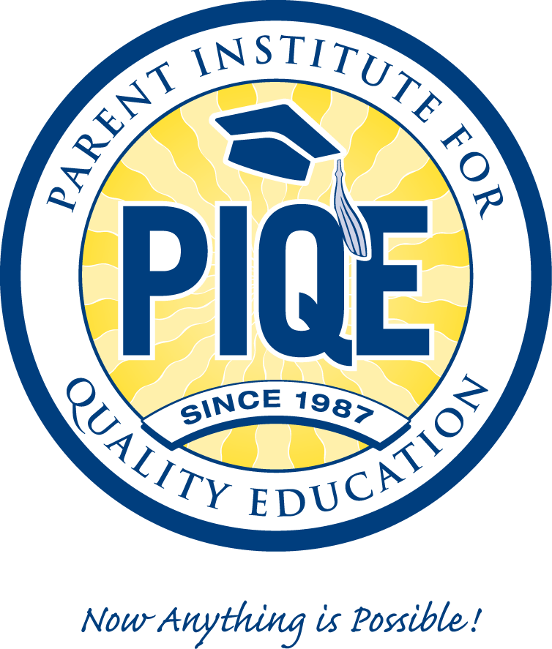


David Valladolid, National President & CEO

22 West 35th Street, Suite 201, National City, CA 91950
Phone: (619) 420-4499 Fax: (619) 420-4501
dvalladolid@piqe.org
www.piqe.org

Founders  Rev./Dr. Vahac & Eunice Mardirosian  Co-Founders  Dr. Alberto Ochoa, Ph.D.  Board Chair  Board of Directors  Dr. Alberto Ochoa, Ph.D.  Board Chairperson, Professor, SDSU  Gus Chavez, Board Treasurer  Director Emeritus EOP, SDSU  Rosalia Salinas, Board Secretary  Director Emeritus  SD Office of Education  Kenji Ima, Ph.D.  Professor Sociology Emeritus, SDSU  Ricardo Lara  CA State Assembly, District 50  Jose R. Padilla, Esq.  Executive Director  CRLA  Nora Vargas  V.P. of Education and Binational Affairs, Planned Parenthood of San Diego and Riverside Counties  Karen Y. Zamarripa  Assistant Chancellor  California State University | National Advisory Council  Yareli Arizmendi  Actress/Writer  Moctesuma Esparza  Film Director/Producer  Dr. Murray Galinson, Chair  Jewish Funders Network  Emily Gantz, President  Mosaica Inc.  Lawrence & Suzanne Hess  Hess Properties  Dolores Huerta, UFW Co-Founder  Dolores Huerta Foundation  Fahari Jeffers, Former Member  Community College Board of Trustees  Dr. Julian Nava  Former U.S. Ambassador &  LAUSD Board Member  José Pérez, Chair  California Utility Diversity Council-CUDC  Raul Yzaguirre  President & CEO Emeritus  NCLR & U.S. Ambassador  Dominican Republic | CA Statewide Advisory Committee
  Charles Reed, Chancellor
  California State University
  Dr. Warren J. Baker, CSU San Luis Obispo
  Dr. J. Michael Ortiz, CSU Pomona
  Dr. Horace Mitchell, CSU Bakersfield
  Dr. Richard R. Rush, CSU Channel Island
  Dr. Paul J. Zingg, CSU Chico
  Dr. Mildred Garcia, CSU Dominguez Hills
  Dr. Mohammad Qayoumi, CSU East Bay
  Dr. John D. Welty, CSU Fresno
  Dr. Milton A. Gordon, CSU Fullerton
  Dr. F. King Alexander, CSU Long Beach
  Dr. James M. Rosser, CSU Los Angeles
  Dr. Dianne Harrison, CSU Monterey Bay
  Dr. Jolene Koester, CSU Northridge
  Dr. Alexander Gonzalez, CSU Sacramento
  Dr. Albert K. Karnig, CSU San Bernardino
  Dr. Karen S. Haynes, CSU San Marcos
  Dr. Hamid Shirvani, CSU Stanislaus
  Dr. Rollin C. Richmond, CSU Humboldt
  Dr. Stephen L. Weber, CSU San Diego
  Dr. Robert A. Corrigan, CSU San Francisco
  Dr. Don Kassing, CSU San Jose
  Dr. Ruben Armiñana, CSU Sonoma
  Augustine Gallego, Chancellor Emeritus
  San Diego Community College

Parent Institute for Quality Education (PIQE)

Mission Statement:
To connect families, schools and community as partners to advance the education of every child through parent engagement.

Vision Statement:
PIQE is working to create a community in which parents and teachers collaborate to transform each child's educational environment, both at home and at school, so that all children can achieve their greatest academic potential. During the past 23 years, PIQE has graduated more than 500,000 parents from its parent involvement and engagement program and impacted more than 1,500,000 students.

Philosophy:
PIQE’s philosophy is based on the premise that all parents love their children and want a better future for them! Every child can learn and deserves the opportunity to attend and complete a college education, and parents and teachers must work together to ensure the educational success of every child. For children, learning is a natural process that we as parents and teachers must facilitate!

Objectives:
To encourage and support low-income ethnically-diverse parents of elementary, middle and high school children to take a participatory role in assisting their children by:

- Creating a home learning environment
- Learn to Navigate the school system
- Ongoing Engagement with Teachers, Counselors and Principals
- Encouraging college attendance
- Supporting a child's emotional and social development

PIQE’s Nine-Week Parent Engagement in Education Program & its Pre-K Curriculums:
The courses are offered in morning sessions and repeated in the evening. Parents choose when they can attend (see attached parent’s testimony and a copy of the certificates parents receive upon graduation). PIQE classes have been taught in eighteen (18) diverse languages. Classes are taught by credential teachers and professionals trained by PIQE. The initial planning session and meeting with parents seeks their input on what issues and questions they would like to be addressed in the course. Topics include:
Pre-K: ( 3-5 Years)  - Brain Development Ages and Stages  - Your Child’s Well-Being, Health, Nutrition and Active Living  - Positive Discipline  - Language Development  - Pre-Conventional Reading  - Your Child and Math Community Services | Elementary:  - Establishing the Collaboration between Home, School, and Community  - Fostering Self-Esteem and Academic Achievement  - Relating Positive Discipline with Academic Achievement  - Reviewing Academic Standards and Preparing for the Teacher Conference  - Acquiring a Better Understanding of the School System  - Becoming Familiar with College Requirements
Middle:  - Supporting the Academic Achievement of Adolescents throughout their changes  - Connecting Academic Success and Positive Self-Esteem  - Overcoming Obstacles to School Success  - Motivating Teenagers to Read  - Understanding the Importance of Middle School as a Bridge to High School  - Preparing to Meet the University Admission Requirements | High:  - Understanding the High School System  - Identifying the Classes that Form Part of the A-G Requirements  - Recognizing the Importance of the Grade Point Average (GPA)  - Reviewing other Important Requirements and Programs  - Discussing Higher Education Options  - Identifying the Different Financial Aid Options

Organization Overview:
Rev. Dr. Vahac Mardirosian and Dr. Alberto Ochoa (current Board Chair) founded the Parent Institute for Quality Education (PIQE) in October 1987 in San Diego, CA. In 1998, David Valladolid was promoted from VP of Operations to President & CEO. PIQE has regional offices in Bakersfield, Bay Area, Fresno, Los Angeles, Modesto, Riverside, San Diego, San Gabriel, San Jose, Santa Ana that serve 36 of the 58 counties in California.

PIQE Program Results and Outcomes:
- In 2003-04, Dr. Janet Chrispeels from the University of California, Santa Barbara conducted a control group evaluation of PIQE at a Middle school in the Los Angeles Unified School District (LAUSD). The results were consistent across grade levels (6-8) and are important since parent engagement is generally considered minimal at middle and high schools. The PIQE curriculum was effective in informing parents about the education system, helping them to support their children’s schoolwork and motivating them to encourage their children to pursue a university level education in the future.
- In 2004, San Diego State University (SDSU), School of Business Administration conducted the first longitudinal study on PIQE. They contacted and surveyed 241 Latino parents who live in San Diego who had graduated from PIQE in 1997-98-99. These parents represented 351 students 18 years and older. The findings indicate that 93% of these PIQE students graduated from high school versus the current Latino graduation rate of 50+% and 79.2% of the PIQE high school graduates enrolled in college versus the Latino College bound rate of 52% in San Diego County.
- Since 2000, PIQE has begun its expansion outside of California. PIQE’s program has been replicated and incubated in Texas at the Dallas Concilio and in Houston at Springfield Community College; and, in Phoenix, Arizona at Arizona State University (ASU). PIQE best practices have been implemented in parent programs in Montana, Minnesota, Florida, Kansas and Missouri. In Montana, the PIQE program has been implemented on six Indian Reservations (Crow & Cheyenne). In 2008, PIQE opened an office in Fairfax, Virginia at George Mason University.
- On April 29, 2010, Chancellor Charles Reed with the California State University (CSU) system extended the PIQE CSU agreement to six years (2006 – 2011). CSU Chancellor Reed pledged $3,400,000 to implement the PIQE nine-week classes in thirty schools in each of the twenty-three campus regions. In addition, each child of a PIQE graduate now receives a CSU “College Admission Certificate” committing an extra effort to admit them to a university once they graduate from high school and meet all the admission requirements.

Key Accomplishments:
- PIQE has worked in more than 2,600 schools in 334 different school districts in California.
- PIQE has served 200 GEAR-UP middle schools in California over the past six years and has received six annual awards of excellence.
- In 2003, PIQE implemented a “Birth to Five Parent Curriculum” in Santa Clara County for families with children whose ages are between 0-5. In 2004, PIQE contracted with San Diego Unified School District to serve 3,000 Pre-K parents in 30 low-performing schools, over 3 years.
- PIQE has designed and implemented in collaboration with Stanford Research Institute (SRI), a six-hour “Teacher Workshop on Parental Engagement”. It has been successfully piloted in more than 100 schools throughout California and graduated more than 2,000 teachers.
- In 2004-05, through funding from the Washington Mutual Foundation and Citigroup, PIQE implemented a pilot “Family Financial Literacy Education Program” to provide parents attending its nine week classes with basic money management skills. It has been piloted in eleven schools throughout Southern California and to date more than 1,000 parents have graduated from the program.
PIQE PARENT ENGAGEMENT IN EDUCATION PROGRAM
PARENT GRADUATE TESTIMONY AT SANGER HIGH SCHOOL
NOVEMBER 09, 2010


Good evening fellow PIQE graduates, Sanger High School personal and PIQE administrators, family members and future college graduates.
Benjamin Franklin once said, “An investment in knowledge pays the best interest”. Every single parent here tonight should be proud! Because for the past nine weeks that is exactly what we have been doing, investing and investing in knowledge that will benefit our best interest, our kids.
Some of us came here knowing exactly what PIQE was and for some of us PIQE was a new experience, a new adventure in our kid’s education. What I didn’t know was that PIQE not only benefits my junior high student, but it’s also helping my 5 and 3 year old. Imagine that, PIQE an investment in knowledge for my two toddlers. The advantage for them is huge. I now have the additional tools to start them off on the right track for their entire 12 years of school here at Sanger Unified.
Mrs. Sylvia Lovett
PIQE has given us the basic information to understand the high school system such as: CAHSEE, the A-G requirements, CELDT and CST testing. They have reminded us of the importance of our student’s GPA and have educated us on the difference between AP and Honor courses. PIQE has emphasized the importance of knowing how to read our students transcripts and they finally explained to me that PSAT and PLAN are practice test for taking the SAT and ACT. In the final two weeks we learned about the CCC California Community Colleges, CSU California State Universities, UC’s University of California and also about financial aid, like grants and loans.
So what is PIQE to me? If I had to summarize PIQE in one word it would be, empowerment! Empowerment to know what classes our kids should be taking, empowerment to know that deadlines are crucial! Empowerment to keep track of their GPA, empowerment to help them succeed in taking the SAT and the ACT! Empowerment to communicate with their counselor regularly and empowerment to talk to our kids about the future today!

At this time I would like to address my daughter Alex Lovett.
As you well know I didn’t finish up at Fresno State. Life just kind of happened and I quit after obtaining only my 2 year degree. My desire for you is that you gain the empowerment to do what I couldn’t do, to graduate from college.
I also have a question for you? Do you remember when we took the training wheels off your bike and we went across the street to Sanger Academy? Remember how you kept wobbling and tipping over and when you fell of the curb I grabbed you by your ponytail? That’s how high school and college will be. You will wobble, you will stumble and you will fall and although you may not wear ponytails anymore, I will always be there to help you get up.
Congratulations to everyone here and thank you Sanger high and PIQE for a wonderful opportunity. I end with the words of Winston Churchill, “Success is not final, failure is not fatal, it is the courage to continue that counts”.
Good luck to all of you and good night.

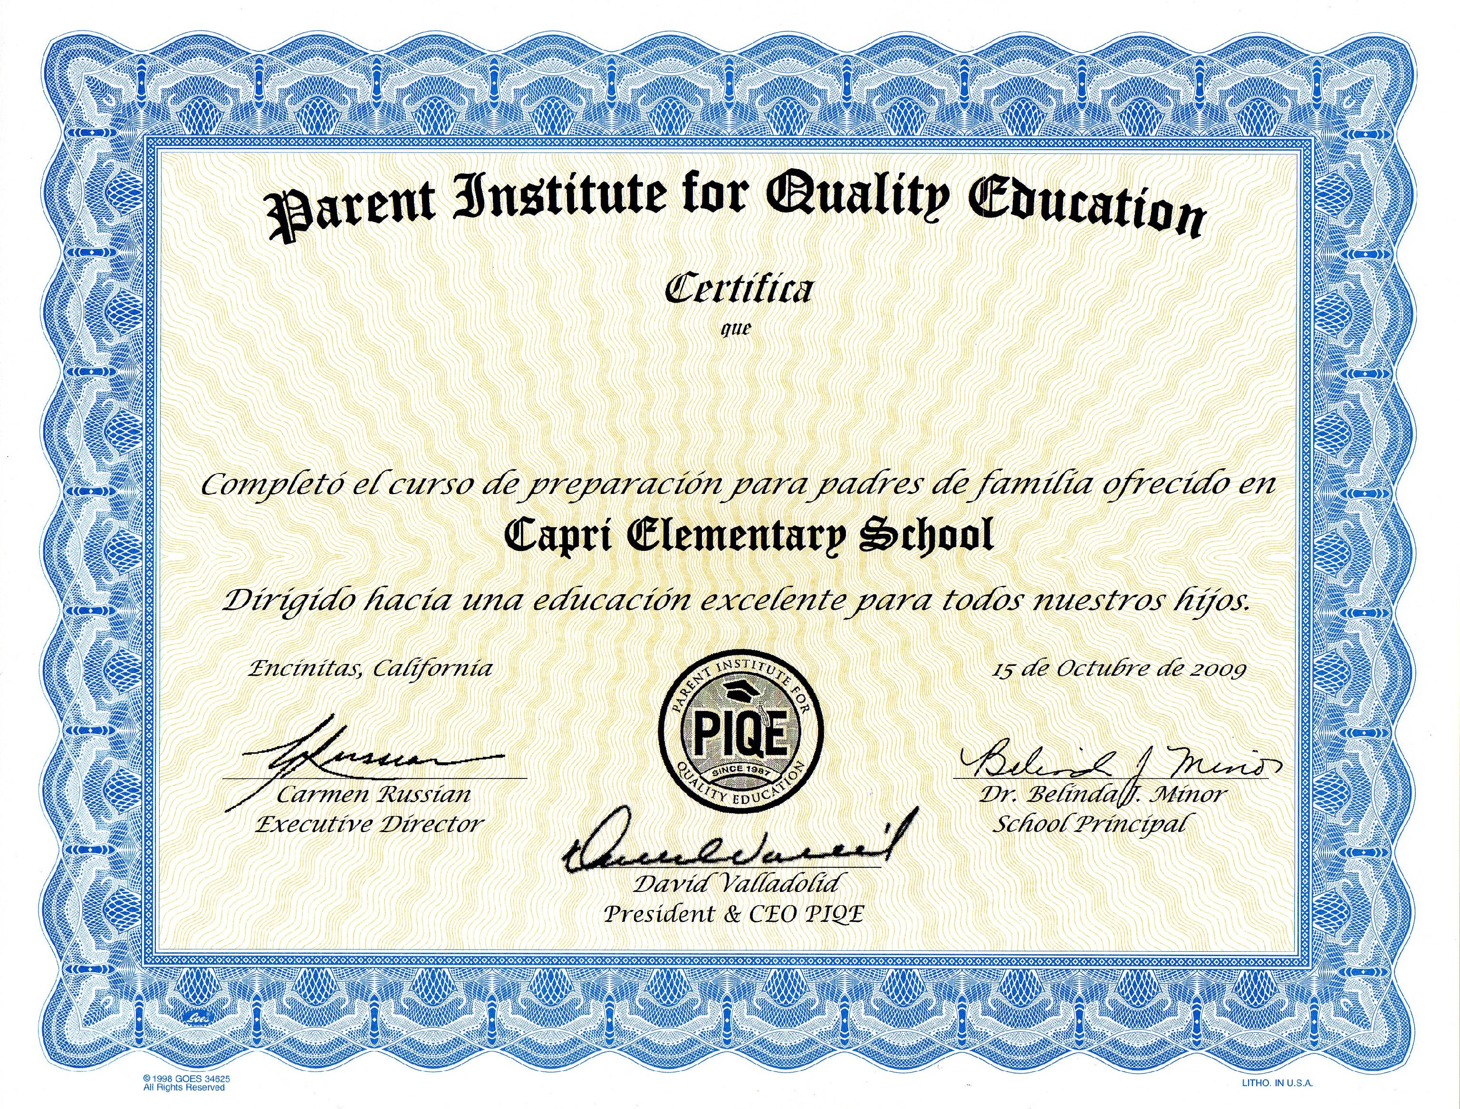

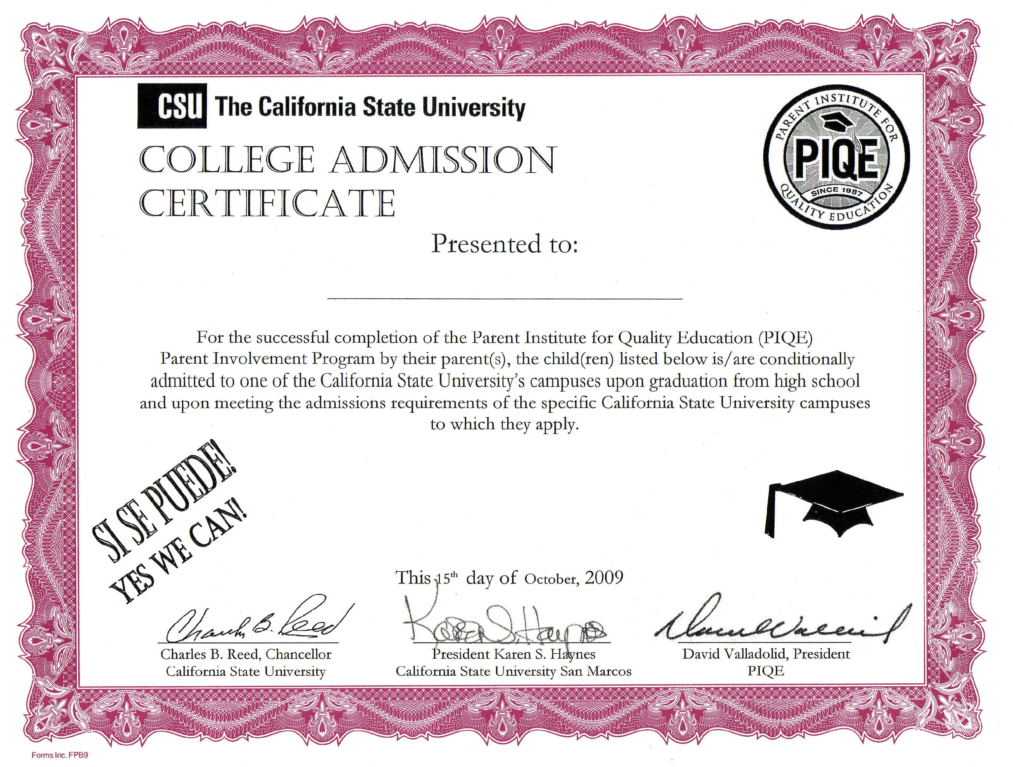

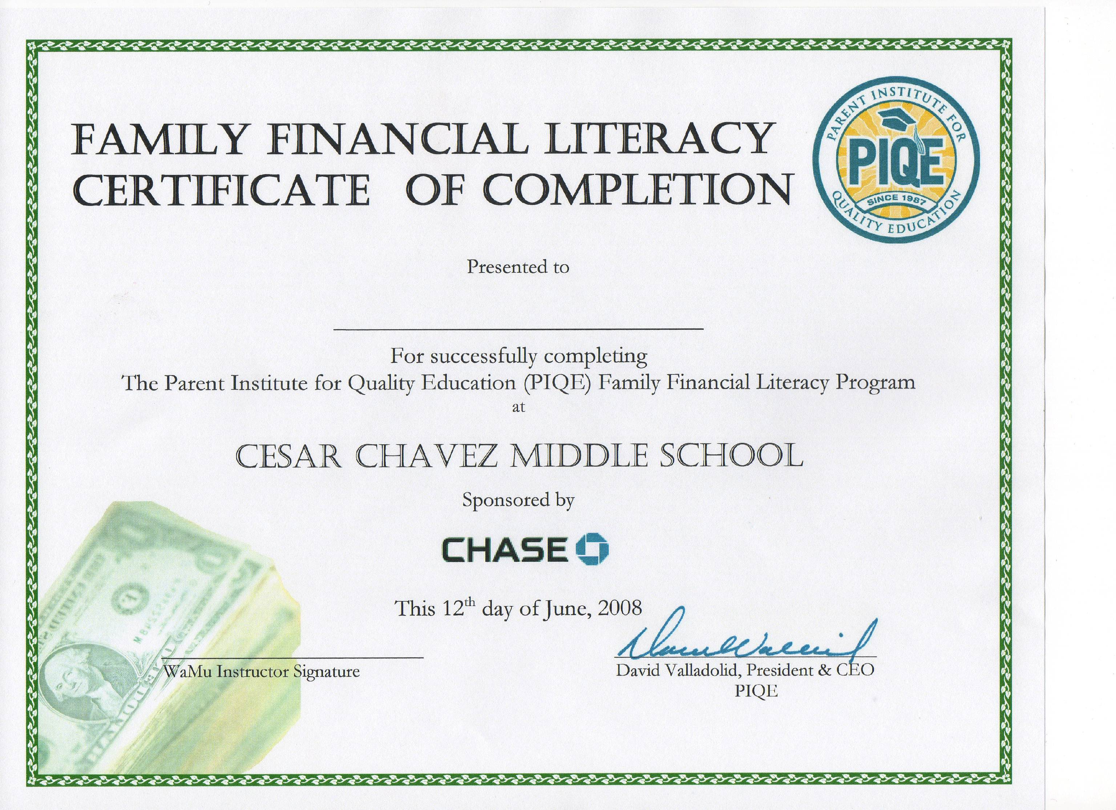
PIQE OFFICE DIRECTORY

Corporate  David Valladolid, President & CEO  22 West 35th Street. Suite 201  National City, CA 91950  Tel: (619) 420-4499 Fax: (619) 420-4501 dvalladolid@piqe.org  Bay Area  Mildred Dumeng, Executive Director  2041 Bancroft Way, Suite 303  Berkeley, CA 94704  Tel: (510) 845-7210 Fax: (510) 845-7205  mdumeng@piqe.org  Bakersfield  Alma Grimaldo, Executive Director  1500 Baker Street, Suite A  Bakersfield, CA 93305  Tel: (661) 325-5292 Fax: (661) 325-4497  agrimaldo@piqe.org  San Gabriel Valley  Lilian Hernandez, Executive Director  955 N. Grand Avenue  Covina, CA 91724  Tel: (626) 455-0126 Fax: (626) 455-0943 lhernandez@piqe.org  Fresno  Olga Nunez, Executive Director  4222 W. Alamos, Suite 209  Fresno, CA 93722  Tel: (559) 277-9858 Fax: (559) 277-1284  onunez@piqe.org  Los Angeles  Maria Elena Meraz, Executive Director  3370 San Fernando Rd., Suite 105  Los Angeles, CA 90065  Tel: (323) 255-2575 Fax: (323) 255-5120  mmeraz@piqe.org  Modesto  Teresa Guerrero, Executive Director  1124 11th Street, Suite B  Modesto, CA 95354  Tel: (209) 238-9496 Fax: (209) 238-9495  tguerrero@piqe.org | Orange County  Felipe Moreno, Executive Director  902 N. Grand Avenue, Suite 200  Santa Ana, CA 92701  Tel: (714) 540-9920 Fax: (714) 540-9926  fmoreno@piqe.org  Riverside  Lilian Hernandez, Executive Director  955 N. Grand Avenue  Covina, CA 91724  Tel: (626) 455-0126 Fax: (626) 455-0943  lhernandez@piqe.org  San Diego  Carmen Russian, Executive Director  22 West 35th Street. Suite 201  National City, CA 91950  Tel: (619) 420-4730 Fax: (619)420-4505  crussian@piqe.org  San Jose  Lorena Lechuga, Executive Director  1510 Park Avenue, Suite 200  San Jose, CA 95126  Tel: (408) 275-9171 Fax: (408) 275-9172  llechuga@piqe.org  Arizona  Alex Perilla, Program Director  411 N. Central, Suite 650  Phoenix, AZ 85004  Tel: (602) 496-0441 Fax: (602) 496-1029  Alex.Perilla@asu.edu  Houston, Texas  Lidia Junek, Executive Director  1010 W. Sam Houston Pkwy North, Suite 900P  Houston, TX 77043  Tel: (713) 718-7046  ljunek@piqe.org

