Change of Major/Minor Guide

  - Changing your Major
Step 1: At the Student Center page, select the Menu icon.
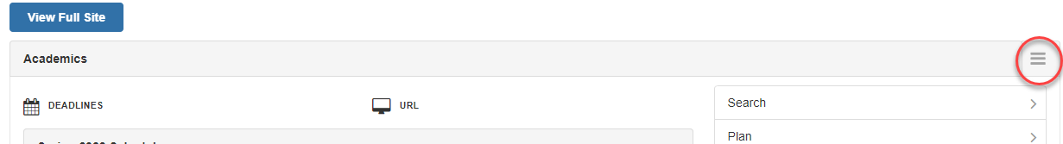

Step 2: A drop-down menu will appear, select Change of Majors/Minors.
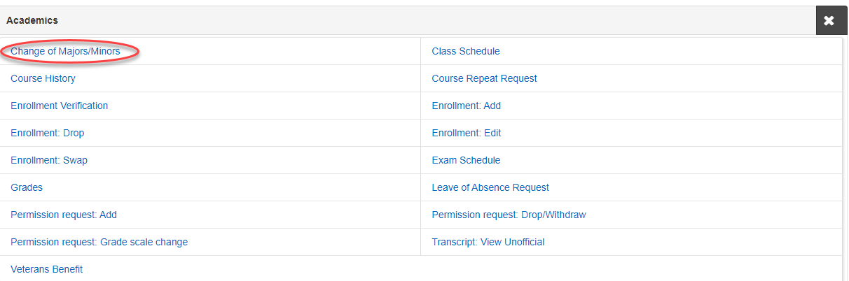

Step 3: Select Create New Request to be directed to the next page.
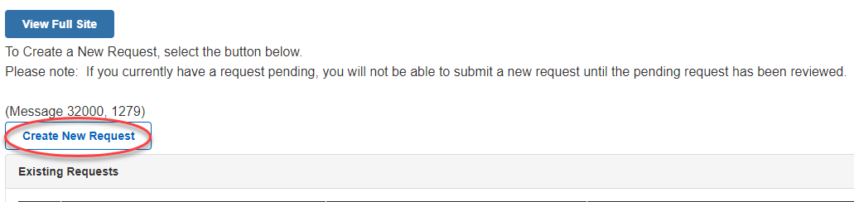

Step 4: Select Change from the dropdown menu, then after select the Search for New Plan.
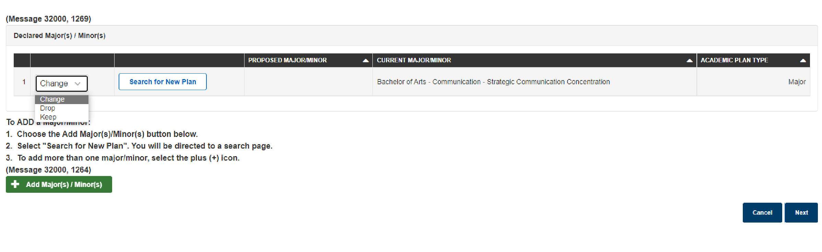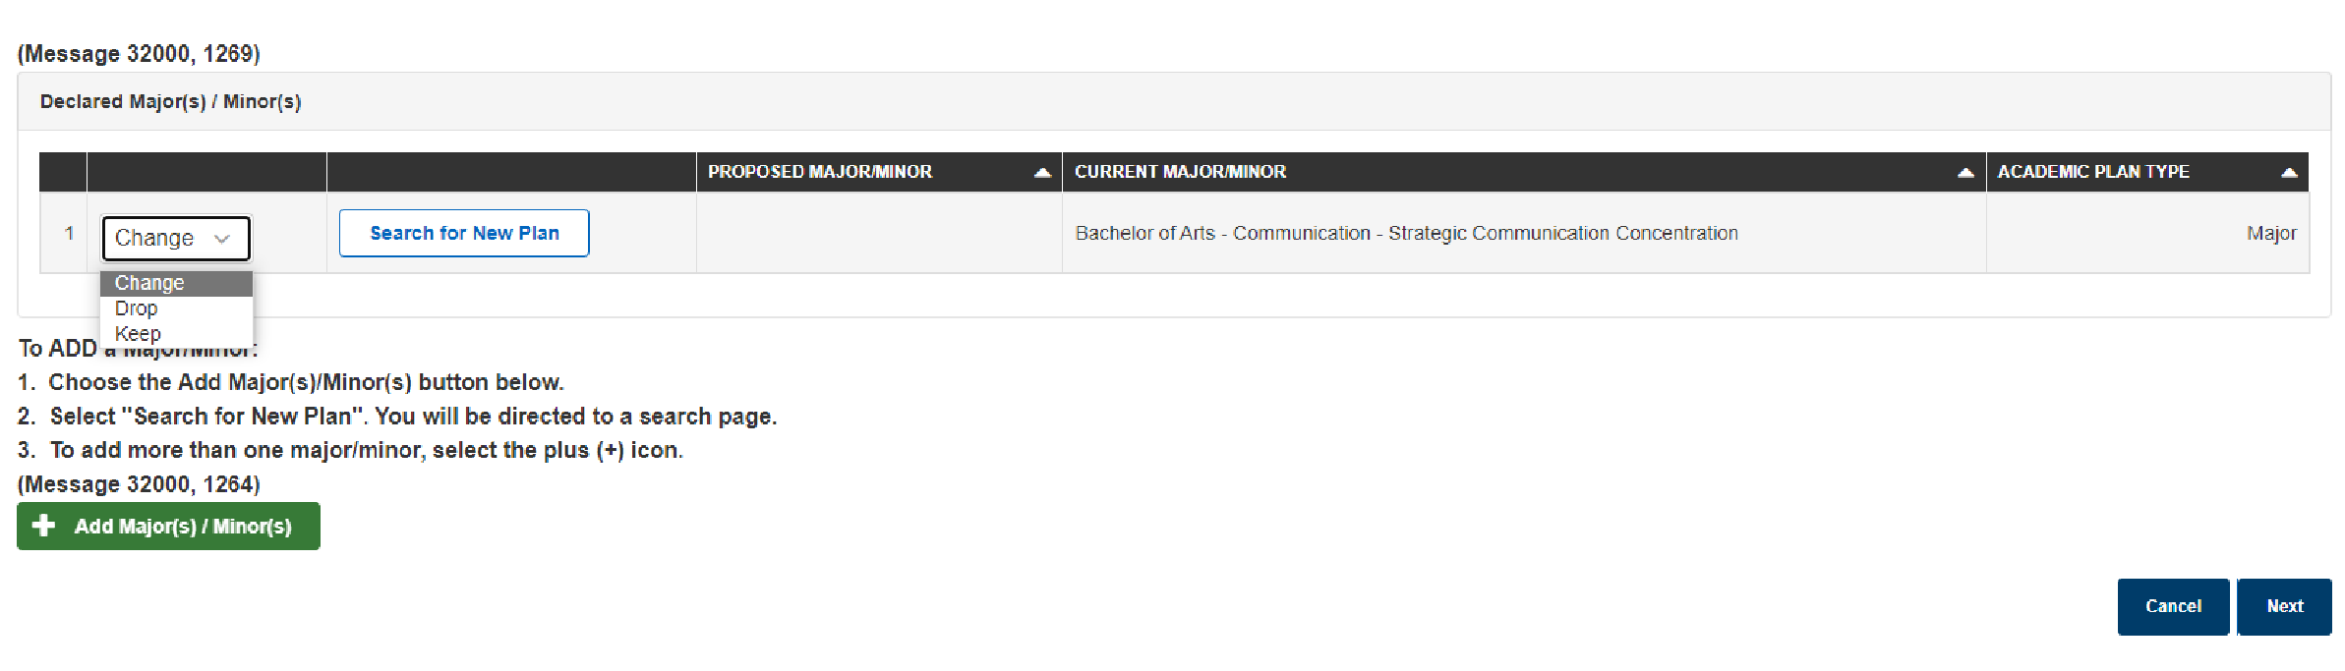
Step 5: Enter the name of the major in the Search Box, then select Search.

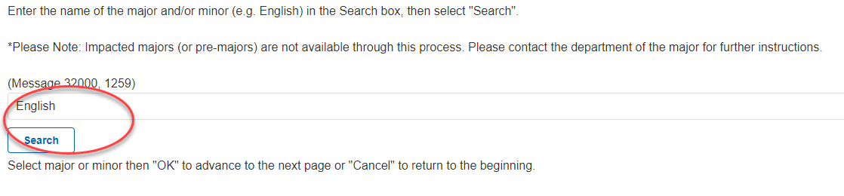

Step 6: Select the major and then OK to proceed to the next page.
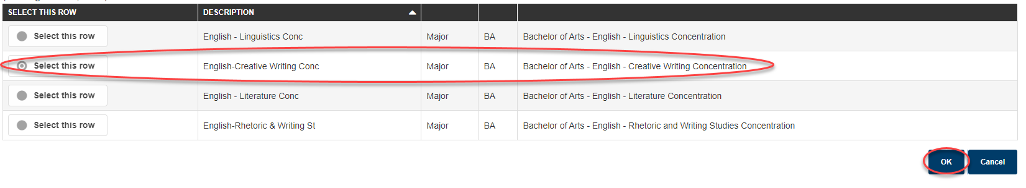

Step 7: Double check to make sure the proposed major is correct, then select Next.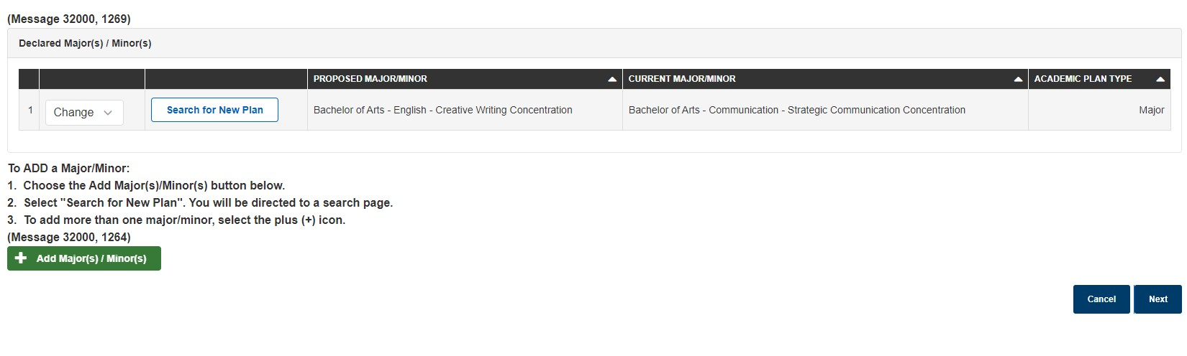

Step 8: Provide a reason for the change of major request in the box provided and then select Submit.
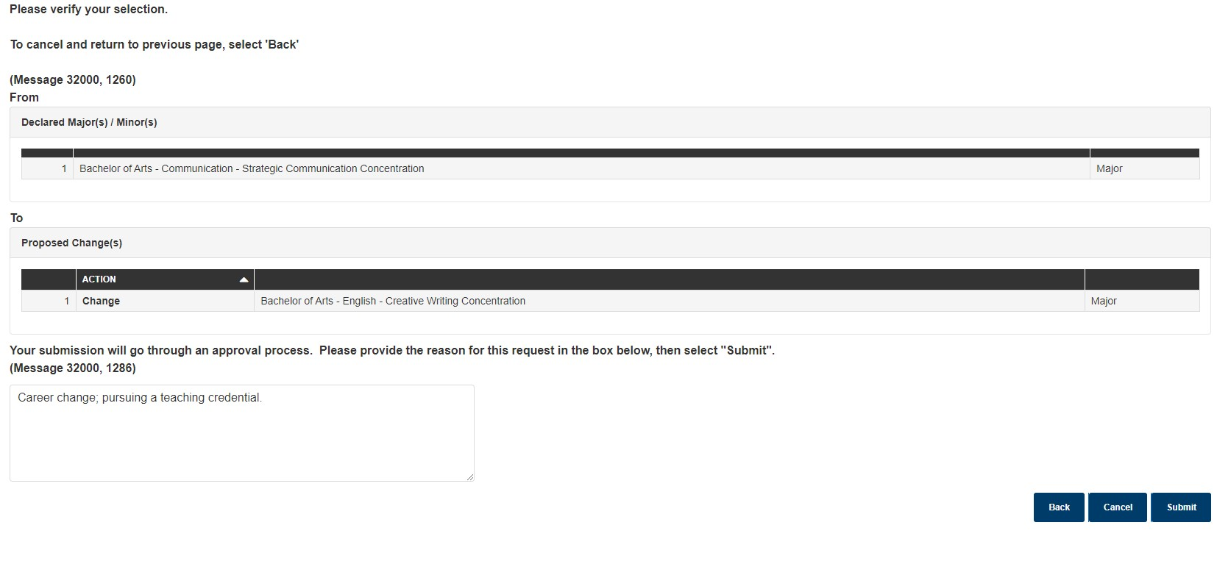

  - Changing your Minor
Step 1: Select Keep on the dropdown menu by your major, then select Add Major(s)/Minor(s).
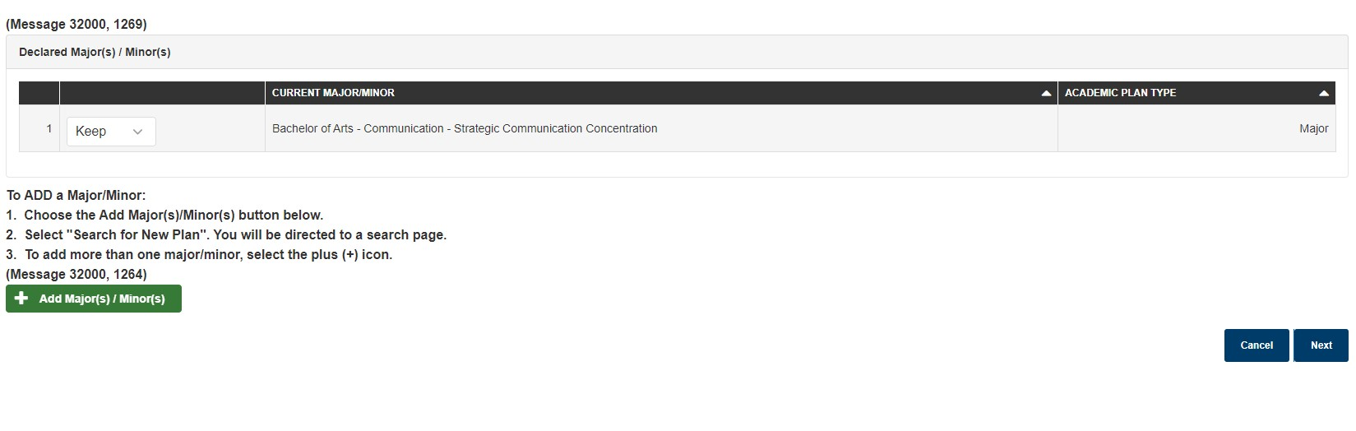

Step 2: Select Search for New Plan to be guided to the next page.
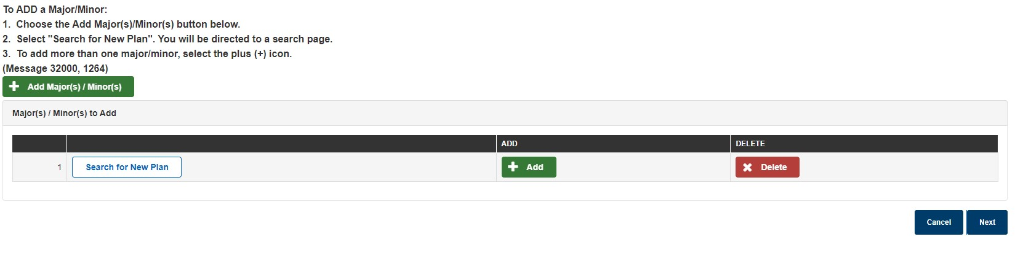
Step 3: Enter the name of the minor in the Search Box then select Search.
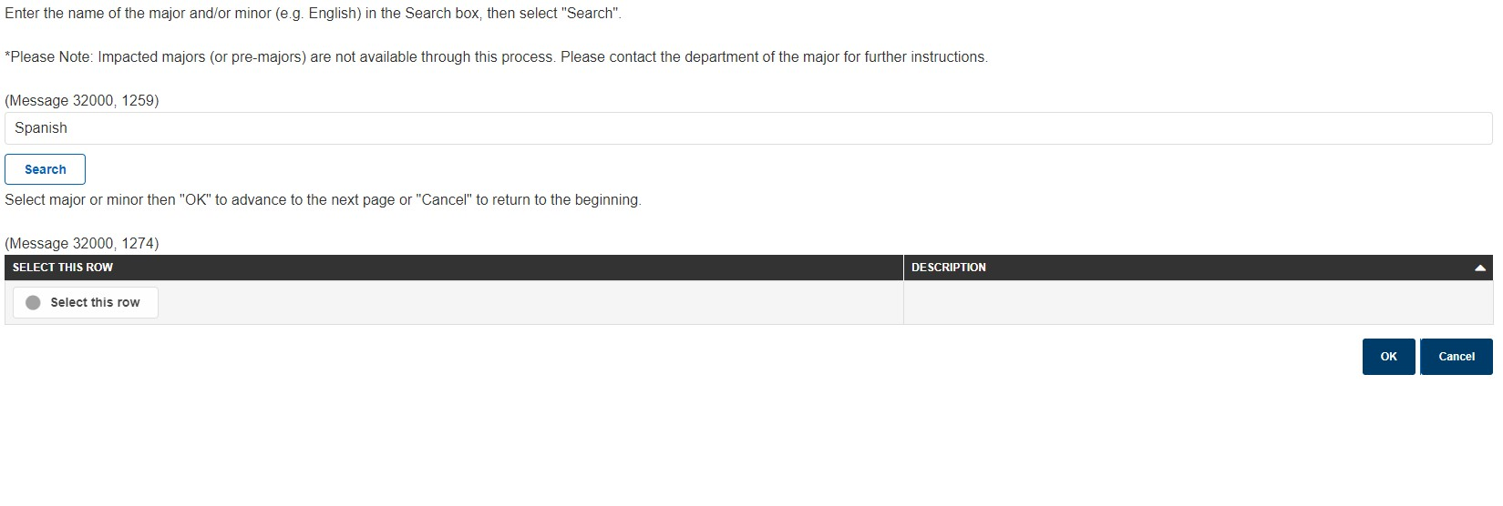

Step 4: Select the minor then OK to proceed to the next page.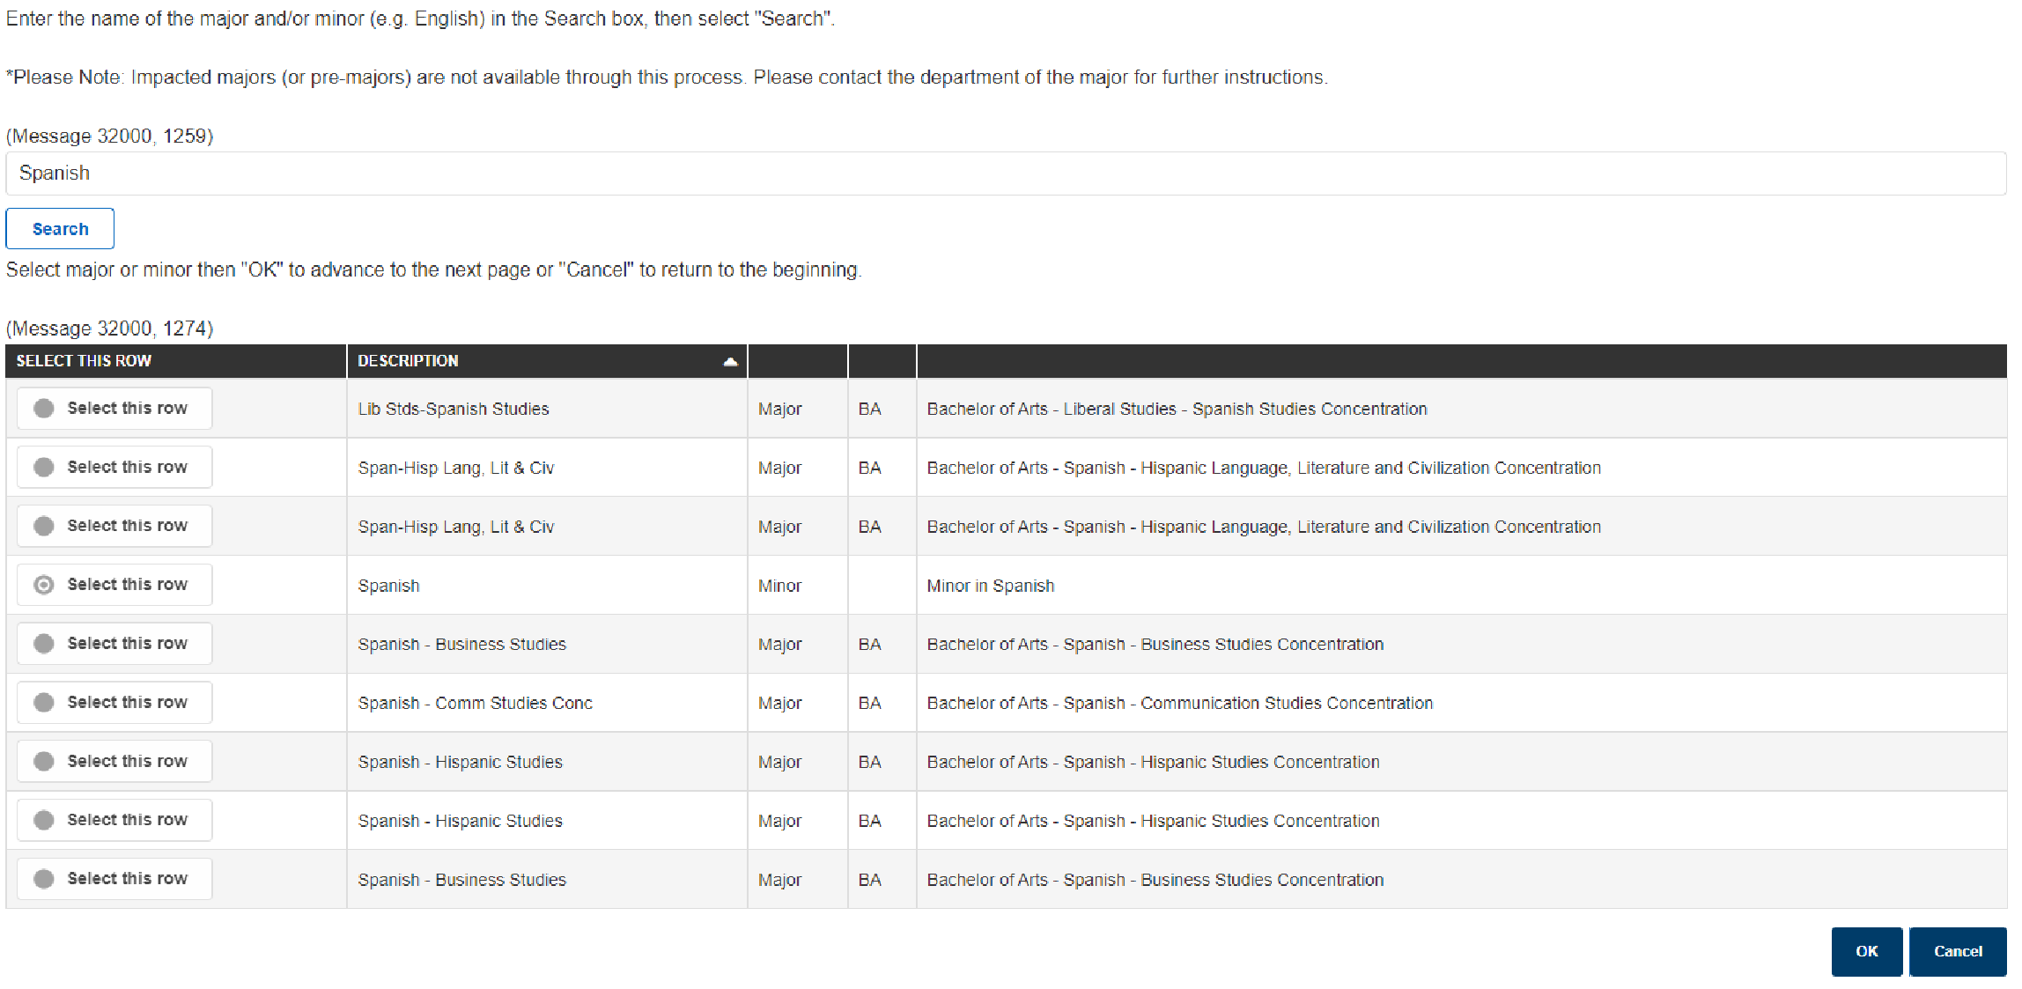Step 5: Once returned to the Academic Plan page, select Next.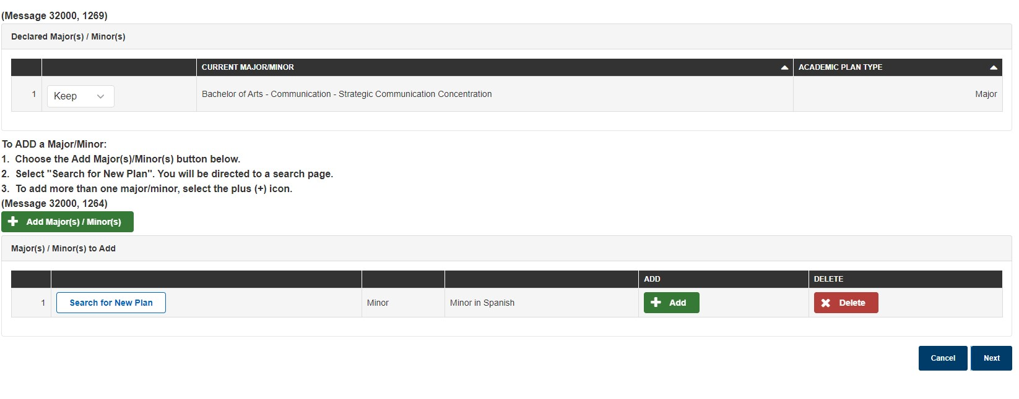

Step 6: Verify your proposed change and enter the reason for this change. Then select Submit.
