BIANNUAL REPORT ON PRME INITIATIVES OF
THE JACK H. BROWN COLLEGE OF BUSINESS & PUBLIC ADMINISTRATION
VOL.10, ISSUE 1, July 1, 2021

Developer & Editor: Professor Breena E. Coates
In Spring 2012, CBPA became a signatory to PRME—Principles for Responsible Management Education. These Principles for Responsible Management Education were launched in in 2007 as an initiative of six academic institutions (including AACSB International) and the United Nations Global Compact. PRME seeks to establish a process of continuous improvement among institutions of management education in order to develop in our students a new generation of business leaders who view corporate strategy within a broader perspective of all stakeholders over traditional shareholder value. Guided by the PRME philosophy, CBPA’s mission is to inspire and champion ethical and responsible management education, research, and thinking for global leadership. At CBPA, we endorse conscious capitalism. We are continuously embedding PRME values into our Educational Value Chain. We highlight some of these

endeavors in reports like this.

A Message from Dean Lawrence C. Rose
I am pleased to report that despite the interruptions and challenges created by the COVID-19 pandemic, the Jack H. Brown College of Business and
Public Administration remains committed to strategically preparing responsible
management professionals within a dynamic region and a globally connected world. We do this by creating academic programs and scholarly activities that promote innovation, and integrity, and connect to the social needs of the

In keeping with the seventeen Sustainable Development Guidelines of the United Nations, the Jack H. Brown College informs its stakeholders about critical planetary needs.—economic, ecological and social.

Below, you will find a few highlights of our latest projects that support our mission and align with the values of PRME--our 10-year partner in education:

The college has spent the past year updating its strategic plan, emphasizing learning and societal impact, concrete goals, sustainability, diversity and more.

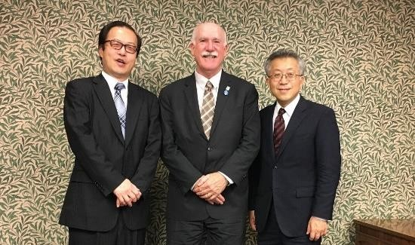
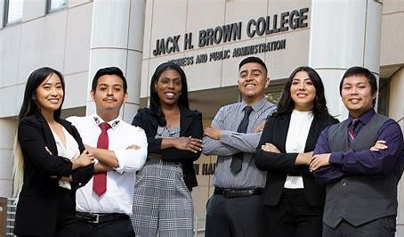
In light of our membership in PRME, our Assurance of Learning Committee is working on revising BA and MBA program learning goals to reflect the new emphasis of the 2020 AACSB standards on the societal impact of the program. The revised versions call for students to be able to identify and evaluate ethical issues and sustainability implications inherent in global and diverse business

decision making and social responsibility and graduate students should be able to demonstrate an understanding of the leadership skills
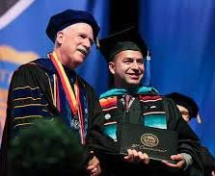
necessary to build team effectiveness for making ethical decisions and accomplishing positive social changes.

Outside of the classroom we greatly increased our support for local business sustainability and international expansion.

Finally, our JHBC Office of Academic Equity (OAE), which launched in 2019, has boosted efforts to address equality,
inclusion and diversity in the college
and in the community, especially during virtual operations. The annual fall JHBC ShEconomy, focused on entrepreneurs who shared the impact of COVID-19, moved to a virtual platform and was featured by NBC4 News. The office continued its series of The Voices.

Finally, I am retiring at the end of July
2021. I have appreciated the support of the CSUSB, the Jack Brown College, and my colleagues all over the world. I cherish the association we have had with PRME, and I look forward to seeing our business education, management and partnerships continue to grow, evolve and result in positive environmental societal, and economic impacts.

EMPOWERMENT OF WOMEN: FINANCE SECTOR:

The Jack H. Brown College has an active Department of Finance and Accounting that provides our students knowledge and strategies about challenges for women and minorities in global financial sectors.
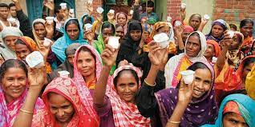
The social status of women in various cultures worldwide can hamper the efforts of women to obtain finance to create businesses. In many global cultures, society still sees women as having primarily duties within the home. Banks like the Grameen Bank in Bangladesh thinks otherwise. Women are capable, innovative and eager to undertake creation of new small businesses. This microfinance experiment is today proof that women are superb risks when it comes to borrowing money. The Grameen Bank model pioneered by Dr. Mohammad Yunus, economist, teacher, banker and Nobel Prize winner, (2006) had the inspiration that women, working in groups are more reliable than men in repaying loans. What is even more crucial is the finding by Yunus that loaning money to women, can ensure that the family and society
at large benefit as women contribute to the economy. They also become more engaged in social and political uplift through new ideas that enhance their lives and the lives of other women.
Microfinance loans directed at women enhance their literacy in mathematics, reading and writing. Many microfinance institutions provide business training, information access, technology development, as well as training in policy and advocacy.
Decades later, today, the vision of Dr. Yunus has become a reality. Micro loans serve almost 20 million people living in poverty. The Jack H. Brown College provides opportunities for our students to avail themselves in the SHe Economy—see next page.
Nancy Pelosi

The SHECONOMY:
Women in the Financial Sector
Under the leadership of Professor and Associate Dean, Dr. Francisca Beer, there has been a focus on the ShEconomy. A number of webinars and conferences has ensued. Gender Equity is a stated goal of the United Nations’ 17 Sustainable Development Goals passed in 2015, with an aim to reach planetary sustainability by 2030. The 2nd Annual ShEconomy Conference took place on February 6, 2020, at CSUSB.
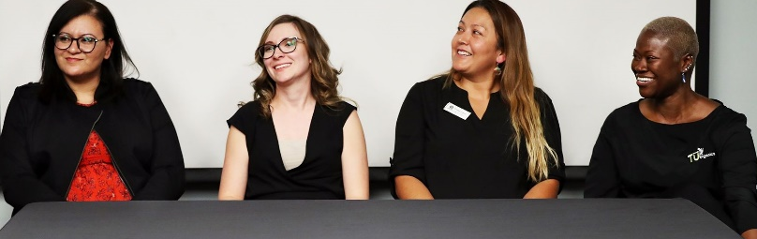
This was a joint event between the Office of Academic Equity, the Marketing Department, and the Inland Empire Entrepreneur Center (IECE) to celebrate the Women’s Entrepreneur Week. Professor Michelle Skiljen Executive Director, of the IECE , and moderator of the panel, commented on “the profound perseverance, competitiveness, and passion” evidenced by the experiences of the women panelists.

Dr. Beer highlighted her own research on the topic of women in the financial sector, stressing the need for women entrepreneurs, owners, partners , depositors and borrowers across a variety of verticals, sectors and categories from all over the world. Narrowing the gender gap, she said, would foster greater stability in the banking system and in national fiscal and monetary policy.
But, More Needs to be Done Globally…
& The Jack Brown College is Helping…

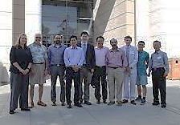
The Jack H. Brown College of Business and Public Administration knows that diversity in the financial sector continues to be a global need. This is also the aspiration of Finance and Accounting Department Chair, Dr.Taewon Yang, shown below and the Finance Department faculty shown left.
Faculty of the Department of Accounting and Finance

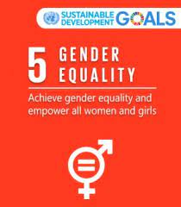
The Global Findex reveals remarkable global progress in the world’s ability to reduce the unbanked communities. Yet the data also reveals a glaring gap: women lag behind men when it comes to financial access. The World Bank has noted that globally, this gender gap is seven percentage points, while in developing countries, it is nine percentage points. This gap between men’s and women’s financial access is even more visible in some regions – for example, South Asia has an 18% gap in ownership of accounts and the Middle East has a 10% gap. The gap exists also for access to formal savings or credit. Without access to finance, women face difficulties in collecting and saving income, growing their businesses, and pulling their families out of poverty. As a result, women remain largely excluded from the formal economy.
This is an issue addressed by Dr. Francisca Beer, as shown in the previous section, and it closely connects to PRME, and U.N. values ….

WOMEN ON CORPORATE BOARDS: Why Diversity Matters

“This is an opportunity for Women!” said Professor Anna Phillips, Department of Management, The Jack H. Brown College

On September 30, 2020, Governor Gavin Newsom signed into law Senate Bill (SB) 979, which was another sharp policy instrument that obligates publicly-held corporations in California to achieve diversity on their boards of directors by January 2023. This policy followed an earlier law, SB 826 which required that California corporations to have at least one director by the close of 2022. She spoke at a Webinar in November, 2020 to a packed audience.

This law requires that every
Public company with securities listed on a major U.S. stock exchange and that has its principal executive office in California, as listed on its form 10-K (“covered corporations”), to have at least one director from an underrepresented community on its board of directors by the end of the 2021 calendar year and upwards of three directors from an underrepresented community on its board of directors by the end of the 2022 calendar year.

Under the new law, the California secretary of state may impose a $100,000 fine “[f]or failure to timely file board member information” for the first violation and $300,000 for each subsequent violation.

This Webinar held in November 2020, was sponsored by the directors from
Office of Academic Equity. The Jack H. Brown College of Business and Public Administration. Professor Phillips revealed that she has served as a corporate board member in the past.

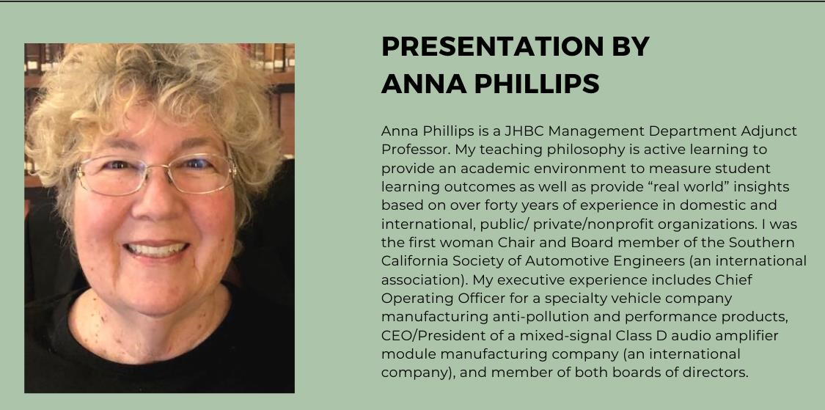
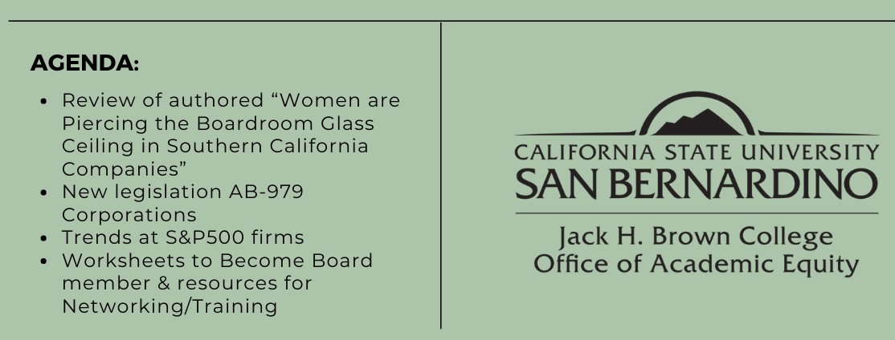

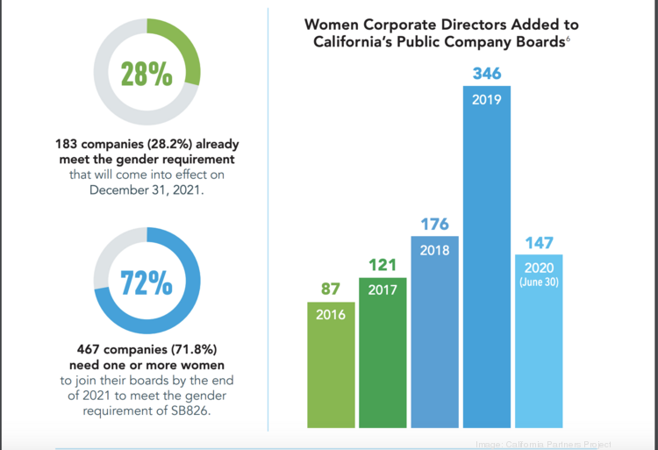

The CSUSB OMBUDS OFFICE:

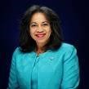
Professor Twillea Evans-Carthen, a faculty member in the Jack H. Brown College, also serves as the CSUSB organizational ombuds (also known as ombudsman.) She serves as a designated neutral party for students, staff, faculty, and community within the campuses of CSUSB and Palm Desert. As the organizational ombuds, she listens impartially to problems, develops options for actions, and provides confidential, informal, independent and impartial assistance through problem-solving methods that may include informal mediation, conflict coaching, facilitation, shuttle diplomacy, and/or identifies systemic problems. Professor Evans-Carthen does not advocate for any individual, issue or interest, nor does she represent any side in a dispute. Evans-Carthen is bound by ethical principles and as a Professor of Business, she also respects our PRME values.
Professor Evans-Carthen has illustrated that conflict is unavoidable in a university institution. However, if the situation is left untreated, the consequences can be debilitating to an institution. Thus, the role of the University Ombuds is vital in ensuring organizational harmony.
Twillea Evans-Carthen has further explained that the Ombudsman designation was first employed in the 1800s in Sweden, and since then has grown to be an essential
feature of any complex organization across
the globe. Based upon its Scandinavian roots, the word ombudsman is gender-neutral in origin, as the ‘man’ suffix, itself, is gender neutral.
The International Ombudsman
Association, for example, has stated that: The word “Ombudsman” is Scandinavian and means
“representative” or “proxy.” The term is used by the International Ombudsman Association (IOA) to communicate to the widest possible community.

Variations of the term exist (i.e. ombuds, ombudsperson) and are common among those practicing in the ombudsman field.
…….
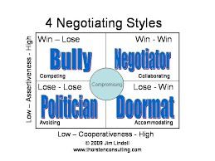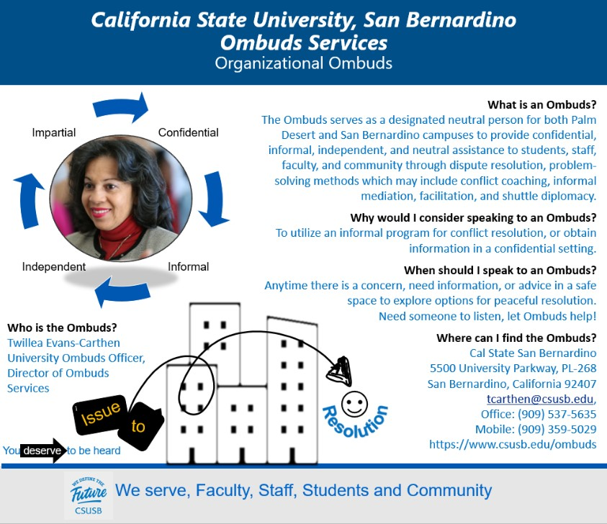

ETHICS, STRATEGIC MANAGEMENT & LEADERSHIP:

Following on the heels of the recent national discourse on policing and law enforcement, Professor Thomas G. McWeeney brought this timely topic to the CSUSB campus. His high level public administration contacts, faculty and students heard Speakers discuss Strategic Management and Law Enforcement Reform. He noted that in light of recent public calls for transformation of police departments, their role and relationship to local communities requires a change in culture, accountability, and leadership.

Conference Topics included:
- Strategic Planning—Results Matter in order to achieve strategic planning success.
- Relevance to Contemporary Law Enforcement Reform—Challenges faced by Law Enforcement Require Commitment to Progressive Planning.
- The NCIS Transformation—How Leadership in the Aftermath of a Tragedy Drove Full Agency Engagement and High Risk Initiatives
[See next page for key speakers]
Dr. Thomas McWeeney is a political scientist, strategic planner, management consultant, and professor of government and public administration. Dr. McWeeney has served as the principal consultant to key executives in several federal law enforcement agencies. In these efforts, he has worked on behalf of agency senior executives and has led comprehensive projects that provided innovative thinking, new direction, and organizational transformation to high profile agencies facing challenges from a changing external environment and diminishing internal capacity.

Professor McWeeney’ s Research Interests include: a) Regional governance as a solution to problems of intergovernmental relations and intergovernmental cohesion b) Public sector strategic management: the integration of strategic planning, performance budgeting, performance measurement and evaluation as the critical success factor for the innovation and transformation of public agencies. c) The distinction between public leadership and public management.

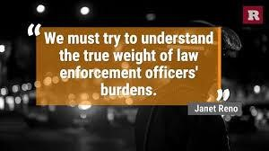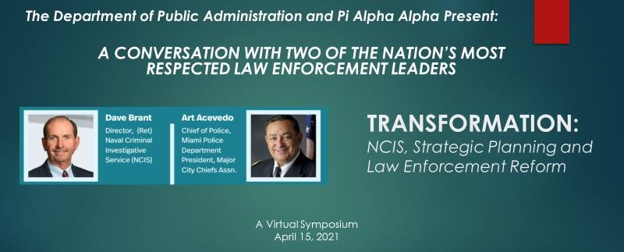

Through Her Conferences and Webinars
Professor Victoria Seitz, Promotes Empowerment of Women

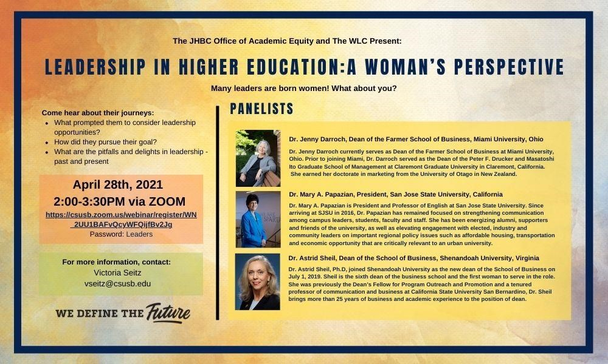
‘let’s
Investigative Service
Professor Victoria Seitz …
…has created and facilitated a series of events at the Jack Brown College—geared to the empowerment of women. Dr. Seitz serves as Chair of the Department of Marketing, and has just been appointed Interim Chair of the Department of Public Administration. She writes and lectures on the empowerment of women. Her book, "I Don't Wear A Suit," is available through the website of the same name - check it out!

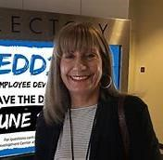

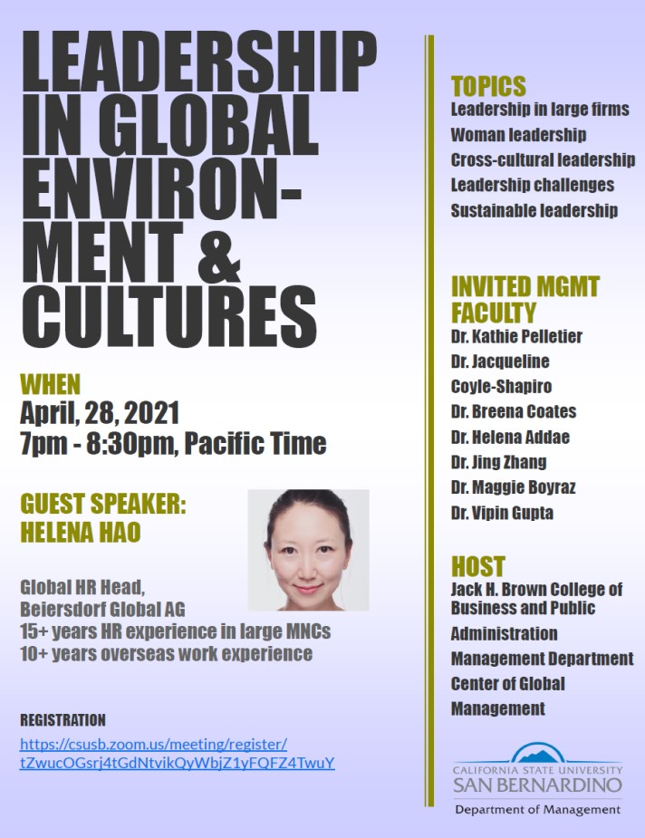
The program above was directed and facilitated by Management Department Chair, Professor Rangfeng Qiu, 2021

"Strong men, men who are truly role models, don't need to put down
women to make themselves

feel powerful."

Michelle Obama,
201
6
.

CSUSB Sustainability Committee
The Jack H. Brown College, participates in the CSUSB Sustainability Committee, with the engagement of Management representative, Professor Breena E. Coates. The Committee ensures campus-wide engagement and participation in sustainability commitments and the Resilient CSUSB Plan. The Committee facilitates implementation of the Plan, other sustainability commitments, and monitors their progress. It also establishes and gives oversight to Working Groups charged with specific actions that support Resilient CSUSB goals.

Sustainability Committee Leadership
Professor Dorothy Chen-Maynard & Mr. Miguel Martin
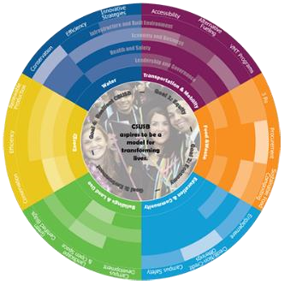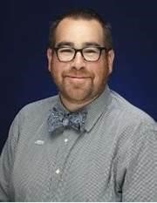

Sustainability Committee Values:

The Resilient CSUSB Plan
"Resilience is the ability of a system or community to survive disruption and to anticipate, adapt, and flourish in the face of change." - Second Nature
- Energy: Both the San Bernardino and Palm Desert campuses will produce on-site energy required for campus operations on an annual basis.
- Water: Water will be used efficiently and returned to be used as a positive resource.
- Waste: Both campuses will divert all materials from entering the landfill and reuse them as a beneficial resource through reuse, composting, recycling or other means.
- Food: Both campuses will provide food security to its students. Additionally, the University will provide healthy food from sustainable sources.
- Transportation: Both campuses will have fewer people driving individually in a car to the University.
- Buildings and Lands: Is being finalized. ……

SUGGESTED FILMS
THE CUTTING EDGE

Welcome to Womanhood--
Efforts to stop female genital mutilation in Uganda.

"Although this is a grisly topic, female genital mutilation, but is presented in this program without sensationalism or undue gore. Kogbara interviewed both opponents and proponents of the custom, and their onscreen comments make up much of this short program. Kogbara herself makes no effort to hide her own despair at the situation. What she discovered was that while some young Sabiny women, due at least in part
to the efforts of REACH, are now avowing to never undergo the procedure, still 'six thousand young girls continue to be mutilated daily in Africa” In the remote Kapchorwe region of Uganda, female circumcision ceremonies occur among the Sabiny people every two years. NOT THE NUMBERS GAME producers
looked at the United Nations Population Fund's 'REACH' effort to stop the practice of female genital mutilation in “The Cutting Edge.” http://www.bullfrogfilms.com

“Together, we can eliminate female genital mutilation by 2030.
Doing so will have a positive ripple effect on the health, education and
economic advancement of girls and women. “
UN Secretary-General António Guterres

THE RIGHT TO CHOOSE:

Women are denied human rights in Ethiopia and northern Nigeria.

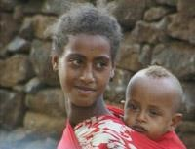
Nibret is eleven -- and they're marrying her off to a man she's never met. Forced marriage isn't unusual in northern Ethiopia. It helps to cement ties between families and establish land rights. Besides, claim Ethiopian scholars, there are no schools for young women, so why not marry them off early?
It's a view shared
"An illustration of the grotesque consequences of treating women as
property or, even worse, as financial liabilities." Timothy McGettigan,
Professor of Sociology, University of Southern Colorado
by some Islamic leaders in northern Nigeria. They believe women's role is to comfort men, and see nothing wrong with marrying girls as young as seven, often in polygamous marriages. This program reports on the dissonant voices arguing for change in local cultures -- and the calls for reproductive health care and primary education for women. Does widespread discrimination and violence against women now constitute a violation of human rights on a massive scale. www.tve.org/life/archive (Producer's web site) www.tve.org/life/archive/life8main.html 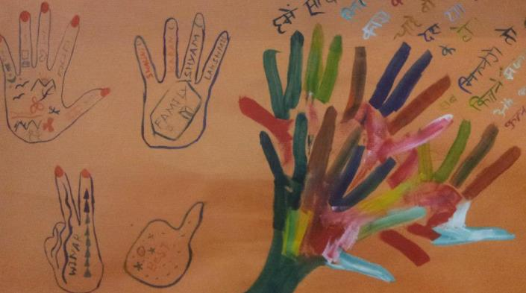 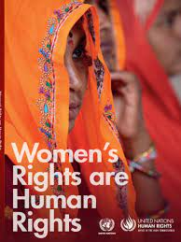

The untold story of the involuntary sterilization of Native American women by the Indian Health Service well into the 1970s
The women were removed from their families and sent to boarding schools. They were subjected to forced relocation away from their traditional lands and, perhaps worst of all, they were subjected to involuntary sterilization.
The result of nine years painstaking and sensitive work by filmmaker Lorna Tucker, the film features the testimony of many Native Americans, including three remarkable women who tell their stories – Jean Whitehorse, Yvonne Swan and Charon Asetoyer – as well as a revealing and rare interview with Dr. Reimert Ravenholt whose population control ideas were the framework for some of the government policies directed at Native American women.
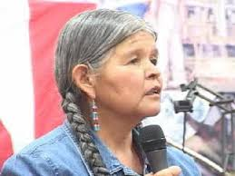
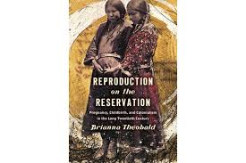
It is estimated over a twenty-year period between 1960 and 1980 that tens of thousands of Native American women were sterilized without their knowledge or consent. Due to poor record keeping during this era the number may in fact be much higher. Many of these women went to their graves having suffered this incredible abuse of power.
The film ends with a call to action – to back a campaign to get a formal apology from the US government, which would then open the door for the women to bring a lawsuit. ….
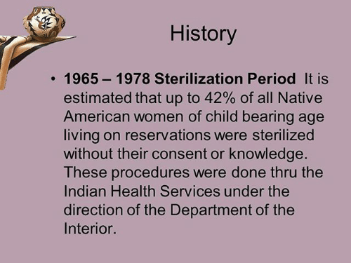

No Mas Bebes

Film on The Sterilization of Immigrant Hispanic Women
Immigrant mothers sue county doctors, the state, and the U.S. government after they were tricked into sterilizations in the 1960s and 1970s.

No Más Bebés tells the story of a little-known but landmark event in reproductive justice, when a small group of Mexican immigrant women sued county doctors, the state, and the U.S. government after they were sterilized while giving birth at Los Angeles County-USC Medical Center during the late 1960s and early 1970s.
Marginalized and fearful, many of these mothers spoke no English, and charged that they had been coerced into tubal ligation — having their tubes tied — by doctors during the late stages of labor. Often the procedure was performed after asking the mothers under duress. The mothers’ cause was eventually taken up by a young Chicana lawyer armed with hospital records secretly gathered by a
whistle-blowing doctor. In their landmark 1975 civil rights lawsuit, Madrigal v. Quilligan, they argued that a woman’s right to bear a child is guaranteed under the Supreme Court decision in Roe v. Wade.
The filmmakers spent five years tracking down sterilized mothers and witnesses. Most were reluctant at first to come forward, but ultimately agreed to tell their story. Set against a debate over the impact of Latino immigration and overpopulation, and the birth of a movement for Chicana rights and reproductive choice, No Más Bebés revisits a powerful story that still resonates today.

BOOKS for Sustainability Classes:

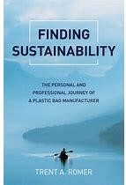
What if the foundation of your family business were threatened by something out of your control? What if the livelihood of 70 employees and their families were at stake, as the license to operate your business became called into question? What if 57 years of family history,
grown through generations of hard work and sacrifice, were at risk of being lost? What if the reasons were actually one with which you fundamentally agreed?
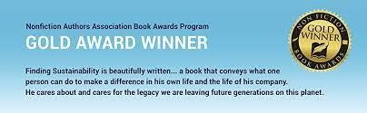

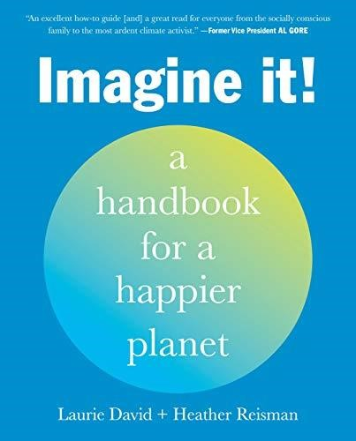
An inspirational, accessible, and actionable guide for empowering and inspiring you to take concrete steps
towards living more sustainably. “An excellent how-to guide [and] a great read for everyone from the socially conscious family to the most ardent climate activist.”—Former Vice President Al Gore Imagine It! is a handbook for those who want to begin or advance a journey toward
living in better balance with our planet. It inspires, supports, and offers easy ways to replace old, planet-hurting habits with new healthy ones. In Imagine It!

A compelling-and illuminating-look at how our daily habits impact the environment."--Vanity Fair "If you're looking for something to cling to in what often feels like a hopeless conversation, Schlossberg's darkly humorous, knowledge-is-power, eyes-wide-open approach may be just the thing."--Vogue "Shows how even the smallest decisions can have profound environmental consequences."--The New York Times From a former New York Times science writer, this urgent call to action will empower you to stand up to climate change and environmental pollution by making simple but impactful everyday choices

.

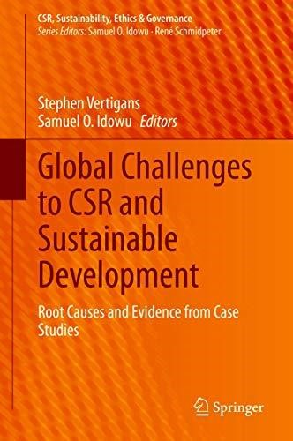
This book examines and analyzes the challenges programs for Corporate Social Responsibility (CSR) and sustainable development are facing in global management practice. It looks at the dichotomy of a general and popular demand for responsible and resilient management, and the counterplayers that impact the positive effect of such efforts. The book assembles latest research looking at the root causes for this opposition, and
new case studies that showcase the dilemma and possible solutions to overcome it.
https://youtu.be/C3x5Q3BfacY

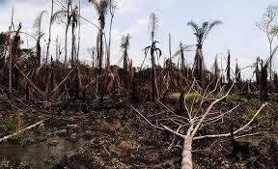

The 17 U.N. Sustainable Development Goals to Transform Our World
The 17 Sustainable Development Goals are a call for action by all countries – poor, rich and middle-income – to promote prosperity while protecting the planet by 2030. They recognize that ending poverty must go hand-in-hand with strategies that build economic growth and address a range of social needs including education, health, social protection, and job opportunities, while tackling climate change and environmental protection.
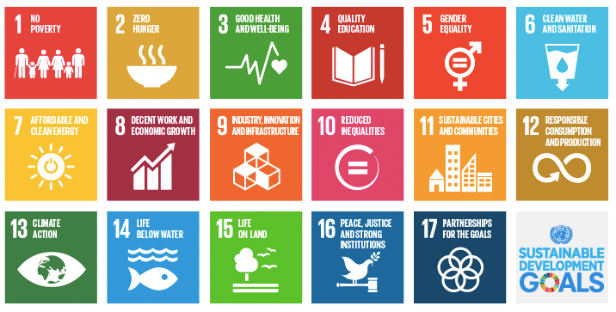

…And, Our JHBC Faculty do their Part To Support the U,N,
- Align curricula and research to the SDG commitments and agenda
- Insert new content, learning methods and transformative approaches (i.e., experiential and interdisciplinary learning and new skills into the curricula)
- Seek more applied research around the SDGs that can create solutions to help businesses be more effective and sustainable
- Engage with students to commit to and act in support of the SDGs
- Act as leaders of public opinion, advisers, suppliers of knowledge and solutions and mediators among businesses government and civil society in support of the SDGs (contributing, for example, with the SDGs National Plans)
- Contribute through our PRME Chapter to scale-up efforts in our region and identify the local priorities towards building global sustainability.
…..

WEBINAR on Key Findings from the 2019

CEO Study on Sustainability

2020--As we approach 2030 and with ten years to achieve the Global Goals set out by governments with business and other stakeholders, it is clear that we are not on track. This webinar
features key insights from our 2019 CEO
Study on Sustainability, which spotlights how business contribution towards the Sustainable Development Goals can, and must, be accelerated.
Presented by Lise Kingo, CEO & Executive Director of the UN
Global Compact and Peter Lacy, Senior Managing Director of Accenture Strategy, discover insights drawn from 1,000 CEOs across 21 industries and 99 countries, reflecting over 100 in-depth interviews and 1,500-plus senior business leaders.

…………

PLEASE SEND NOTICES FOR THIS BULLETIN TO: bcoates@csusb,edu, Thank you!

