**How to download/print my paystub from Paylocity?**

[**https://access.paylocity.com/**](https://access.paylocity.com/)

**Web access:**

Login to Paylocity using your user access.

1. Navigate to **HR & Payroll > Employees > Employee Payroll File > Pay > Current Check**

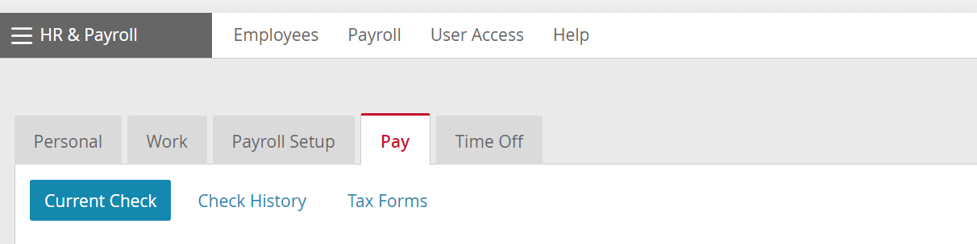

1. Select the appropriate **Check Date** from the dropdown menu on the right.
2. Select the **Download Printable Version**option located in the lower left-hand corner of the page.
3. Indicate an option for printing:
   1. Password to protect the PDF file. It is not possible to disable this.
      1. Enter a password for protection.
      2. Select **View PDF**.
      3. Enter the password again to view the PDF.
   2. No password protection:
      1. Enable the **Do not password protect this information: my computer is secure and free from spyware or other potential unauthorized access.**option.
      2. Select **View PDF**.
4. Select the **Print**icon to print the check.

**Mobile access:**

1. Log into the [Paylocity Mobile Application](https://paylocity.egain.cloud/system/templates/selfservice/pctycss/help/customer/locale/en-US/portal/308600000001010/content/PCTY-54144/Paylocity-Mobile-App-Requirements).
   * Scroll down for more instructions ………….
2. Tap **Pay**from the main menu. View the most recently issued check. The display defaults to the check's net pay, earnings, and direct deposit information.  
   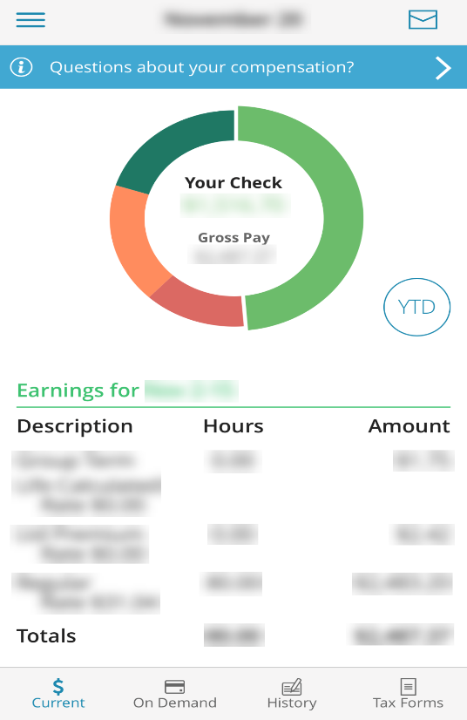
3. Tap the **History** icon at the bottom to view check history.  
   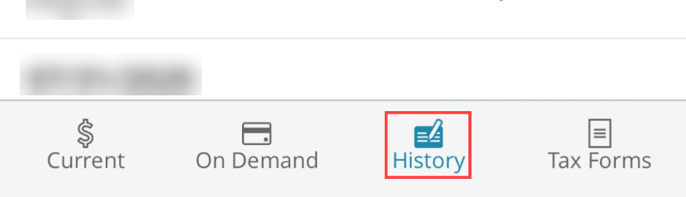
4. Tap the year filter in the top right to filter the history to years past.  
   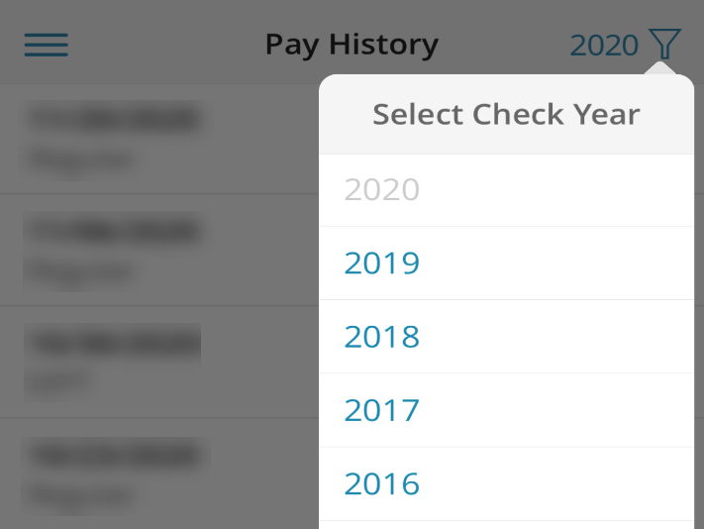
5. Tap the envelop icon at the top right corner.
6. Enter the email information:
   * **To:** Recipient email address
   * **Cc:** Additional recipients if necessary.
   * **Subject:**Will have the Check stub information by default.
   * **PDF Password:** This is an optional security measure that recipient will enter to view the check stub.
   * **Confirm PDF Password:** This will apply when using the PDF Password.