HCM 9.2 Business Process Guide
Admissions Inquiry Pages
Last Revised: 01/22/18
Final: 01/29/2018
REVISION CONTROL
Document Title: HCM 9.0 Business Process Guide: Admissions Inquiry General
Author: Admissions & Student Recruitment
File Reference: HCM 9 Admissions Inquiry General 053112_CMS
Confidentiality Statement
This document has been checked and screen shots do not contain any confidential information (staff names, addresses, social security numbers).
Please add a new line, verifying that screen shots have been checked each time this document is published.
2/10/12 Arlene Reed
Table of Contents Page
Introduction 4
1.1 Search Page 5
1.2 Admissions Summary 6
1.3 Test Summary 9
1.4 Checklist Summary 10
1.5 Comment Summary 11
1.6 Education Data 12
1.7 External Education 13
1.8 Courses and Degrees 16
1.9 Service Indicators 17

Introduction
The Admissions Inquiry Pages Business Process Guide will discuss the updates delivered by CMS Baseline to the PeopleSoft System to display pertinent Admissions information in one set of pages. This guide is intended to discuss only the Inquiry pages and is not intended to replace the Business Process Guide for application maintenance in your system. For in-depth information regarding the data displayed in the Inquiry pages, please refer to the Application Maintenance, 3Cs Maintenance and Test Score business process guides.
The Admissions Inquiry Pages Business Process Guide will discuss features available for functional users. A great feature of CMS is that we have the “one stop shop” page available that provides a quick snapshot of a student’s admission file. Outside of the CSU, people must visit several pages in order to retrieve admissions information. We are fortunate to have it available to us on one screen. The CSU Admissions Inquiry Page will display the most recent row of academic data and academic summary for an individual who has applied to CSUSB as an undergraduate or graduate student.
Definitions
The following (optional) icons are used to draw attention to information in this guide:
New in 9.0 icon
New in 9.2: this icon will appear where a significant change has occurred from 9.0 to 9.2
Note icon
Note: this icon will appear where a significant change has occurred from 9.0 to 9.2

1.0 Admissions Inquiry Pages
Admissions Inquiry pages include search functionality, display of admissions information, as well as appropriate links to pages with detailed information. New in 9.0 icon
Navigation to pages crosses the top of the screen.
Navigation: Main Menu> CSU SA Baseline> CSU Admissions> Inquire> Admissions Inquiry
Image of navigation to admissions inquiry
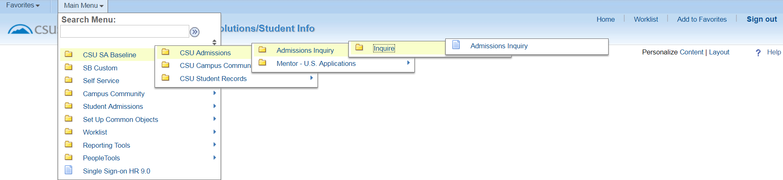
Begin by navigating through PeopleSoft to get to the Admissions Inquiry Page.

Search Page
IEnter the appropriate data to use as search criteria for the applicant. ote icon
Use either individual or a combination of search fields, i.e., Career, Program, and Admit Term, may be used, along with the ID (which may be used if a student has multiple applications in the system), to further refine the search. Date of Birth and name searches are commonly used search fields as well.
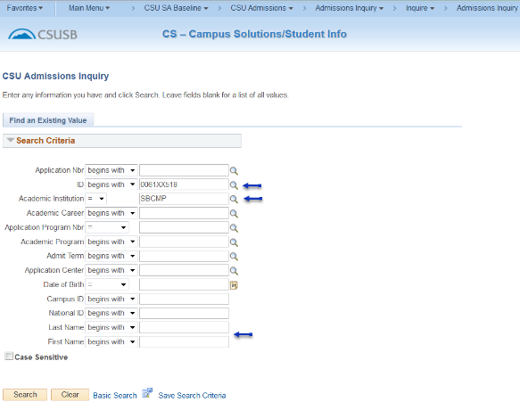
The four tabs associated with Admissions Inquiry include:
- Admissions Summary
- Test Summary
- Checklist Summary
- Comment Summary

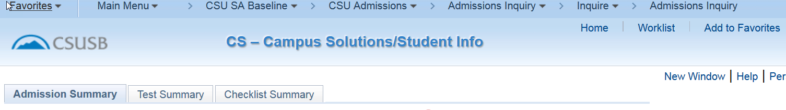
Image of navigation to admissions inquiry

Admissions Summary
Admissions Summary: reflects General Application Information. A summary of the student’s file is available. The data displayed includes the applicant’s biographic and demographic information as well as application information.
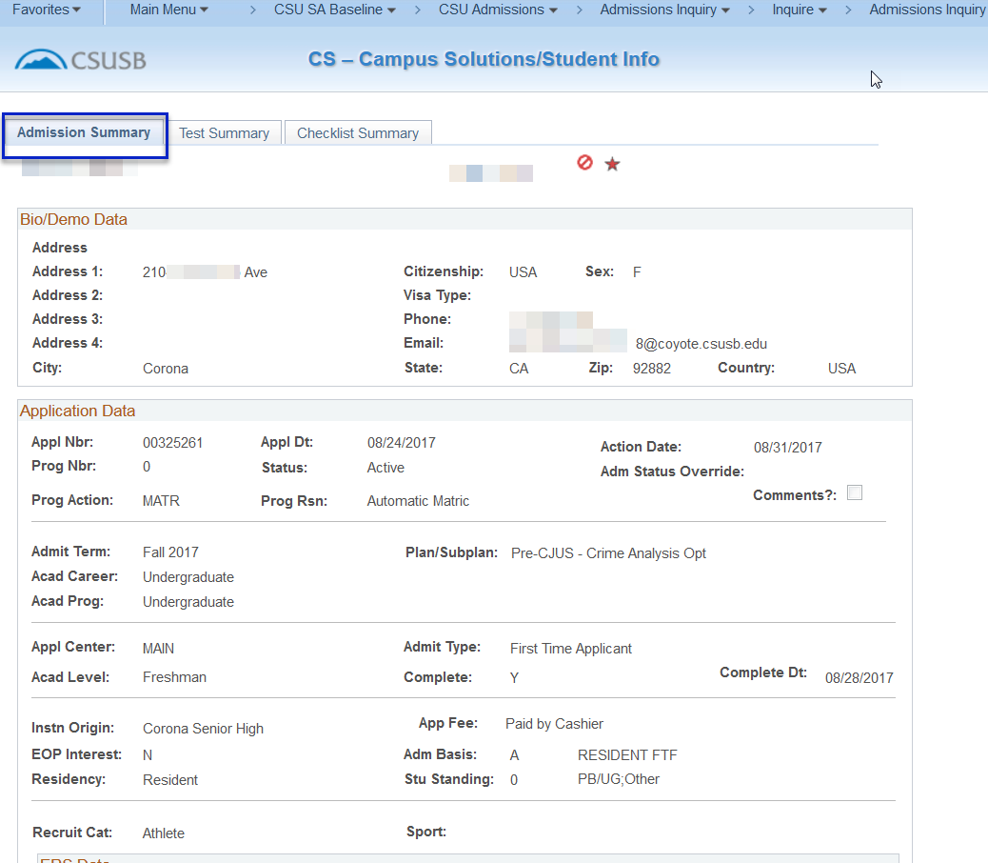
Bio/Demo Data: includes Address, Phone Number, Campus Assigned Email, Country of Citizenship, Sex
Application Data: Includes the basic information about an applicant.
Application Date: reflects the date the information was loaded into Oracle/PeopleSoft, not the date the student submitted their application on CalState Apply or a paper application to the campus.
Action Date: reflects the date a major action occurred on the application such as an Admission Decision
Program Action and Program Reason: reflect the Admissions Decision.
Common values in the Program Action field will include APPL (applicant), COND (conditional admit), DENY (denied), DDEF (deferred decision), MATR (matriculated; eligible to register). Values in the Program Reason field will depend on the Program Action. The Program Reason provides more details about the Program Action. For example, if the students’ Program Action: COND, Program Reason: AUTO to reflect the decision was based on self-reported information.
Program Action: reflects the admission status of the application.
COND= the student has been conditionally admitted and must be submit final documents in order to be fully admitted. Conditional admission will be rescinded if we discover the student is no longer eligible for admission.
MATR= the student has been moved into a status where they are eligible to register. Because many of the students in MATR status are still conditionally admitted, MATR status can be reversed at any time.
CNCL= the offer of admission has been cancelled
DENY= the student is not eligible for admission
Program Reason: reflects the reason for the status of the application.
Admit Term: reflects the term to which the student has applied.
Academic Career: Undergraduate or Post-baccalaureate
Academic Program: Undergraduate, Graduate, CCRE, Transitory (non-degree seeking)
Plan/Subplan: Major
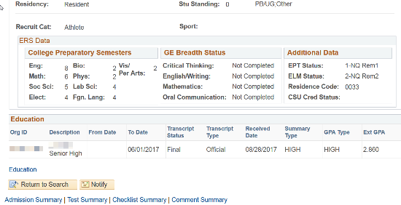
Complete and Complete Date: indicate the final admission decision has been made based on final official transcripts and admission will not be cancelled by Admissions unless requested by the student and the date the final admission decision was made. Complete value must be Y in order for financial aid to disburse and the PAWS Audit to be provided.
Residency: considered for tuition fee purposes.
Recruitment Category: reflects whether a student is in any particular group tracked for admissions purposes.

Image of ERS data and education information on page

ERS Data: includes the number of College Preparatory Semesters completed by first time freshman applicants, GE Breadth Status for transfer applicants, and EPT/ELM information.
EPT/ELM information: the information in the EPT and ELM status box is updated when students submit documentation that allows for the determination of Math and English readiness and/or the need for developmental coursework.
Education: reflects the institutions the applicant has attended as well as the GPA information from those institutions. The functional user may also use this display to determine which official transcripts have been received by Admissions and which are still required. The most recent effective dated row will be displayed. More detailed information may be obtained using the Education hyperlink and will be covered in section 1.5 of this document.
Note icon
Additional access to the Education data page is required to view contents.

Test Summary
Test Summary: includes all test results in the student record. Common test results for applicants include, but are not limited to: SAT, ACT, AP, GRE, GMAT and TOEFL.
Access to the Test Summary page is not granted to all functional users with Admissions Inquiry access. View will depend on the access individual users have to the page.

Image of test summary tab
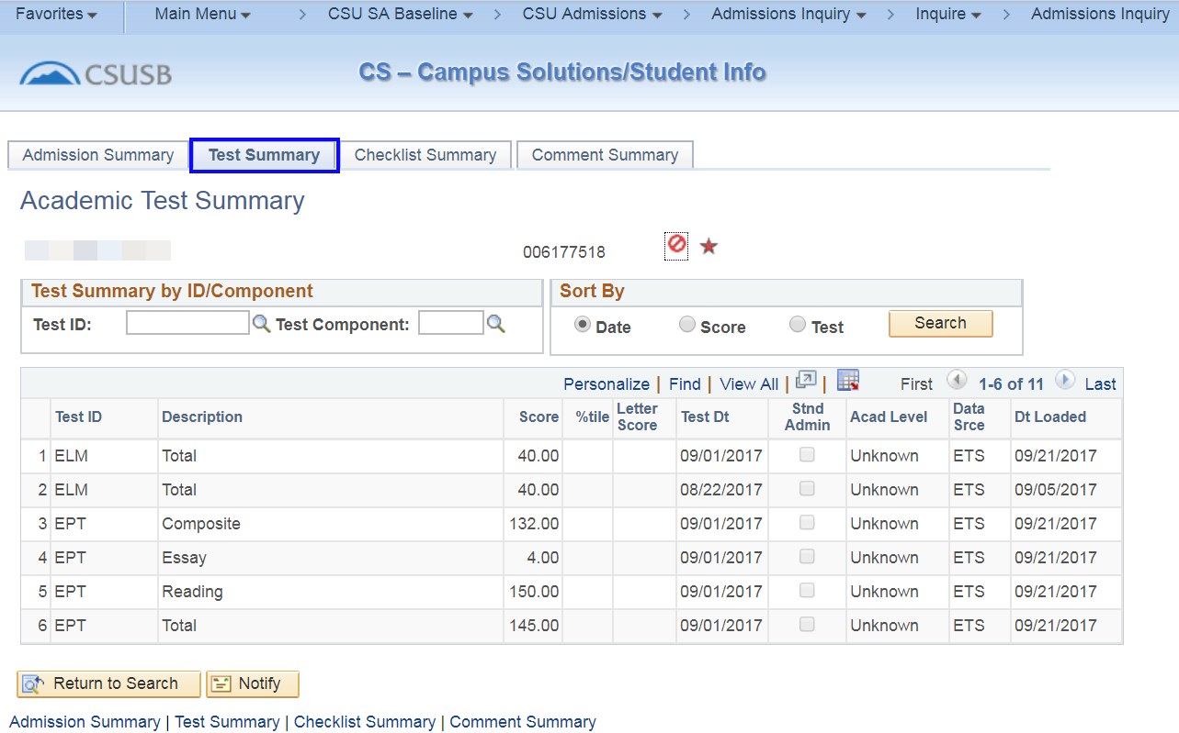
Users with access may go to the Test Summary tab and click the image of search button button to display all test data for the applicant.
The Test Summary by ID/Component may be used to further refine or limit the search criteria. If the applicant has multiple Test IDs, such as ACT, SAT, etc., entering ACT, in the Test ID field, then clicking the image of search button button will limit the display to only ACT scores.
Populating the Test Component field, in addition to the Test ID, will provide an even more detailed search. By selecting the Test ID: ACT and the Test Component: Composite, only ACT Composite scores will display after clicking on the image of search button button.
Clicking on the Date, Score, or Test radio buttons allows users to sort their results.
i

Checklist Summary
Checklist Summary: used to communicate real time document status to the student through the portal. Admissions information on the applicant/student’s Checklist is displayed to the student through the To Do and Application Status links on the applicant/student’s MyCoyote account.
Note icon
Access to the Checklist Summary page is not granted to all functional users with Admissions Inquiry access. View will depend on the access individual users have to the page.

Image of checklist summary tab 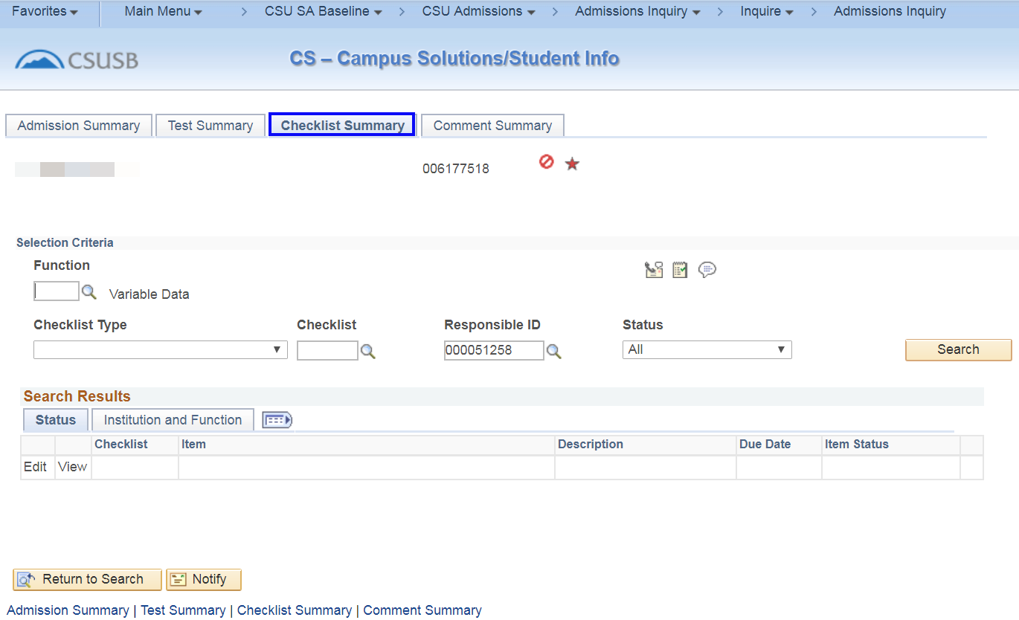
The Checklist Summary page allows users to click the mage of search button button to view all checklist items for the applicant. Selection criteria fields may be used to refine the search results.
Leave the Responsible ID box blank to get a full display of Checklist Items. Entering an ID in the Responsible ID box will limit the display to only those Checklist Items assigned by the individual with that ID.
This page displays the status of items the applicant needs to complete their application. In this example, the applicant was required to submit the $55 application fee and their final college transcript. Both items have been supplied by the applicant and the checklist item has been completed. When the applicant/student views the To Do list in the portal, they will see they have no To Do items for Admissions and the Application Status will reflect Completed.

Comment Summary
Comment Summary: displays the comments made on a student record through the Campus Community navigation to comments. In an effort to maintain confidentiality during the application process, Admissions does not make any comments about applicants through the Campus Community navigation.
Note icon
Access to the Comment Summary page is not granted to all functional users with Admissions Inquiry access. View will depend on the access individual users have to the page.
Image of comment summary tab
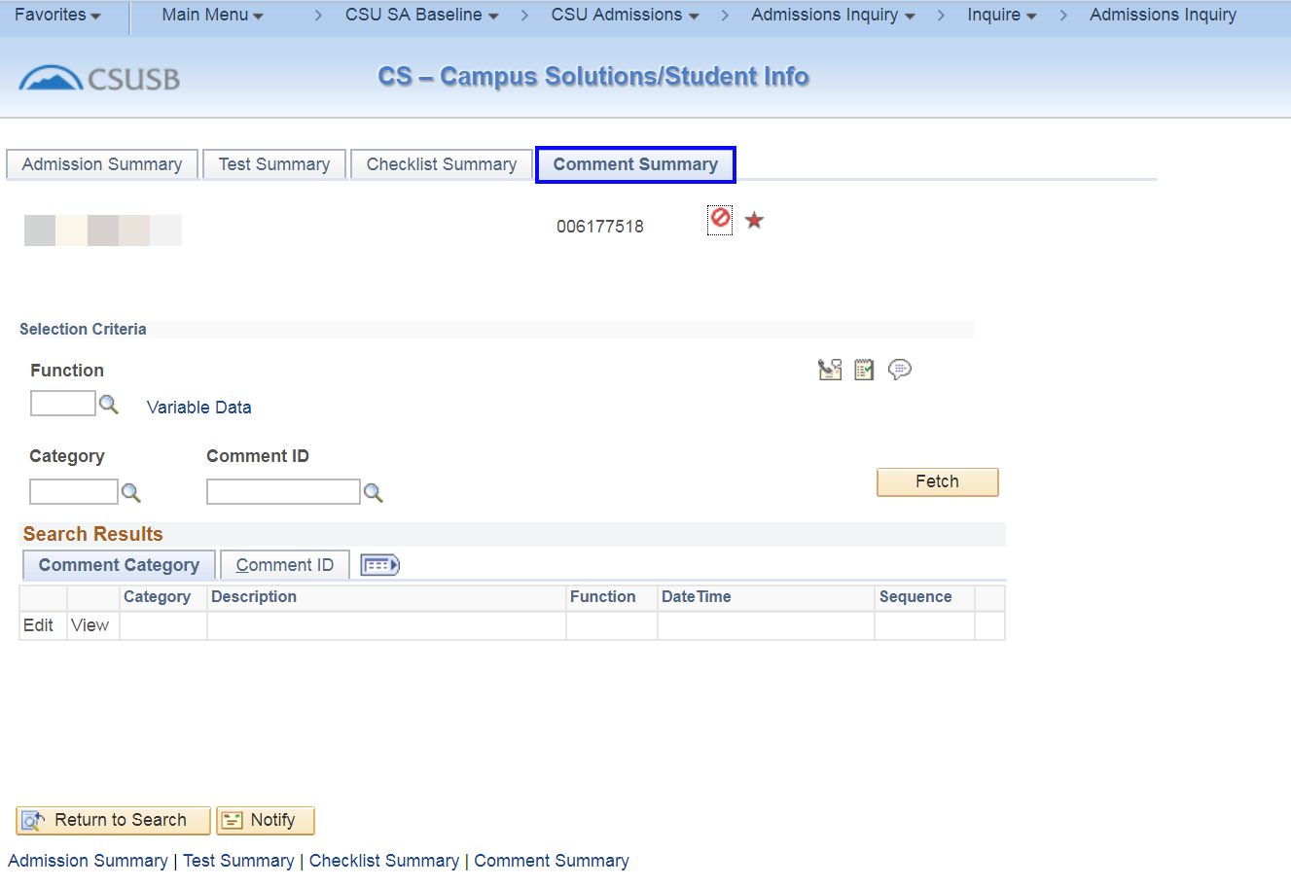
On the Comment Summary page, click the mage of search button button to retrieve all comment data for the student.
Note icon
The Comment Summary page allows users to view staff-entered comments related to a student’s record. The Comment Summary page does not display entries made on the Admissions Comments page.
When the Edit or View hyperlink for a comment is clicked, the Person Comment Detail page will open in a new window. This page provides details about the comment.

Education Data
The Education data hyperlink will lead the functional user to extensive information regarding the institution(s) the student has attended. Additional access to the Education data page is required to view contents.
Image of Education hyperlink
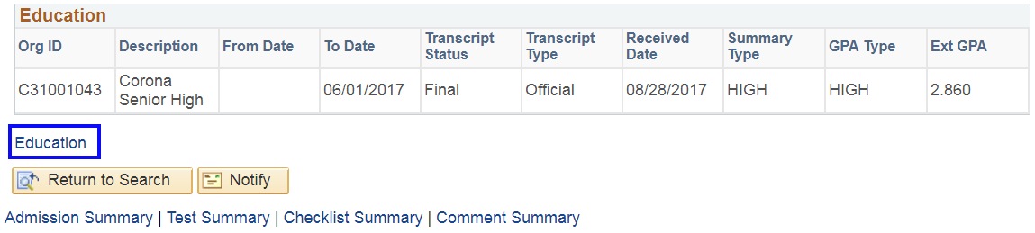
New in 9.0 icon
The two tabs associated with the Education data link include:
- External Education
- Courses and Degrees
Image of external education tab
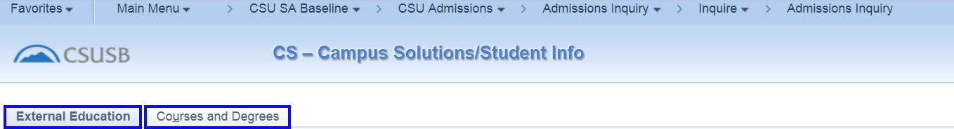

External Education
External Education: displays all of the information about the schools an applicant/student has attended.
Image of External Education tab with row information
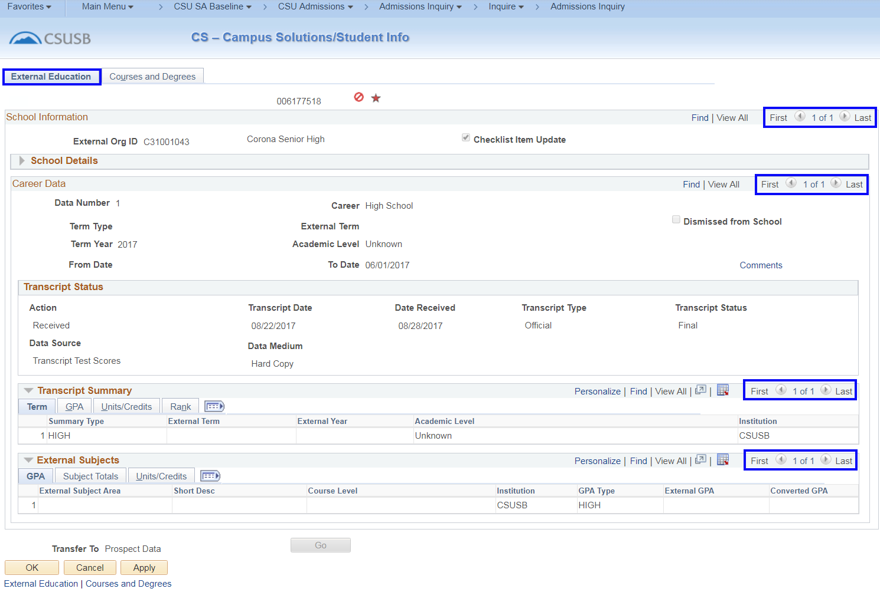
Note icon
Take notice if there are multiple External Orgs (schools) or multiple entries for any particular data row. If it says 1 of 1, that means the functional user is looking at the only external organization information reported for the student. However, if it indicates the student attended more than one External Org, you must click on the arrow to get the additional information for each school OR you can click on “View All” to see all schools on one continuous page.
Image of external education tab carrer data 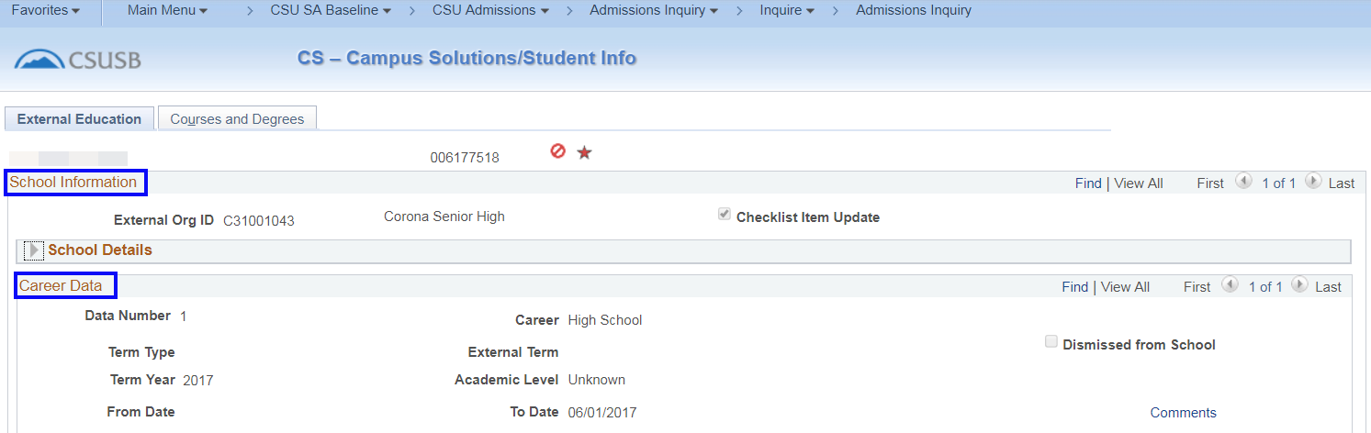
School Information: displays the External Org ID. The name of the school is listed beside the External Org ID. The Career Data box displays how many rows of data are available for that particular school, type of term at the school, and the dates the student attended.
Image of external education school details
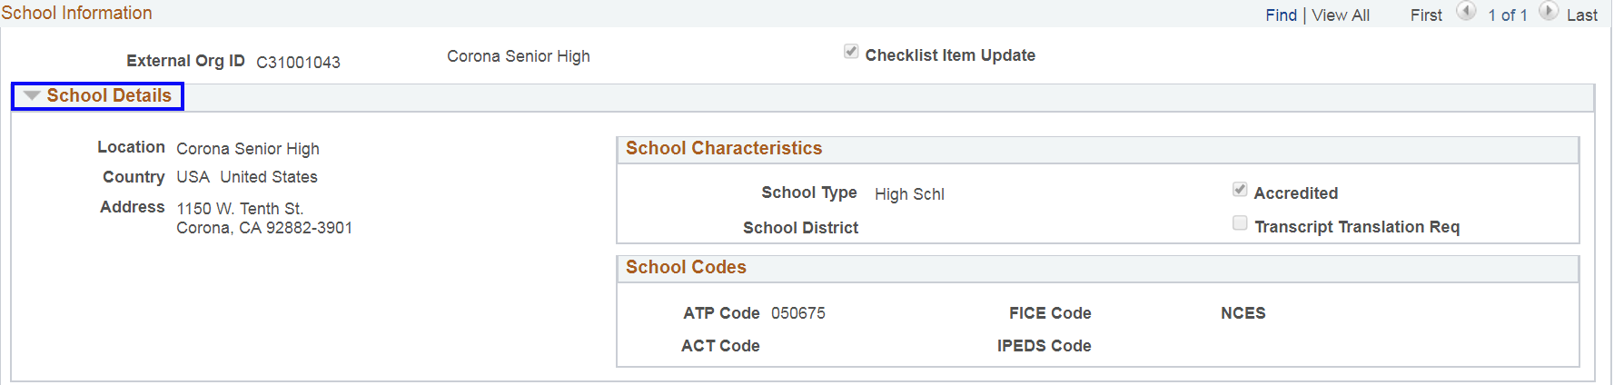
Clicking on School Details displays the address and system codes for each institution the applicant/student has attended. Admissions Inquiry access does not allow access to School Details to most functional users. Additional security access is required.
Image of transcript status
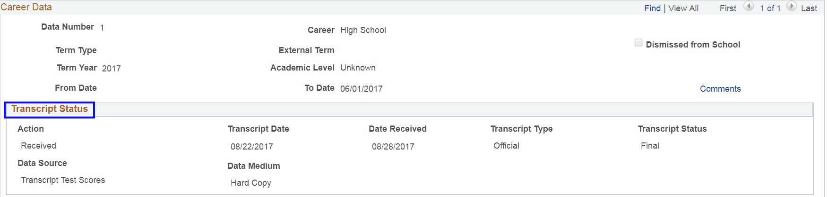
Transcript Status: displays what was External Data in PeopleSoft v8.9. The Action field displays whether a transcript is Desired, Not Desired, or Received. The Transcript Date displays the date of the Action.
Image of transcript status
The data row for the school is usually completed when the Official transcript has been updated to the Action of Received.
In PeopleSoft, the information displayed on the External Academic Summary tab is displayed in PeopleSoft under Transcript Summary.
Transcript Summary: may be expanded out across the page by clicking on the image of column expander icon button or viewed as it is in the screen shot. Here, it appears the Transcript Summary row displays the type of school the External Org is, GPA/Unit information, and student Rank as separate tabs when they are, in fact all one row. Image of transcript summary
The Admissions Office does not update Rank information of applicants as the student’s rank at any institution is not part of the application process. Likewise, the External Subjects row is not updated by Admissions.

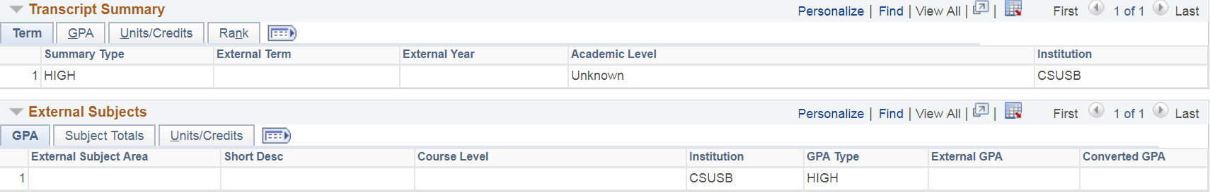Courses and Degrees
Tracking degree information is an important part of the applicant/student record. Depending on the type of degree earned, there may be a delicate balance where a student can only be held to a specific pattern of courses to meet graduation requirements.
mage of courses and degrees tab 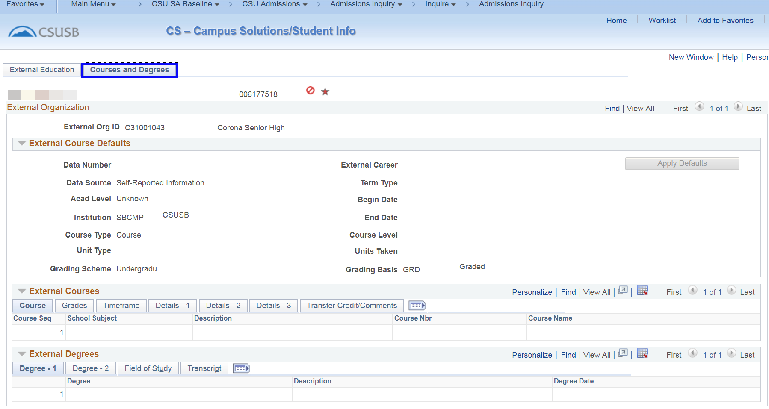
Courses and Degrees: displays information about specific courses taken at the particular External Org. At this time, Admissions does not record specific course information within PeopleSoft.
Image of degree tab in the external degrees section
External Degrees: reflects any degree an applicant/student has earned from a previous institution. The type of degree, the date it was awarded, and the field of study the degree was awarded for will be indicated as well.
Service Indicators
Student records are often managed with Service Indicators. Service Indicators may be merely notes on a student’s record or they may have an impact on the services a student may receive from the campus. Whether positive or negative,
A Star red star symbol symbol: there is a Positive Service Indicator on the student record. Click on the icon to find out what the positive service indicator means. Details about the Service Indicator and the terms affected will be displayed.
The student has no access to view Positive Service Indicators through their MyCoyote account and often has no idea the indicator exists on their record.
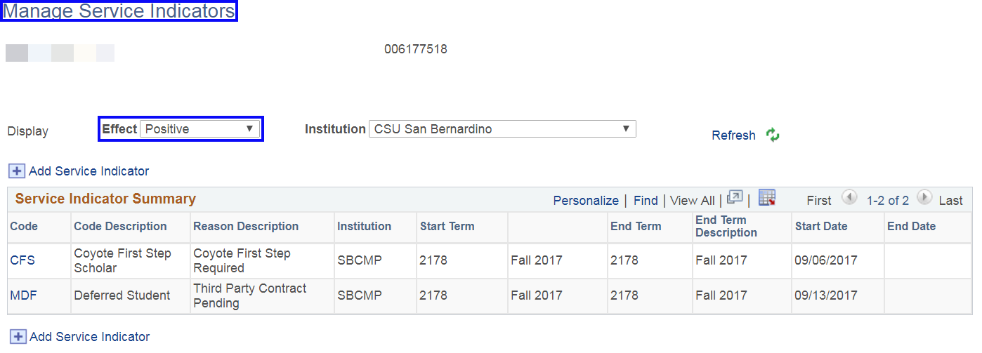
A No crossed out circle icon symbol: there is a Negative Service Indicator on the student record. Click on the icon to find out what the negative service indicator means. As with the Positive Service Indicator, details about the Service Indicator and the terms affected will be displayed.
The student will be able to view their negative service indicators as Holds in their MyCoyote account by clicking on the Details in Holds in Student Center and then clicking on the link in the Hold Item box.
Image of service indicator summary
