Table of Contents

Early Explorations of the Americas

Acknowledgements i

Table of Contents 1

Unit Overview 2
History-Social Science Grade 5 Standard 2
Common Core State Standards

Lesson 1: Exploration and Technology 3
Activity # 1 Where in the World? The Story of Marco Polo
Activity # 2 When Did that Event Happen?
Activity # 3 Close Reading of the Textbook
Lesson 2: Technology and Navigational Tools 10
Activity # 1 Early Maps used by Explorers
Activity # 2 Navigational Tools Catalog
Activity #3 Navigational Tools Today
Lesson 3: Maps Galore 13
Activity # 1 Voyages of Exploration
Activity #2 Conquistadores in North America
Activity #3 Routes of Early Explorers
Lesson 4: Explorer Research Report 17
Activity # 1 Research Project on an Explorer of the Americas
Activity # 2 Presenting Your Research Report
Optional Projects

Extended Activities 21

Resources for Early Explorations of the Americas 30
Teacher Evaluation Form 32

Unit Overview: Early Explorations of the Americas
This curriculum supports the attainment of the following Grade 5 History-Social Science Standards for California Public Schools and Common Core State Standards.

History-Social Science Content Standards
Standard 5.2: Students trace the routes of early explorers and describe the early exploration of the Americas.
1. Describe the entrepreneurial characteristics of early explorers (e.g., Christopher Columbus, Francisco Vásquez de Coronado) and the technological developments that made sea exploration by latitude and longitude possible (e.g., compass, sextant, astrolabe, seaworthy ships, chronometers, gunpowder).
2. Explain the aims, obstacles, and accomplishments of the explorers, sponsors, and leaders of key European expeditions and the reasons Europeans chose to explore and colonize the world (e.g., the Spanish Reconquista, the Protestant Reformation, the Counter Reformation).
3. Trace the routes of the major land explorers of the United States, the distances traveled by explorers, and the Atlantic trade routes that linked Africa, the West Indies, the British colonies, and Europe.
4. Locate on maps of North and South America land claimed by Spain, France, England, Portugal, the Netherlands, Sweden, and Russia.

Common Core State Standards
Reading Standards for Information Text (RI)
RI 5.1 Quote accurately from a text when explaining what the text says explicitly and when drawing inferences from the text.
RI 5.2 Determine two or more main ideas of a text and explain how they are supported by key details; summarizes the text.
RI 5.7 Draw on information from multiple print or digital sources, demonstrating the ability to locate an answer to a question quickly.
RI 5.9 Integrate information from several texts on the same topic in order to write or speak about the subject knowledgeably.
Common Core State Standards: Writing Standards (W)
W 5.2 Write informative/explanatory text to examine a topic and convey ideas and information clearly.
W 5.7 Conduct short research projects that use several sources to build knowledge through investigation of different aspects of a topic.
W 5.8 Gather relevant information from print and digital sources; summarize or paraphrase information in notes and finished work, and provide a list of sources.
Common Core State Standards: Speaking and Listening Standards (SL)
SL 5.1 Engage effectively in a range of collaborative discussions building on others’ ideas and expressing their own clearly.
SL 5.4 Report on a topic, sequencing ideas logically and using appropriate facts and relevant descriptive details to support main ideas; speak clearly at an understandable pace.

Lesson 1: Exploration and Technology
Essential Question: Why did Europeans begin to look for a sea route to Asia?
Activity # 1 Where in the World? The Story of Marco Polo
Materials needed: a copy for each students of Marco Polo (Handout #1.1, page 7) the Early Explorations of the Americas (Handout #1.2, page, page 8); a globe; a large classroom map of the world or copies of Reflections Grade 5 textbook The United States: Making a New Nation, or any Grade 5 U.S. History textbook.
Step 1: Using a large map of the world (or a world map in the reference section of the textbook), have students:
- Review the name of the city, county, state, country, and continent in which we live.
- Name and locate the 7 continents on a map of the world.
- If you lived in Europe and wanted to travel from Spain or Portugal to Asia, how would you travel?
Ask the questions, “Who is Marco Polo?” “Has anyone ever played the game “Marco Polo?” Though prior knowledge is important, resist the temptation to provide a multitude of details about the lesson at this point.
Step 2: Distribute to each student a copy of Marco Polo (Handout #1.1, page 7). Students read the handout independently. Encourage students to interact with the text while they read by underlining words, phrases or sentences that are unclear. Remind students that if they come to an unfamiliar word, they should look inside the word or surrounding words in the text for clues to figure out the meaning.
Step 3: After the first independent reading, ask students to talk to a partner and share something they learned from the text. Sentence frames and guiding questions are useful aids. An example of conversational starters might be, “I did not know that ______.” As students engage in conversations, circulate and check students’ understanding. This along with the observations made during independent reading, will inform the content of the Think Aloud in the Step 4. These collaborative discussions are about building on others’ ideas and expressing their own ideas clearly to create understanding and find shared meaning.
Step 4: Conduct a “Think aloud” to model effective strategies for students to utilize when they encounter challenging text on their own. Explain to students that you are letting them hear what you are thinking. Students follow along silently with their own copy of the text while the teacher models strategies to unlock the meaning of unknown vocabulary words, challenging syntax, structure, author’s purpose, and context to help them understand the content.
Step 5: This is the second independent activity in which students attempt to understand the text on their own. The goal is to teach students to reread text to acquire knowledge, develop fluency, and reinforce their use of text evidence whenever possible.
Step 6: Ask students to respond to concise text-dependent questions and quote accurately from the text when explaining what the text says explicitly and when drawing inferences from the text. This compels students to extract information directly from the text to help them understand important concepts and develop higher level critical thinking and problem solving skills.
It also models the need and process of returning to the text in order to gain full understanding of the content. The goal of text-dependent questions is to provide opportunities for students to use the text to support answers, deepen comprehension of information, and apply learning to real world scenarios. Examples of a text dependent questions are “Who was Marco Polo?” “Where did Marco Polo travel?” “What did some people say about Marco Polo’s book?
(This Close Reading activity is based on the work of Rebecca Valbuena, Glendora Unified School District)
Step 7: On the student’s copy of the Early Explorations of the Americas (Handout #1.2) complete the information about Marco Polo. Additional print and digital sources may be used to locate further information about Marco Polo. Students retain their copy of the handout.

Activity # 2 When Did that Event Happen?
Materials needed: a large time line displayed in the classroom that can be used throughout the 5th grade curriculum (see below); a large number of post-its or library pockets and 3 x 5 cards for adding events to the time line; for each student, a copy of Reflections Grade 5 textbook The United States: Making a New Nation, or any Grade 5 U.S. History textbook.
As an alternative, make a foldable time line. Use 2 sheets of 12” by 18” paper for each century. Tape the 2 sheets together. Glue 10 library pockets horizontally across the bottom of the paper, one pocket for each decade.
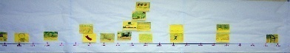
In preparation for this unit, construct a large time line for the Grade 5 standards titled The History of the United States 1400 to 1860. Make the time line approximately 7 yards long.
Draw a line horizontally from one end of the time line to the other. On this line, make short vertical lines about 6” apart. Label the vertical lines beginning with 1400. Label each successive date in ten year intervals (decades) 1410, 1420, 1430, 1440… ending with the year 1860 (or later, if desired).
At the top of the time line, label each century.
14th century | 15th century | 16th century | 17th century | 18th century | 19th century
Give the time line a title and mount it in the classroom.

Step 1: Tell students that in this unit they will read about how Europeans in the late 1400s sailed across the Atlantic Ocean and explored and claimed land in the Americas.
View the time line In the Reflections textbook on pages 96-97. Point out that the events at the top of the time line relate to European exploration and colonization of the Americas. The events at the bottom of the time line took place during the same time period but are not directly related to the Americas or the exploration of them. Ask questions such as, “How many years after Columbus reached San Salvador did Balboa see the Pacific?” (21 years)
Step 2: Introduce the classroom time line. Explain that the 15th century incudes the dates 1401 to 1500. Write several dates on the board and have students work collaboratively with a partner to identify the correct century for each date. For practice, write different dates on a post-it and have students place the date on the time line in the correct decade.

Activity # 3 Close Reading of the Textbook*
Materials needed: For each student, a copy of Early Explorations of the Americas (Handout #1.2, page 8) and Main Ideas and Supporting Details (Handout #1.3, page 9); access to digital on-line sources (preferred, but not mandatory); Reflections Grade 5 textbook The United States: Making a New Nation, or any U.S. History textbook appropriate for Grade 5; a variety of informational texts about explorers. To enable more interaction with the text, consider duplicating textbook pages 110 to 117 so each student can underline words, phrases or sentences that are unclear.
Step 1: On a map of the continent of Europe, locate the countries of Spain and Portugal. To establish the purpose for the students, discuss the essential question for this lesson (Why did Europeans begin to look for a sea route to Asia?). Though prior knowledge is important, resist the temptation to provide a multitude of details about the lesson.
Step 2: In the Reflections textbook (or any American History textbook appropriate for Grade 5), have students use the Table of Contents to locate the page number for Unit 2, Chapter 3, Lesson 1. Students independently read pages 110 to 111. Encourage students to interact with the text while they read by looking for words, phrases or sentences that are unclear. Remind students that if they come to an unfamiliar word, they should look inside the word or surrounding words in the text for clues to figure out the meaning.
Step 3: After the first independent reading, ask students to talk to a partner and share something they learned from the text. As students engage in conversations, circulate and check students’ understanding.
Step 4: Conduct a “Think aloud” to model effective strategies for students to utilize when they encounter challenging text on their own. Students follow along silently with their own copy of the text while the teacher models reading strategies to unlock the meaning of unknown vocabulary words, challenging syntax, structure, author’s purpose, and context to help them understand the content.
Step 5: This is the second independent activity in which students attempt to understand the text on their own. The goal is to teach students to reread text to acquire knowledge, develop fluency, and reinforce their use of text evidence whenever possible.
Step 6: Ask students to respond to concise text-dependent questions and quote accurately from the text when explaining what the text says explicitly and when drawing inferences from the text. This compels students to extract information directly from the text to help them understand. This models the need and the process of returning to the text in order to gain full understanding of the content.
Provide opportunities for students to use the text to support answers, deepen their comprehension of information, and apply learning to real world scenarios. Examples of questions are “What is meant by the term Renaissance?”; “How long ago was Marco Polo’ book first published?”; “What obstacles prevented Europeans from sailing to Asia?” and, “Who were the merchants? Do we have merchants today?”
Step 7: Students determine two or more main ideas of the text and explain how they are supported by key details; summarizes the text. Distribute to each student a copy of Main Ideas and Supporting Details (Handout #1.3, page 9). Write the title of the lesson (Exploration and Technology) in the Key Topic box.
In each of the Main Idea boxes, write the titles of the sub-topics for the lesson (A Rush of New Ideas, The World Awaits, The Business of Exploring, and Two Worlds Meet). Note: Since there are 4 topics and only 3 boxes, have student fold over the right 3rd of their paper and draw a new set of boxes for the 4th topic.
Model for the students how to select the supporting details to write into the boxes for the main idea “A Rush of New Ideas.”
Step 8: Continue to read the rest of Lesson 1 completing the Main Ideas and Supporting Details handout for each section of the text. For additional scaffolding, duplicate the reading lesson organizer on page 37 from Reflections Reading Support and Intervention.
Step 9: On the student’s copy of the Early Explorations of the Americas (Handout #1.2, page 8) complete the information about Christopher Columbus. Additional print and digital sources may be used to locate further information about Columbus. A good website for Columbus is http://ageofex.marinersmuseum.org/index.php?type=webpage&id=51
*For a more advanced group of students who do not need extra help reading the textbook, divide them into groups of 4. Assign each group a sub-topic (main idea) of Lesson 1 (Reflections pages 110 to 117). There will be multiple groups working on each sub-topic of the lesson. Students work with a partner to read and complete one sub-topic of the Main Ideas and Supporting Details (Handout #1.3, page 9). Partners then share their ideas with the other set of partners in their group to fine tune their work. Each group then presents to the rest of the class the main idea and supporting details for their section (sub-topic) of the textbook as classmates take notes on their copy of Handout #1.3.
Step 10: Working in groups, students engage in a collaborative discussion on the following questions building on others’ ideas and expressing their own clearly.
- Why explore?
- What were the risks?
- What were the opportunities and the benefits?
Have each group share their ideas with the class. Additional questions to discuss: Why would an individual want to explore unknown lands? What’s in it for the explorer? Why might the king and queen of a country want people to lead explorations? Why would religious leaders encourage exploration? Why might other countries be jealous of your country’s explorations? How would the people in the lands you are exploring feel about your presence?
Optional Activities
To reinforce the academic content vocabulary, have students keep a Vocabulary Journal. Record key vocabulary words, write their definition, draw a picture (as appropriate) and use the vocabulary word in a sentence that helps to explain its meaning.
Newspaper reporter – Columbus is mentioned in the Reflections text on pages 106-109, 114-117, and 126-127. After reading the text, write the title of an article about Columbus. Write 5 questions to ask Columbus and the possible answers. Next, write 5 questions to ask the Taino leader and the possible answers.
Read to students Jane Yolan’s book about Columbus titled Encounter. The book is written from the viewpoint of a young Taino boy. (Refer to the Resources section of this guide.)
Handout #1.1 Marco Polo

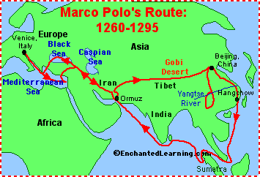
Marco Polo (1254-1324) was an Italian who was one of the first Europeans to travel across Asia through China, visiting the Kublai Khan in Beijing. He left in 1271 (he was a teenager at the time) with his father (Nicolo Polo) and uncle (Maffeo Polo); they spent about 24 years traveling.
Polo sailed south from Venice, Italy, in the Mediterranean Sea to the Middle East. They then went southeast overland to Persia (now Iran), then through the Gobi Desert to Beijing, China. They explored the area south of Beijing and traveled south to Hangchow, China. They then sailed south along the coast of China to what is now Sumatra. They sailed west to India, and then back to Ormuz (on the Persian Gulf). They went northwest overland to the Black Sea, then the Mediterranean Sea, and back to Venice, Italy.
Marco Polo's written accounts of his travels were the first Western record of porcelain, coal, gunpowder, printing, paper money, and silk. Polo’s book “The Travels of Marco Polo” made him a celebrity. However, many people did not believe Marco Polo’s tale. They thought his book was a work of fiction. In fact, it became known as “The Million Lies.” However, since then, historians have verified many of the things Marco Polo claimed to have seen.
Two hundred years later in the 1450s the printing press was developed by Johannes Gutenberg. Marco Polo’s book became one of the most popular books published. People wanted to buy the goods such as silks and spices from India that Marco Polo described. Many traveled the long, hard overland route to Asia. Christopher Columbus believed that sailing west would be a faster way to get to India. Source: Col, Jeananda. Enchanted Learning. http://www.EnchantedLearning.com 1996
Today, a popular children’s game is Marco Polo. Played in the swimming pool, one player is chosen as "It". This player closes his/her eyes and tries to find and tag the other players without the use of vision. The player who is "It" shouts "Marco" and the other players must respond by shouting "Polo", which "It" uses to try to find them. If a player is tagged, then that player becomes "It". The game can also be played on land, with slightly modified rules. One person is blindfolded while others choose hiding places around the room. Source: Wikipedia

Handout # 1.2 Early Explorations of the Americas
Explorer  (Full Name) | Sponsor  Country | Year(s) | Aims/Goals | Accomplishments | Obstacles/Failure
 |  |  |  | .

Handout # 1.3 Main Ideas and Supporting Details Name:
Key Topic:

Main Idea | Main idea | Main idea
Supporting details Supporting details Supporting details
SUMMARY (a general statement about the information)

Lesson 2: Technology and Navigational Tools
Essential Question: What kinds of new technology enabled Europeans to explore the world?
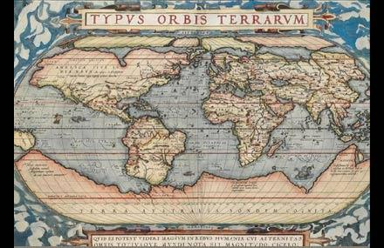
Explain to students that an ocean has no landmarks to use for reference. However, the Earth, the stars and the moon move in predictable and measurable paths. In this lesson we will study navigation tools to better understand the obstacles Europeans faced and how technology helped them overcome these obstacles.
Activity # 1 Early Maps used by Explorers
Step 1: The map of the world shown here was created by Abraham Ortelius in 1574 (Refer to Reflections page 119.) The map was one of the early navigational tools. Refer to Ptolemy’s 1482 map on Reflections page 114.
Step 2: Use Google to search for Mercator 1569 map and other early maps. Go to the Library of Congress and search for early maps of the world after 1492.
Step 3: Using the Map Analysis Worksheet (Handout #2.1, page 12), select one or more of the early maps for students to analyze. What is accurate on the map? What is missing?
Optional: For more work with old maps and the analysis of primary source photos, refer to Analyzing a “Puzzle Piece” of History on pages 26 to 29.
Activity #2 Navigational Tools Catalog
Materials needed: a variety of print catalogs such as Brookstone, Hammacher Schlemer, etc.; For each student, a 3x5 index card (or a sheet of plain white paper cut in quarters); colored pencils (or crayons). For each group of four, a sheet of 9x12 construction paper, glue stick). Reflections Grade 5 textbook (or other similar textbook).
Step 1: Divide students into groups of four. Pass out a variety of catalogs to each group. Have students analyze the format used to advertise products and list what needs to be included, e.g. photo, name of the item, description of the item, an item number, and a price.
Step 2: Have students number from 1 to 4. Assign each number a navigational tool, including a compass, chronometer, an astrolabe, and a sextant.
Step 3: Job-alike groups (students with the same number) read about their navigational tool on Reflections pages 118-119 and conduct research using print and digital sources for navigational tools. Two useful websites include: 8 Tools Used to Navigate the World before GPS http://www.citylab.com/tech/2013/04/7-examples-how-we-used-navigate-world-around-us/5286/ and http://www.cccoe.net/lifeatsea/student/navtools.htm
Step 4: Individual students, with assistance from their job-alike group, write the rough draft of the catalog text for their navigational tool. It should be in sentence format using interesting words to attract the buyer. (Note: Omit the price since it is unknown.)
Step 5: Students return to their home group and peer edit the text for each navigational tool.
Step 6: Students draw their navigational tool or search for a digital photo to add to their 3x5 card. Students write the final version of the text for their navigational tool on the 3x5 card locating it attractively next to the illustration of the tool. (See pg. 25 for an alternative project.)
Step 7: The four students in each group place their 3x5 cards on a 9x12 sheet of construction paper. Using marking pens, ask students to create a border to give the page unity.
Step 8: Post the catalog pages and give each catalog page a number. Create a Voting Sheet that provides space for writing the page number for a catalog. Students vote for most effective advertisement for each navigational tool, the most effective page, and the most artistic page. Sample Rating Sheet:
Catalog of Navigational Tools - A Rating Sheet
Which advertisement is the most effective?
Compass page ___ chronometer page ___
Astrolabe page ____ sextant page ____
Which catalog page is the most effective? page ___
Which catalog is the most artistic? page ___
While students are working on their advertisements, discuss terms such as dead-reckoning and celestial navigation. Ask students to explain how technology helped improve navigation.
Activity #3 Navigational Tools Today
Step 1: Discuss the types of navigational tools used today, e.g., maps, compass, GPS, satellites, computer. Provide students with information about navigational tools developed in the 20th century.
Background Information: A great revolution in navigational occurred in the 20th century when radio signals came into use. The development of radar, loran and radio direction finding during World War ll caused fundamental changes in navigational practice; a mariner or pilot today can turn on a Loran or Global Positional System receiver and determine position and course to within a few yards. Inertial guidance systems, most often used to navigate submarines, aircraft, and spacecraft, allow navigation without contact with a ground base. In such systems, a computer navigates the vehicle with the aid of an inertial navigator devise, which consists of a gyroscope to indicate direction and an accelerator to measure changes in speed and direction. Inertial guidance systems and terrain-following radar allow a cruise missile to fly a thousand miles and hit its designated target. The development of navigation satellites beginning in the 1960s led in the 1990s to the U.S.’s Global Positioning System (GPS), which provides location and other information through the reception and interpretation of signals received from satellites; Russia and China have since created similar navigation systems. GPS receivers, which are now incorporated into smartphones and other devices, have made it possible to create navigation systems for vehicles and other forms of transportation. Source: http://www.infoplease.com/encyclopedia/history/navigation-modern-navigationaltools.html
Step 2: Have students each create an advertisement for one of today’s navigational tools. If desired, create catalog pages as described above in Activity #2.
Handout # 2.1
MAP ANALYSIS WORKSHEET
- TYPE OF MAP (Check one)
______Raised relief map ______Artifact Map ______Satellite photo
______Topographic map ______Military map ______Pictograph
______Political map ______Bird's-eye view ______Weather map
______Contour-line map ______Other
2. UNIQUE PHYSICAL QUALITIES OF THE MAP (Check one or more)
_____ Compass ________Scale _______Notations
_____ Handwritten _______Name of mapmaker _______Legend (key)
______Date ________Title ______Other
3. DATE OF MAP_____________________________________________________
4. CREATOR OF THE MAP_____________________________________________
5. WHERE WAS THE MAP PRODUCED?__________________________________
6. MAP INFORMATION:
A. List three things on this map that you think are important
1.__________________________________________________________________
- _________________________________________________________________
- ______________________________________________________________________________________________________________________________________________________________________________________________________________________________________________________________________________________________________________________________________________________________________________________
B. Why do you think this map was drawn?

_____________________________________________________________________________

C. What information does the map add to the textbook's account of this event?
D. Does the information in this map support or contradict information that you have read about this event? Explain. ________________________________________________________________________________________________________________________________________________________________________________________________________
E. Write a question to the mapmaker that is left unanswered by this map.

Lesson 3: Maps Galore
Essential Question: What European explorers led key expeditions and what routes did they follow?
Materials needed: For each pair of students, a set of colored pencils; and a black and white copy of the maps on Harcourt Reflections page 124 (Handout #3.1), page 131 (Handout # 3.2) and page 139 (Handout #3.3) (Note: This activity can be adapted to other textbooks.)
Activity # 1 Voyages of Exploration
Step 1: Using the map Voyages of Explorations (page 124 in the Reflections textbook or Handout # 3.1, page 14) do this activity together as a guided practice. Have each student use a finger to trace the route of each explorer on the map and identify their claims.
Step 2: Give each student a black and white copy of the Voyages of Exploration map (Handout # 3.1, page 14). Students work with a partner to make a color key. (Note: the colors may vary from those in the textbook.) Using the map on Reflections page 124 as a guide, use a different color for each explorer’s route and record the color on the map key.
Step 3: Each student writes a question that can be answered by the map and then writes the answer to the question, including the main parts of the question. Model a few questions.
- When did ___expedition take place? The _______ expedition took place in _____.
- What areas did ___ explore? ______ explored _______.

Activity #2 Conquistadores in North America
Step 1: Using the Conquistadores in North America map (Reflections page 131 or Handout #3.2, page 15), use a finger to trace the route of each explorer and identify their claims.
Step 2: Write a question that can be answered by the map and then write the compete answer. Students work with a partner to color code the route for each explorer.
Step 3: Each pair meets with another pair. Share your questions and answers. Each foursome selects the best question/answer for their group.
Step 4: Do a “once around” the room having each foursome read their best question and letting the rest of the class answer the question.

Activity #3 Routes of Early Explorers
Step 1: Using the Routes of Early Explorers map (Reflections page 139 or Handout #3.3, page 16), use a finger to trace the route of each explorer on the map and identify their claims.
Step 2: Write a question that can be answered by the map and then write the compete answer. Students work as partners to color code the route for each explorer.
Step 3: Form an In/Out Circle with half of the students on the inside of the circle and the other half forming the outside circle. Project the map on page 139 so it is visible to all students. The person on the inside asks the partner on the outside a question that can be answered by the map. The outside partner answers using a complete sentence. The outside partner then asks a question and the inside partner answers the question in a complete sentence.
Step 4: The inside circle rotates clockwise to get a new partner. Repeat the procedure.

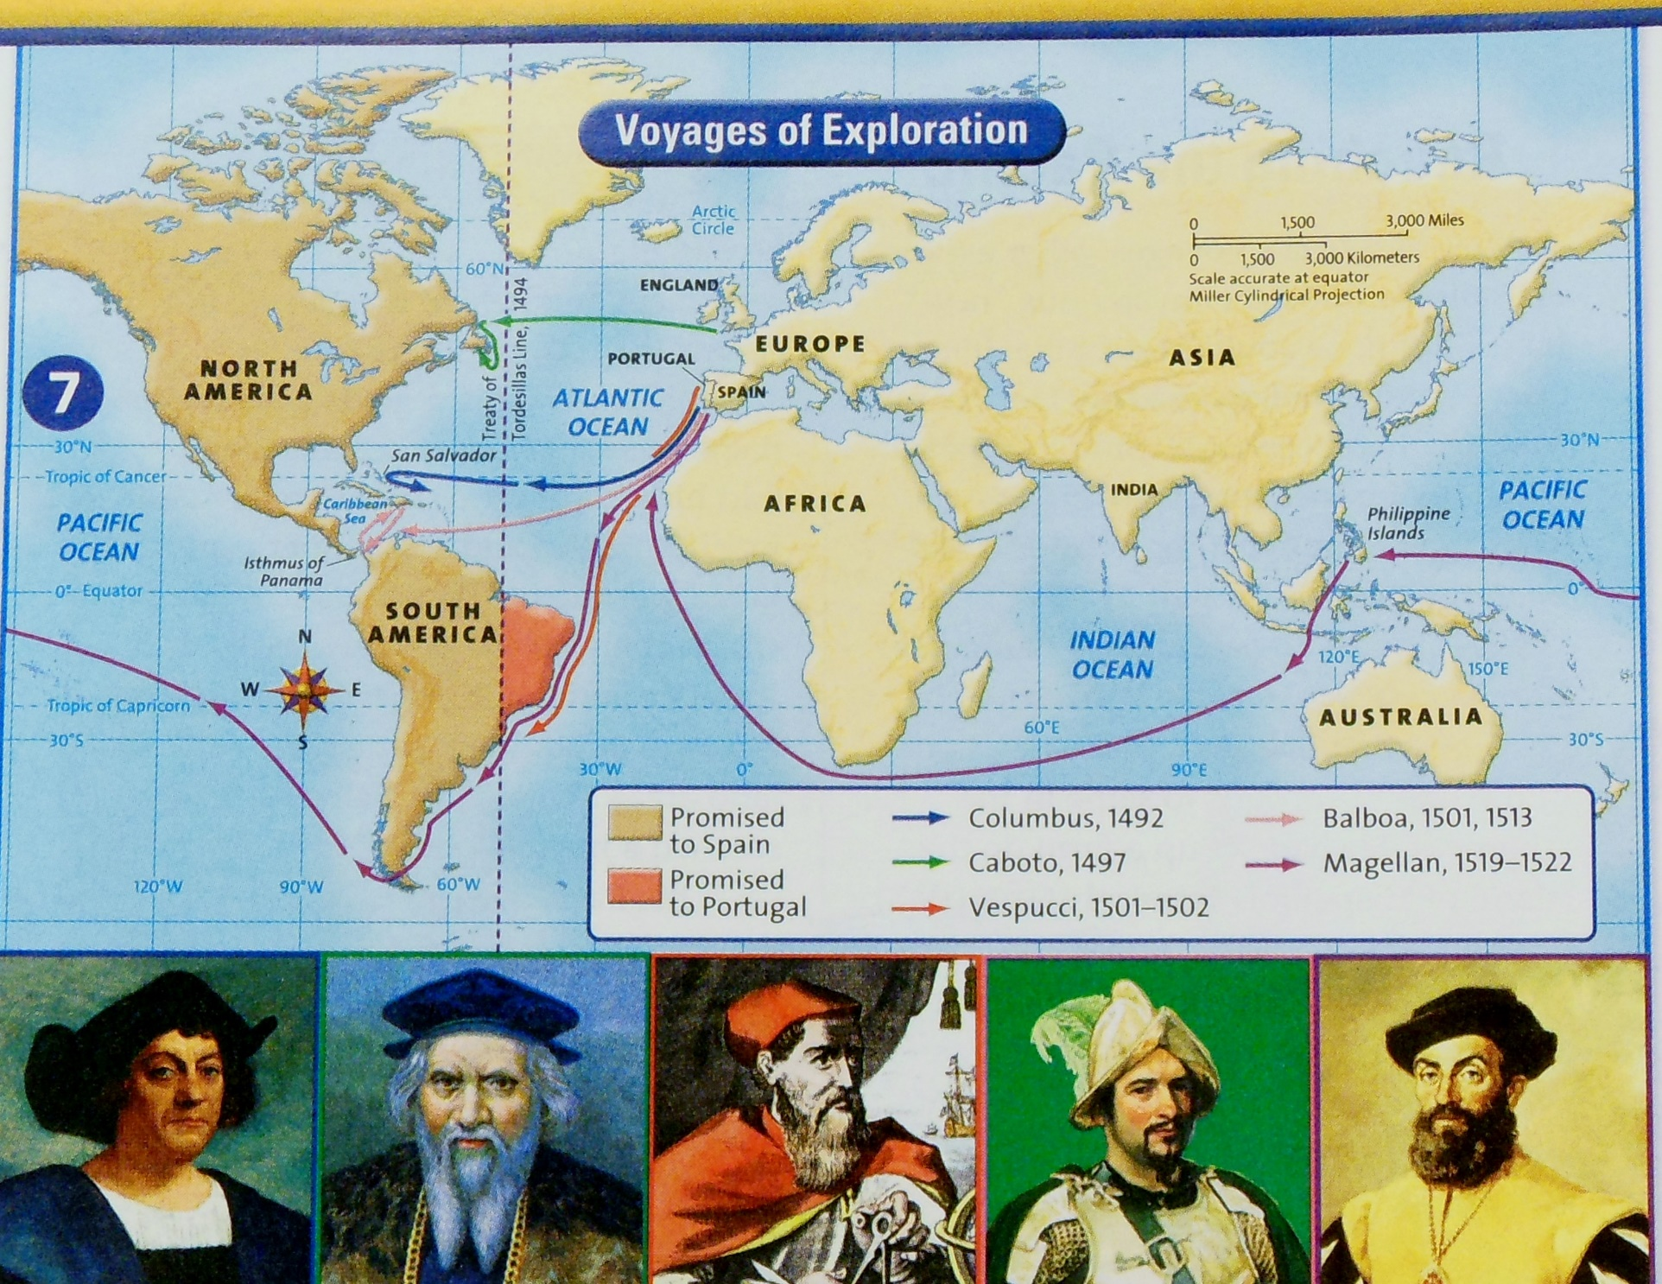
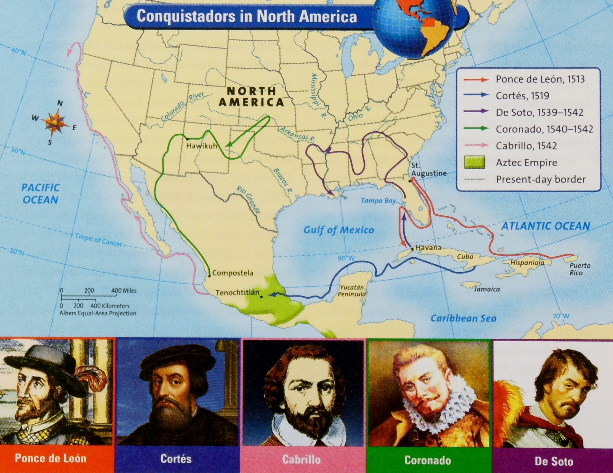
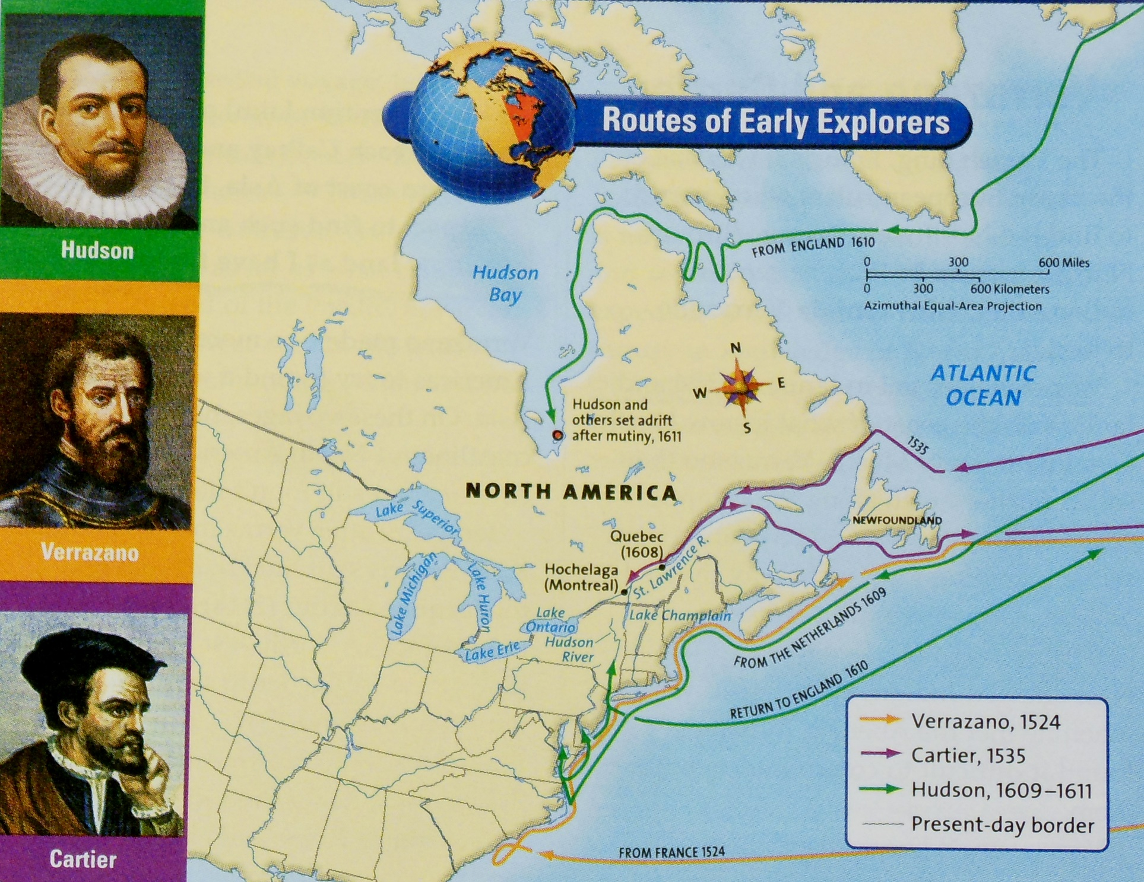

Lesson 4: Explorer Research Project
Essential Question: What were the aims, obstacles and accomplishments of the early explorers of the Americas?
Activity # 1 Research Project on an Explorer of the Americas
Teacher Information: In this lesson, students will individually, or with a partner, conduct a short research project on one of the early explorers of the Americas, using print and digital sources. Fourteen explorers are listed in the chart below, enough for two to three students per explorer. The teacher should decide if students will work with a partner or whether each student will complete his/her own research project. The following chart is to help the teacher organize the project. Refer to the Extended Activities section for more biography ideas.
Explorer | Textbook Pages (Also, use the Biographical Dictionary) | Map | Names of Students in each Research Pair
Marco Polo | 110-111 | Handout #1.1
Columbus | 106-109; 114-117; 126-127 | pg. 124
Cabato | 121 | pg. 124
Balboa | 123 | pg. 124
Magellan | 124 | pg. 124
Vespucci | 122 | pg. 124
Ponce de Leon | 129 | pg. 131
Cortes | 130 | pg. 131
De Soto | 132 | pg. 131
Coronado | 131 | pg. 131
Cabrillo | 131 (map only) See Gr. 4 text | pg. 131
Verrazano | 138,140 | pg. 139
Cartier | 140-141;177 | pg. 139
Hudson | 142-143 | pg. 139
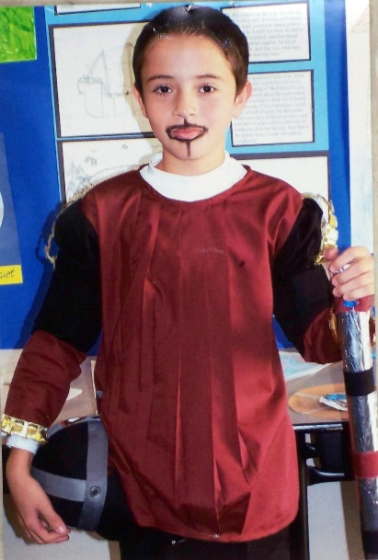
Step 1: Instruct students to write 20 questions they want to answer about their explorer. Discuss and model possible types of questions.
Step 2: Students find their explorer in the Biographical Dictionary on Reflections pages R78 to R85 and add the information to their copy of Early Explorations of the Americas (Handout #1.2, page 8). Remind them to use the complete name and capital letters to begin each name.
Step 3: Students use the Reflections index to locate and read the textbook pages related to their explorer, recording information on the Main Ideas and Supporting Ideas (Handout #1.3) for the sections they read.
Step 4: Assist students as they locate other print and digital resources to use for their report. Show students the proper format to credit their sources.
Ponce de Leon
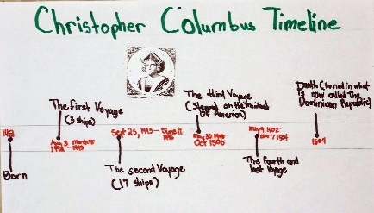
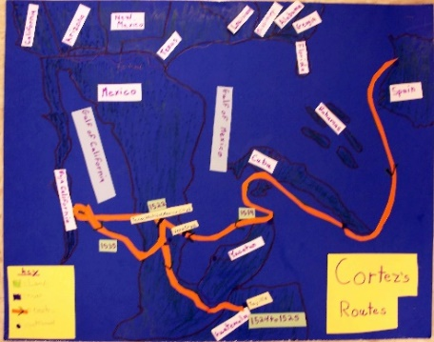
Encourage students to search the Library of Congress website to select portraits of the explorers for their report. Read the section “About this item” to see the date the portrait was created. Note: Most of the portraits were not drawn during the lifetime of the subject which leads to a discussion of primary sources and secondary sources.
Step 7: Draw a map showing the route of your explorer. Write a detailed caption to explain the map.
Christopher Columbus Time Line
Map of Cortez's route
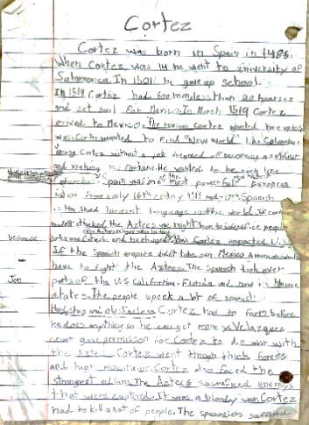
Step 8: Draw a time line for your explorer with at least 5 major events and a brief description of each event. If possible, include a hand-drawn portrait or a digital drawing of the explorer.
Rough draft of Cortez Report.
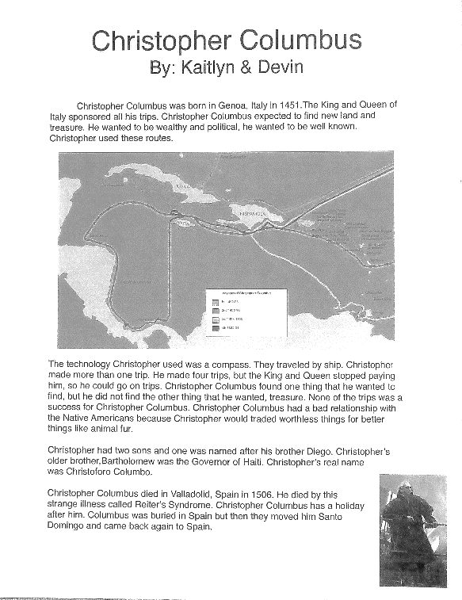
Step 9: Conduct a short research project on an explorer that uses several print and digital resources to build knowledge through investigation of different aspects of the topic.
Christopher Columbus report written by 2 students with a map and digital sources.
Include the explorer’s full name, sponsor country, year(s), aims, accomplishments, and obstacles/failures; a map to show major routes taken by the explorer (Step 7); and a time line for the explorer with at least 5 significant events (Step 8).
In your report, you will get extra points for using key vocabulary words: explorer, technology, navigation, expedition, entrepreneur, conquistador, mutiny, or the names of any navigational tools.
Refer to Explorer Project (Handout # 4.1, page 20) for a scoring rubric.
While students are working on their reports, you can use the following from Reflections: Distinguish Fact from Opinion, pages 136-137; Homework & Practice Book Skills: Distinguish Fact from Opinion, page 28. Have students write 2-3 fact versus opinion statements about their explorer.); Homework & Practice Book page 26 (Includes first person accounts for Balboa, Cabato, Magellan, Vespucci.) Have students create quotes for their explorer.
Activity # 2 Presenting Your Research Project
Step 1: Create a sequencing chart to show the parts of your oral presentation.

Once research has been completed, students integrate information from several texts on the same topic in order to speak about the subject knowledgeably. Students report on the topic, sequencing ideas logically and using appropriate facts and relevant details, and descriptive details to support the main ideas or themes. Student should speak clearly at an understandable pace.
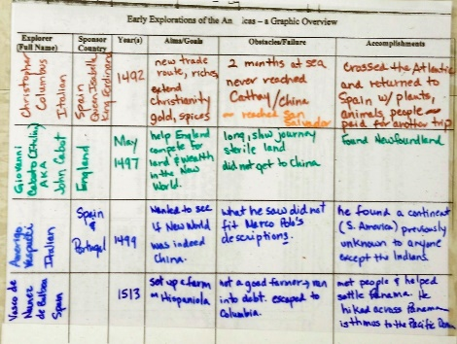
As students present their explorer research, including the explorer’s full name, sponsor country, year(s), aims, accomplishments, and obstacles/failures, their classmates take notes and add appropriate information on their copy of the Early Explorations of the Americas (Handout #1.2).
Students also present their map showing major routes taken by the explorer and a time line for the explorer with at least 5 significant events.
Give extra points for students who use key vocabulary words: explorer, technology, navigation, expedition, entrepreneur, conquistador, mutiny, or the names of any navigational tools.
Early Explorers of the Americas chart
Optional projects:
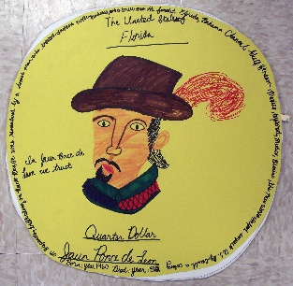
- Design a stamp or coin that honors an explorer.
- Design a book cover for a biography of your explorer. Use the facts about the person to create a design that represents the person’s life. Be sure to include the title of the book.
- Use the Wixie (Chrome) or Pixie (Apple) program to make playing cards (like baseball cards) for their explorer. Put the graphic on one side and some basic facts on the other side. Trade like baseball cards.
- With Google Docs (or Pages for Mac Books), use the presentation application to create a presentation about your explorer. Open a new presentation document; select a theme (Explorer of the Americas); insert a title into the presentation; insert a subtitle into the presentation, insert a bulleted list into the presentation; insert an image; insert a caption; change the size of the font within the presentation; create a new slide; view the presentation as a slide show; download the presentation in different formats.

Handout #4.1 Explorer Project
Prompt: Using print and digital resources, write a short research report with the explorer’s full name, sponsor country, year(s), aims, accomplishments, obstacles/failures. Include a map to show major routes taken by the explorer and a time line with at least 5 key events. In your report, you will get extra points for using key vocabulary words: explorer, technology, navigation, expedition, entrepreneur, conquistador, mutiny, or any navigational tools.
INDICATORS | ADVANCED | PROFICIENT | BASIC | BELOW BASIC
KNOWLEDGE OF  HISTORICALLY ACCURATE  CONTENT | Student demonstrates an in-depth understanding of the historical content; all main ideas are supported by facts with no obvious inaccurate facts; contains substantial supportive evidence. | Student demonstrates a clear understanding of the historical content; all main ideas are supported by facts; contains no obvious inaccurate facts; would be improved with more evidence. | Student demonstrates a limited understanding of the historical content; most main ideas are supported by facts, no obvious inaccurate facts; would be improved with more evidence. | Student demonstrates little understanding of the historical content; facts may be inaccurate; lacks supportive evidence.
KNOWLEDGE OF CHRONOLOGICAL THINKING | Student correctly places key events and/or people of the historical era they are studying into a chronological sequence and explain in-depth the significance of the events. | Student correctly places key events and/or people of the historical era they are studying into a chronological sequence and explain the significance of the events. | Student correctly places a few key events and/or people of the historical era they are studying into a chronological sequence and/or provides limited significance of events. | Student fails to correctly place key events and/or people of the historical era they are studying into a chronological sequence and/or provides no significance of events.
KNOWLEDGE OF GEOGRAPHIC  CONTENT and  SPATIAL THINKING | Student demonstrates an in-depth understanding of the geographic content and spatial thinking. | Student demonstrates a clear understanding of the geographic content and spatial thinking. | Student demonstrates a limited understanding of the geographic content and spatial thinking. | Student demonstrates little understanding of the geographic content and spatial thinking.
USES ACADEMIC LANGUAGE ACCORDING TO HISTORY CONTENT | Student shows a deep understanding of historical language that is woven in an interesting way whether written or oral. | Student shows an effective use of historical language that is woven in an interesting way whether written or oral. | Student shows a limited use of historical language whether written or oral. | Student shows little or no use of historical language whether written or oral.
Extended Activities
Sentence Extension (or Expansion) This is a quick activity designed to build fluency.
Step 1: Write a short phrase on the board. Use words from the explorer’s unit such as “Vasco da Gama explored.”
Step 2: Ask questions using the 5 W’s, such as, “From where did the explorer sail?” “For what country did he sail?” “When did he sail?” “Where did he go?” Do this one step at a time. To clarify this activity, model and expand a simple sentence.
- Vasco da Gama explored (to where?)
- Vasco da Gama explored the coast of Africa (from where?)
- Vasco da Gama left Portugal and explored the coast of Africa (when?)
- Vasco da Gama left Portugal in 1497 and explored the coast of Africa (why?)
- Vasco da Gama left Portugal in 1497 and explored the coast of Africa in search of a faster route to India.
Hint: Begin with simple sentence patterns such as noun/verb, noun/verb/adverb, or noun/linking verb/adjective. Sentence frames provide useful aids for grammar and syntax.
Encourage students to use their social studies textbook or other references to ensure historical accuracy. It is important to take time to model sentence extension. Work on one skill at a time. For example, focus on the use of adverbs. Brainstorm words that describe how the explorer sailed. (The ship sailed furiously.) Then use adjectives to describe the subject (The adventurous Spanish explorers…) Add prepositional phrases to tell when (in 1543) or where (to San Sebastian).
Step 3: Conclude the sentence extension activity by having each student write and then share a sentence with group members who in turn select one of the sentences to share with the entire class.
As a variation, have students model and practice using the focus words in different parts of the sentence such as at the beginning, in the middle or at the end of the sentence.
- The exploration of the California coast began with Cabrillo.
- The Spanish exploration of California began with Cabrillo.
- Finally, in 1543, the Spanish began an exploration of California.
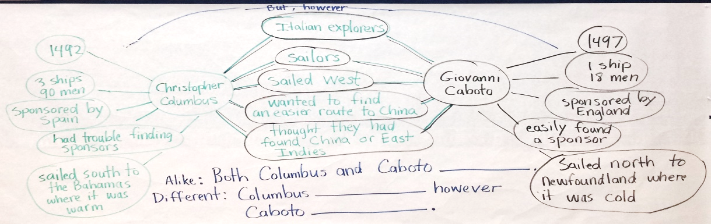
Double Bubble with Sentence Frames Write compare and contrast sentences using a “double bubble” format as shown at the right.

Biography Project

Biography: ________________ Student Name: ____________

These items must be completed by each student:

- Read a biography about your chosen historic character. You may also digital sources, reference books, or an additional biography about the same person. Take notes.
- Draw a map and label important places in your character’s life.
- Create a timeline with at least 8 significant events in your character’s life.
- Locate a photograph or drawing of your character and include a copy.
- Make an illustrated folder for your research notes, map, timeline, photograph, and any other material you would like to include.
- Pretend you are your character as you wear a hat (or entire outfit) that your person would wear. Orally tell the class about “yourself” using first person narrative. The presentation should be at least one minute long.

Choose at least one of the following activities:
- Write a play in which important events in your character’s life are told.
- Write a conversation between two people about your character.
- Make a puppet that represents your character and have it talk to the class.
- Write a song or poem about your character.
- Create a scrapbook for your character that contains key items from his or her life.
- Design a dollar bill with pictures of things from your character’s life and your character at the center.

Project due date: ___________________________

Adapted from Angela Whitaker, Beaumont Unified School District
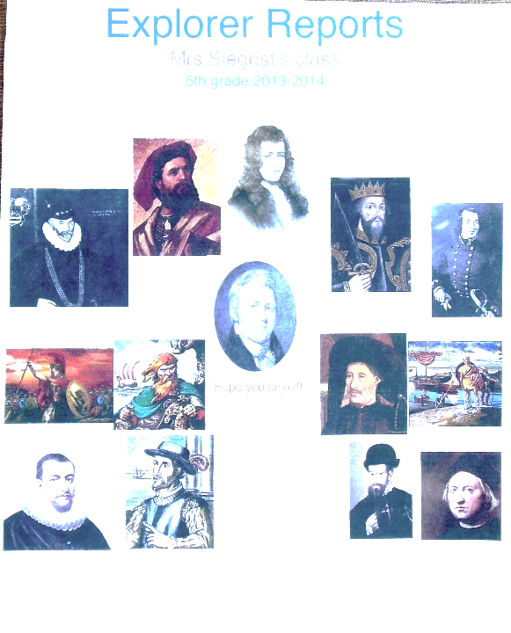
Making Biographies Come ALIVE in the Classroom – More Ideas
High quality biographies provide excellent models for student writing. Identify information pertaining to the context, the setting, and the vocabulary that students need to understand to successfully read a biography.
- Introduce biographies as a genre.
- Begin with a book. As students listen to a biography read aloud, ask them to be thinking what makes the person special and what makes their story worth telling. Differentiate between fact and fiction and between primary and secondary sources.
- During a second read, ask students to expand their thinking to include what risks or problems were taken and what were the person’s accomplishments or solutions to the problem. Pull out the juicy details from the story. Chart their responses and post this in the classroom. This is a good time to share primary source documents – compare with illustrations in book.
Cover page for the Explorer Reports written by Laurie Siegrist's class at Cielo Vista School, Palm Springs Unified School District.
- Student chooses a biography to read. Refer to the list of names mentioned in the Grade 5 Standards for History-Social Science on page 24.
- Conduct a Famous Person Tea. Students mingle with each other in costume, talk in the first person and make connections through their conversations.

“What if” a different decision were made?
Myra Zarnowski recommends a questioning approach. “What if?” Determine the turning points in a life story – the times when a person made a decision that affected the rest of his or her life. Once we know the decisions, we can ask “what if” a different decision were made. History is not a one-way street timeline that leads from the past to the present with only one possible route. It is not a linear, tightly packed, one-way narrative. We know how things turned out and we lose sight of the fact that it didn’t have to turn out as it did. (Historians refer to hindsight bias.)
Explorer Chart Bulletin Board
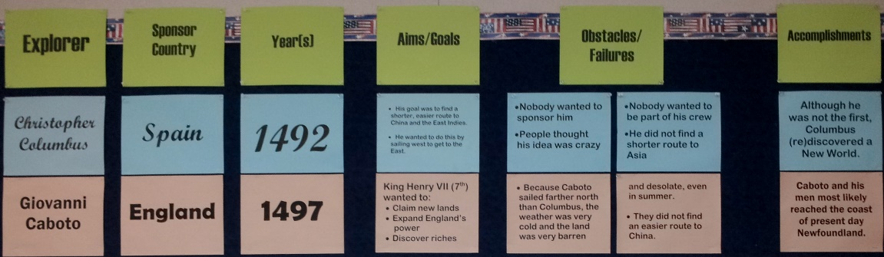
As each explorer is studied, add information on to a bulletin board version of the chart.

List of People Mentioned in Grade 5 History-Social Science Standards
Students select an historical character to research. When a specific standard is studied, students present their research to the class.

Columbus, Christopher |  |  |  | 5.2.1
Coronado, Francisco de Vasquez |  |  |  | 5.2.1
Marshall, John |  |  |  | 5.3.6
Jackson, Andrew |  |  |  | 5.3.6
Chief Tecumseh |  |  |  | 5.3.6
Chief Logan |  |  |  | 5.3.6
Chief John Ross |  |  |  | 5.3.6
Sequoyah |  |  |  | 5.3.6
Smith, John |  |  |  | 5.4.2
Williams, Roger |  |  |  | 5.4.2
Penn, William |  |  |  | 5.4.2
Lord Baltimore |  |  |  | 5.4.2
Bradford, William |  |  |  | 5.4.2
Winthrop, John |  |  |  | 5.4.2
King George III |  |  |  | 5.5.4
Henry, Patrick |  |  |  | 5.5.4
Jefferson, Thomas |  |  |  | 5.5.4
Washington, George |  |  |  | 5.5.4
Franklin, Benjamin |  |  |  | 5.5.4
Adams, John |  |  |  | 5.5.4
Lafayette, Marquis de |  |  |  | 5.6.2
Kosciuszko, Tadeusz |  |  |  | 5.6.2
von Steuben, Baron Frederich |  |  |  | 5.6.2
Adams, Abigail |  |  |  | 5.6.3
Washington, Martha |  |  |  | 5.6.3
Pitcher, Molly |  |  |  | 5.6.3
Wheatley, Phillis |  |  |  | 5.6.3
Warren, Mercy Otis |  |  |  | 5.6.3
Lewis, Meriwether |  |  |  | 5.8.3
Clark, William |  |  |  | 5.8.3
Pike, Zebulon |  |  |  | 5.8.3

Technology Brochure
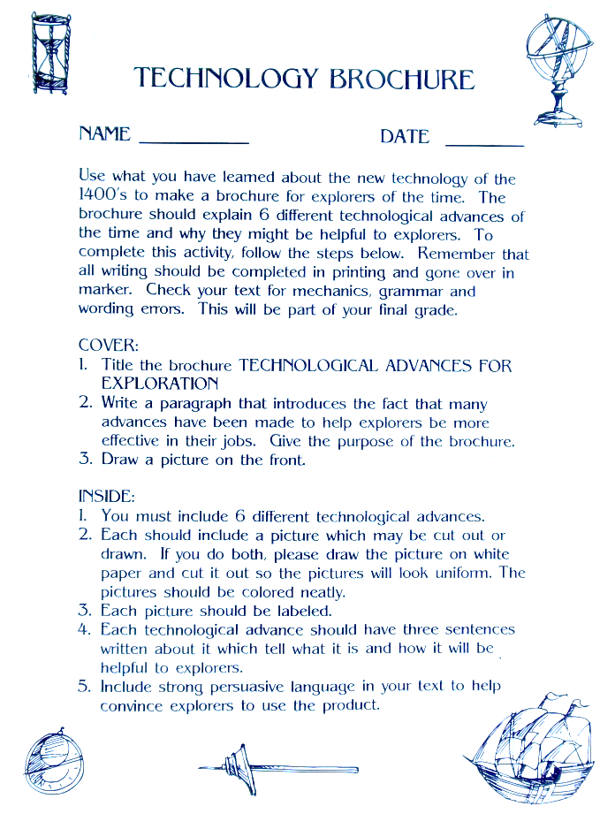
Use what you have learned about the new technology of the 1400’s to make a brochure for explorers of the time. The brochure should explain 6 different technological advances of the time and why they might be helpful to explorers.
Cover
Title the brochure “TECHNOLOGICAL ADVANCES FOR EXPLORATION”. Write a paragraph that introduces the fact that many advances have been made to help explorers be more effective in their jobs. Give the purpose of the brochure. Draw a picture on the front.
Inside
You must include 6 different technological advances. Each should include a picture which may be cut out or drawn. If you do both, please draw the picture on white paper, and cut it out so the pictures will look uniform. The picture should be colored neatly. Each picture should be labeled. Each technological advance should have three sentences written about it which tell what it is and how it will be helpful to explorers. Include strong persuasive language in your text to help convince explorers to use the product.
(Courtesy Ms. Frick, Garretson School, Corono-Norco School District.)

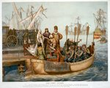
Analyzing a “Puzzle Piece” of History
The following activity works well with a photograph, a painting, or a lithograph. In this case, the lithograph shows Christopher Columbus bidding farewell to the Queen of Spain on his departure for the New World on August 3, 1492.
Materials needed: a copy of the lithograph The First Voyage, from the Library of Congress website (L. Prang & Co., 1893). Go to http://www.loc.gov/pictures/item/91721172/ and print a copy for each group of 3 students to analyze. In advance, cut the lithograph into 3 puzzle pieces. Label the back of each piece A1, A2, A3 respectively. For the next group of 3, label the pieces as B1, B2, B3. Continue until all students have a labeled puzzle piece. It is important to remember that each lithograph should be cut to no more than 3 pieces. This is helpful when students work in a group to put their puzzle pieces together.
A copy for each student of Analyzing a Puzzle Piece of History (Handout # EA1, page 28) and for each group of 3 students, a copy of Analyzing Photographs, Prints, Portraits (Handout # EA2, page 29).
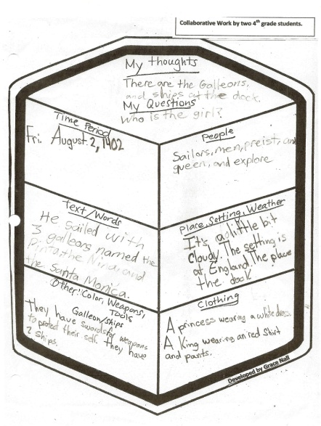
Step 1: Divide students into groups of 3 and provide each group with a copy of the lithograph cut into 3 pieces as described above.

Explain to students that historians find artifacts which can be in pieces or as a whole. Using the Analyzing a “Puzzle Piece” of History (Handout #EA1, page 28), give each student within the group of 3 a different “puzzle piece” to use to complete the handout.
Step 2: When the “Puzzle Piece” handout is complete, have students share their observations. Next, students assemble the 3 puzzle pieces into a “bigger picture” and discuss the results and complete the top half of Analyzing Photographs, Prints, Portraits (Handout # EA2, page 29). Each group shares their analysis with the class. As an alternative, the bottom section of Handout # EA2 may be used. Other photo analysis worksheets are available at http://www.archives.gov/education/lessons/worksheets/photo_analysis_worksheet.pdf
When using a primary source, it is advisable to remind students that the sources “reflect attitudes from the time when they were created, and that beliefs and values, as well as commonly-accepted ways of expressing them, may have changed.”

If access to the internet is available, show students how to navigate through the Library of Congress website and find the “kids and parents” section. Select portraits of the explorers for their exploration project in Lesson 4. Read the section “About this item” to see the date the portrait was created.
Background Information: A primary source is a document or physical object which was written or created during the time under study. Some types of primary sources include original documents (diaries, letters, official records, eyewitness accounts, oral histories), artifacts (maps, pottery, clothing, architecture) and creative arts (photographs, art, music, poetry).
Examples of secondary sources include a history textbook, an encyclopedia, a book about an event. It was common in the 1800s for artists to create lithographs, engravings, drawings and portraits of earlier time periods. Most of the portraits were not drawn during the lifetime of the subject. Sometimes the only documents relating to an event or person were written decades or centuries later. This can lead to a discussion of primary sources and secondary sources.
Viewing a primary source should be regarded as a starting point for discussion and not as a conclusive interpretation. It is also important to consider the artist's intentions for making a painting or photograph of a particular subject. Finally, the historical and social context in which a painting or photograph was made must also be carefully considered.

Step 3: Sorting Sources into Chronological Order
Sorting primary and secondary sources into chronological order can further enhance content knowledge. Students notice details that help to reinforce their understanding. Some print sources to consider are the following from the Library of Congress:
- Waldseemuller, World Map of the Americas in 1507
- Portrait of Amerigo Vespucci (This portrait can be helpful to students in identifying Vespucci in the Waldseemuller map)
- Picture- Discovery of the American Continent by Americus
- Picture-Discovery of the Mississippi: By Ferdinand De Soto, and his followers, May 1541
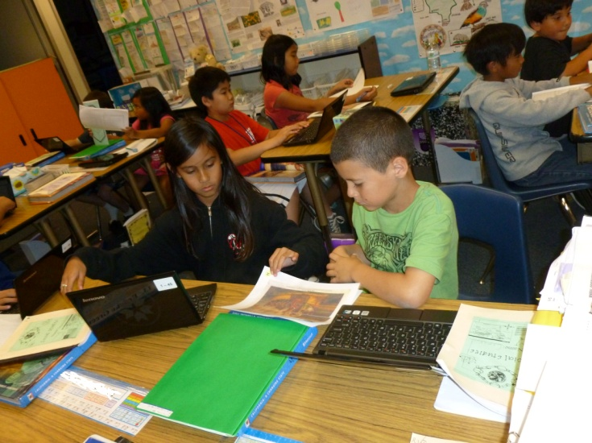
Begin this activity as a whole class. If you do not already have large classroom time line, prepare a long sheet of white butcher paper or several sentence strips taped side-by-side and show students how this will be used as a timeline. Discuss a “range” of dates for the timeline. Next, give students two sizes of yellow post-it notes: medium or large size for labeling the 14th Century, 15th Century, 16th Century and the mini size for 1410, 1420, etc. for each of the decades. Have students place the post-it notes on the time line spacing them accordingly.
In small groups, have students find the dates on the prints or by viewing each picture on the Library of Congress website. Then, for each picture, have students write the date on an index card.
Show the index cards with the dates and have students place them on the time line. Then, have the students identify the prints matching the dates on the timeline.
This activity is based on the work of Grace Nall, San Diego Unified School District.
Handout # EA1
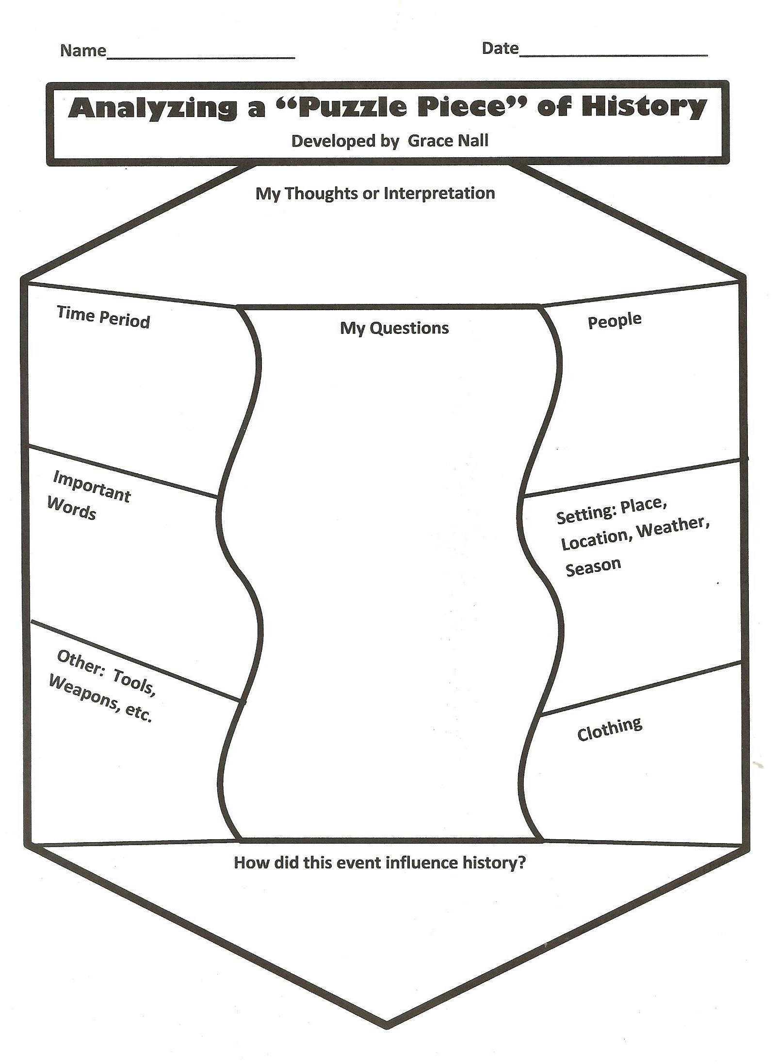
Handout #EA2
Analyzing Photographs, Prints, Portraits
Observe | Reflect | Question and Thoughts
What do you see?  What do you notice first?  How is the text or information arranged in this puzzle piece?  Describe anything about the puzzle piece that looks familiar, strange, or unfamiliar.  Context Clues? Details?  -Time Period  -Text/Words  -People  -Setting, place, weather  -Clothing  -Other: Galleon/ships, weapons, tools, color | What is happening in this image? Why do you think this image was made? | What do you wonder about?  Who?  What?  When?  Where?  Why?  How?
What do you want to know more about?

As an alternative, try the following Photo Analysis Guide from Tally, 1997.
Observation | Knowledge | Interpretation
Describe exactly what you see in the photo.  What people and objects are shown?  How are they arranged?  What is the physical setting?  What other details do you see? | Summarize what you already know about the situation and time period shown, and the people and objects that appear. | Say what you conclude from what you see.  What’s going on in the picture?  Who are the people and what are they doing?  What might be the function of the objects?  What can we conclude about the time period?
Further Research What questions has the photo raised? What are some sources I can use to find answers?
Resources for Explorations of the Americas

Aronson, Marc & Glenn, John W. The World Made New: Why the Age of Exploration Happened and How It Changed the World. Washington D.C.: National Geographic Society, 2007. Richly illustrated with specially commissioned maps, colorful paintings, archival prints, and informative time lines, the text addresses the causes, what happened, and the consequences of the explorations of Columbus and the European explorers.

Aronson, Steven M. L. Explorers. FANDEX Family Field Guides. New York: Workman Pub., 1999. Print. (A series of explorer information cards assembled together like a fan.)

Columbus, Christopher. The Log of Christopher Columbus: The First Voyage - Spring, Summer and Fall 1492. Robert Sabuda, illustrator. New York: Philomel Books, 1992. Print. Christopher Columbus’s own words reveal the disappointments and wonders of discovery.

Conrad, Pam. Pedro's Journal. New York, N.Y.: Scholastic Teaching Resources, 2003. Print. Pedro is a ship’s boy aboard Christopher Columbus’ Santa Maria. The journal covers August 3, 1492 to February 14, 1493. Easy-read, 81 pages.

Copeland, Peter F. Exploration of North America Coloring Book (Dover History Coloring Book). Dover Publications. 1992. Realistically rendered line drawings with lots of information.

Greenway, Shirley. Exploration of North American. Great Explorers Series. Barrons Educational. 1998.

Maestro, Betsy. Exploration and Conquest: The Americas After Columbus: 1500-1620 (American Story). New York: Harper Collins, 1994. Columbus was not the first to discover the Americas, but his voyages led to European exploration of the New World. This book details the conquest of the Americas beginning with Columbus.

Maestro, Betsy, and Giulio Maestro. The Discovery of the Americas: From Prehistory through the Age of Columbus. New York: Mulberry Paperback, 1991. Print. From the Stone Age through the 16th century, America was “discovered” again and again.

Menard, Valerie. Alvar Nunez Cabeza de Vaca. Bear, Del.: Mitchell Lane Publishers, 2003. Print. Biography (Latinos in American History series).

O'Donnell, Kerri. Explorers in North America: Solving Addition and Subtraction Problems Using Timelines. New York: Rosen Publishing Group, 2004. Print. The book uses timelines to show the history of exploration in North America from the Vikings to Lewis and Clark.

Taylor-Butler, Christine. Explorers of North America (True Books: American History). New York: Children’s Press. 2008. Print.

Whiting, Jim. Francisco Vasquez de Coronado. Bear, Delaware: Mitchell Lane Publishers, 2003. Print. Biography (Latinos in American History series).

Whiting, Jim & Garcia, Kimberly. Hernando de Soto. Bear, Delaware: Mitchell Lane Publishers, Print. Biography (Latinos in American History series).

Whiting, Jim. Juan Ponce de Leon. Bear, Delaware: Mitchell Lane Publishers, 2003. Print. Biography (Latinos in American History series).

Yolan, Jane. Encounter. Illustrations by David Shannon. Harcourt Publishers. 1992. The story of the first meeting with Columbus as told through the eyes of a Taino boy.

Websites to Explore:
http://www.cccoe.net/lifeatsea/student/navtools.htm
http://www.citylab.com/tech/2013/04/7-examples-how-we-used-navigate-world-around-us/5286/ 8 Tools Used to Navigate the World before GPS.

http://ageofex.marinersmuseum.org/index.php?page=tools From the Mariners’ Museum. The stories of explorers and their quest for new trade routes, the discovery of gold, or adventure have captivated people around the world. Learn more about the famous and the not so famous explorers.

http://www.archives.gov/education/lessons/worksheets/photo_analysis_worksheet.pdf

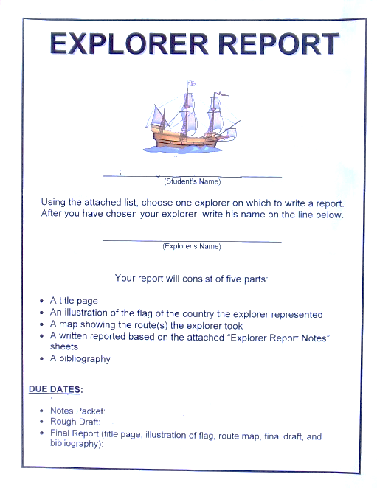
Teacher Evaluation Form

Dear Teacher:
We hope that you enjoyed this curriculum guide! We’d like to hear from you about what worked for your class and what did not. What would you like to see changed? Please take a minute to fill out this form and mail or email it to the address below. Thank you for your time.

- Which parts of the Teacher Guide did you find the most useful? (Check all that apply.)
____ Lesson Activities _____Background Information
____ Handouts _____Extended Activities
____ Connection to Standards _____Resources

- What should be added in future guides?

- What should be deleted in future guides?

- Will you keep this guide for future reference? Pass it to another teacher?

- Did the guide meet your expectations? Suggestions for improvement are welcome.

- Which grades would most benefit from this guide?

(Optional) Your Name:

Email Address:

Grades you teach: Subjects:

School Name and District

We appreciate your opinions. Please return this form to:
Dr. Priscilla H. Porter
Palm Desert Campus
California State University San Bernardino
37-500 Cook Street
Palm Desert, California 92211
prisporter@aol.com

