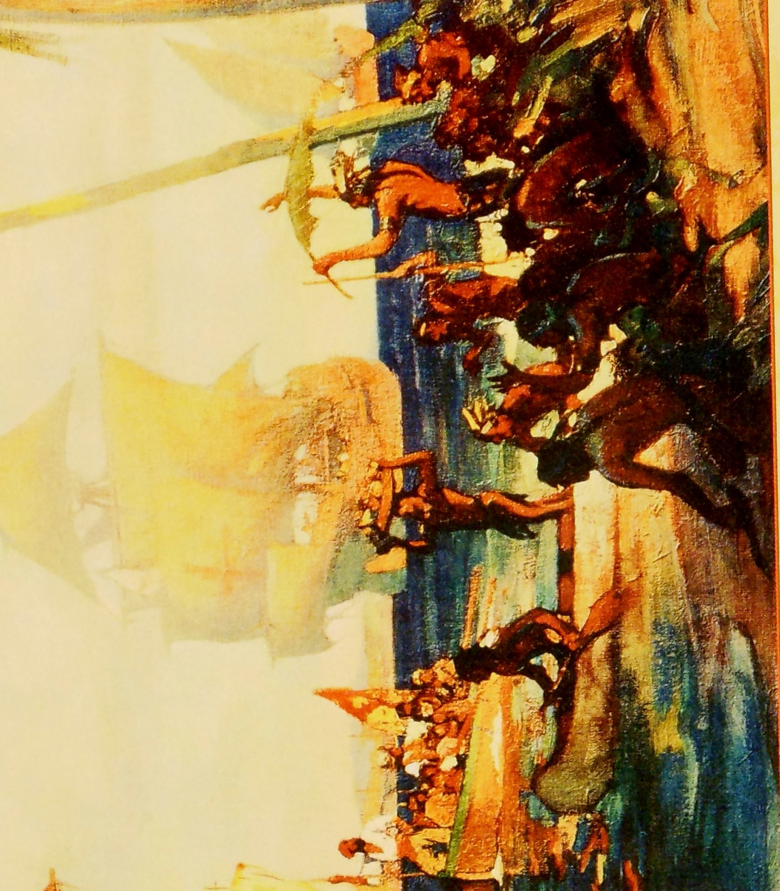

**Porter History-Social Science Resource Center**

**Palm Desert Campus**

**California State University, San Bernardino**

**Early Explorations**

**of the Americas**