CSUSB Risk Assessment: Generic
This risk assessment template helps employees responsible for staff and/or programs assess, plan, and implement measures to control risks, as well as evaluate its effectiveness. Campus units are responsible for conducting risk assessments and incorporating appropriate mitigation steps when hazards are identified. On occasion there are no specified policies and procedures or trainings which outline how to prevent injury or illness. Therefore, it is up to the Department or Program to not only consider the various types of hazards that may be encountered but to also identify safety controls to reduce them. Risk Management strongly recommends all campus units use this template as a guide and is available for consultation if assistance is needed.

Instructions

- Provide a brief description of the program and context for this assessment:

- Complete Generic Risk Assessment Table 1.1 in its entirety. Use as many of the worksheets as needed.
  - Activity Type: What are the activities involved in your learning site?
  - Identify Hazard: What are the hazards associated with the activity listed?
Hazards can be Environmental (Heat, Fire, Noise)
Physical (Heights, Moving Parts, Office work, patient care)
Specific to the program – (weapons, minors)
Biological/Chemical – (Infectious Disease, Allergens, Access to Drugs, Food Consumption)
  - Safety Controls: Choose safety control methods that can reduce the hazard. Safety controls are discussed extensively below on page 3.
  - Responsible Person: Identify the person who is responsible for implementing the control and/or spot checking it at the event.

Safety Controls
It will not always be possible to eliminate risks, but it is expected that an assessment is conducted to identify the elimination, substitution and engineering safety controls whenever possible.
The best time to consider security methods is in the design of the worksite or program. Redesign offers the best way to design out hazards in the planning or construction phase. The National Institute for Occupational Health & Safety’s (NIOSH) Prevention through Design (PtD) program highlights design as the most effective tool to address safety hazards, followed by the Hierarchy of Controls which allows safety measures to be classified as most to least effective.
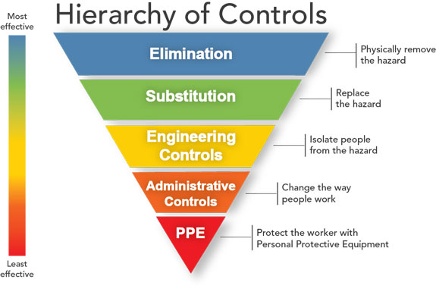

Hierarchy of Controls

Elimination: Preventing access to the hazard such as rescheduling or physically removing the hazard
Substitution: Replacing the materials, machinery, or process for less hazardous ones
Engineering Controls: Designs that reduce exposure to risk: fume hood, fall protection, lifting device, controlled space
Administrative Controls: Training sessions, procedures,
Personal Protective Equipment (PPE): Providing personal protective equipment (PPE) and ensuring workers wear it

Table 1.1 - Generic Risk Assessment

- Activity Type  Example: Counseling Children | - Identify Hazard  Example: Infectious Disease | C. Safety Controls  Example: Vaccine or weekly testing & face covering | - Responsible Person  Student Name and Field Supervisor

Table 1.1 - Generic Risk Assessment

- Activity Type  Example: Counseling Children | - Identify Hazard  Example: Infectious Disease | C. Safety Controls  Example: Vaccine or weekly testing & face covering | - Responsible Person  Student Name and Field Supervisor

