Authoring Accessible PowerPoint Presentations
Create Good Structure
- Use predesignated slide templates:

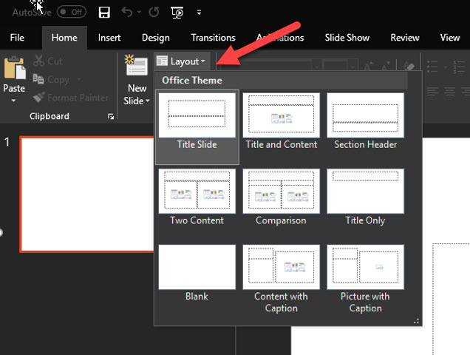

- Do NOT use text boxes for written content
- Use a unique heading title for every slide
- Ensure fonts are easy to read andare of a good size (12 pt. or better)
- Utilize the Outline View to ensure that your slides are logically sequenced and that slide titles are meaningful:

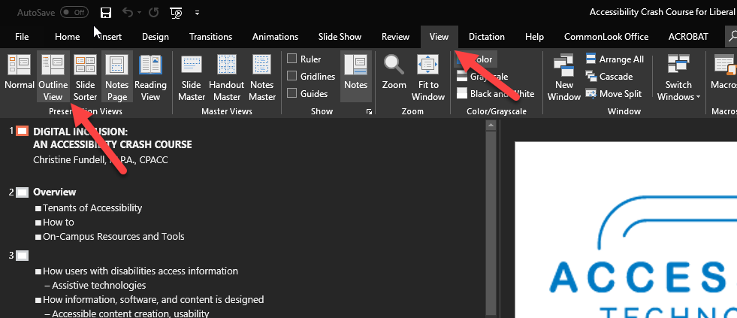

Images
- Include alternative text for images. There are two ways to do so, depending on your version of Office. Option 1:
    - Right-Click on Picture and select “Edit Alt Text”
    - For informational images, enter a succinct explanation in the “Description” field (screen readers ignore alt text of more than 125 characters).

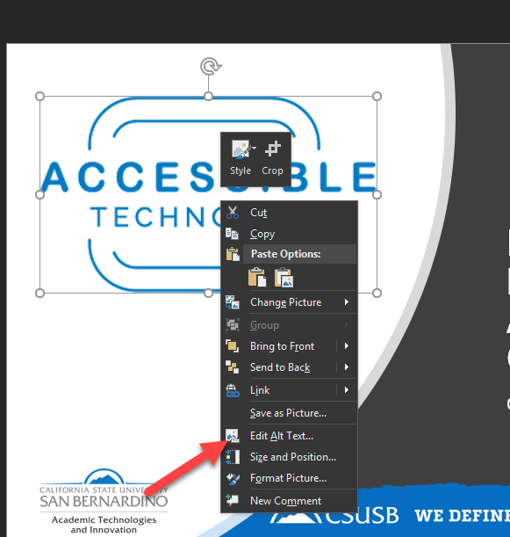

Option 2:
- Right click on the image and select FORMAT PICTURE to reveal the pane on the right side of the document.
- Select LAYOUT PROPERTIES to reveal the ALT TEXT pane.
- For informational images, enter a succinct explanation in the “Description” field (screen readers ignore alt text of more than 125 characters). Ignore the “Title” field.

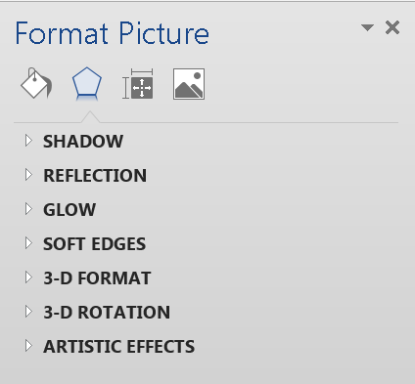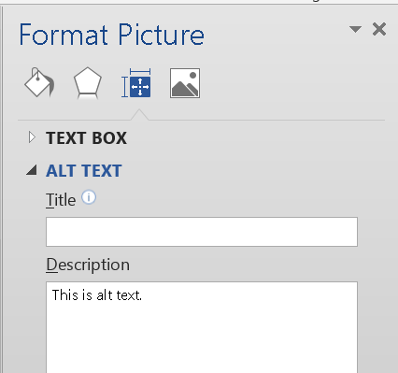

- Insert charts, graphs, and tables using the insert menus or appropriate slide layout.
- Include extended descriptions for charts and other graphics intended to convey information.

Content
- Avoid using text boxes that aren’t part of a pre-defined template
- Text will be read by screen readers in the order created regardless of the order that it appears on screen.
- Ensure good color contrast between text and background.

