Business Process Guide

For Cherwell Accounting Forms

**Table of Contents**

**Customer Access and Request Creation**

1. Journal Entry Request………………………………………………………………….2

2. Chargeback Request……………………………………………………………………4

3. Invoice Request…………………………………………………………………………6

**Customer Confirmation**

1. Customer Status Portal……………………………………………………………….10

2. Emails…………………………………………………………………………..…...….11

3. Sample Emails…………………………………………………………………………13

**Customer Access and Request Creation**

**1. Journal Entry Request**

<https://csusb.cherwellondemand.com/CherwellPortal/Accounting/One-step/JournalEntryRequest>

Journal Entry Request can be used for transfer of expenses or funds, adjustment to various accounting lines, record deposits or change to salary and benefits.

Once you enter the link, your contact information will automatically be populated and you can proceed to fill out the requested information.

Please specify:

1. The Request Type – Indicate the purpose of your request (ex. Transfer of Expense, Adjustment, Deposits, etc.)
2. Business Unit – Specify the business unit the request will affect
3. Email of Person or Department Charged
4. Email to Approver – optional
5. Justification of Transfer – Long description for the transaction

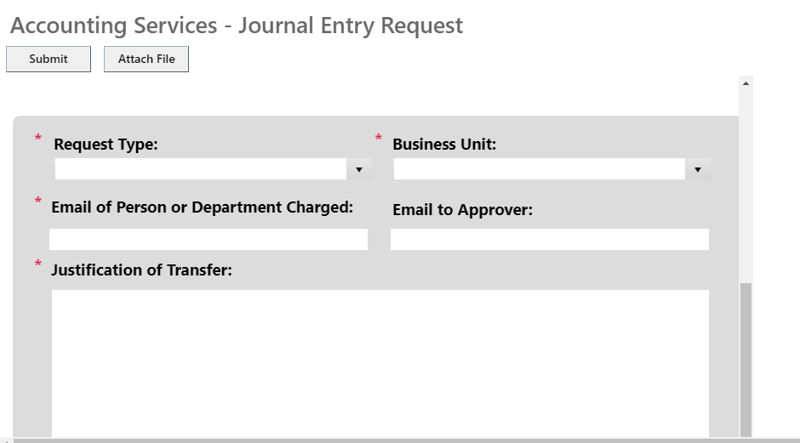

You can enter up to 5 transaction lines each for Credit and Debit lines. Please indicate:

1. Number of lines
2. Chart field strings
3. Journal Line Reference – Optional (Ex. internal note, name of employee for salary/benefit lines, etc.)
4. Short Line Description – Short description that will show in DataWarehouse
5. Amount – credit line will automatically indicate (-) sign once processed

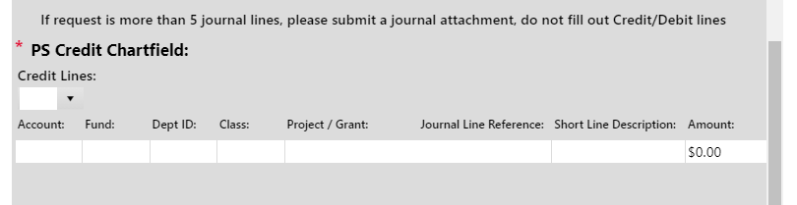

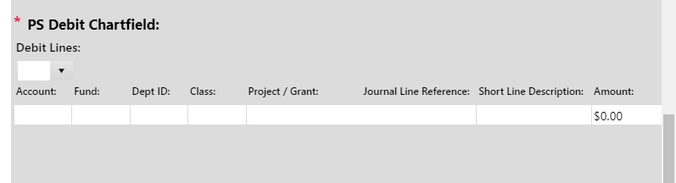

If you have more than 5 journal lines, a journal template can be attached and only the following information is required:

1. The Request Type – Indicate the purpose of your request (ex. Transfer of Expense, Adjustment, Deposits, etc.)
2. Business Unit – Specify the business unit the request will affect
3. Justification of Transfer – Long description for the transaction

**Journal template** - 

**2. Chargeback Request**

<https://csusb.cherwellondemand.com/CherwellPortal/Accounting/One-Step/ChargebackRequest>

A chargeback should be used to record the transaction between campus departments for goods/services provided. One department is being charged for the product or services provided by another campus department.

For departments such as Facilities Services, Telecommunications and Network Services, Printing Services*, Mail Services, Parking Services and etc. that provide services and materials on a regular basis, please submit a journal template with all the charges for the month.

**Journal Template** - 

Please specify:

1. Short Journal Line Description – Specific description for each journal line
2. Email of Person or Department Charged
3. Chargeback Dollar Amount - Credit line will automatically indicate (-) sign once processed
4. Justification of Transfer – Long description for the transaction

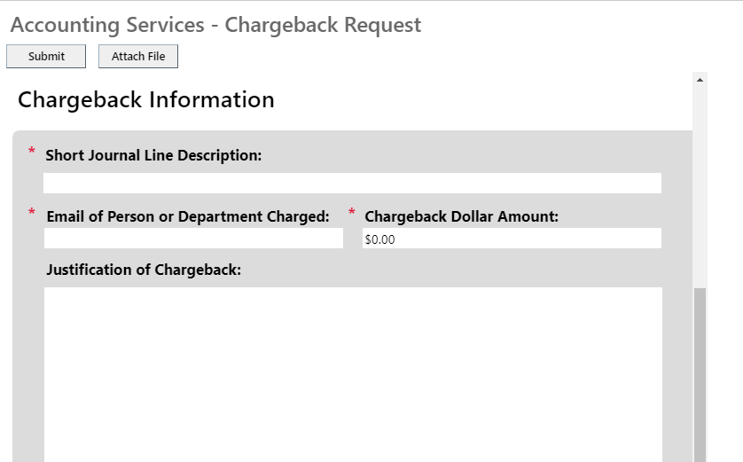

Next, please provide the chart field strings for the credit and debit lines.

The following are required: Account, Fund, Dept. ID and XR class code for any SB002 fund.

1. Credit chartfield - The revenue chartfield of the department providing the services or materials.
2. Debit chartfield - The expense chartfield of the department receiving the services and materials.

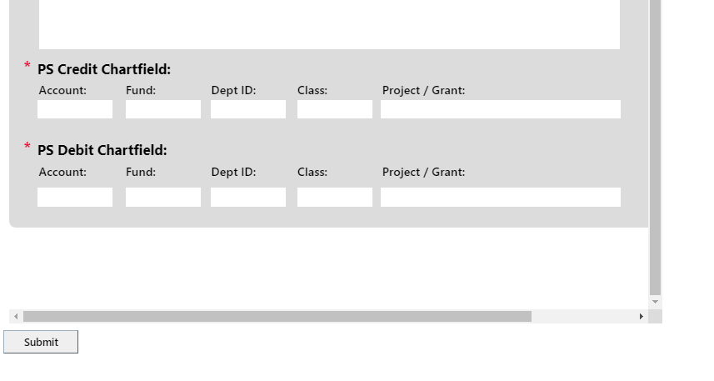

**3. Invoice Request**

<https://csusb.cherwellondemand.com/CherwellPortal/Accounting/One-Step/InvoiceRequest>

1. Determine the Business Unit you are billing for:
2. SBCMP – Stateside
3. SBFDN – University Enterprises Corp.
4. SBPHL – Philanthropic Foundation
5. SBASI – Associate Student Inc.
6. SBSUN – San Manuel Student Union
7. Determine whom are you billing:
8. Outside entity such as off-campus organizations, and off-campus businesses that rent the campus’ facilities for a special event or meeting. Please use “Other” form.
9. Campus Auxiliaries such as, UEC, PHL, ASI, and Student Union. Please use “Auxiliaries” form, if billing for SBCMP.
10. Campus departments such as Accounting or Educational Psychology & Counseling. Please use “Other” form, if billing for any Aux. business unit.

**\*SBPHL invoice is only to bill SBCMP campus stateside or other CSUSB Auxiliaries (no outside customers).**

Once you select the business unit you are billing for, the forms selection will be populated. If you are billing for stateside – SBCMP, you will have 2 forms: “Auxiliaries” and “Other”. If you are billing for other business unit you will only have 1 form; “Other”.

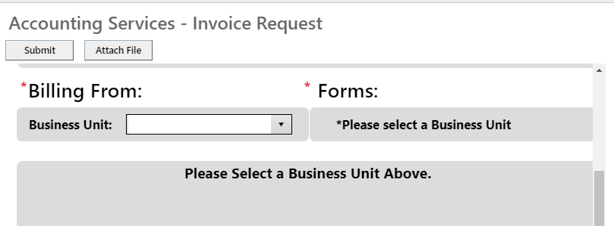

**Invoice Upload Template** – Similar to Journal Entry Request or Chargebacks, if you have multiple transactions then you can use the journal upload template for Invoice Request. If using the journal template please only select the business unit you are billing for, other fields can be omitted.



SBCMP – “Auxiliaries” Form

Please fill out the contact information for any new customer.

If you are billing an old customer, please provide the *Customer ID* and *Customer’s Name* only.

*Customer ID* can be found on prior invoice under *Account Number*.

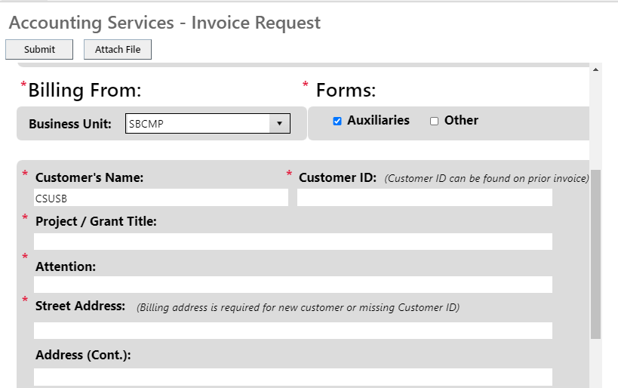

Billing Email – Please provide all email address for anyone who should receive a copy of the invoice.

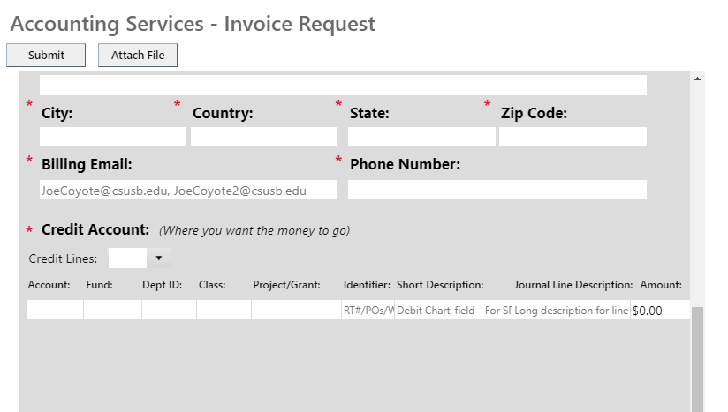

Credit Chartfield String – Where you want the money to go:

1. You can have up to 5 invoice lines.
2. The Credit Account will always be the same 580095.
3. The Identifier will be the Work Order #, Purchase Order, and RT number (if applicable).
4. The Short Description will be the debit chart field string (if applicable).
5. The Journal Line Description will be your long description/explanation for each invoice line.
6. If you need to provide more description, please fill out the Explanation box.

Customers must attach a file to submit. There are three submission buttons.

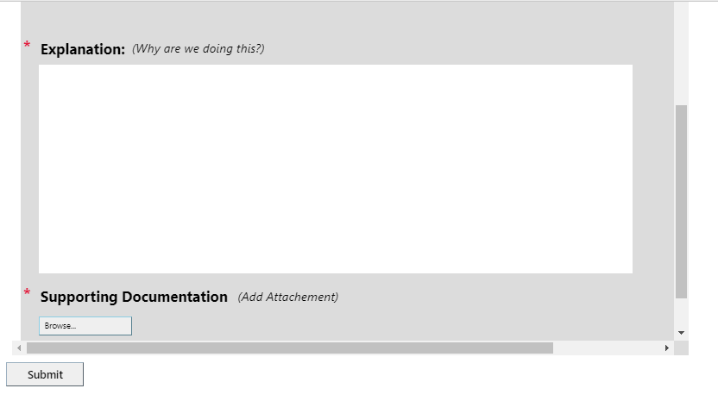

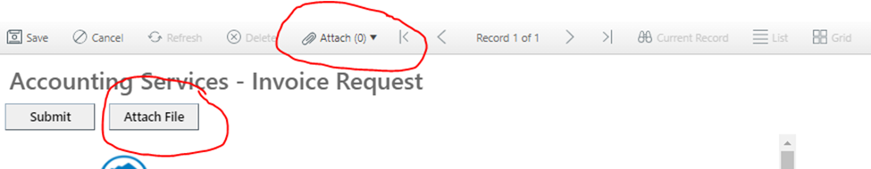

SBCMP and Auxiliaries Business Units – “Other” Form

The criteria are the same as the “Auxiliaries” form except for the following information:

1. The Credit Account can be any revenue account, or expense, if there is existing charge in the expense account.
2. Customer ID is not required

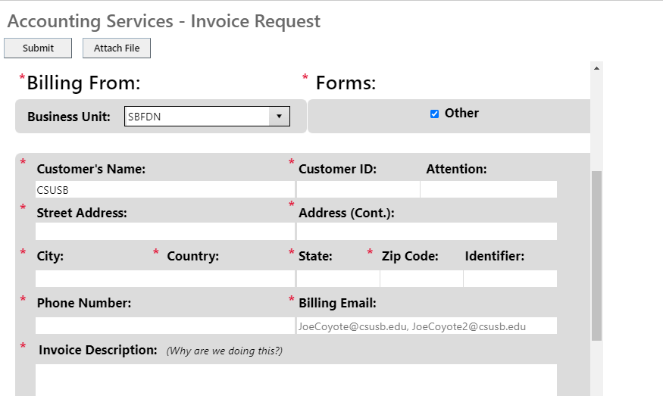

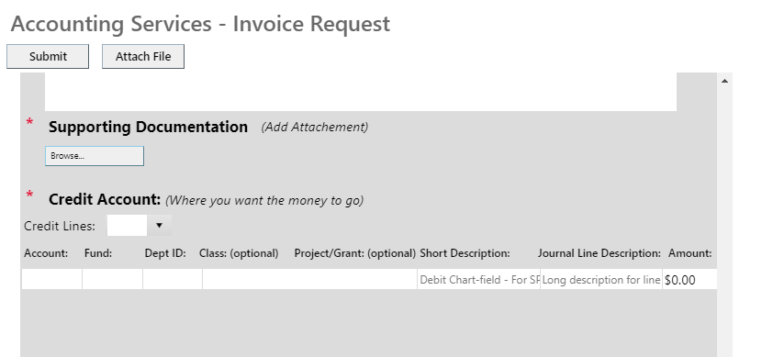

**Customer Confirmation**

1. Customer Status Portal

<https://csusb.cherwellondemand.com/CherwellPortal/Accounting>

Customer can check their request status by accessing the Customer Status Portal.

The status will provide you with the request ID, status, and who to contact if you have any question.

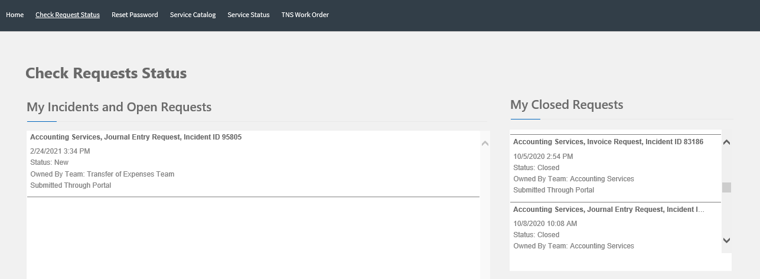

2. Emails

Upon submission, customer will receive an email confirmation with the information submitted on the request. The email will also have the link to the Customer Status Portal.

Once the request has been completed, the customer will also receive a resolution email.

If Accounting staff needs to contact customer regarding any missing information or questions, the email will come from Cherwell system and customer needs to reply directly to the system email.

Example Emails

1. **Customer Confirmation**

|  |  |
| --- | --- |
| *cid:946c809c4280c6b4222a1e43d1b9890aea7a05557c@Cherwell.com* | *Request #: 65913*  *Request Type: Invoice Request* |
| *Dear Frank Cortez,*    *We are please to inform you that your reported Invoice Request has been created. Your assigned Invoice Request number is 65913. Please retain this number for reference purposes.*    *Invoice Request ID: 65913*  *Name: Frank Cortez*  *Date Submittied: 5/14/2020 1:20 PM*  *Department: Technology Support Center*  *Extension: 77717*    *BILLING INFORMATION:*  *Customer Name: CSUSB*  *Customer ID:  Project/Grant Title:*  *Attn:*  *Address:*  *Phone: 77717*  *Billing Email:  Journal Line Reference:  Test Journal*  *Invoice Explanation: Test Explanation*     |  |  |  |  |  |  | | --- | --- | --- | --- | --- | --- | | *Credit Lines* | | | | | | | *Account* | *Fund* | *Dept ID* | *Class* | *Project/Grant* | *Amount* | | *580094* | *SB001* | *D0200* | *X* | *X* | *$2,500.00* | | *580095* | *SB002* | *D0201* | *X* | *X* | *$6,000.00* | | |
| *Please do not hesitate to contact us if you have any questions. You may view the status of your request by visiting our* [*Customer Portal*](https://csusb.cherwellondemand.com/CherwellPortal/IT/samllogin/Command/Queries.GoToRecord?BusObID=6dd53665c0c24cab86870a21cf6434ae&PublicID=65913) *for more details.*    *Thank You,*    *Accounting Services*  *California State University, San Bernardino*  *PH (909) 537-3153* | |

1. **Customer Resolution**

All customers will receive the same resolution template.

*Subject: [Transfer of Expenses] 65761 has been resolved*

*Body:*

*We are pleased to inform you that your request 65761 has been processed.*

*Please do not hesitate to contact Accounting Services if you have any questions, or use our Customer Portal to view more details: Request Portal .*

*Thank You,*

*Accounting Services*

*California State University, San Bernardino*

*PH (909) 537-3153*