Canadian Rockies with Victoria & Vancouver

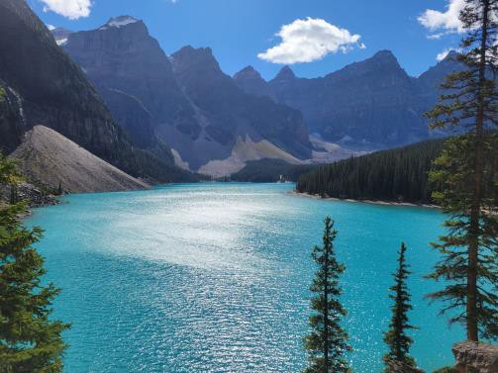
In partnership with Gate 1 Travel, Escorted by Sue Anderson
September 5-14, 2023
10 days/9 nights
$3,259 pp double occupancy
Pay by check or bank transfer
to save an additional 5%.
land tour only (air available separately)

Maximum of 42 travelers
Activity level: Moderate w/ considerable walking
- Explore wondrous Banff National Park, designated a UNESCO World Heritage Site
- Ascend by gondola to the summit of Sulphur Mountain with its stunning views
- Visit beautiful Lake Louise, known for its incredible blue water
- Enjoy the spectacular ride to Jasper National Park, where you’ll cruise to Spirit Island on Maligne Lake
- Travel on the Icefields Parkway past glaciers, ice fields and a cornucopia of mountains
- Ride the all-terrain Ice Explorer to the surface of the massive Athabasca Glacier
- Visit the world-famous Butchart Gardens in Victoria
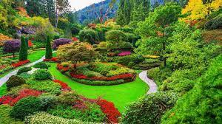
- Enjoy interesting city tours of Calgary, Victoria, and Vancouver

It’s included:
  - 9 nights’ accommodations
    - 1 night Calgary
COVID-19 vaccine required for this tour.
    - 2 nights Banff
    - 2 nights Jasper
    - 1 night Kamloops
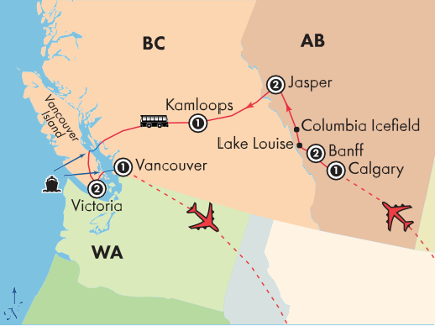
    - 2 nights Victoria
    - 1 night Vancouver
  - Hotel porterage, taxes, fees & service charges
  - 12 meals: 9 breakfasts, 3 dinners
  - Sightseeing in modern air-conditioned motor coach
  - Ferries between British Columbia and Vancouver Island
  - Services of English-speaking tour manager
  - Entrance fees per itinerary

Reserve your spot today.

Reservations & Information: 1-267-585-5100
Reservation Code: 2093172 Click Here to Reserve Online

37500 Cook Street, Palm Desert, CA 92211 osher.csusb.edu · 909-537-8248

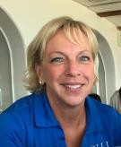

Sue Anderson
OLLI Travel Coordinator
920-660-2067
sue.anderson730@gmail.com

