CNS Course Delivery Mode Approval Form
Please list all courses (course number and title) to which this form applies:

Requested Delivery Modes (Mark an “X” for all modes which approval is requested):
___ FO: Fully Online
Specify below the ways in which the department/program expects faculty to interact with students within this course when offered in fully online mode and the degree of interaction that students may expect from faculty. For example: Instructor will engage with students in discussion boards on a weekly basis, offering prompts to refocus students to the task at hand when necessary. Instructor will provide multiple options for being contacted by students and will respond within ___ week days. Instructor will provide feedback on assignments within __ weeks. (Departments may draft their own language below; they do not need to use the language above).

___ OL: Online Asynchronous
Specify below the ways in which the department/program expects faculty to interact with students within this course when offered in online asynchronous mode and the degree of interaction that students may expect from faculty. For example: Instructor will engage with students in discussion boards on a weekly basis, offering prompts to refocus students to the task at hand when necessary. Instructor will provide multiple options for being contacted by students and will respond within ___ week days. Instructor will provide feedback on assignments within __ weeks. (Departments may draft their own language below; they do not need to use the language above).

___ OS: Online Synchronous
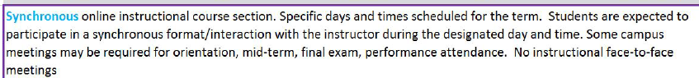

___ HO: Asynchronous and synchronous online
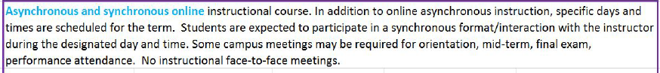
If the % of instruction that will be offered synchronously is other than 50%, specify the number of hours per week (or total hours per term) of synchronous online instruction: ______
If <50% of instruction will occur synchronously, explain why:

Specify below the ways in which the department/program expects faculty to interact with students for the asynchronous component of the course and the degree of interaction that students may expect from faculty. For example: Instructor will engage with students in discussion boards on a weekly basis, offering prompts to refocus students to the task at hand when necessary. Instructor will provide multiple options for being contacted by students and will respond within ___ week days. Instructor will provide feedback on assignments within __ weeks. (Departments may draft their own language below; they do not need to use the language above).

___ CA: Hybrid: in person and asynchronous online
If the % of instruction that will be offered in person is other than 50%, specify the number of hours per week (or total hours per term) of in-person instruction: ____________
If <50% of instruction will occur in-person, explain why:

Specify below the ways in which the department/program expects faculty to interact with students for the asynchronous component of the course and the degree of interaction that students may expect from faculty. For example: Instructor will engage with students in discussion boards on a weekly basis, offering prompts to refocus students to the task at hand when necessary. Instructor will provide multiple options for being contacted by students and will respond within ___ week days. Instructor will provide feedback on assignments within __ weeks.
___ CS: Hybrid: in person and synchronous online
If the % of instruction that will be offered in person is other than 50%, specify the number of hours per week (or total hours per term) of in-person instruction: ____________
If <50% of instruction will occur in-person, explain why:

___ CM: Course Match
Please consult with the Dean’s office to learn about the Chancellor’s Office process for approving courses for the Course Match program.
___ P: In-person
___ TO: Televised (for sections being broadcast)
___ TR: Televised (for sections receiving a broadcast)
___ OC: Off-campus

______________________________ ____________________________ _________________
Department Chair (Printed Name) Department Chair Signature Date Signed

