Michelle A. Behne
Contact info: cia-support@csusb.edu
Information Security & Emerging Technologies Office
Information Technology Services Division
CIA DELEGATE GUIDE
Assistance for Creating CIA Requests

Contents

Contact Info & Key Websites 2
OnBase Workflow 2
Information Technology & Emerging Technologies 2
ITS Training 2
New CIA Requests 3
Create a CIA Request 3
Basic Steps to Create a CIA Request 3
Important Details 4
Monitoring Requests 5
Custom Queries 5
Finding Forms 5
Things to Note: 5
Interpreting Custom Query Results 5
Table: WF Status Translation 6
FAQs 7
CIA Request Process Flow 10
CIA Components – Descriptions, Requirements, & Training 11

TIP: use this document in its digital form for convenient copying & pasting of links.

CIA Delegates Guide

Contact Info & Key URLs

OnBase Workflow
URL for creating and retrieving CIA Requests.
https://workflow.csusb.edu

TIP: to create a bookmark or favorite – login first before saving either link as a bookmark or favorite. That way when you click your bookmark or favorite you’ll go right to the login screen.

Office of Compliance Initiatives
This office manages and monitors CIA Requests. Contact OCI with questions about CIA Requests.

Email: cia-support@csusb.edu Phone: 77262
OCI Web: https://www.csusb.edu/its/security/submit-computerized-information-access-cia-request
Knowledge Base Articles: https://www.csusb.edu/its/support/knowledge-base-articles

NOTE: The link to the OnBase CIA Request form is NOT on the OCI website.

ITS Training Services
This office monitors and tracks fulfillment of training requirements for CIA Requests. They are the best resource for any questions regarding training requirements.

Email: ITSTrainingServices@csusb.edu Phone: x77425

Link to sign up for training:
https://info001.csusb.edu/cms/reg/courseview.php

Users can go to CSULearn to review their training records.

TIP: Give training link to requesters so they can sign up for training & review what training they’ve taken.

New CIA Requests

Create a CIA Request

Basic Steps
Use screenshot of the CIA Request form below to ensure you follow basic steps in filling out a request:
STEP 1 - Fill out all the information on the Employee tab.
STEP 2 - Select the tab with the necessary components. (Circle 1)
STEP 3 - Click the ADD button (Circle 2) to open the drop down menu. Click ADD again if more component are needed. DON’T FORGET THIS STEP!!! Omitting this step breaks the process.
STEP 4 - select one or more components needed access using the dropdown (Circle 3).
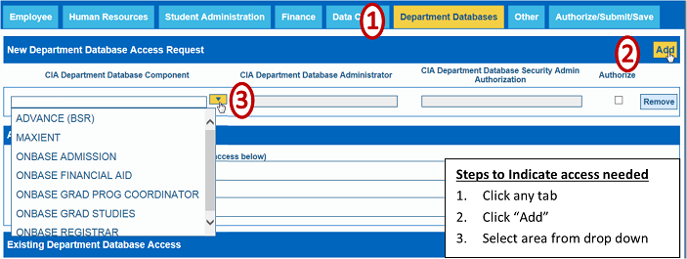
STEP 5 - When finished selecting all the access needed go to the AUTHORIZE/SUBMIT/SAVE tab to click the "SAVE" button. This submits the form.
NOTE: Blank forms are forms without a component added on any of the pages. This prevents CIA Requests from moving through the process.

Important Details
Several important details to pay attention to when creating CIA Requests.

MPP Information
Ensuring the right MPP is listed when creating a CIA Request is critical. After adding the requester’s employee ID the form should populate with PeopleSoft’s information on the requester, their MPP and Supervisor. Here are situations when this won’t occur:
- Requester’s position is funded by an Auxiliary like UEC, ASI or SMSU.
- PeopleSoft has incomplete or inaccurate information.
Solution:

Mirroring
This field is found on the first page - the Employee page. Located midway down on the right, this required field asks “Should access mirror someone?” is a general point of reference. This does not enable the form to be processed. Components must still be added to the request form. Situations where this information is helps:
- Areas where multiple people have the same access. Aids in identifying that all access is being given.
- The requester is filling a previously held position. Aids in ensuring details of access are granted.
- When access is complex. Almost all components found on the Student Administration tab have complex security and this detail can be very helpful.

Reason for submitting this request & “Comments” fields on each page.
Filling out these open fields can eliminate unnecessary phone calls and delays in granting access. Helpful information includes:
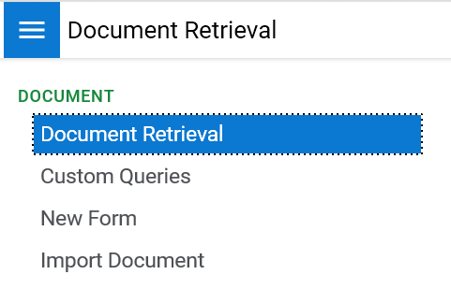
- Identifying specific information needed
- Naming specific PeopleSoft pages or processes that access will support.

Monitoring Requests
“Custom Queries” provides the Workflow (WF) status of CIA Requests.
Click the 3 horizontal bars in the upper left corner of the window. This reveals all options available to you

Custom Queries
TIP: To avoid these steps save this page as a “Favorite”. Click the star next to the document carat. You’ll be asked to name this “Favorite”. Use “Monitor CIA Requests”. Click save. Next time you login click the star & the “Monitor CIA Requests” will be listed as a Favorite
- Choose “CIA General”
- Enter at least one search parameter.

Finding Forms
- Enter one or more parameters into the appropriate field(s).
- Click “Enter” or the binoculars in the bottom left of the page.

Things to Note:
- OnBase’s search wildcard is “ * “ (asterisk)
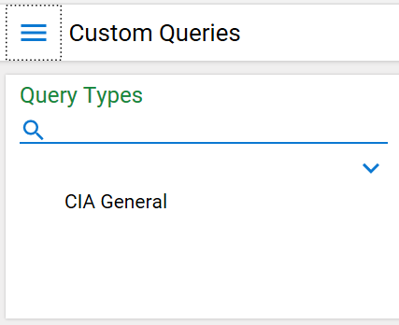
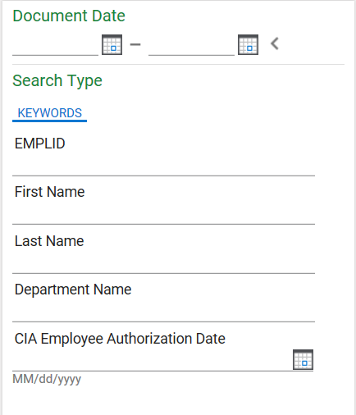
- Use wildcard when searching partial words
- or partial name.
- Only one search parameter is needed.

Example: Someone’s last name is Brown-Welty. The search for last name must be “Brown*” or “Bro*”

Example: Searching someone’s first name: Mich* will pull names like Michelle, Michael and Michaela.

Interpreting Custom Query Results
Here’s a sample search. Notice the WF Status column (WF = Workflow). This is the information needed to determine the form’s status.
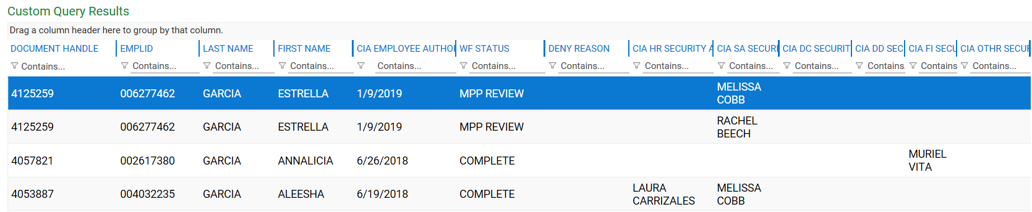

Pay attention to details like the date of the CIA Employee authorized to discern if there’s more than one submission.

WF Status Translation
WF Status | Meaning | OnBase Queue
MPP REVIEW | Waits for MPP approval | MPP
SECURITY ADMIN REVIEW | Security Admin authorization required | Security Admin
IN PROGRESS | Waiting for training validation or ready for implementation. | Training Validation or  Implementation
COMPLETE | No longer in Workflow – request is finished or fell out of workflow. | No Queue

FAQs

ACCESS REQUIREMENTS
- What components have paperwork requirements? And what are those requirements?

CIA COMPONENT | PAPERWORK REQUIRED | DEPT. TO CONTACT
Absence Management – Timekeeper or Approver | Signature Authorization Form | Payroll
Master Pay Warrant Authorization (MPWA) | Signature Authorization Form & MPWA form | Payroll
ProCard | ProCard application | Purchasing
Requisitions | Approval form with signature of authorized signer for chart-string account | Purchasing

- How to know if a CIA Request form is needed. – CIA Request Checklist:

Does access need. . . | MPP Approval | Training & Paperwork  Validation | Security Admin Authorization
New Employee | Y | Y | Y
New Access | Y | Y | Y
Department Transfer | Y | Y | Y
Adding Dept. IDs | Y | Y | Y
Adjusting Access | N | N | Y

If all three are “YES” then submit a CIA Request.

REQUEST MODIFICATION
- Am I allowed to modify a request after submission?
No. Email cia-support@csusb.edu and “cc” the requester & the requester’s MPP. In the email include name, emplid, date of submission and what needs to be changed.
- Can CIA Delegates change the MPP after the form has been submitted?
No. Email cia-support@csusb.edu and cc the new MPP. Include in the email: Requester’s name & emplid and date of CIA Request submission along with who will be the MPP Approver.
- Does a manager have to approve the entire CIA Request?
Managers have the ability and authority to add or remove components from a CIA Request. The “Add” and “Remove” buttons on the component’s line allow modification of CIA Requests.
- What if a request needs to be removed?
Email cia-support@csusb.edu and “cc” the requester’s MPP. Include name, emplid, date of submission along with the request to remove from Workflow.

PROCESS REQUIREMENT
- When is a CIA Request not needed for changing access?
A person increasing their current access in a specific component will not need a CIA Request. For example, if the Student Records View access needs upgrading or slight modification. The only exception is when adding departments to those with MPWA or Absence Management Access. This is when a new CIA Request is required.
- What if a new employee’s access needs to mirror someone no longer at the university?
Screen shots are made of the PeopleSoft access of exiting personnel. Email cia-support@csusb.edu to request details about retrieving PeopleSoft access screen shots.
- Why is a new CIA Request needed when people transfer?
New managers must accept the access of their employees. Plus, it cannot be assumed a transferee's access for their new duties will match the access of their old position. Hence, standard security practice is to remove administrative PS access then require a new CIA request. However, CIA Delegates can submit requests for incoming personnel before they arrive. Additionally, OCI has begun a new process that allows transferees to retain their access.

FORM FUNCTIONALITY
- Common form issues & solutions
No auto-population of employee info | Wrong MPP  info | Missing MPP info
Auxiliary Hire | PeopleSoft not updated | Wrong ID# for MPP
Student Assistant | Common to:  Department transfers | MPP not in OnBase
Not hired in PeopleSoft yet | New MPPs | PeopleSoft not updated
Keying error in employee ID

- What are the steps in the CIA Request process?

CIA Request Process Flow
Descriptions of steps in the CIA Request process.
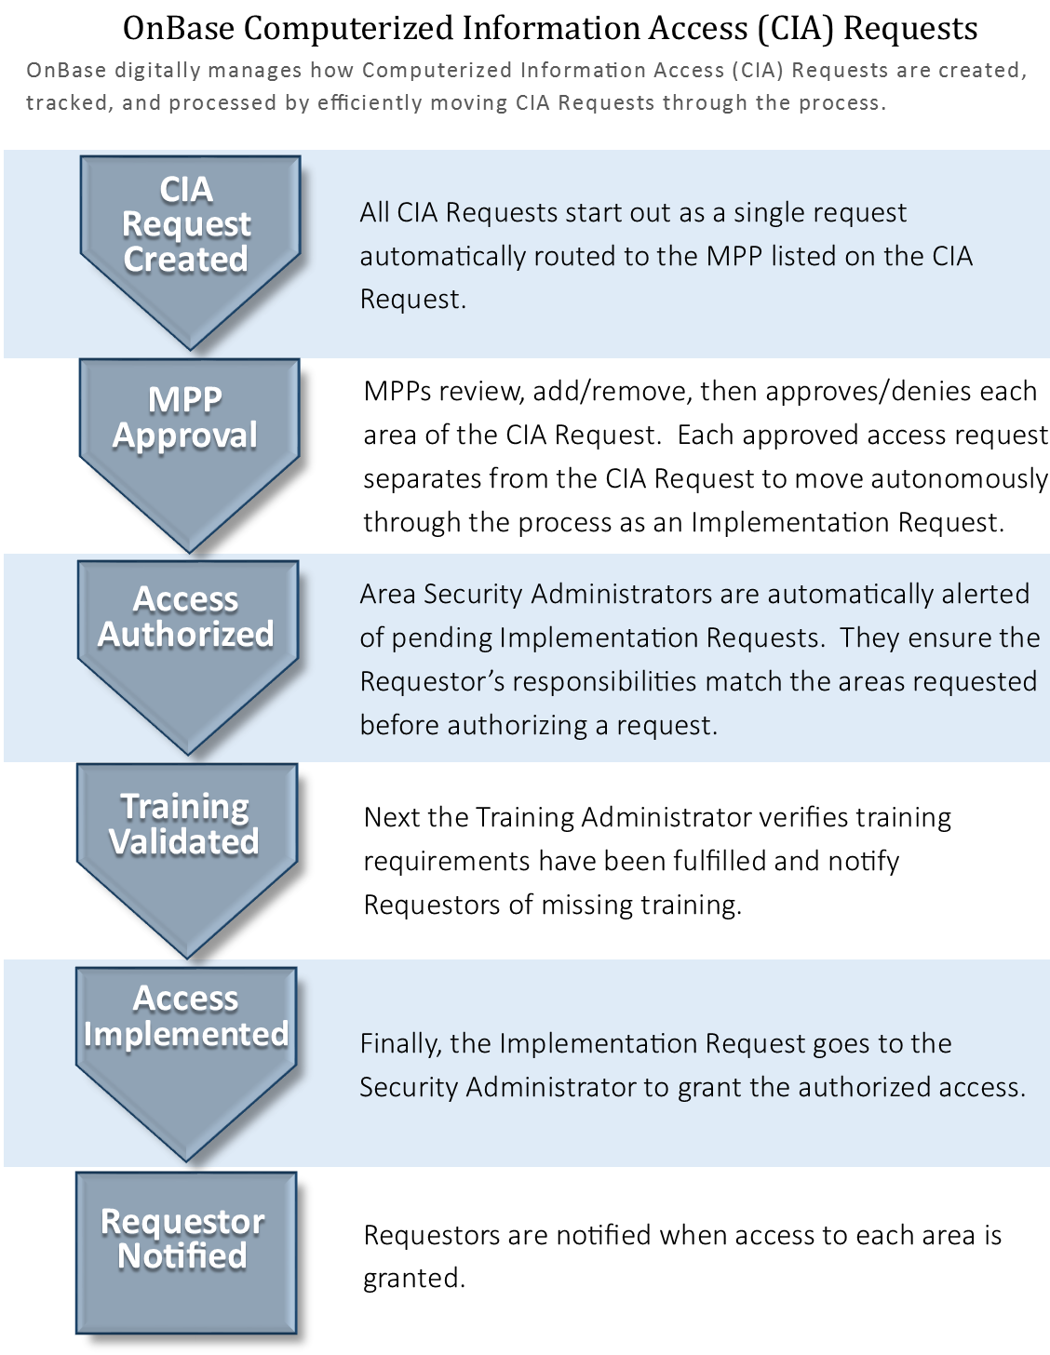

CIA Components – Descriptions, Requirements, & Training
The spreadsheet containing this information is available separately. Retrieve it from the OCI website listed in the header of this document or email cia-support@csusb.edu for a copy.

TIP: Use the CIA Components spreadsheet with descriptions, requirements and training in its digital form to enable easy search capabilities and manipulation of the information.

