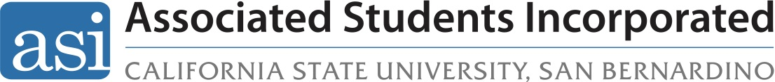

Howl Grant Policy
Adopted per BD 53-20 | April 14, 2020

Purpose: The purpose of this policy is to establish rules and regulations for the Howl Grant.

Scope: This policy applies to all student clubs and organizations at the CSUSB San Bernardino campus and at the Palm Desert Campus.

- Eligibility

  - Only Clubs and Organizations that are currently chartered through the Office of Student Engagement and are recognized by the University to be good standing are eligible for funding.

- Funding Guidelines

  - Each currently enrolled CSUSB student whether at the San Bernardino or Palm Desert Campus will be allowed to allocate up to $3.00.

  - Funds are from student fees and as such must be in compliance with all local, state and federal laws; including, but not limited to Title 5 of the California Education Code.

  - Funds must be used in accordance with both CSUSB and ASI policies.

  - Funds will only be available to clubs and organizations through the Office of Student Engagement disbursements, in accordance with the OSE policy.

  - Funds are available to the organization beginning July 1st of the following fiscal year and are available for expenses incurred through June 1st of the same fiscal year.

  - All disbursement requests are due no later than June 1st.

  - Any not disbursed funds at the end of the fiscal year will be returned to the general Howl Grant account.

  - Original receipts must be provided for fund disbursement

  - All Clubs and Organizations that are currently chartered with the Office of Student Engagement and in good standing will be placed on the ASI general election ballot.

- Howl Grant Process

  - Each currently enrolled student who is eligible to participate in the ASI general election in accordance with Article 1 of the ASI By-Laws will be allowed to allocate up to $3.00 to eligible clubs and organizations listed on the ballot.

  - All clubs and organizations placed on the ballot for funding must adhere to the ASI campaign regulations as stated in section C of the ASI Policy and Procedures.

  - Failure to adhere to these regulations will result in an immediate removal from the ballot and ineligibility to receive funding.

Approved and Revised Per BD 10-18, February 27th, 2018
Revised Per BD 52-19, April 30th, 2019
Revised Per BD 53-19, April 14th, 2020

