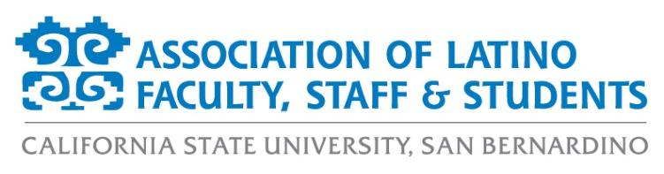
ALFSS General Meeting Agenda
Tuesday, June 1st, 2021
12:00pm – 1:00pm
ZOOM:
https://csusb.zoom.us/j/9710671398

- Approval of the Agenda (2 minutes)
- Approval of the Minutes (2 minutes)
- Old Business (5 minutes)
  - LatinX Graduate Recognition Ceremony Recap
- New Business (20 minutes)
  - Membership Report
  - Financial Report
  - President’s Diversity, Equity, and Inclusion (DEI) Board Updates
  - Scholarship Report
  - Election Results
    - Appointed position nominations now open
  - 2020/2021 Annual Report
- Events Calendar (10 minutes)
  - Fall 2021 Programs
    - Fall Bienvenida – August 18th at 12:00pm
    - ALFSS HHM Kickoff Event – September 15th
    - Day of the Dead – November 2nd (or Oct. 30th or Nov. 6th)
    - Social Event – November 16th
    - Fall LatinX Graduate Recognition Ceremony – December 4th at 10:00am
- Officer Reports (10 minutes)
  - Monica McMahon, President
  - Aurora Vilchis, Vice President
  - Leah Stiff, Executive Secretary
  - Ericka Saucedo, Treasurer
  - Miranda Canseco, Director of Marketing
  - Francisco Alfaro, Director of Programs
  - Jonathan Gonzalez-Montelongo, Director of Membership
  - Edgar Astorga, Director of Scholarships
  - Evelin Ortiz, Spring 2021 Student Representative
- Discussion Topics (10 minutes)
- Adjournment (1 minute)

