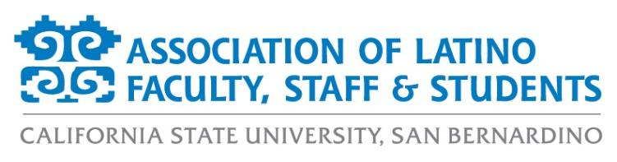
ALFSS E-Board Meeting Agenda
Monday, May 10th, 2021
5:00pm – 6:30pm
ZOOM:
https://csusb.zoom.us/j/97408496542

- Approval of the Agenda (2 minutes)
- Approval of the Minutes (2 minutes)
- Old Business (20 minutes)
  - ByLaws Updates
  - Elections Updates
  - Annual Report
- New Business (20 minutes)
  - Membership Report
  - Financial Report
  - Scholarship Report
  - President’s Diversity, Equity, and Inclusion (DEI) Board Report
  - Annual Report
- Events Calendar (10 minutes)
  - LatinX Graduate Recognition Ceremony (May 15 @ 10am)
- Officer Reports (15 minutes)
  - Monica McMahon, President
  - Aurora Vilchis, Vice President
  - Leah Stiff, Executive Secretary
  - Ericka Saucedo, Treasurer
  - Miranda Canseco, Director of Marketing
  - Francisco Alfaro, Director of Programs
  - Jonathan Gonzalez-Montelongo, Director of Membership
  - Edgar Astorga, Director of Scholarships
  - Evelin Ortiz, Spring 2021 Student Representative
- Discussion Topics (20 minutes)
- Adjournment (1 minute)

